**Jupiter’s Great Red Spot**

Jupiter, the largest planet in the Solar System is a gas giant whose atmosphere is usually violent and has a wide range of weather phenomena including band instabilities, vortices, storms, and lightning. The vortices that reside on the Jovian atmosphere usually appear as large red, white or brown spots and the two largest of such spots are known as the Great Red Spot and Oval BA, which is also red. The Great Red Spot is an enormous storm that has been raging on the surface of Jupiter for a long period of time. Large enough to be spotted by telescopes on the earth, it was first spotted by an Italian astronomer by the name of Domenico Cassini in 1665, the storm is believed to have existed for well over 300 years.

The storm rotates anticlockwise and has a rotation period of about six Earth days. An article on Encyclopaedia Britannica [2] mentions that unlike a typical hurricane seen on earth which is usually 600 miles across and possesses wind speeds of around 240 Kilometers per hour, the great red spot on Jupiter is a much larger anticyclone and is called so because due to the presence of high pressure in the center as opposed to low pressure as seen in a typical earth bound cyclonic system. It is usually reddish in appearance and is about 24 to 40,000 kilometers west to east and 12 to 14,000 kilometers south to north large, which makes it large enough to engulf about three earths. In addition to this, the wind speeds on the outer edges of the storm are much greater and are usually estimated to be around 400 Kilometers per hour.

Some interesting features of this storm include a red colored appearance and the fact that it is almost always stationary.

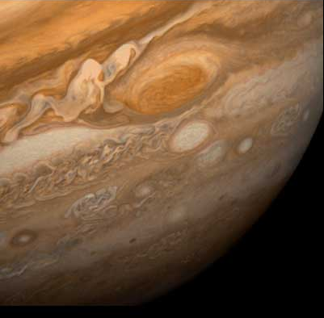

Figure 1. Image of the great red spot and its surroundings taken by Voyager 1 when it was approaching Jupiter in 1979.

Image Source: NASA, Planetary Data System archives, 2005.

According to an article by Universe Today [1] blog, although the exact reason behind the redness of this storm is not known, it is speculated that the color may be caused by organic molecules like red phosphorous and/or sulfur compounds. Moreover, the overall appearance also changes from time to time from bright red to a dull brown shade. An article from Wired magazine [3] mentions a popular theory which hypothesizes that sulfurous molecules from deep within Jupiter’s atmosphere would be broken down by ultraviolet light after being raised by the storm winds, giving the deep red appearance to the spot.

An interesting feature [1] to note about the Great Red Spot is that the storm is held in place by an eastward jetstream to its south and a very strong westward jetstream to its north. Moreover, although there are strong winds on the outer regions of the storm, the inner regions seem to lack in/outflow winds. Infrared scans of the spot found that the central region is warmer than its surroundings by 4 Kelvin which slowly rotates in a direction opposite to the surrounding regions of the storm. Similar to the storms on Earth, the storms[5] on Jupiter are roughly about 1000 kilometers in size and appear in groups from time to time in the cyclonic regions, especially within the strong west bound jets.Infrared data showed that the Great Red Spot is colder and is 8 kilometers higher than other cloud regions.

Another interesting fact to note about the Great Red Spot is that the region is observed to be shrinking with time. Scientists have speculated that given the rate at which the Great Red Spot is shrinking, it will become circular in shape as opposed to oval by 2040. NASA [4] hypothesized that the reason behind this phenomenon is due to the feeding of very small eddies from the surroundings which might be altering the internal dynamics of the region.

Although not much is known about the Great Red Spot as of now, NASA plans to send new probes which will reach Jupiter by early 2020s and will perhaps reveal a lot more about Jupiter’s atmospheric behavior and the Great Red Spot as well.

**References**

1. J.Coffey, Universe Today, 2008. Retrieved from <http://www.universetoday.com/15163/jupiters-great-red-spot/> (visited July 22, 2014)
2. Great Red Spot. (2014). In Encyclopædia Britannica. Retrieved from <http://www.britannica.com/EBchecked/topic/243638/Great-Red-Spot> (visited July 22, 2014)
3. A.Madigral, Wired Magazine, “Red in Jupiter’s spot not what astronomers thought”, March, 2010. Retrieved from <http://www.wired.com/2010/03/jupiter-spot/>
4. NASA, Planetary Data System archives, 2005
5. [Vasavada (2005)](http://en.wikipedia.org/wiki/Great_Red_Spot#Vasavada), pp. 1982, 1985–1987