**Project3**

**Yinglai Wang MA266**

**00251 48530**

1. 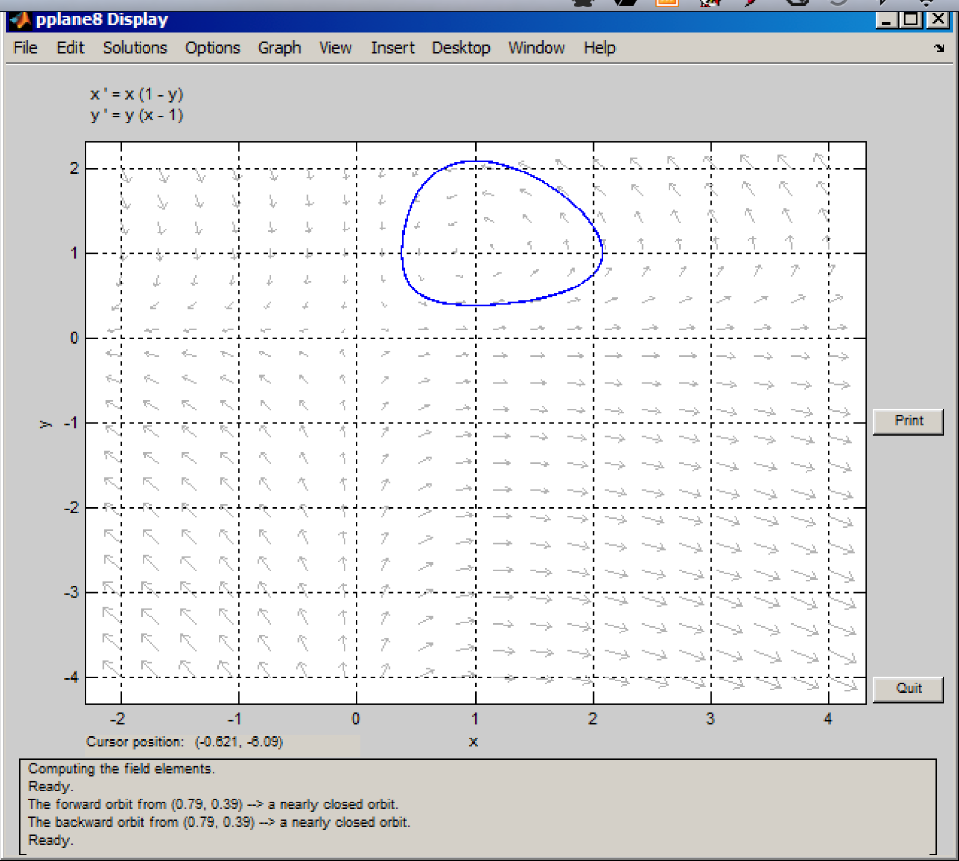

Based on the graph, the aphid population never smaller than 300,000

(y > 0.3).

The aphids eradicated when 0.4 < x < 0.8 approximately.

The ladybug population exceed 2 million almost all the time.

2.

s=0.5

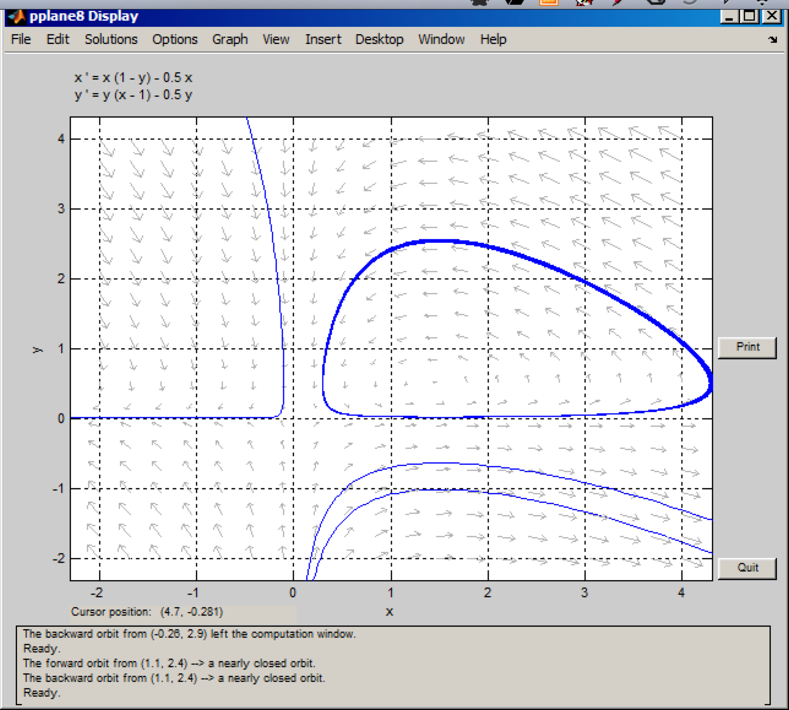

s=0.75

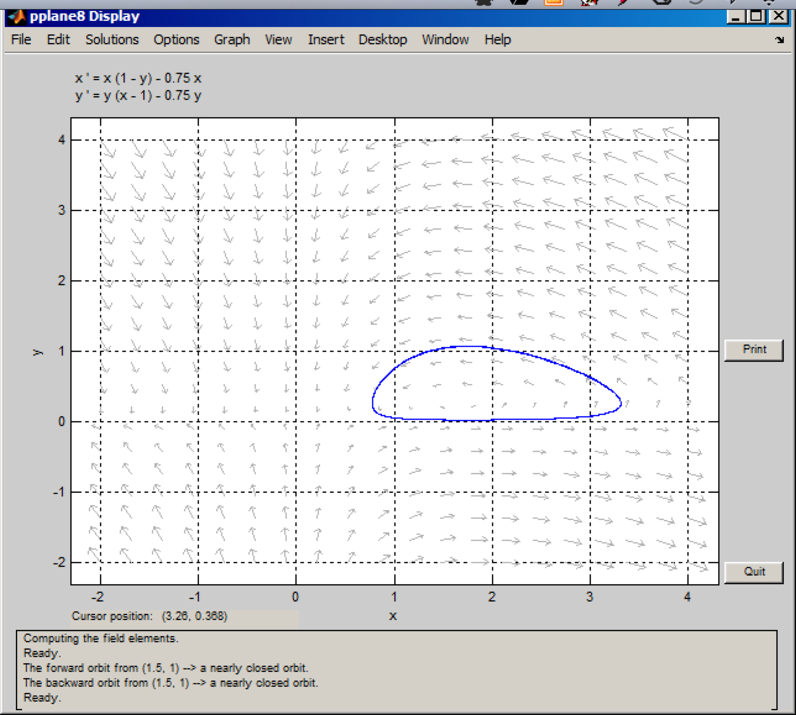

The aphids never get totally eliminated.

3.

I would recommend use s=0.0 (no pesticide).

4.

s=1.5

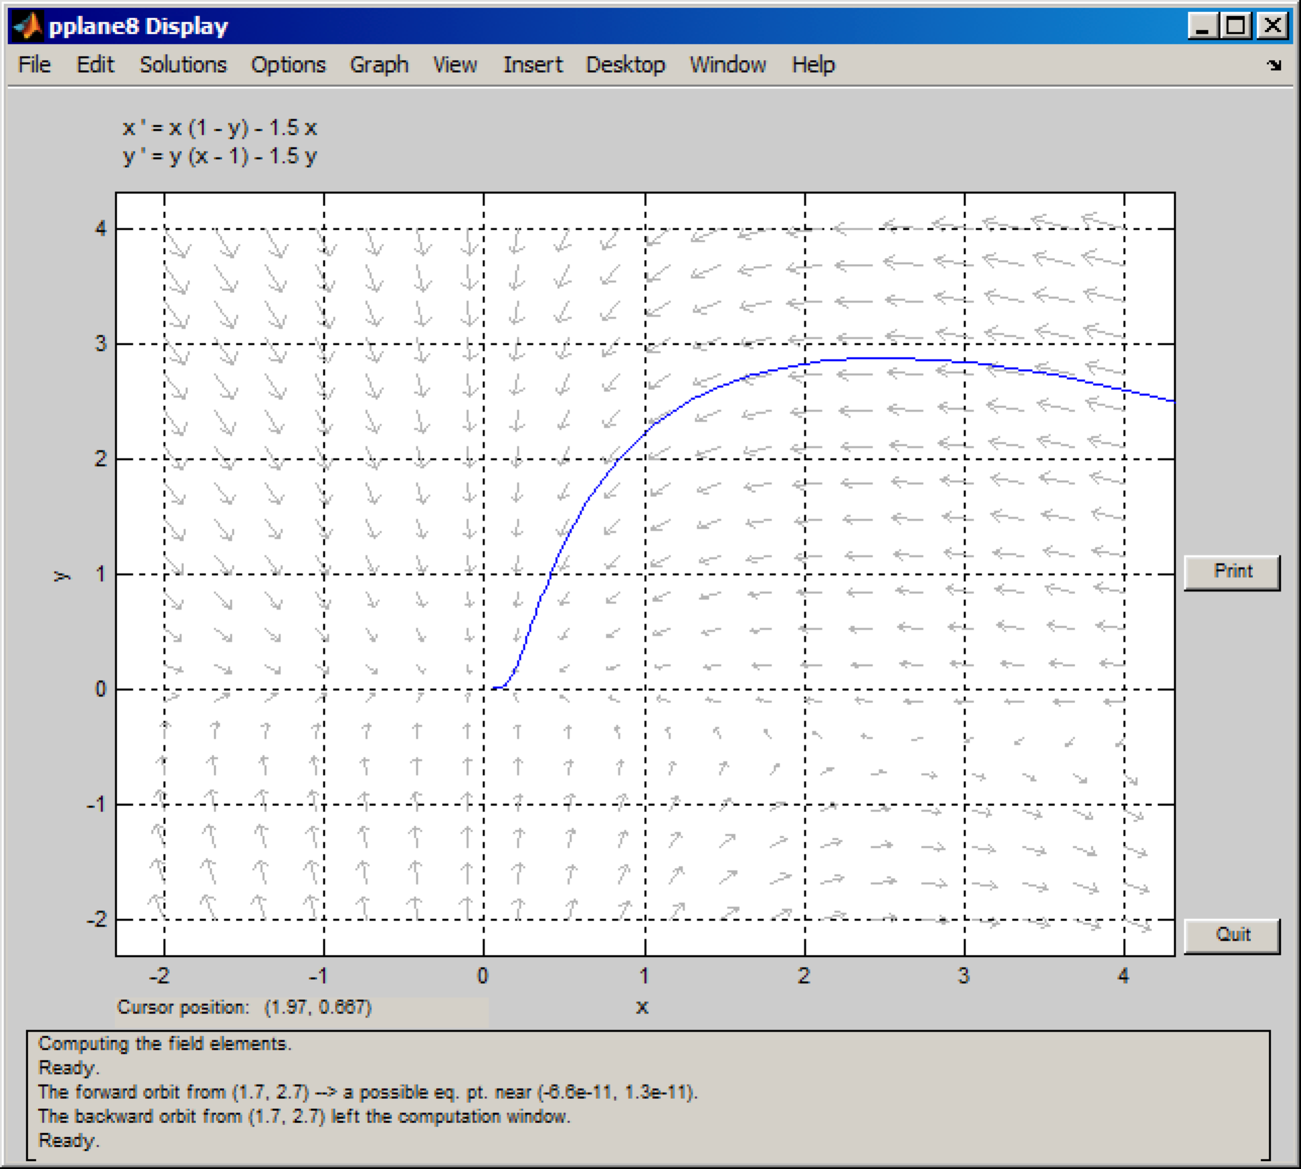

Ladybugs and aphids will all eradicate if she use this pesticide.