Problem 1.

1. Correlation of percent alcohol and the carbohydrates is 0.287.
2. Correlation of percent alcohol and the carbohydrates after delete the outlier is 0.287.
3. 
4. 

Problem 2.

1. 
2. The regression equation is

Fund = 319 + 0.935 EAFE

1. 
2. The correlation of Year and EAFE is 0.749.

The regression equation is

EAFE = -2060200 + 1035 Year

R-Sq = 56.0%

Problem 3.

1. 
2. The regression equation is

Population = - 113 + 0.156 OpenSpace

1. R-Sq = 95.2%

Problem 4.

(a)

Row City Population OpenSpace RESI1

1 Los Angeles 3695 29801 -837.35

2 WashingtonDC 572 7504 -485.07

3 Minneapolis 383 5694 -391.96

4 Oakland 399 3712 -67.04

5 Boston 589 4865 -56.75

6 Philadelphia 1518 10685 -34.87

7 San Francisco 777 5916 -32.56

8 Baltimore 651 5091 -29.97

9 Long Beach 462 2887 124.55

10 Miami 362 1329 267.39

11 New York 8008 49854 350.12

12 Chicago 2896 11645 1193.50

(b) The regression equation (include New York City) is

OpenSpace = 1248 + 6.10 Population R-Sq = 95.2%

The regression equation (without New York City) is

OpenSpace = 1105 + 6.26 Population R-Sq = 82.6%

New York is not an outlier.

According to the regression equation and the R-square values, this is not an influential point.

Problem 5.

1. 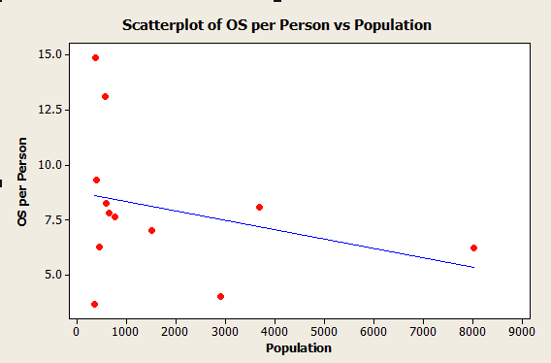
2. OS per Person = 8.74 – 0.000424 Population
3. R-Sq = 8.7%