(b) ﷽﷽﷽﷽﷽﷽kew shape of these two group are almost the same. Therefore, the use of t procedure is acceptable.**Problem 1.**

(a) Stem-and-leaf of sales N = 50

Leaf Unit = 1.0

8 1 01233344

24 1 5566667778999999

(8) 2 00124444

18 2 5555566667

8 3 244

5 3 5

4 4 1

3 4 8

2 5

2 5

2 6 3

1 6

1 7

1 7 9





(b) **One-Sample T: sales**

Variable N Mean StDev SE Mean 95% CI

sales 50 23.56 12.52 1.77 (20.00, 27.12)

**Problem 2.**

(a) **Stem-and-Leaf Display: IBI**

Stem-and-leaf of IBI N = 49

Leaf Unit = 1.0

2 2 99

5 3 233

6 3 9

8 4 13

10 4 67

12 5 34

18 5 556899

22 6 0124

23 6 7

(5) 7 11124

21 7 56889

16 8 001222344

7 8 556899

1 9 1





There is no outlier present in the box plot, but very few outliers can be found in the probability plot.

The distribution skewed right.

I think t procedure should be used to analysis these data. This data has very few outliers and has a skewed shape; t test is robust for this kind of data, so we should use it.

(b) **One-Sample T: IBI**

Variable N Mean StDev SE Mean 95% CI

IBI 49 65.94 18.28 2.61 (60.69, 71.19)

**Problem 3.**

(a) **Paired T-Test and CI: Jockos, Other**

Paired T for Jockos - Other

N Mean StDev SE Mean

Jockos 10 1216 550 174

Other 10 1136 521 165

Difference 10 80.0 84.6 26.7

95% CI for mean difference: (19.5, 140.5)

T-Test of mean difference = 0 (vs not = 0): T-Value = 2.99 P-Value = 0.015

The null hypothesis is µ=0 and alternative hypothesis is µ≠0. The degrees of freedom are both 9. The P-value is 0.015, so we do not reject the null hypothesis. We can conclude there is no difference between these two garages.

**Problem 4.**

(a) **Power and Sample Size**

1-Sample t Test

Testing mean = null (versus not = null)

Calculating power for mean = null + difference

Alpha = 0.05 Assumed standard deviation = 1.23

Sample

Difference Size Power

0.6 10 0.281539



(b) **Power and Sample Size**

1-Sample t Test

Testing mean = null (versus not = null)

Calculating power for mean = null + difference

Alpha = 0.05 Assumed standard deviation = 1.23

Sample

Difference Size Power

0.6 25 0.648278



**Problem 5.**

1. 

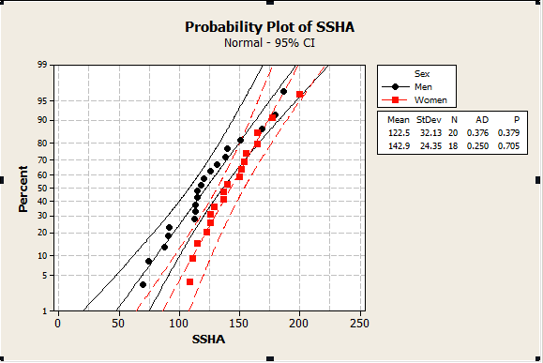

From the boxplot and probability plot, we can tell there are no outliers, and the skew shapes of these two groups are almost the same. Therefore, the use of t procedure is acceptable.

1. H0: umen = uwomen

Ha: umen = uwomen

**Two-Sample T-Test and CI: SSHA, Sex**

Two-sample T for SSHA

Sex N Mean StDev SE Mean

Men 20 122.5 32.1 7.2

Women 18 142.9 24.4 5.7

Difference = mu (Men) - mu (Women)

Estimate for difference: -20.44

95% upper bound for difference: -4.91

T-Test of difference = 0 (vs <): T-Value = -2.22 P-Value = 0.016 DF = 35

The P-value is smaller than 0.05, we reject the null hypothesis H0. The mean SSHA score for men is lower than women.

(c) **Two-Sample T-Test and CI: SSHA, Sex**

Two-sample T for SSHA

Sex N Mean StDev SE Mean

Men 20 122.5 32.1 7.2

Women 18 142.9 24.4 5.7

Difference = mu (Men) - mu (Women)

Estimate for difference: -20.44

90% upper bound for difference: -8.43

T-Test of difference = 0 (vs <): T-Value = -2.22 P-Value = 0.016 DF = 35

**Two-Sample T-Test and CI: SSHA, Sex**

Two-sample T for SSHA

Sex N Mean StDev SE Mean

Men 20 122.5 32.1 7.2

Women 18 142.9 24.4 5.7

Difference = mu (Men) - mu (Women)

Estimate for difference: -20.44

90% lower bound for difference: -32.46

T-Test of difference = 0 (vs >): T-Value = -2.22 P-Value = 0.984 DF = 35

We can conclude that the 90% confidence interval for the mean difference is

(-8.43, -32.46)

**Problem 6.**

1. 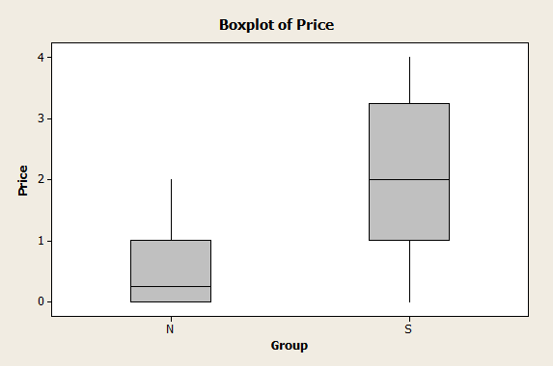

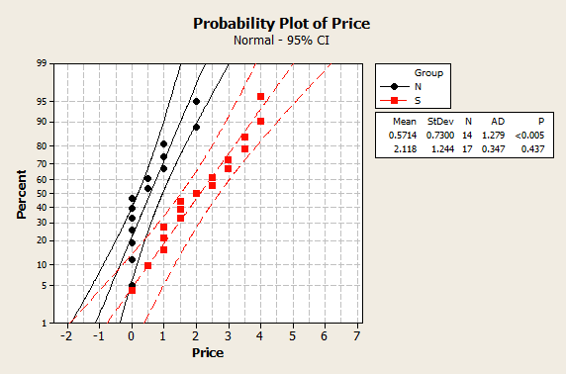

From the probability and boxplot we can see there is no outlier in these two groups of data. And they are all right skewed. Use t procedure for this data is appropriate.

(b) **Descriptive Statistics: Price**

Total

Variable Group Count Mean StDev

Price N 14 0.571 0.730

S 17 2.118 1.244

(c) H0: µs=µn

Hα: µs>µn

(d) **Two-Sample T-Test and CI: Price, Group**

Two-sample T for Price

Group N Mean StDev SE Mean

N 14 0.571 0.730 0.20

S 17 2.12 1.24 0.30

Difference = mu (N) - mu (S)

Estimate for difference: -1.546

95% upper bound for difference: -0.933

T-Test of difference = 0 (vs <): T-Value = -4.30 P-Value = 0.000 DF = 26

We can conclude that there is strong evidence can prove that people in sad mood would like to go shopping. Because of the P-value is 0.

(e) 95% lower bound for difference: -2.159

From these two sets of data we can get the interval is (-0.93, -2.159).