**Problem 1.**

(a). 

**Regression Analysis: IBI versus Area**

The regression equation is

IBI = 52.9 + 0.460 Area

Predictor Coef SE Coef T P

Constant 52.923 4.484 11.80 0.000

Area 0.4602 0.1347 3.42 0.001

S = 16.5346 R-Sq = 19.9% R-Sq(adj) = 18.2%

(b). 



The residuals appear to be approximately Normal distributed. According to the graph,it is easy to see that the plot follows the regression line and the distribution seems to be normal. We can conclude that it is approximately normal distributed.

(c). Predicted Values for New Observations

New Obs Fit SE Fit 95% CI 95% PI

1 77.77 4.19 (69.34, 86.21) (43.46, 112.09)

Values of Predictors for New Observations

New Obs Area

1 54.0

(d). The 95% prediction interval is (43.46, 112.09) for a future response when an area is 54km­2.

(e). **Correlations: Area, IBI**

Pearson correlation of Area and IBI = 0.446

P-Value = 0.001

H0: p=0 Ha: p≠0

The P-value is 0.001. It is smaller than the significant level 0.05, so we reject the null hypothesis.

t = r(n-2)0.5 / (1-r2)0.5 = 3.41621

p = (0.001+0.0005) / 2 = 0.00075

These two p-values are approximately equal, so the correlation is a good numerical measure to describe these data.

**Problem 2.**

(a). 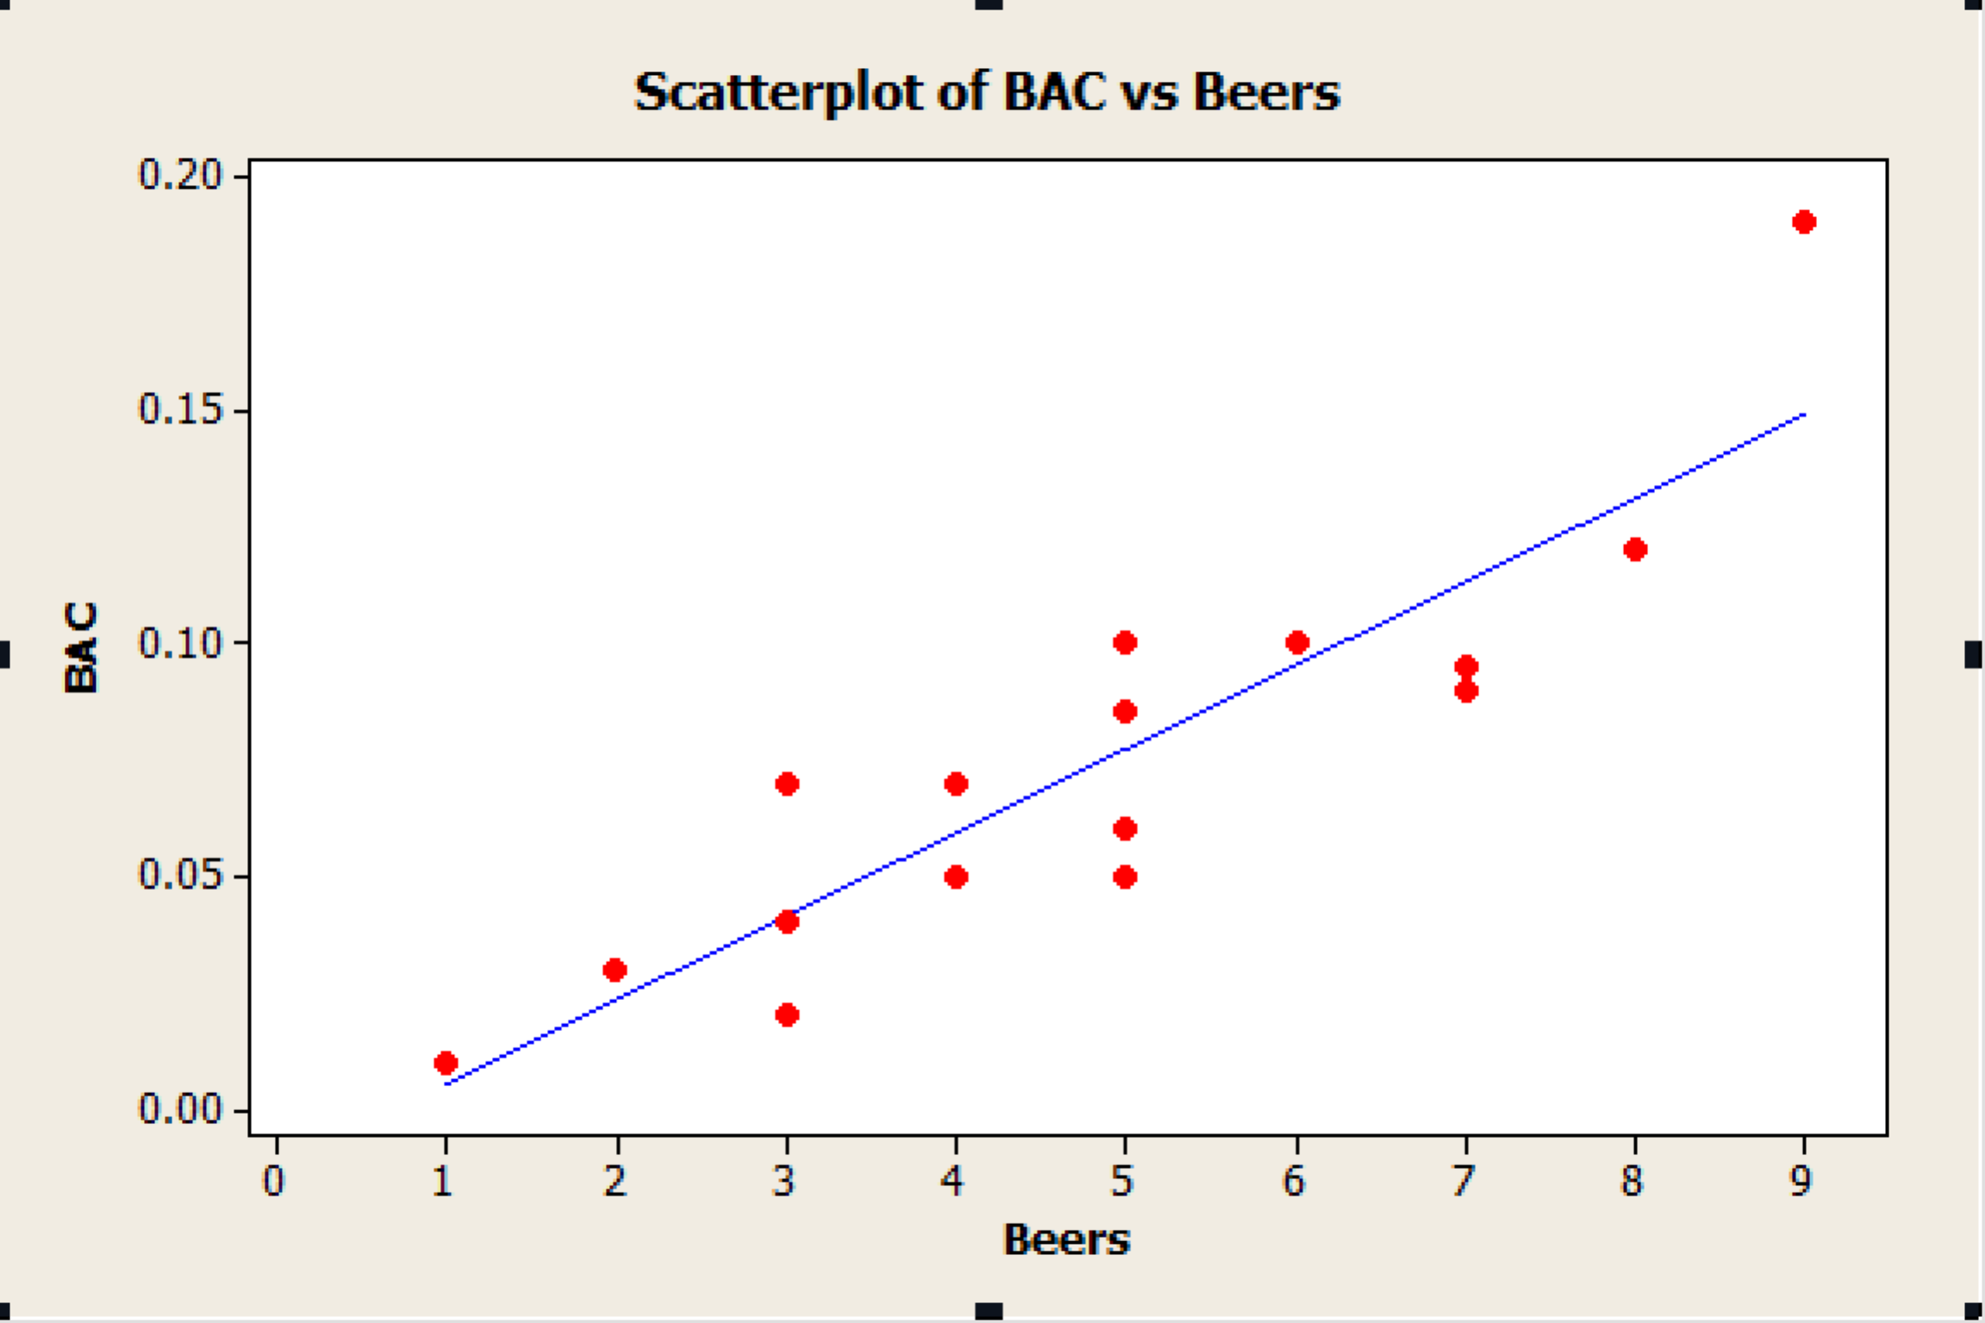

**Regression Analysis: BAC versus Beers**

The regression equation is

BAC = - 0.0127 + 0.0180 Beers

Predictor Coef SE Coef T P

Constant -0.01270 0.01264 -1.00 0.332

Beers 0.017964 0.002402 7.48 0.000

S = 0.0204410 R-Sq = 80.0% R-Sq(adj) = 78.6%

Analysis of Variance

Source DF SS MS F P

Regression 1 0.023375 0.023375 55.94 0.000

Residual Error 14 0.005850 0.000418

Total 15 0.029225

R-sq is 80%.

The data analysis shows that there is a strong relationship between the beer that student drank and the blood alcohol content. The more beers the students drink, the more BAC they get.

(b) H0: p=0

Ha: p≠0

**Correlations: Beers, BAC**

Pearson correlation of Beers and BAC = 0.894

P-Value = 0.000

T = 7.48

Based on the T value, the related P-value is less than 0.0005.

So there is a significant evidence shows that drinking more beers increase BAC on the average in the population of all students.

(c) **Regression Analysis: BAC versus Beers**

The regression equation is

BAC = - 0.0127 + 0.0180 Beers

Predictor Coef SE Coef T P

Constant -0.01270 0.01264 -1.00 0.332

Beers 0.017964 0.002402 7.48 0.000

S = 0.0204410 R-Sq = 80.0% R-Sq(adj) = 78.6%

Analysis of Variance

Source DF SS MS F P

Regression 1 0.023375 0.023375 55.94 0.000

Residual Error 14 0.005850 0.000418

Total 15 0.029225

Unusual Observations

Obs Beers BAC Fit SE Fit Residual St Resid

3 9.00 0.19000 0.14897 0.01128 0.04103 2.41R

R denotes an observation with a large standardized residual.

Predicted Values for New Observations

New†Obs Fit SE Fit 90% CI 90% PI

1 0.07712 0.00513 (0.06808, 0.08615) (0.04000, 0.11424)

Values of Predictors for New Observations

New†Obs Beers

1 5.00

Since the upper bound of prediction interval is greater than 0.08, so he won’t be confident about he will not get arrested.