Homework 2

Plate Motions from Hotspot Tracks (The Hawaiian

Island – Emperor Seamount Chain) and Ocean Crust Ages (30 points)

EAPS 10000 Y01 Planet Earth online course (March, 2014)

Name_____________________________ If writing by hand, be sure to print legibly.

Part 1. Hawaiian Hotspot Track

Objective: Observation of the age of volcanic rocks in the Hawaiian Island-Emperor Seamount Chain provides data to estimate the direction and velocity of plate motion of the Pacific plate over a fixed mantle hotspot. This assignment produces an actual (and reasonably accurate) measurement of plate motion and provides experience with map and graph analysis.
Procedure: 1. Reading in Text (Lutgens and Tarbuck, 2014 [L&T, 7th ed.]): Evidence: Hot Spots, pages 172-173 (159-161 in L&T, 2011 [L&T, 6th ed.]), Figure 5.26 (Figure 5.22 in L&T, 2011). Hawaiian volcanism and the volcanic structure of the islands are illustrated in Figures 7.3, 7.5, 7.10, 7.11, 7.12, and 7.34C, (Figures 7.3, 7.5, 7.6, 7.10, 7.11, 7.30C in L&T, 2011).
2. You can print out this document and answer the questions by writing (by hand) in the spaces below, and turn in a hard copy or scan and submit electronically. Or, you can use MS Word (or other word processor) and add your answers to the questions (below) in the document and then submit electronically as an attachment in Blackboard (see Directions for Submission document). If you use MS Word (to submit as an attachment), for the small number of points to be plotted on the graphs, you can use the Insert Shape tool in MS Word to plot the points on the graphs provided on pages 3 and 7. If you send as an email attachment, be sure to us the file naming convention described in the Syllabus.

2. Examine the attached figure which is similar to the map shown in Figure 5.26 (Figure 5.22 in L&T, 2011). The Loihi volcano (seamount) is actively growing by undersea volcanic eruption just to the southeast of the island of Hawaii (see inset on attached map). It will become, in several tens of thousands to hundreds of thousands of years, the next Hawaiian island. Measure the distances (you can use the scale shown on the attached page) of each of the Hawaiian Islands from Loihi. Use the approximate center of each island as a location to measure the distances from Loihi. Estimate the age of each island (in millions of years) from the radiometric age dates for volcanic rocks given in the attached figure. If multiple ages are given for one island, use an average. Complete the Table below (the data for the island of Lanai are already entered to provide an example). Enter data in the spaces in the table.

Table 1: Age and Distance Data for Hawaiian Islands
 | Island | Symbol | Age (millions  of years, m.y.) | Distance from  Loihi (km)
 | Hawaii | H
 | Kehoolawe | Ke
 | Maui | Ma
 | Lanai | L | 1.3 | 250
 | Molokai | Mo
 | Oahu | O
 | Kauai | Ki
 | Nihau | N

4. Plot the data from Table 1 on the attached graph. Use a large dot (•) positioned at the appropriate age and distance location for each data point. Write the letter code (symbol) for each island next to the data point. The data and plotted point are shown for the island of Lanai as an example.
Analysis:
1. Notice that the points define a nearly straight line relationship. Because the island of Hawaii and Loihi are still active, the ages for these volcanoes may not line up with the others causing some curvature of the age-distant relation. Therefore, draw an approximate "best-fit" straight line through the data points for islands older than 0.5 million years (ignore H). Use a single straight line to approximately represent the data points. Measure the slope (dy/dx or “rise over run”) of this line. What are the units (dimensions) of the slope of this line? (Information (review) on calculating the slope of a line: http://web.ics.purdue.edu/~braile/eas100/Slope.pdf.) Fill in the Table below:

Table 2. Pacific Plate Velocity Estimates from Slope of

Age-Distance Graph for the Hawaiian Islands

Velocity in km/million years _______________

Velocity in cm/year _______________________ (convert from km/million years)

What do these data and analysis tell us about the lithospheric plate motion relative to a (presumably fixed) hotspot beneath Hawaii? _______________________________________________________
_________________________________________________________________________________
_________________________________________________________________________________
2. Examine map on the attached Figure and Figure 5.26, L&T, 2014 (Figure 5.22, L&T, 2011). Note the trend of the Hawaiian Island chain and the continuation – the Emperor Seamounts. The top of the map is to the North. From the alignment of islands with increasing ages (from 0 to 43 million years), what direction has the plate moved over the hotspot? (Notice that the apparent direction of plate motion was considerably different prior to about 43 million years ago.) Circle the closest direction (just circle the letters corresponding to the correct direction) from the list of directions given below. (The compass directions are abbreviated, for example, NNE = North-Northeast, or half way between North and Northeast or an azimuth of 22.5°. You should be able to just estimate the correct direction from the trend of the islands shown on the map, but you may find a protractor useful if you're not familiar with directional information. More information on compass directions and azimuth: http://web.ics.purdue.edu/~braile/eas100/Azimuth.pdf or http://web.ics.purdue.edu/~braile/eas100/Azimuth.ppt.)

Compass direction: N NNE NE ENE E ESE SE SSE S SSW SW WSW W WNW NW NNW

Equivalent Azimuth: 0° 22.5° 45° 67.5° 90° 112.5° 135° 157.5° 180° 202.5° 225° 247.5° 270° 292.5° 315° 337.5°

3. Describe the relationship (in words) between the distance from Loihi and the age of the volcanism
for the Hawaiian islands that is shown on your graph; also see Figure 5.26, L&T, 2014 (Figure 5.22
L&T, 2011). ________________________________________________________________________
___________________________________________________________________________________
___________________________________________________________________________________

4. Write an equation that represents the line that you have drawn. (Hint: try the equation
of a straight line [two forms of the equation are: y = a + bx, used below; or y = mx + b; one coefficient is the slope and one is the y-intercept of the line]; put numbers in the blanks in this equation).

Distance = __________ + _________ times Age (this is the y = a + bx form of the equation)

The first entry, above is the y-intercept; the second entry is the slope, and x is Age. If your equation is correct, age-distance points on your line will approximately satisfy the equation (substituting the age value and the corresponding distance value into the equation will result in an equality – you should check this for at least two x values). (Information (recommended review) on calculating the slope of a line: http://web.ics.purdue.edu/~braile/eas100/Slope.pdf.)
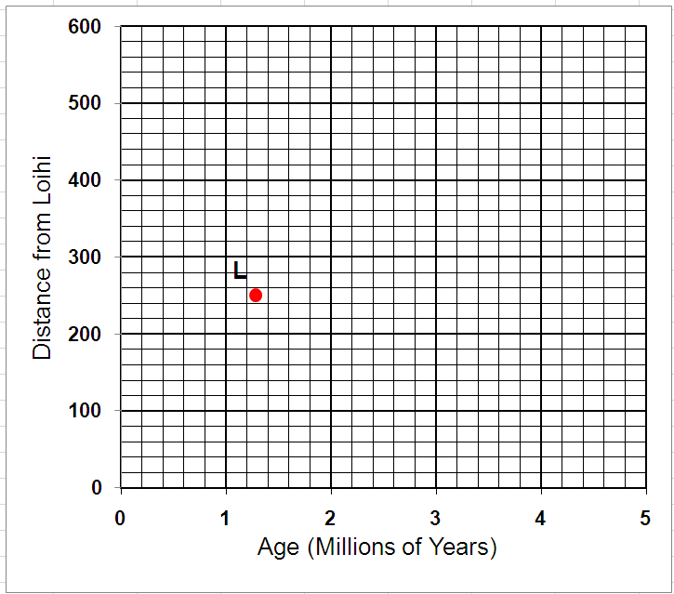
H
← In the MS Word.doc file, you can copy and
paste and edit/move these shapes/text to place them on the graph to
complete your graphing exercise.

Copy (or mark on the edge of a piece of paper)
the scale below for measuring distances on the map (enlargement of Hawaiian Islands; next page).

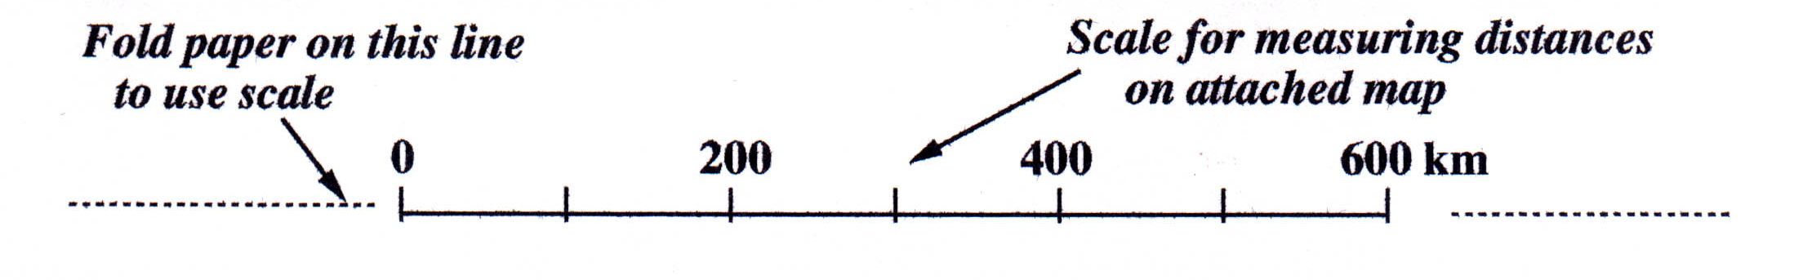

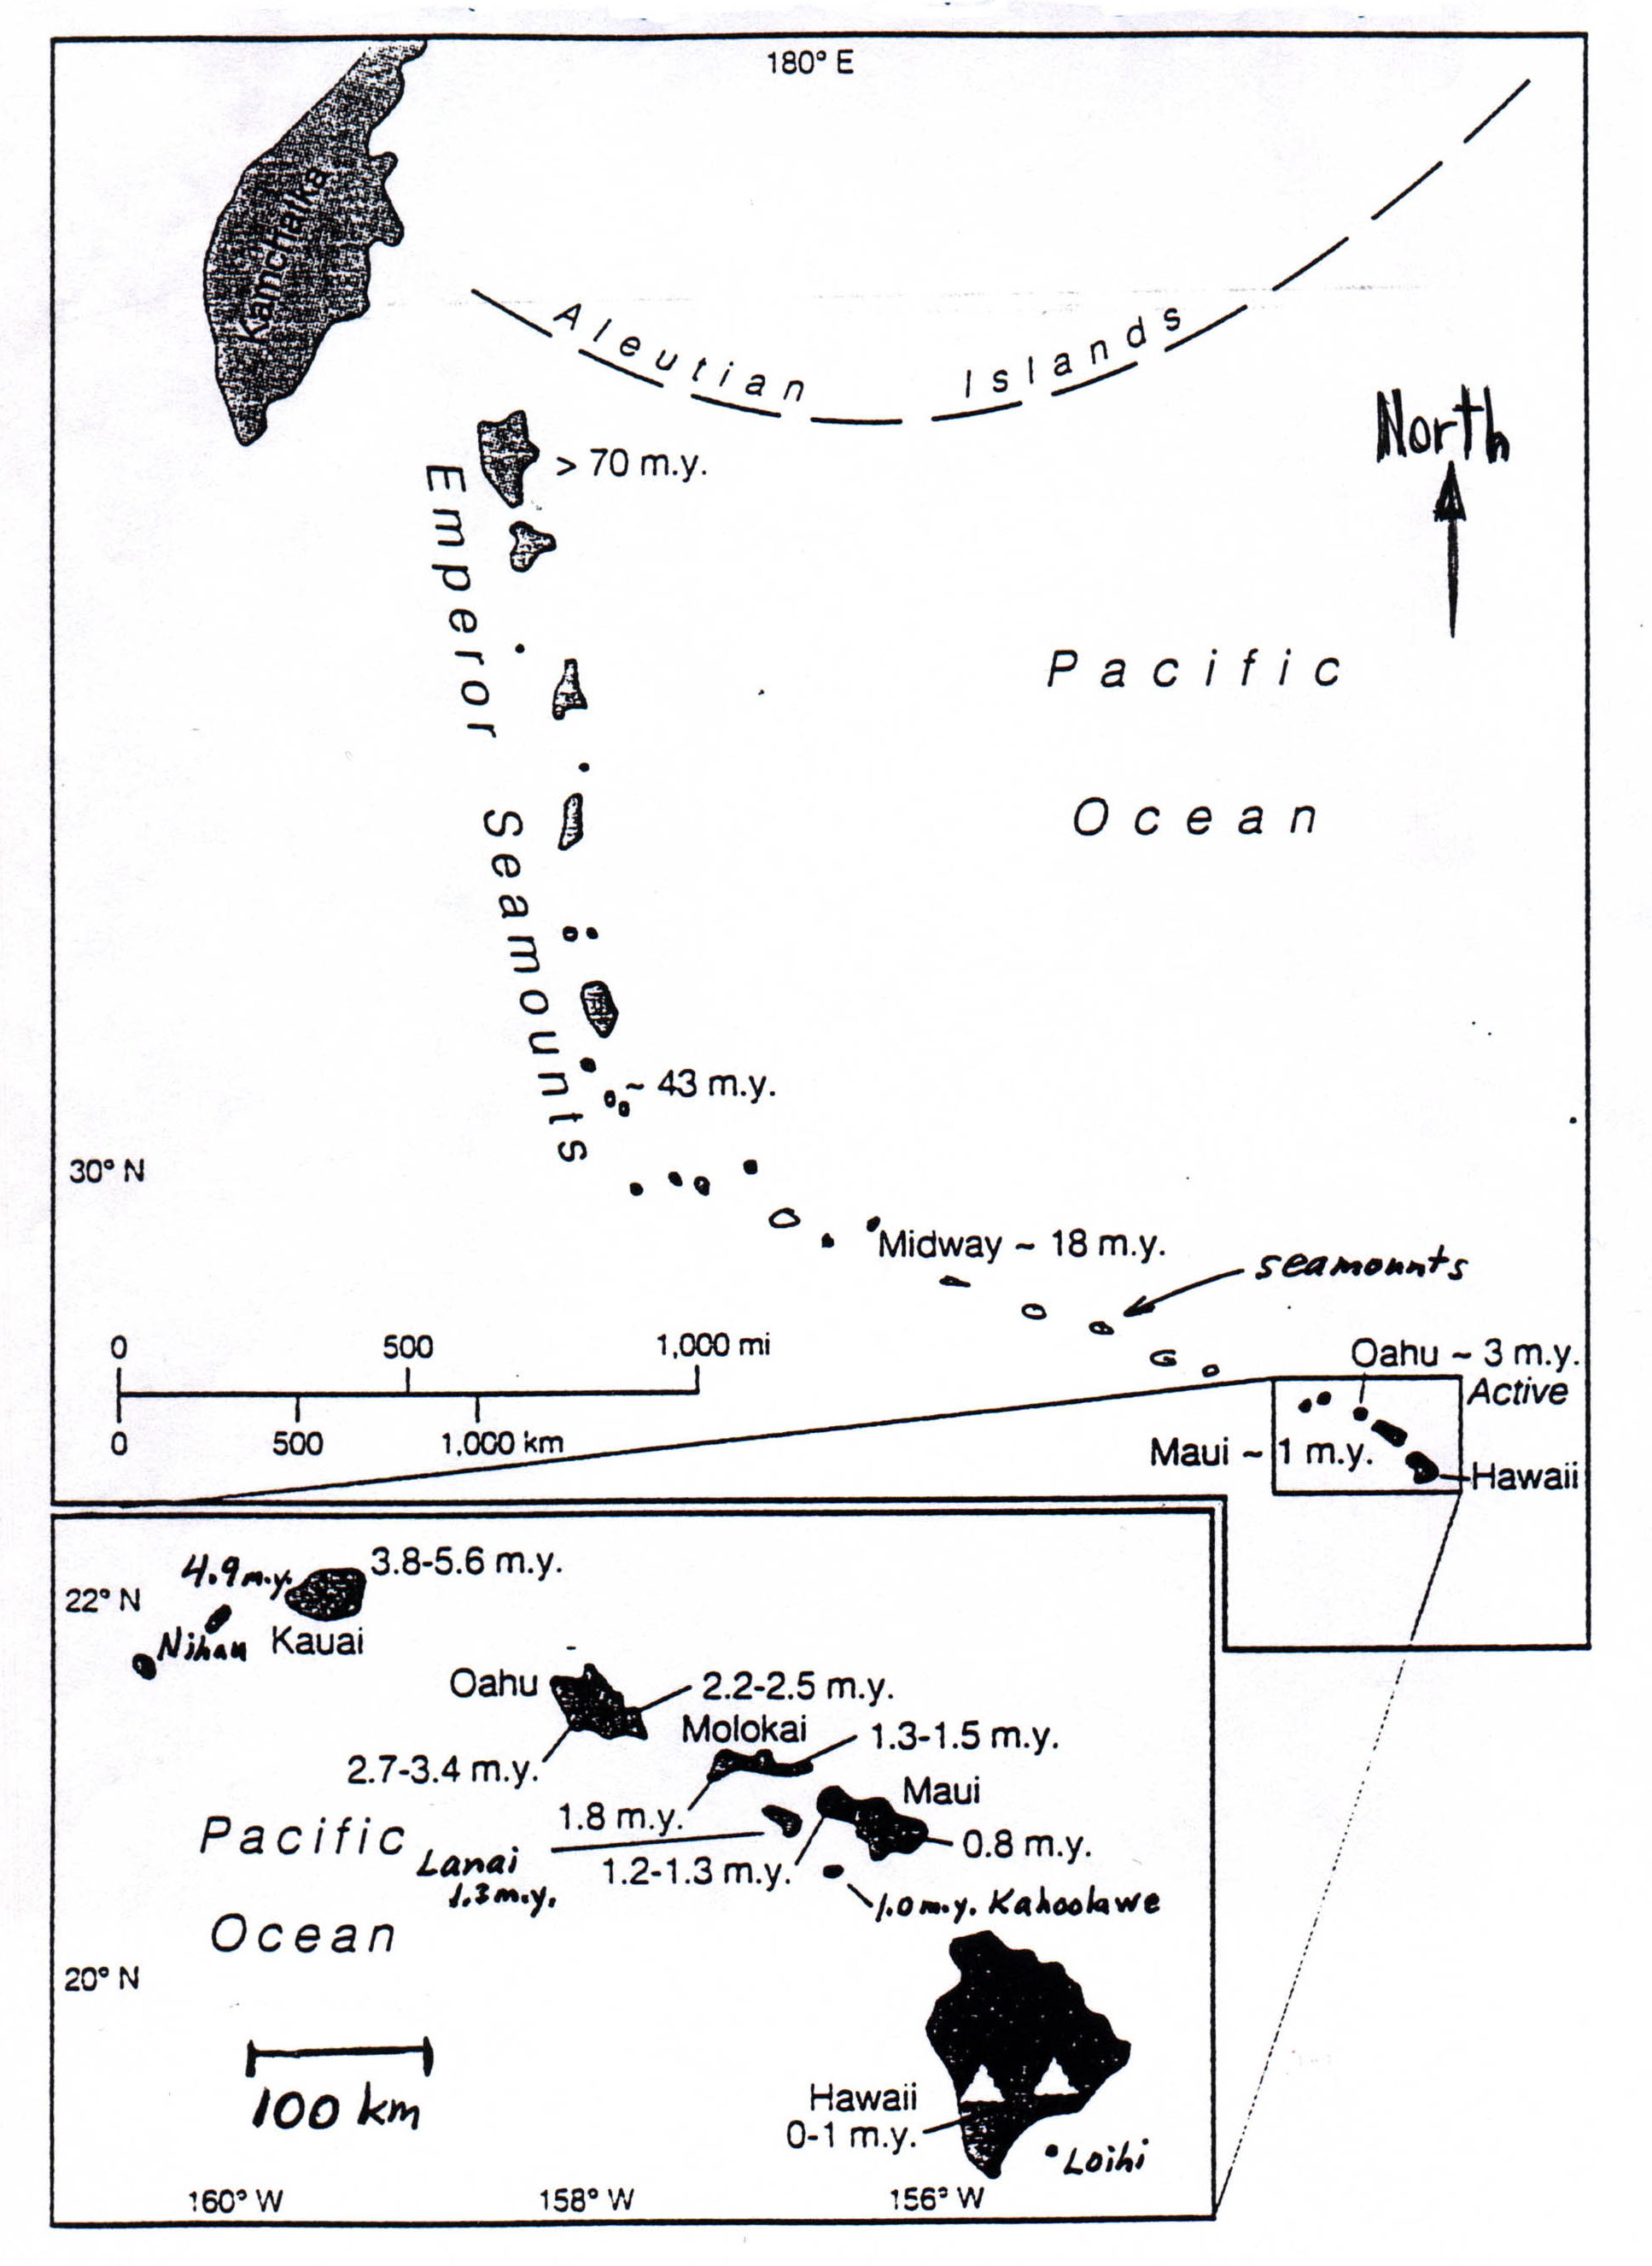
Loihi
1.0 m.y. Kahoolawe
1.3 m.y.
Lanai
4.9 m.y.
Nihau
4.9 m.y.
Map of Hawaiian Islands and ages (in millions of years) of volcanic rocks on each island. Average the ages for each island when multiple ages are given. Measure distance from Loihi to the center of each island.

100 km

Part 2. Plate Velocity Calculated from the Age of the Oceanic Crust

In this section of the exercise, we will examine another approach to determining the motions of the plates. The method utilizes age information for the oceanic crust from which estimates of mid-ocean ridge spreading rates and plate velocities can be made. The age data for oceanic regions come from three main techniques – radiometric dating (mostly Potassium-Argon radioactive decay of igneous rocks created at the mid-ocean ridges – “sea floor spreading”), ages of the oldest sediment overlying the oceanic crust (from stratigraphic correlation and index fossils), and paleomagnetic reversal chronology. Please read pages 172-177 in L&T, 2014 for more information on paleomagnetism (pages 161-164 in L&T, 2011). A map of global ocean crust ages is shown below from Muller and others – the map is best viewed in color on Hw or online (http://gdcinfo.agg.nrcan.gc.ca/app/agemap_e.html). The map, with an approximate scale is also shown at http://web.ics.purdue.edu/~braile/eas100/OceanAge.pdf (page 1). Notice the pattern of younger oceanic crust on both sides of the mid-ocean ridges and older crust far from the ridges. The patterns are interpreted to be the result of sea floor spreading and provide compelling evidence for plate tectonics.

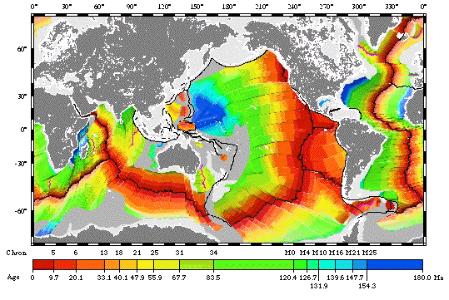

1. In the Figure above, where are the two largest areas of oldest (greater than about 150 million years ago) oceanic crust? __________________________________________________________________

Approximately how far away are these areas from associated mid-ocean ridges (to the east of the areas of old crust)? _______________________________________________________________________
See the color version of this map at http://web.ics.purdue.edu/~braile/eas100/OceanAge.pdf (page 1) to better view the pattern of ocean crust ages and to use a scale to estimate the distances (in kilometers).

2. Examine Figure 5.30A, 5.31 and the accompanying Figure caption and text in L&T, 2014 (Figures5.27, 5.28, L&T, 2011). Briefly explain how magnetic reversals provide a time scale that can be used to determine the age of the ocean crust.
_________________________________________________________________________________

_________________________________________________________________________________

3. Refer to Figure 5.31C (Figure 5.28C, L&T 2011). If the age (in millions of years) of the magnetic reversal marked by the change from the white crustal layer (in the Figure) - normal magnetization, and the pink crustal layer - reversed magnetization, on either side of the mid-ocean ridge (spreading center) is known, how can the spreading rate (in km/m.y., ~ the plate velocity) be calculated?
_________________________________________________________________________________

_________________________________________________________________________________

4. Refer to Figures 5.30 and 5.31 (Figures 5.27 and 5.28, L&T, 2011). The magnetic stripes (caused by magnetic reversals) adjacent to a mid-ocean ridge show a generally symmetric pattern on either side of the ridge. What does this imply about the plate motions on either side of the ridge?
_________________________________________________________________________________

_________________________________________________________________________________

5. Refer to the Map on the following page that shows a close-up of the ocean crust age map for the North Pacific Ocean. The pattern shows that ocean crust ages increase as distance from the ridge increases. See the color version of this map at http://web.ics.purdue.edu/~braile/eas100/OceanAge.pdf (page 2) to view the pattern of ocean crust ages and to use a scale to estimate the distances (in kilometers). Open in your browser and adjust the scale (zoom) so that the scale on your screen is 1 cm = 1000 km (10 cm on screen = 10,000 km on map). If you open in Internet Explorer, you may need to select “Show Adobe Reader Toolbar” at the bottom of the screen to be able to zoom. Then, you can use a metric ruler to measure the distances in km. On the A-B profile, measure the distance in km from the ridge (point A) to each of the age boundaries given in column 1 in the Table below. The first two distances have been entered as examples.

Table of ocean crust ages and distances from the mid-ocean ridge.

Age (millions of years) | Distance from mid-ocean ridge (km)
0 | 0
9.7 | 900
20.1
33.1
40.1
47.9
67.7
83.5
126.7
154.3

6. Next, plot the points from the table on the graph below. Draw a reasonable best fit line through the points and calculate the slope of the line (km/m.y.). The result provides an estimate of the average spreading rate and plate velocity over the past approximately 150 million years. Note that the result is similar in magnitude to the Hawaiian hotspot estimate from Part 1. Slope = _____________________

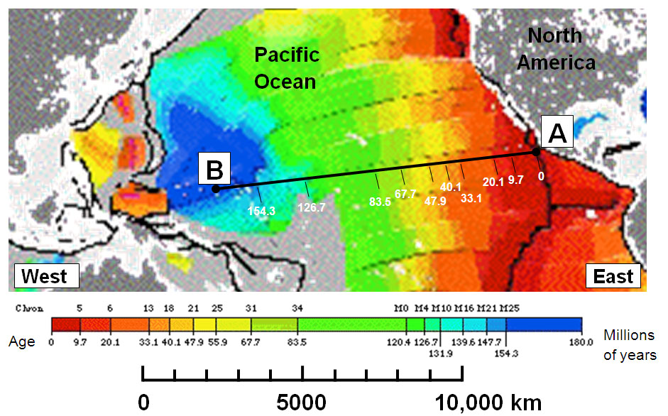
The numbers on the A to B profile are ages (in millions of years) of the oceanic crust.

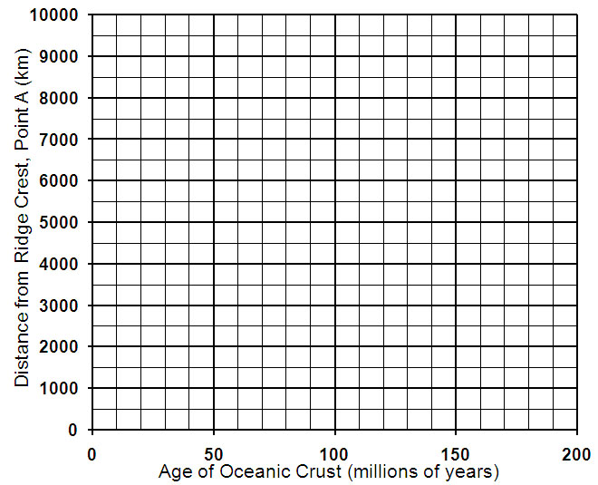
← In the MS Word.doc file, you can copy and
paste and edit/move these shapes to place them on the graph to
complete your graphing exercise.

