1.下载数据

cd ~/caffe/
./data/mnist/get_mnist.sh
./examples/mnist/create_mnist.sh
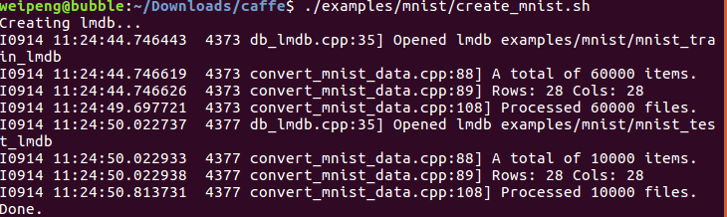
如果caffe版本是cpu的需要修改配置：修改在examples文件下的Mnist下的lenet_solver.prototxt中的solver_mode:CPU

cd ~/caffe/
sudo gedit ./examples/mnist/lenet_solver.prototxt
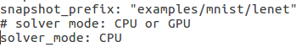

solver_mode: CPU

2.训练模型
cd ~/caffe/
./examples/mnist/train_lenet.sh

3.结果展示

