SystemHealth Deploy Description

Directory descript

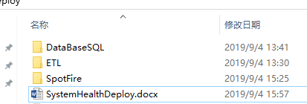

1. databaseSql is directory that save scripts about deploy data
2. ETL is directory that save etl scripts and etl tool(Kettle)
3. SpotFire is directory that save scripts about System Health

First. Data Deploy

1. Restore DataStaging ,path:driver:\…\ TestServerDeploy\DataBaseSQL\DSPStaging.zip

In this database have a table vw_CurrentValues,by this table,I fetch work flow input data,then create ETL Script transfor into DSPSTORE’s SYS_WORKFLOW_TEST_DATA

This file need extract,then use the managestudio of mssqlserver to restore

1. Create view on dsbpm_db in postgres database,path: driver:\…\ TestServerDeploy\DataBaseSQL\ SystemLog.sql

On dsbpm_db excutes SystemLog.sql

1. Excute relation script(create table,view,procedure) on dspstore in mssqlserver, path: driver:\…\ TestServerDeploy\DataBaseSQL\ GenerateView.sql
2. Impot init data,excute script on dspstore in mssqlserver,path: driver:\…\ TestServerDeploy\DataBaseSQL\ GenerateData.sql

Second. ETL Deploy

1. Copy etl tools and etl script into a directory,this directory’s name can not have space symbal,etl tools run on jdk 1.8

* Etl tools path: driver:\…\TestServerDeploy\ETL\data-integration
* ETL Scripts path: driver:\…\TestServerDeploy\ETL

1. Open etl tool,then open etl scripts by etl tool

* Open etl tool in driver:\…\ TestServerDeploy\ETL\data-integration,run Spoon.bat,follow is the picture of opening it:

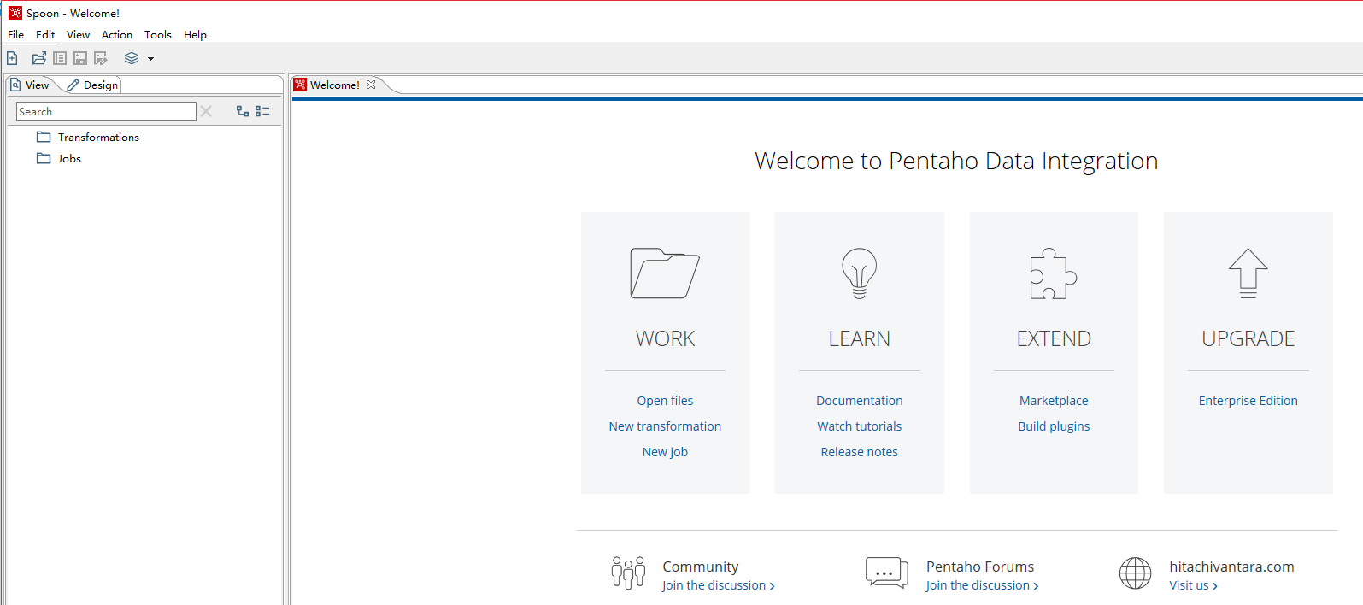

* Open permanace job by etl tool,this script dependent powershell 5.0,in running machine need install powershell 5.0,path: driver:\…\ TestServerDeploy\ETL\PerfermanceCheck.kjb, follow is the picture of opening it:

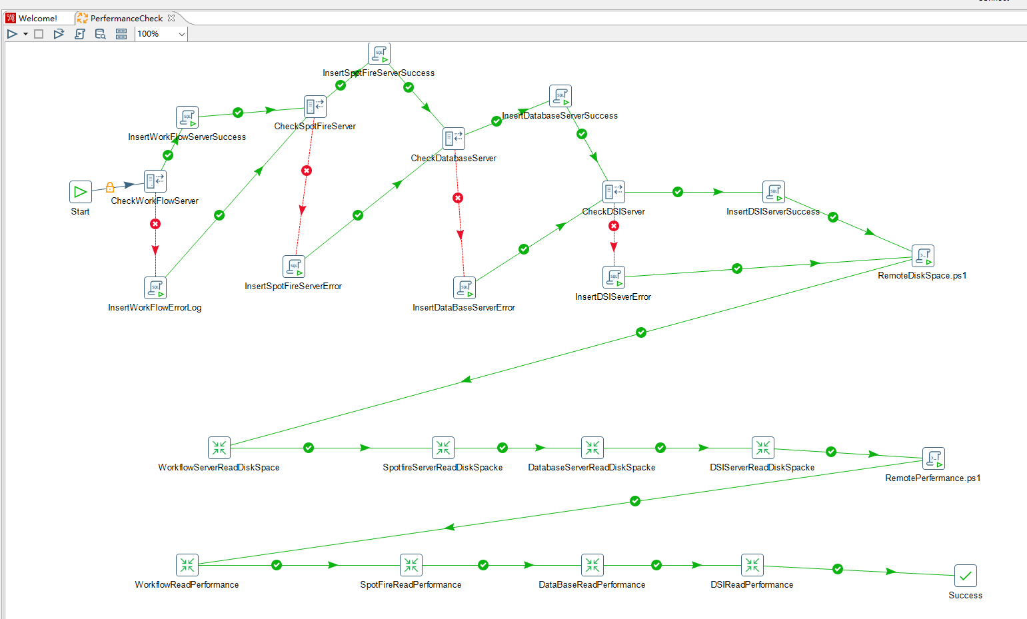

* Modify job setting,click right mouse as follow picture

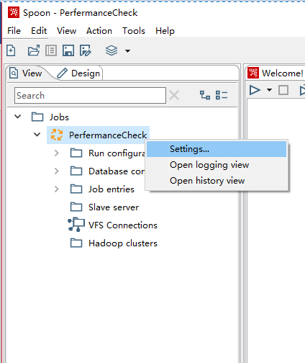

* Opened setting, then Switch tab into Parameters,In popup dialog modify relation information,popup dialog as follow picture

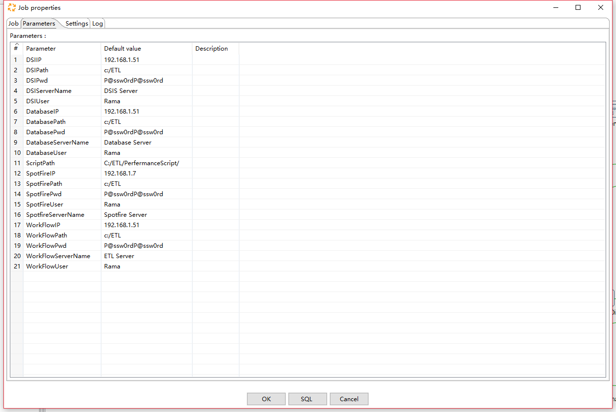

* Information description:

1. DSIIP:Dsis server’s IP address
2. DSIPath:In Dsis server save the path of the performance’s report,need permiss to power shell user
3. DSIPassword:Power shell’s user access password of dsis server
4. DSIServerName:save in database the name about Dsis Server
5. DSIUser:Power shell’s user
6. Other similar information is modified accordingly,include SpotFire server\Database server\ETL server
7. Script path: Save the script’s path of powershell and transformation that can be changed to the current path, driver:\…\ TestServerDeploy\ETL\,this modify is impotant,otherwise this job can not running,because it can not find relation script.

* Modify database access link,double click node,as follow picture:

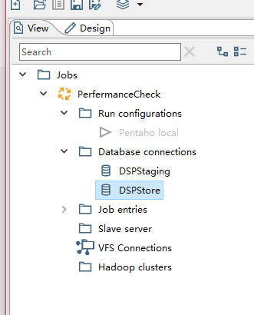 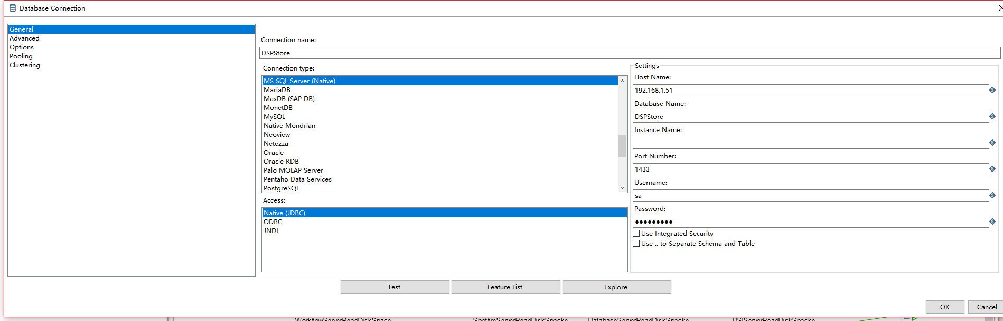

After setting up this access link,back previous page,then right click node,select share and click share,as follow picture:

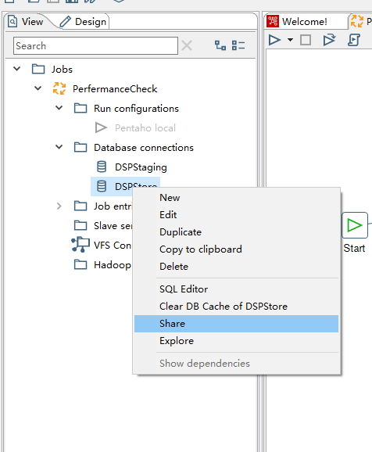

This step is impotant,otherwise transformation job can not run.

* Open DBCheck.kjb,path: driver:\…\ TestServerDeploy\ETL\ DBCheckConnection.kjb, follow is the picture of opening it:

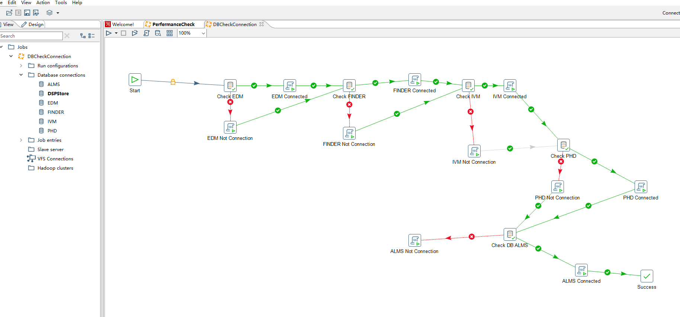

After Opened this kjb,modify kinds of connection as above,connections include ALMS,EDM,FINDER,IVM,PHD,if you had modified dspstore and shared connetion, You don't have to modify the dspstore

* Open insertworkflowinput.kjb,path: driver:\…\ TestServerDeploy\ETL\ insertworkflowinput.kjb, follow is the picture of opening it:

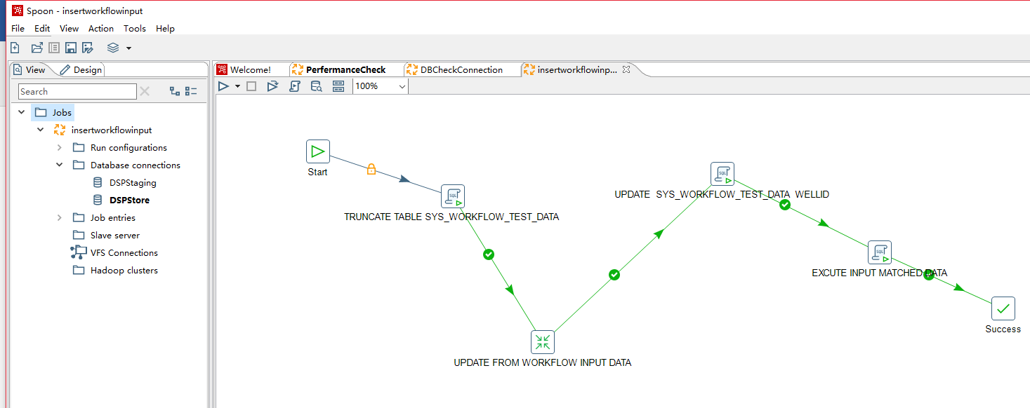

After Opened this kjb,modify kinds of connection as above,connections include DspStaging,if you had modified dspstore and shared connetion, You don't have to modify the dspstore,DSPStaging need share connetion,it is important

All above of modified and opened is complished,then you need running these scripts,you can click as follow picture(every job need click):

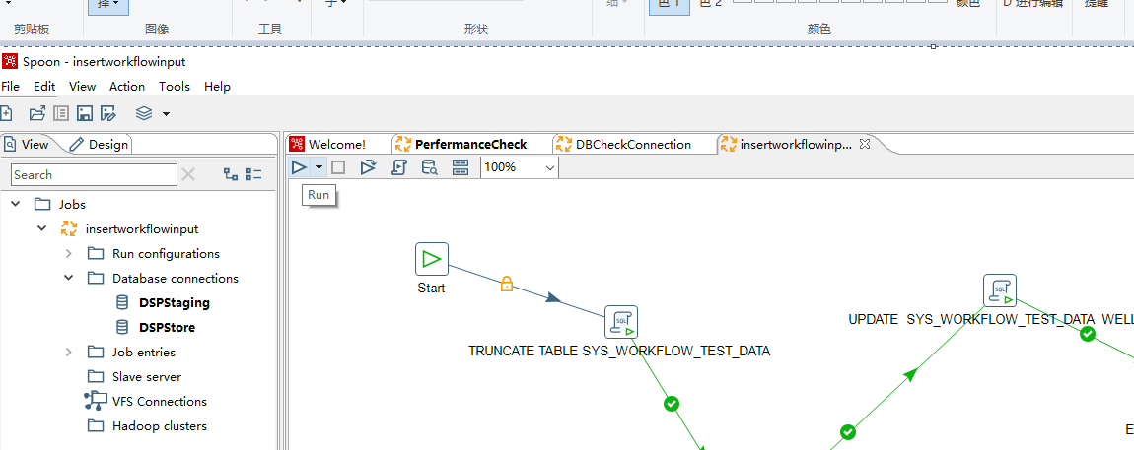

When you restart the machine of running etl script,you have to reopen etl tools and start every job.

Third. Spotfire package deploy

1. Deploy SystemLog package,this script is running in dsbpm_db of postgres,path: driver:\…\ TestServerDeploy\SpotFire\System_Log.dxp,after deployed as follow picture:

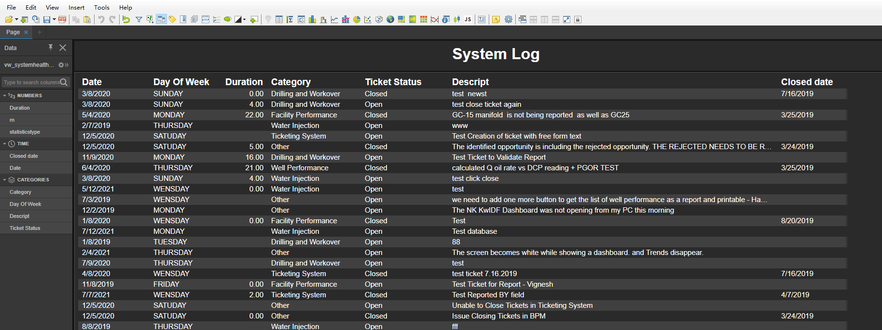

1. Deploy ESP Pump Validation package,this script is running in dspstore of mssqlserver,path: driver:\…\ TestServerDeploy\SpotFire\ ESP_Pump_Validation.dxp,after deployed as follow picture:

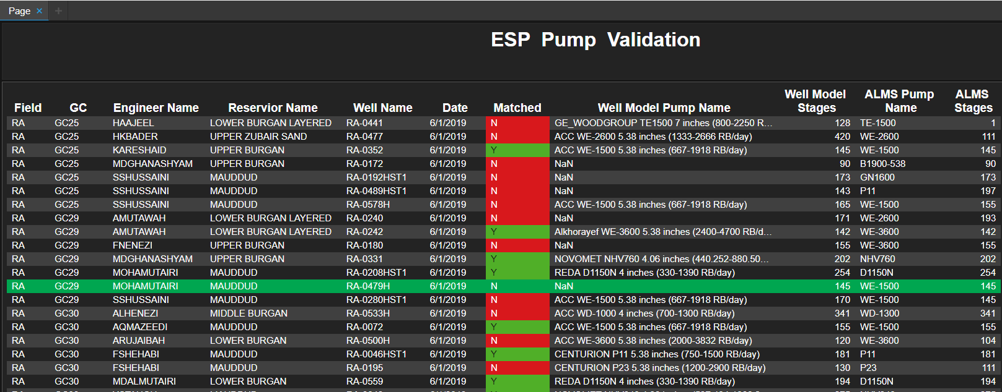

1. Deploy Well Model Quality package,this script is running in dspstore of mssqlserver,path: driver:\…\ TestServerDeploy\SpotFire\ Well_Model_Integrity.dxp,after deployed as follow picture:

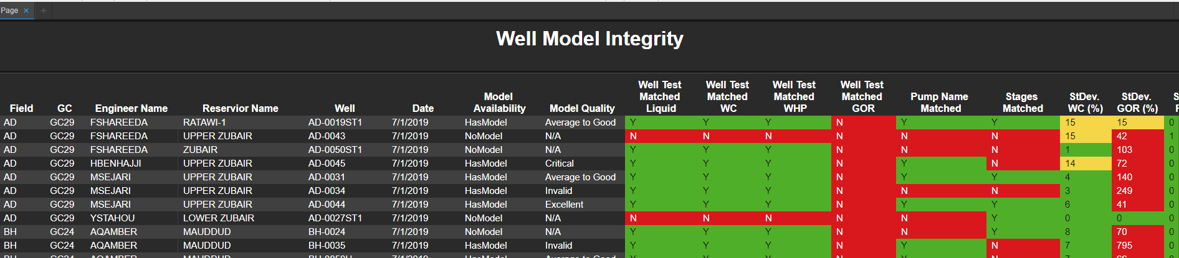

1. Deploy System Health Status package,this script is running in dspstore of mssqlserver and dsbpm_db of posgres,path: driver:\…\ TestServerDeploy\SpotFire\ SystemHealth_ServerPerformance.dxp,after deployed as follow picture:

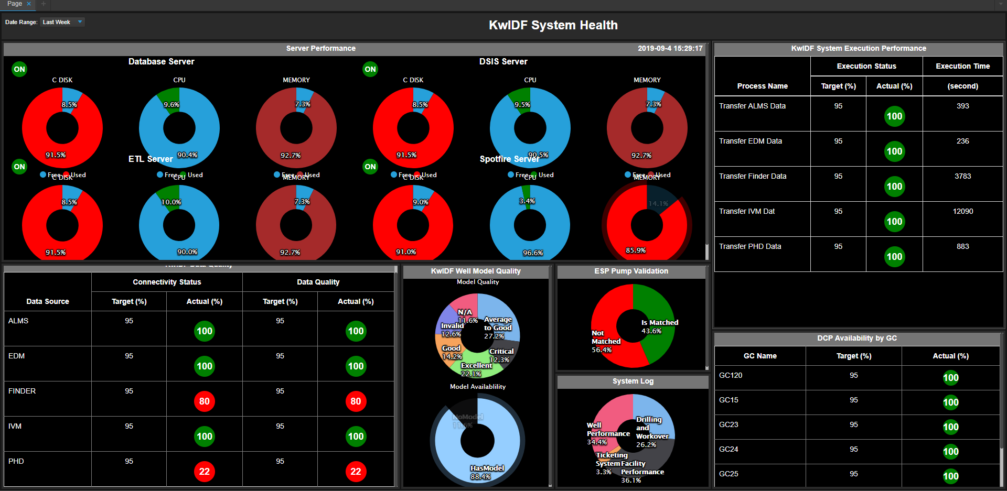

This package need modify document trust script and property,modify property as follow picture:

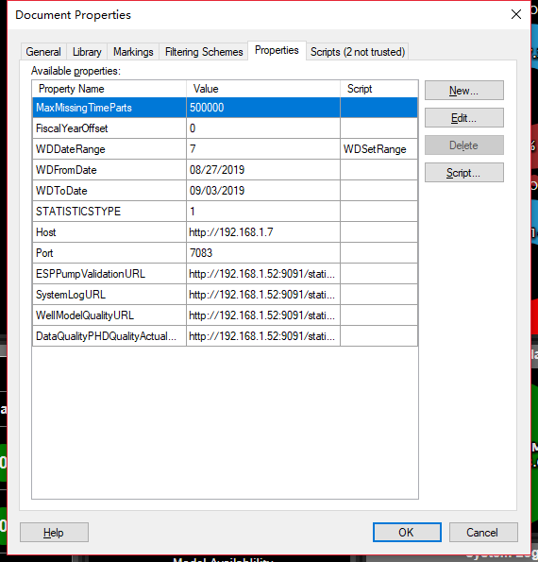

Information decript:

1. ESPPumpValidationURL:link to ESP Pump Validation,eg: <http://192.168.1.52:9091/static/content/KwIDF/System/ESP_Pump_Validation.html>
2. SystemLogURL:link to SystemLog,eg: http://192.168.1.52:9091/static/content/KwIDF/System/System_Log.htmlt
3. WellModelQualityURL:link to Well Model Quality,eg: http://192.168.1.52:9091/static/content/KwIDF/System/Well_Model_Integrity.html
4. DataQualityPHDQualityActualURL:link to RT Master,eg: <http://192.168.1.52:9091/static/content/KwIDF/DrillingDown/SPS/RealTimeMasterReport.html>
5. Another items you can set default imformation.