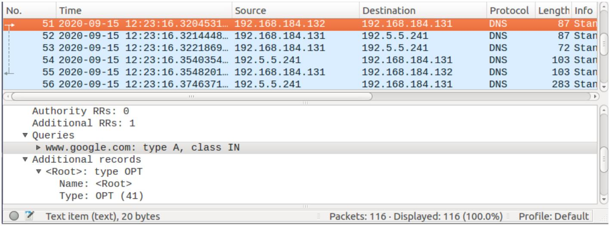
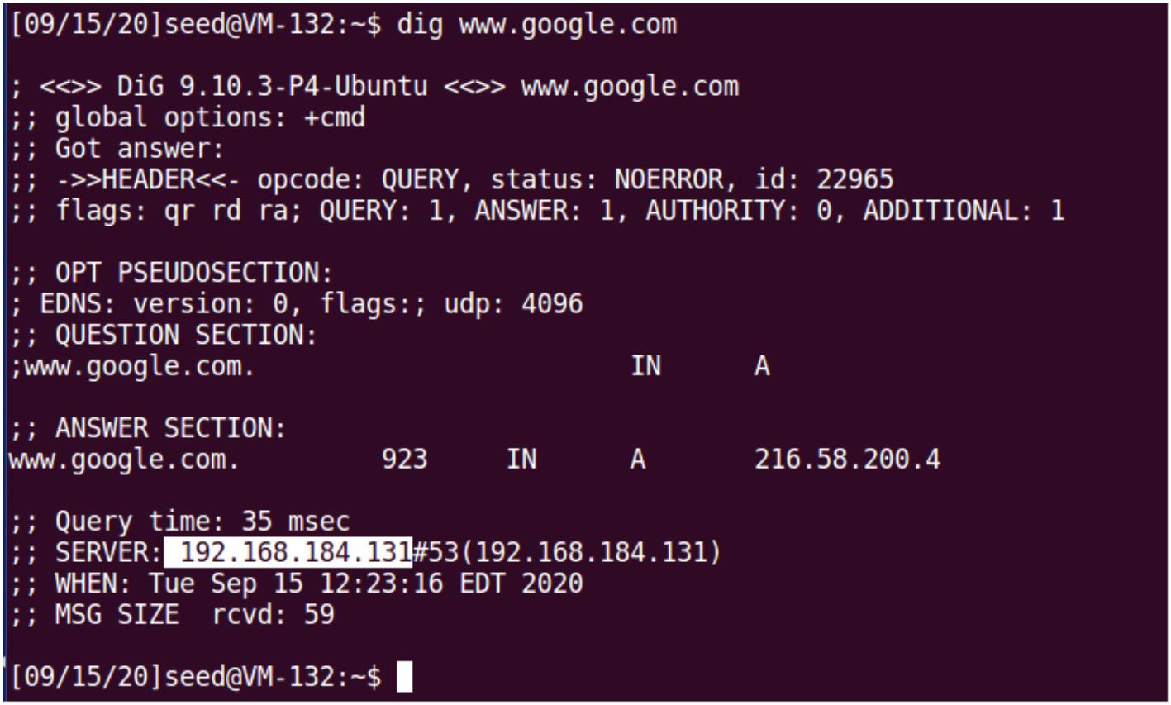
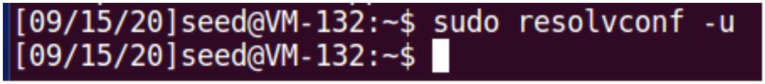
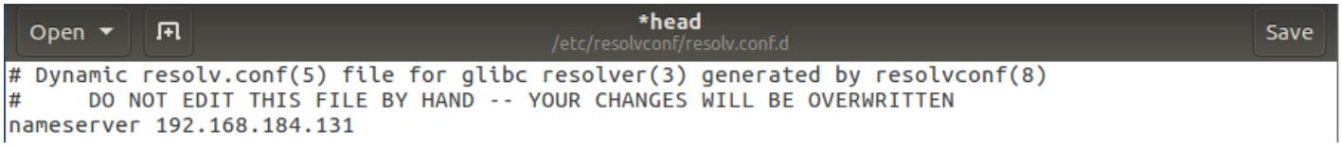
Local DNS Attack Lab
Task 1: Configure the User Machine
1. Add a new entry in the resolver configuration file to set a static primary DNS server.
2. Use the dig command to get an IP address from www.google.com. From the response we
can see that it came from the server we just set. Also in our server, Wireshark has captured
the DNS requests.
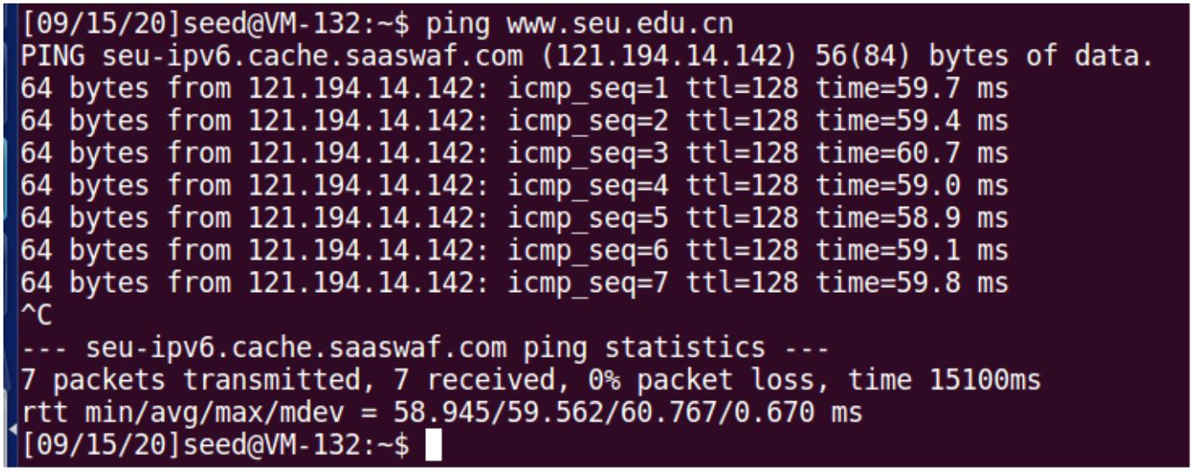
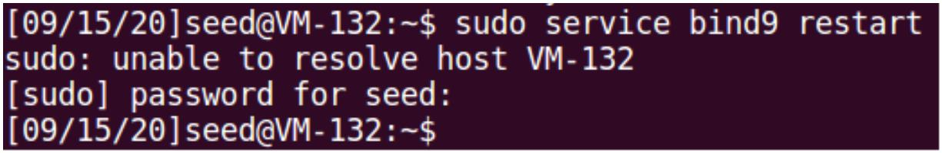
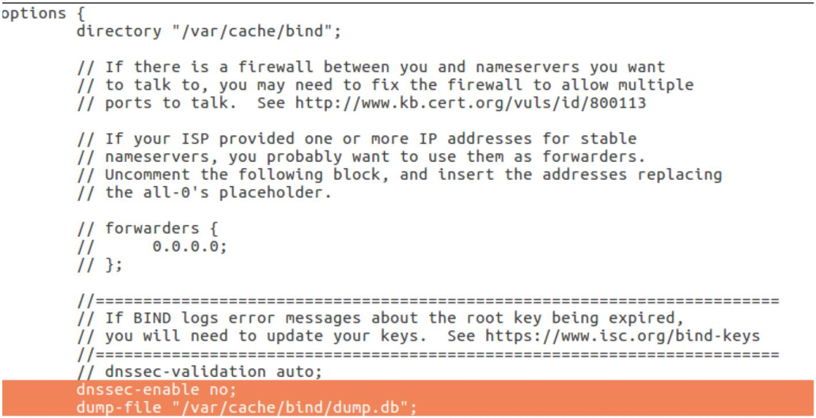
Task 2: Set up a Local DNS Server
1. Add options that specifies the file path where the cache content should be dumped to, and
disables the DNSSEC mechanism.
2. Restart the BIND 9service.
3. The ping request triggered the a DNS request and the server return the IP address referring
to the cache file.
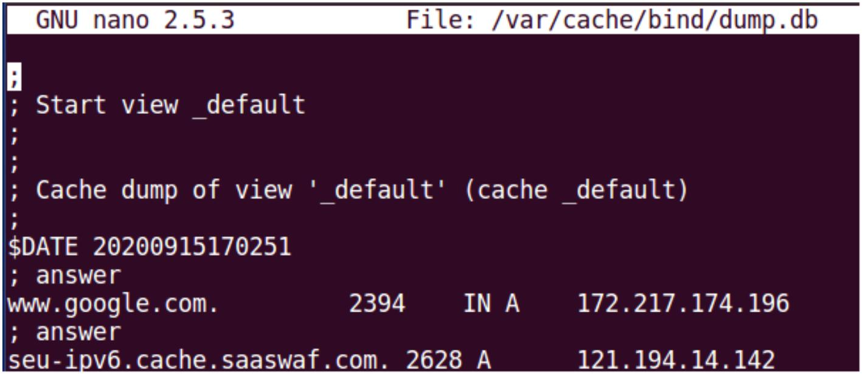
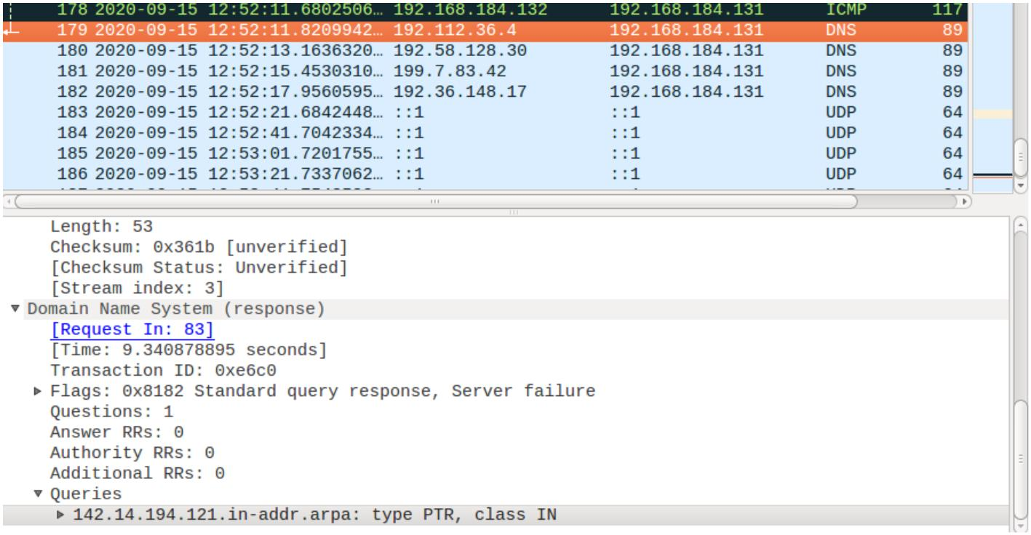
Task 3: Host a Zone in the Local DNS Server
1. Create zones in the configuration file.
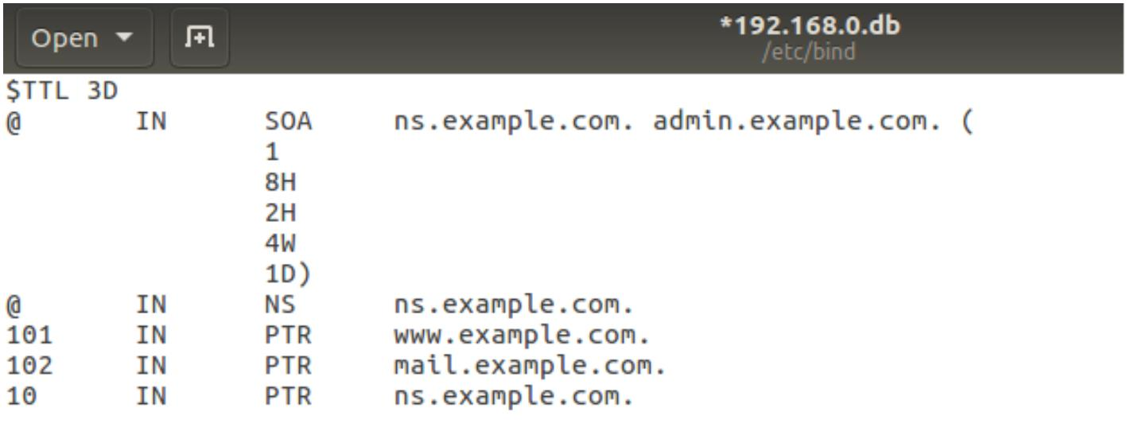
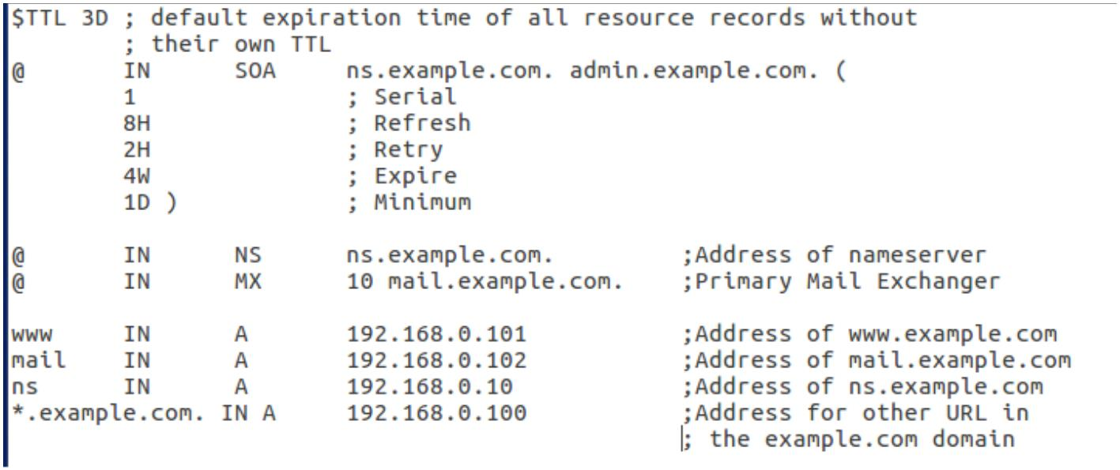
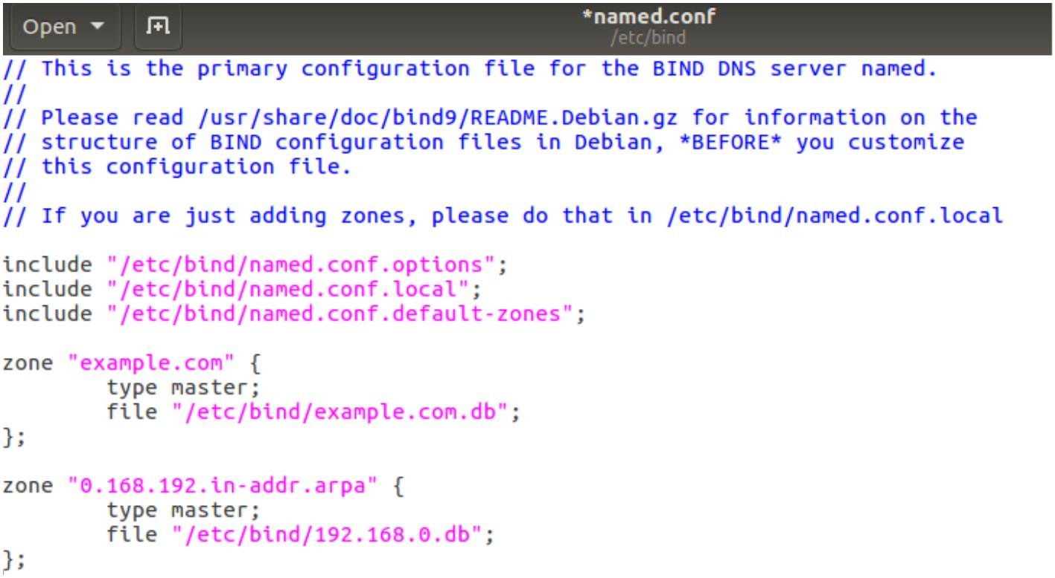
2. Create and edit the forward lookup zone file.
3. Create and edit the reverse lookup zone file.
4. Restart the BIND 9service. Use the digcommand to look for the IP address of
www.example.comon local DNS server.
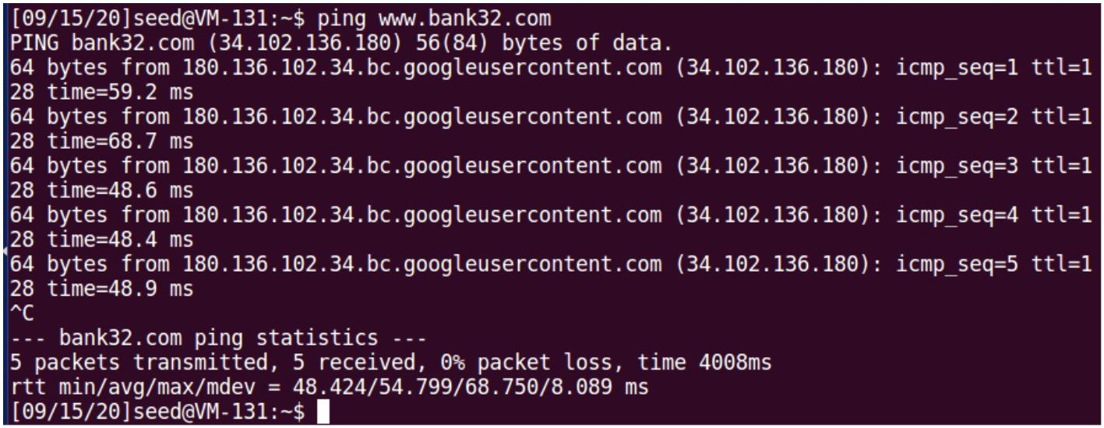
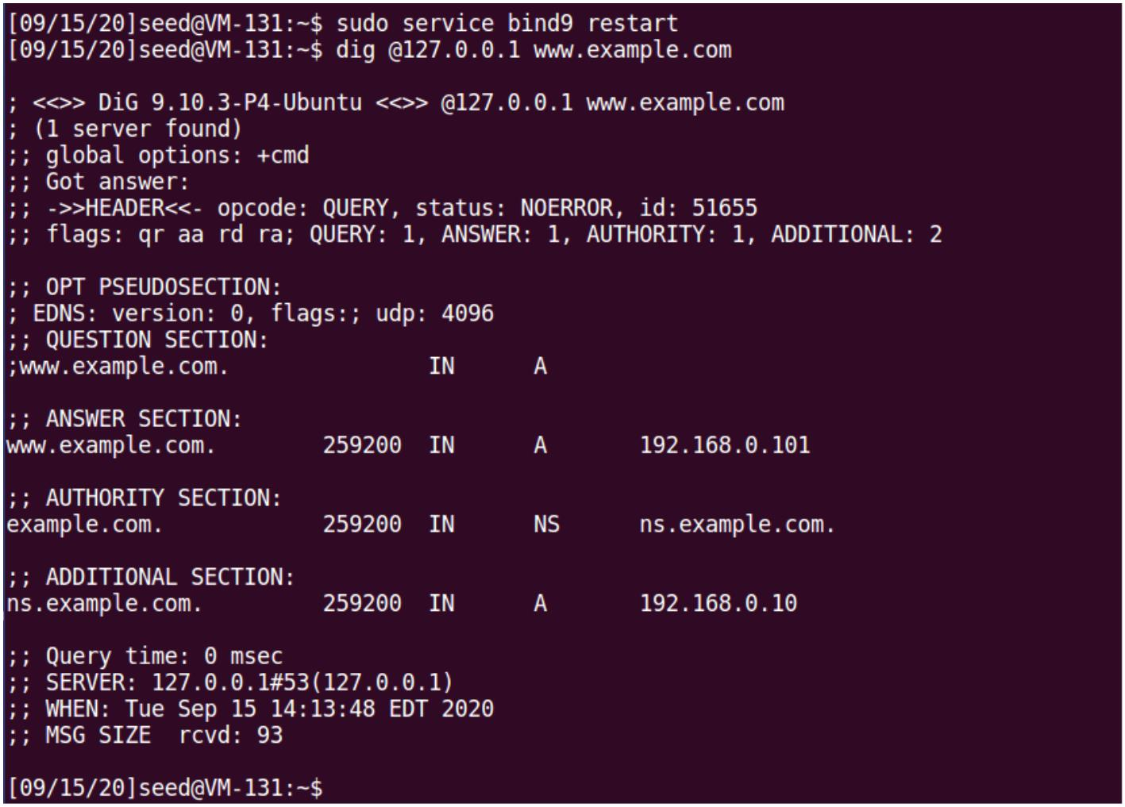
Task 4: Modifying the Host File
1. Ping results and the web page before modifying the host file.

