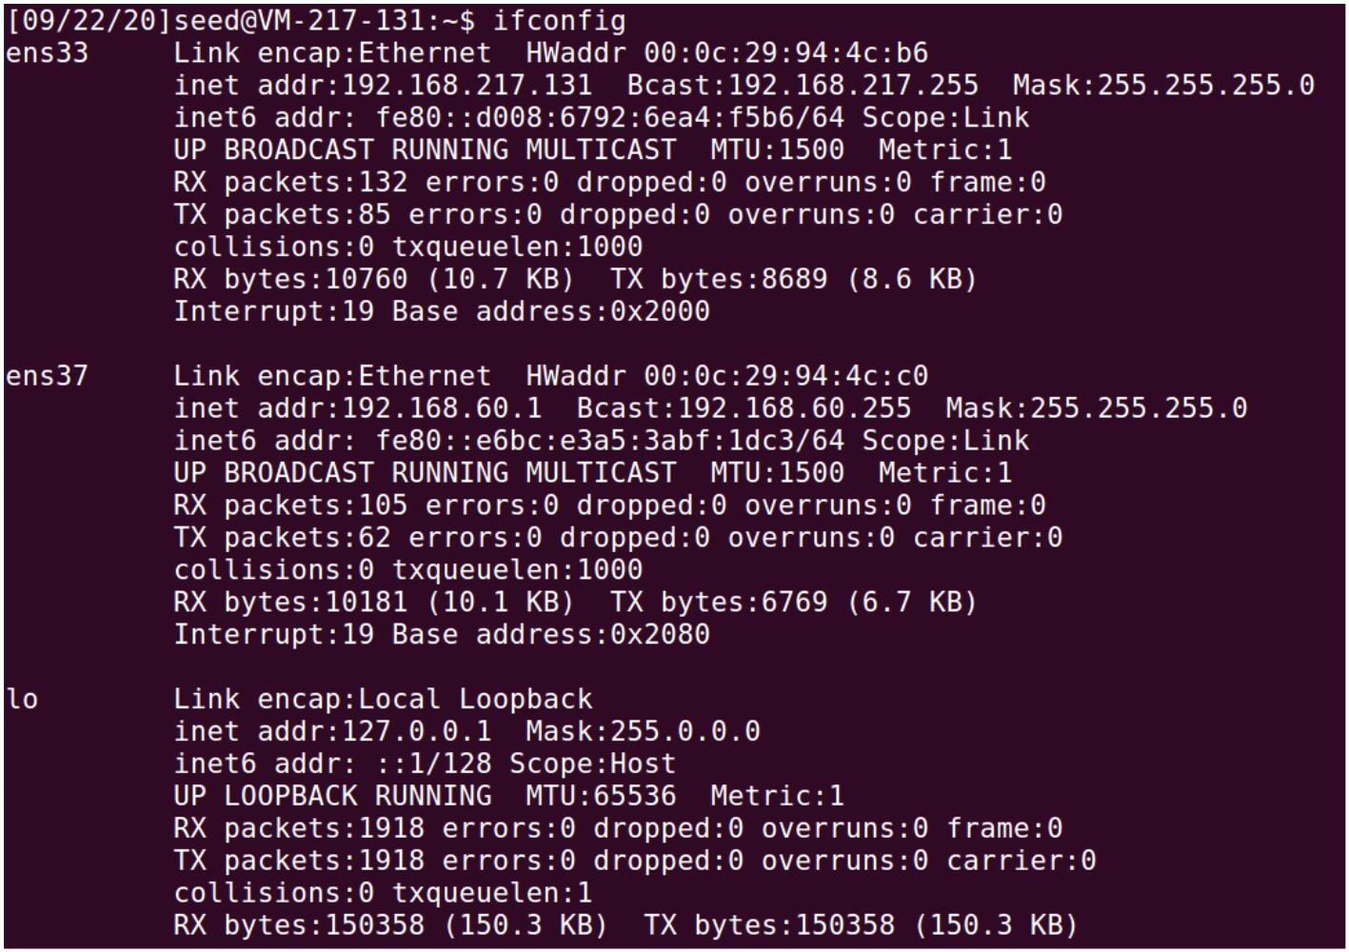
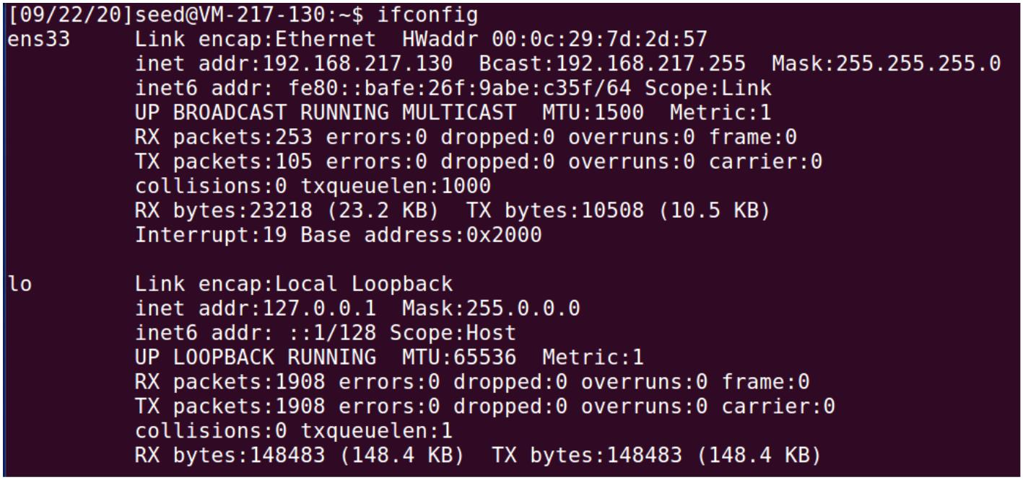
VPN Tunneling Lab
Task 1: Network Setup
1. Configure the network with following settings. Note that the VM’s hostname (i.e. the “VM-
xxx-xxx” string after the username in command line) indicates the IP address of this machine. Client (Host U):
Gateway (VPN Server):
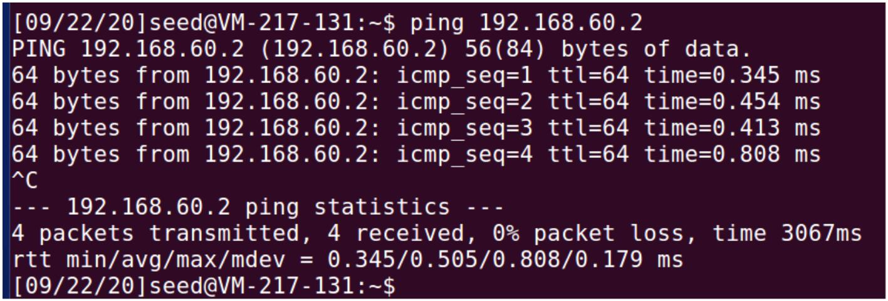
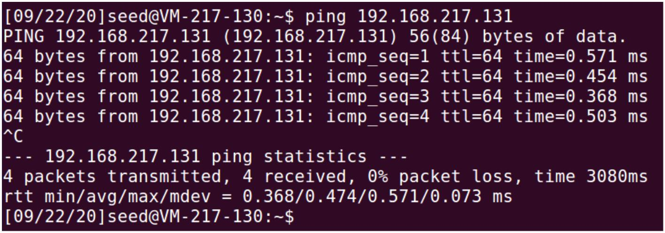
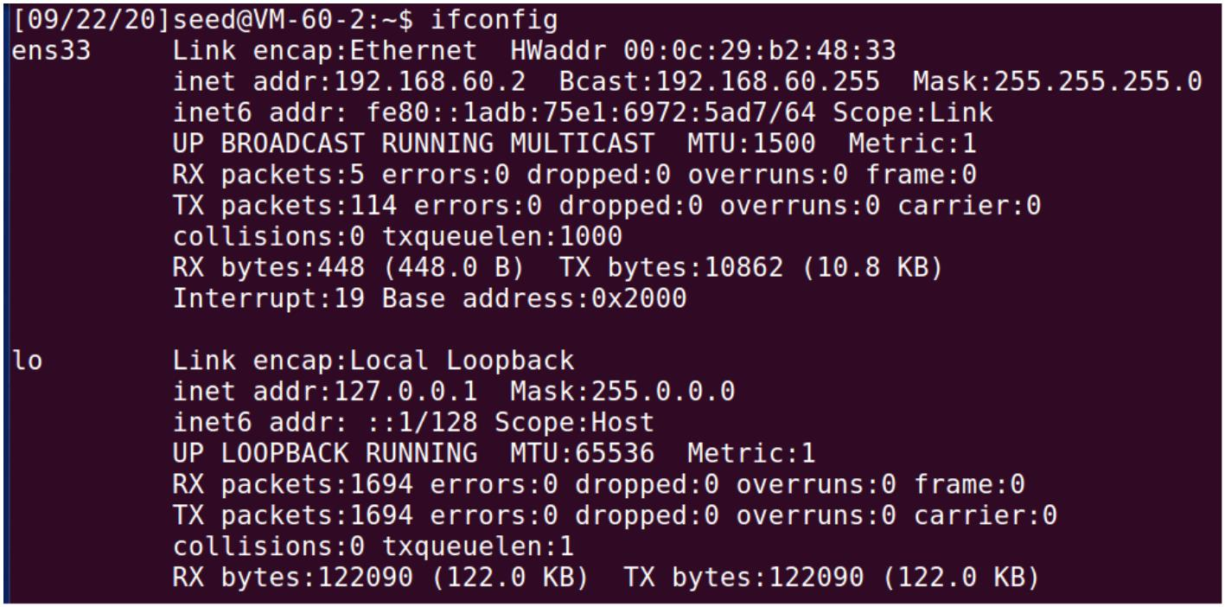
Host in private network (Host V):
2. Test if these machines meet the requirements in the task.
Host U pinging VPN Server:
VPN Server pinging Host V:
Host U pinging Host V:
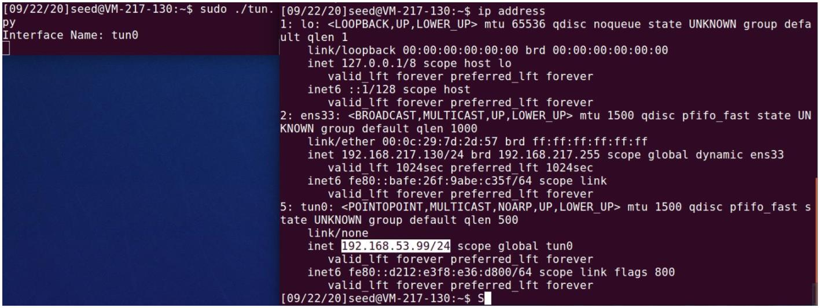
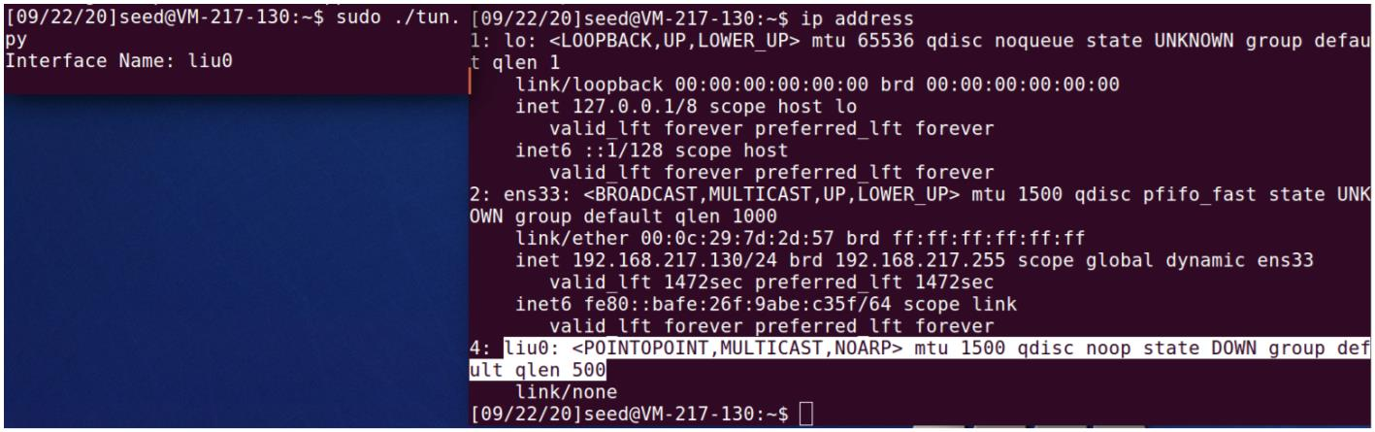
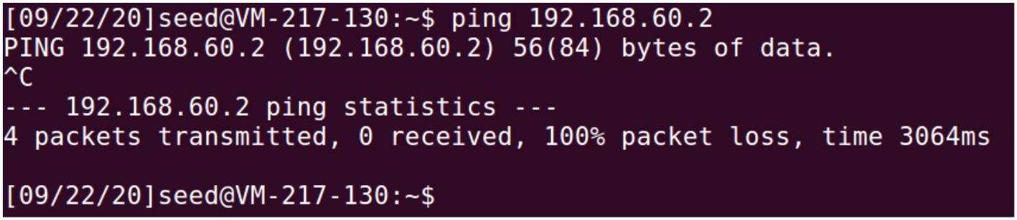
Task 2: Create and Configure TUN Interface Task 2.a: Name of the Interface
1. Execute the Python program and we find a new network interface with our custom prefix is
created.
Task 2.b: Set up the TUN Interface
1. After adding the two commands into the Python file, an IP address is assigned to this
interface and the state of the interface is changed to UNKNOWN.
Task 2.c: Read from the TUN Interface
1. Ping a host in the 192.168.53.0/24 network. The content of this ICMP request is printed
out in the Terminal that is running tun.py. As the TUN interface is up and has an IP address
in the same network, the IP packet is sent out through this interface and can be captured by
the Python program.
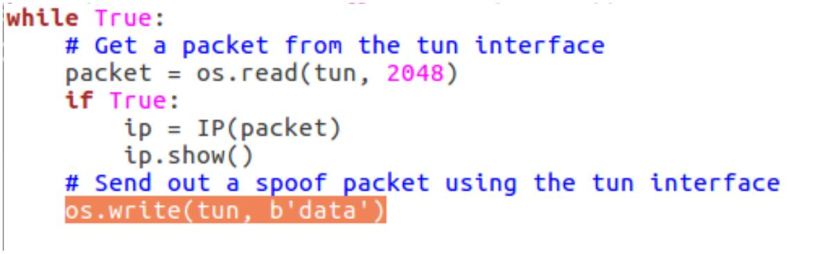
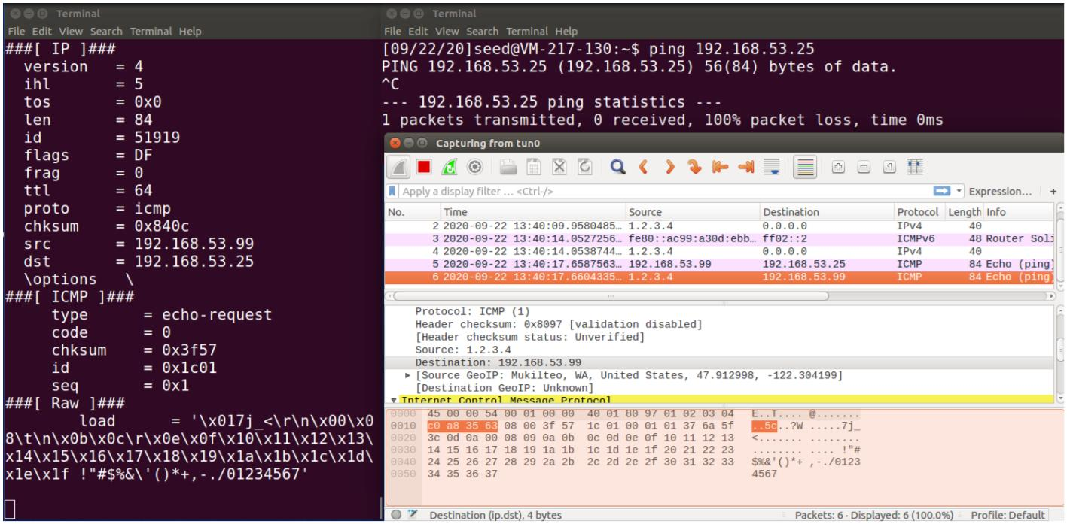
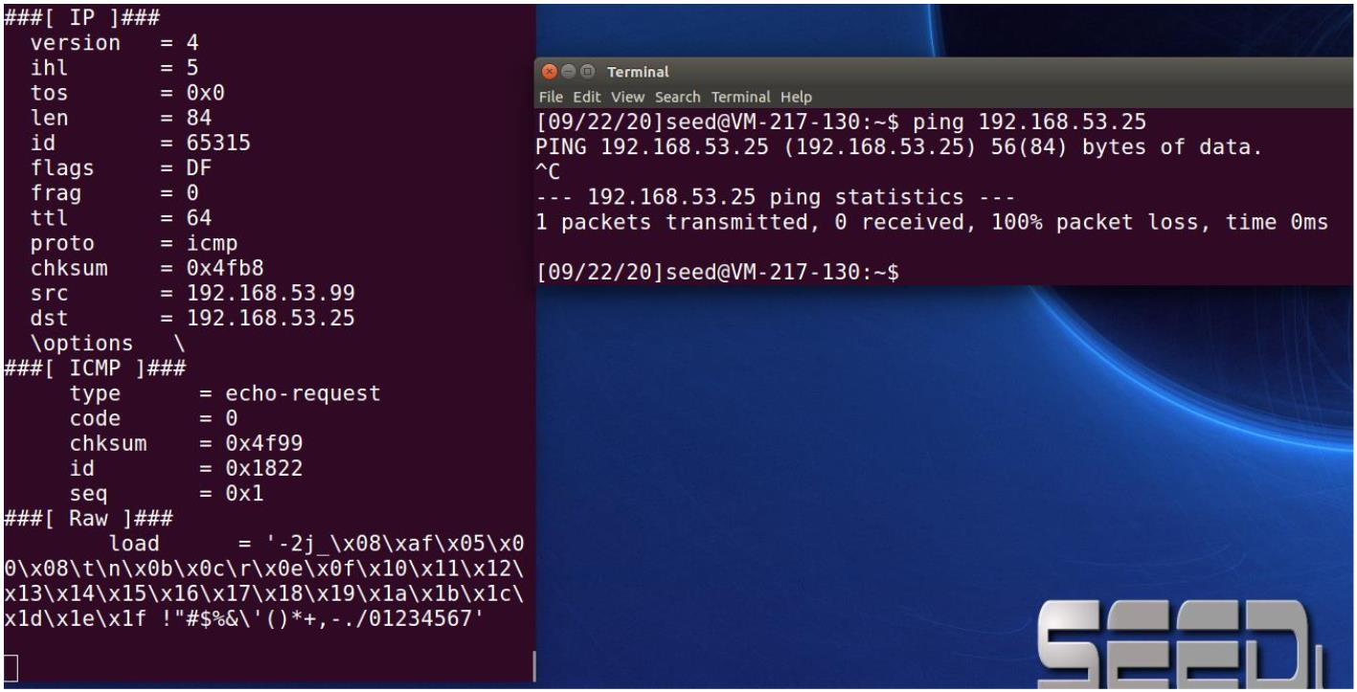
2. Ping a host in the 192.168.60.0/24 network. Nothing is printed out. The destination host
is not within the same network as the TUN interface, thus the request will not be sent
through this interface.
Task 2.d: Write to the TUN Interface
1. Send out a new packet with same payload that the original IP packet carries, with source
address ip.src and destination 1.2.3.4.
2. Edit the last line in tun.py to send some text into TUN interface.
3. In Wireshark we notice that some malformed raw packets were sent out but can’t be
recognized.
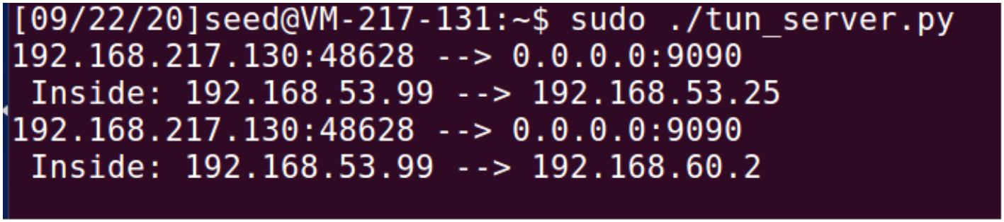
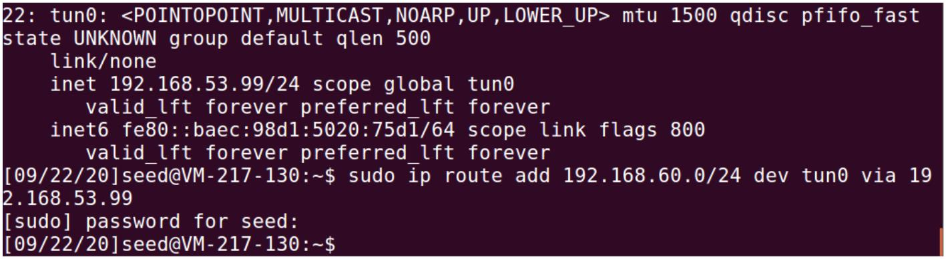
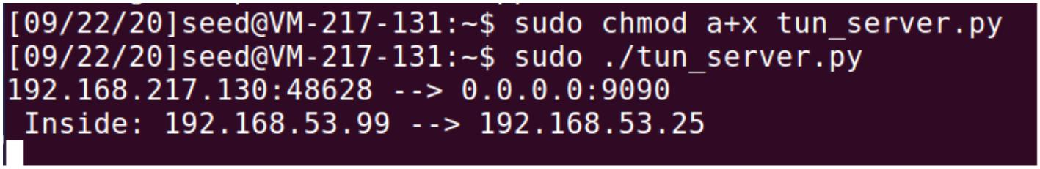
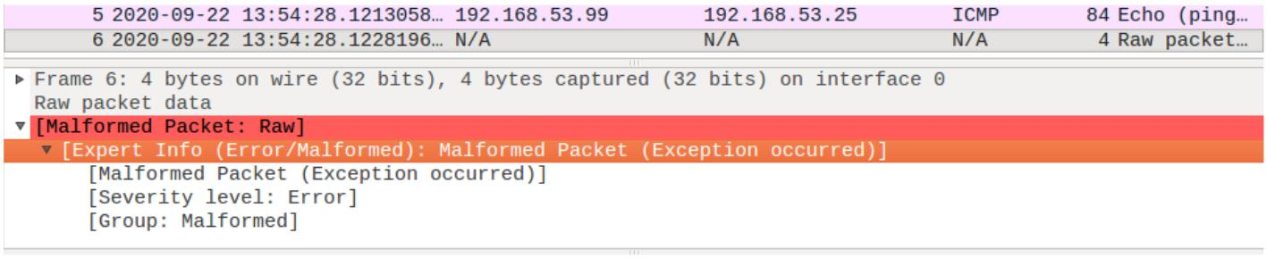
Task 3: Send the IP Packet to VPN Server Through a Tunnel
1. Ping a host in the 192.168.53.0/24 network. The IP packet is sent through the tunnel and
the content of the UDP packet, including the extracted IP packet inside, is printed out on the
VPN Server machine. This is because the original packet is routed to the TUN interface,
encapsulated in a UDP packet, and sent from the virtual (physical) ethernet network
interface to the server.
2. The packet will not be sent to the server and nothing will be printed out. Why it happens is
as stated above in Task 2.c.
3. Add a static routing entry to force ICMP requests to network 192.168.60.0/24 to be
routed to the TUN interface.
4. Now the server is receiving the packet.
Task 4: Set Up the VPN Server
1. Enable IP forwarding.
2. Execute Python programs on both client and server machine.

