Controls-only and Utopia - UX Brief
The purpose of this document is to define the UX problem space, provide effort estimates and assist in project planning.

1. Project at-a-glance
*Final UX delivery date and GA date are auto-populated from the table in 6. Schedule estimation
Summary
Author of doc (UXD) | James Y. Huntley
Date of last update | 4/10/2025
Project name | Control-only Experience and Utopia
AWS service | AWS Control Tower
Short description | The control-only experience unblocks customers from discovering AWS managed controls in the Control Tower console. Customers are provided assistance in enabling Control Tower that meets them where they are in their journey towards governance coverage by either enabling with a simplified setup or the option to be walked through all optional configurations.
Size | Large
Tracking
Asana intake ticket link | Controls-only: https://app.asana.com/0/1204895967621577/1208663249825594/f  Utopia: https://app.asana.com/0/1205919681573609/1209140947877215
Asana project link | https://app.asana.com/0/1208717089502179/1208717089558095
Slack primary UX channel | #prj-controls_only+utopia-ux  #aws-ct-project-utopia
Tier | Tier 2
Final UX delivery date* | June 2025
GA date* | re:Invent 2025
Stakeholders
Product manager | Arnaud Coulondre (Controls-only)  Ellie Ray (Utopia)
Program manager | n/a
Engineering team | Kyle O'Connor (SDM - Controls)  Stuart Minshull (SDM - LZ)  Kristin Anthony (FEE)
UX designer | James Y. Huntley
UX researcher | Harshali Wadge
Tech writer | Leslie Lundquist

2. Project goal
The goals of the control-only experience are to allow all customers to search and enable the deep library of Control Tower’s AWS managed controls in the console or via API’s without the pre-requisite of taking an action to first create a landing zone, and to simplify the landing zone setup to modularize the configurations as an optional step for customers.

A landing zone today can create a new organization for standalone accounts or iit requires customers with an existing organization to migrate to Control Tower’s recommended organization structure and employ mandatory controls and baseline configurations. Previously, customers were required to adopt and configure many recommended best practices (a full Landing Zone) at time of set-up including prescribed organizational structure, required services, and more in order to start using the service. For customers who only want to use AWS managed controls such as Capital One, Goldman Sachs and Citi Bank with more matured cloud structures, this feature will help them seamlessly access the comprehensive collection of managed controls in Control Catalog and incrementally enhance their governance stance. As cited by a CitiBank customer representative, if available, they would prefer to use an AWS managed control over a customer managed control. These customers do not want to invest the significant time (estimated at weeks to months) to migrate to the Control Tower landing zone prescribed cloud architecture.

3. User personas

Image | Persona | Avatar name | Primary goal | Primary opportunity from project
 | Cloud platform architect  (aka Cloud Implementer) | Kelly | To design and maintain a secure infrastructure through a combination of policies, compliance and governance controls. | The control-only experience allows me to onboard my established organization to Control Tower and benefit from AWS managed controls without the lengthy migration process to a landing zone. This provides flexibility in achieving my governance coverage outcomes.

4. UX narrative

Kelly is a cloud platform architect that manages Capital One’s cloud infrastructure with AWS Organizations. She would like to use AWS managed controls but doesn’t want to invest time to migrate her environment.

a. Problem
Kelly oversees the cloud architecture team, which has been managing a Policy as Code (PaC) infrastructure where her team authors custom policies. Ever since the 2019 and 2023 data leaks, the cloud architecture team at Capital One has been tasked with finding new mechanisms to tighten security and oversight of their cloud architecture. This has resulted in reviewing existing policies and authoring many new policies. Kelly has long advocated for the move of their AWS Organization environment to be moved under the automated governance of AWS Control Tower. She has been interested in taking advantage of the thousands of AWS managed controls that would replace the need to manually author policies and ensure the controls work within the ecosystem of the AWS services Capital One has onboarded to. The problem has been that she has not received approval for the estimated months of migration time to research and change her organization’s structure to meet the prescribed architecture of Control Tower’s landing zone. Capital One’s organization is complex with nuances to their OU and account structure, which would require time-intensive analysis and strategizing. Kelly has been forced to push this effort to the back burner.

4a.1 User flow for all new customers in Control Tower today
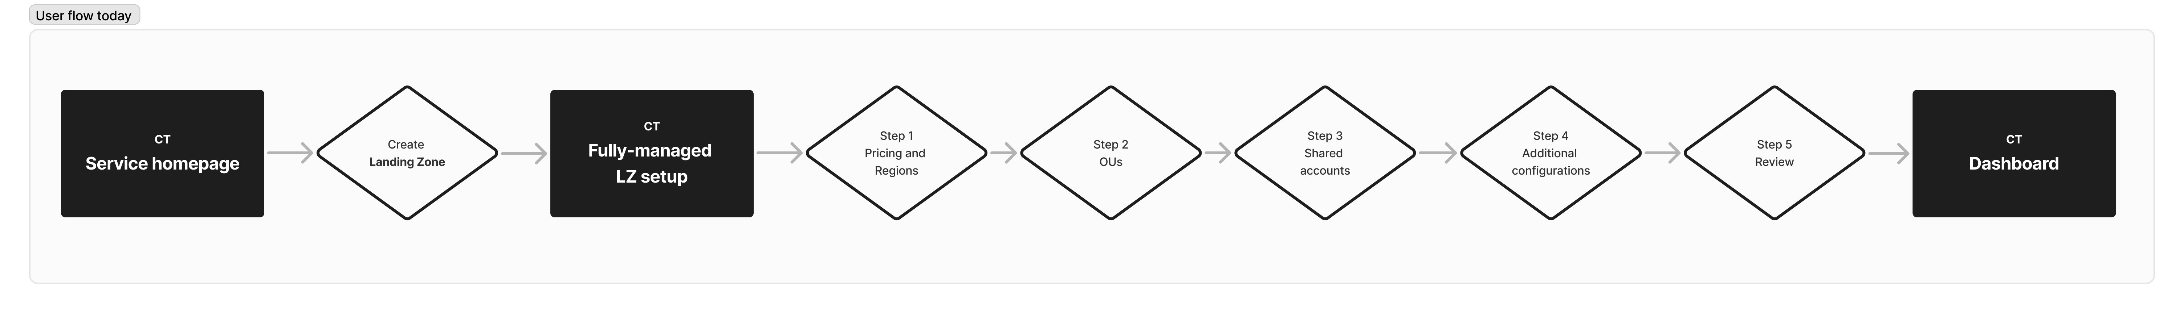

b. Solution
Kelly reads a new “AWS What’s New” post about a new ‘control-only experience’ within AWS Control Tower. Kelly is excited by the prospect of gaining access to the breadth of AWS managed detective controls from Config and Security Hub, alongside the preventive and proactive controls of Control Tower.

Kelly navigates to Control Tower’s management console, and is amazed she is immediately viewing a list of the AWS Control Tower controls. “Wowzas!” Kelly exclaims. In the past, Kelly’s team had to pore over AWS documentation for control details, but now she can view the Controls Library in all its glory (see 5a.3 The before and after of landing page for AWS Control Tower). Kelly filters the list by the domain of ‘Data Protection’ (a highlight for Capital One of recent), and views the filtered list of controls.

She clicks into a control owned by Control Tower, and within the detail page she is able to view comprehensive metadata about the control intent and and benefits. “This control is the one we’ve been spending weeks authoring a policy for!” Kelly exclaims out loud referring to a Control Tower proactive control. She continues to enable the control, performs a one-time enablement of Control Tower to confirm the Regions and turn on trusted access for her organization, and she’s done! “That just took five minutes!” exclaims Kelly, again outloud, jumping out of her chair. Her team saves valuable time in policy authoring and can now take advantage of the thousands of managed controls within AWS Control Tower.

5. UX scope

a. Designs
Important: All screenshots included in this document are exploratory only.

The ‘landing zone’ will remain as an API construct, but ‘Set up landing zone’ it will no longer be named as such prominently in the console UX. Instead of “Set up landing zone”, customers will “Enable Control Tower” that affords different ways to set up Control Tower in order to enable controls efficiently and meet the customer where they are in their organizational strategy. To view the new user flow when entering AWS Control Tower, see 5a.4 User flow for new CT customers with control-only experience.

A new customer without an organization, who is new to cloud governance, can choose to enable Control Tower by creating a fully-managed, multi-account environment with a landing zone and optional configurations, as they do today. An enterprise customer looking for an improved well-architected environment may choose to enable Control Tower by creating a multi-account governance structure, but heavily simplified, and opt-out of additional configurations (see 5a.1 The new CT enablement flow will allow a new customer options on how they would like to have Control…).

Customers can alternatively begin searching the thousands of AWS managed controls in Control Tower’s controls library before they enable Control Tower. When they choose to enable a control, they will be asked to perform a one-time setup of configuring Regions and enabling trusted access for their organization (see 5a.2 First-time customers who choose to enable a CT managed control will be presented with a one-time enablement screen). All customers can also use the APIs, GetControl and ListControl APIs, to programmatically view the controls and use the EnableControl API to enable controls.

Inventory of UX designs:
- Controls library — new customers that link to CT will now land directly in the controls library where they can begin searching and filtering AWS managed controls
- Dashboard – The landing zone dashboard will be modified to nudge a customer towards the setup types and will reflect information relevant to the customer’s setup decision
- A new enablement wizard for enabling CT:
  - With a traditional fully-managed landing zone where configurations (integrations) are optional
  - Controls-only, which includes a nudge strategy towards modularized configurations which will live in /Settings until the larger integration starts in 2025
- Service homepage — The service homepage will still be accessible from the breadcrumb, and language will be modified to provide information on the various ways to enable CT, dependent on the customer’s goals
- Side navigation — The side navigation must adjust based on the type of CT setup the customer selects
- Control enablement — the controls enablement for a single or multi-page enablement will be modified for first-time enablement to include a mechanism for the customer to configure Regions and turn on trusted access if they are enabling controls only
- Getting started — The getting started page content will be reworked to provide recommendations dependent on the setup choice of the customer
- Landing zone settings — This page will likely be renamed to ‘Settings’ and will provide the same configurations as today, but for those customers that opt to enable CT with the controls-only experience, this will also provide the mechanism to migrate to a managed multi-account environment (i.e. a traditional landing zone).

5a.1 The new CT enablement flow will allow a new customer options on how they would like to have Control Tower enable
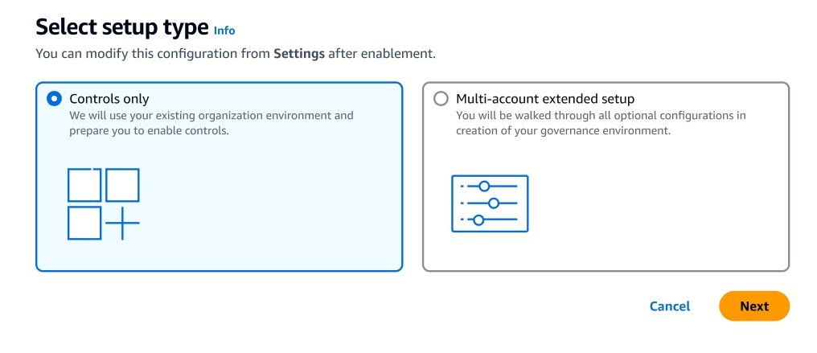

5a.2 First-time customers who choose to enable a CT managed control will be presented with a one-time enablement screen
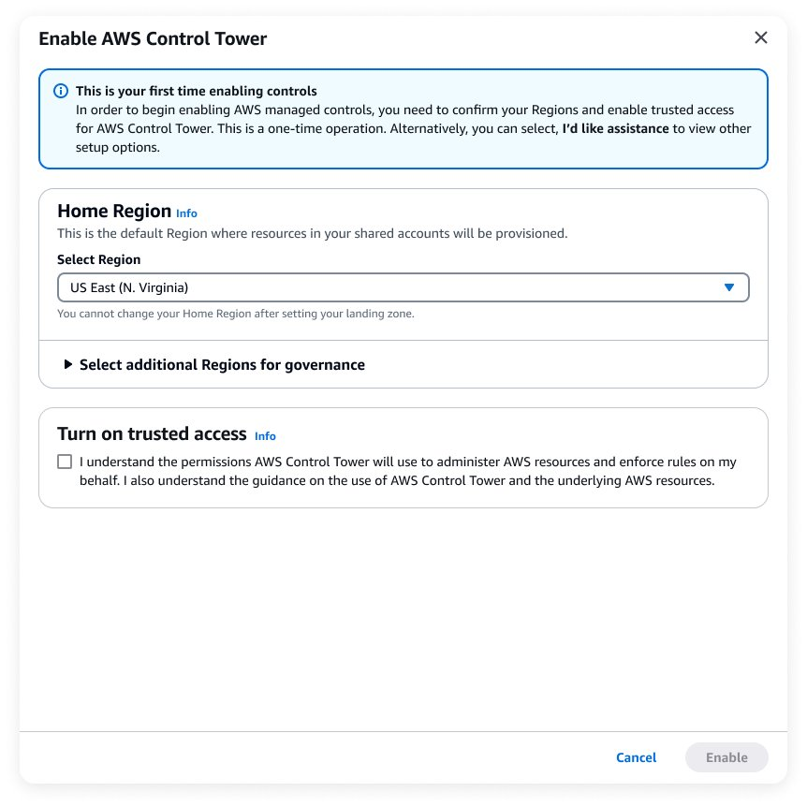

5a.3 The before and after of landing page for AWS Control Tower
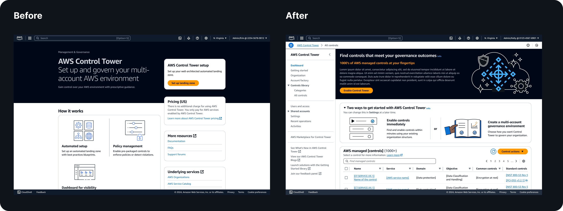

5a.4 User flow for new CT customers with control-only experience

b. UX research needs

Research type | Yes | No | Notes
Customer interviews | ✅ |  | Customer interviews were held during the inception of this project and during re:Invent 2024.
Usability testing | ✅ |  | Ideally we will have usability testing with the new mental model of a historically gated Control Tower experience.
Control Tower is built on the foundation of setting up a best practice well-architected environment surrounding the creation and management of a “landing zone“. The new controls-only experience is going to change the mental model of a customer from ”A landing zone allows me to use Control Tower’s AWS managed controls“, to ”I can use Control Tower’s AWS managed controls with my organization but decide on how I want Control Tower to manage my organization.“ This change will mean that the concept of a ‘landing zone’ will have more than one meaning to customers. It will be important to know if customers understand the distinction of the different enablement paths for Control Tower.

c. Related projects
- Project Hippogriff meta data widget (GA February 2025 - PR/FAQ): Centralization of all AWS managed controls into a single repository that is centrally managed with a common ontology (categorization with relationship properties) and distributes controls via a meta data widget for consistent display.
- Controls search widget (GA April 2025 - PR/FAQ): The Controls Search Widget

6. Schedule estimation
Estimations are high-level, and for planning purposes only.
- Start date: Nov 1, 2024
- Total effort estimate: 18.3 weeks
- Final designs hand-off: Apr 18, 2025
 | A | B | C
1 | Effort and task summaries | Est. weeks | ECD
2 | UX Designer begins effort on project |  | Nov 1, 2024
3
4 | Planning
5 | PR/FAQ support (graphics and collaboration with PM) | 1
6 | UX brief and deep-dive into CX problem | 2
7 | Kick-off meeting with project stakeholders | 0.2 | Jan 23, 2025
8
9 | Generative research
10 | Look though past research and consult, product and SMEs | 0.5
11
12 | Designs (directional)
13 | Create user flow diagram | 0.5 | Nov 8, 2024
14 | Create hi-fi directional designs | 3 | Feb 7, 2025
15 | Review designs with UX team and edit | 0.5 | Feb 13, 2025
16 | Review designs with project stakeholders and edit | 2 | Feb 25, 2025
17 | Review with partner service teams and edit | 0
18 | Review directional designs during a UX Milestones Deep Dive | 0
19
20 | Validation
21 | Prep UX validation study (e.g. usability testing) | 3
22 | Conduct UX validation study, sythensize and share insights | 2 | Mar 25, 2025
23
24 | Designs( finalize)
25 | Align with project stakeholders and service partners | 1
26 | Sign-off with IDCG UX managers or UX leads | 0.5
27 | Sign-off with IDCS leadership (required for tier 1 and tier 2 projects) | 1
28 | Sign-off with UX Milestones program (required for tier 1 and tier 2 projects) | 0.5
29 | Final designs hand-off | 0.4 | Apr 18, 2025
30
31 | Implementation
32 | Bug bash and dev support leading to Fit & Finish with project team | 0.2
33 | Fit & Finish with UX Milestones program (required for tier 1 and tier 2 projects) | 0.2
34
35 | Estimated effort subtotal and GA date | 18.3 | Jun 16, 2025

7. Related links
- (Arnaud) PR/FAQ: https://amazon.awsapps.com/workdocs-amazon/index.html#/document/3b58e7936f098ee2c14acbb7dc4353c11782c7251da520f6f2c7463c5958e755
- (James) UX Decisions: Controls-only experience - UX Decisions
- (James) User flows: https://www.figma.com/board/Jpw1Vmik2jxMRO5e7miPGd/Control-only-UX-and-Simplified-LZ?node-id=94-6216&t=OKegnJaCobhg2Q8q-11
- (James) Design explorations: https://www.figma.com/design/CEfxgFFm5t8vsCO5KzTIFQ/Controls-only-experience-(CT)?node-id=2010-6841&p=f&t=KKyYlCpUSBksKhbC-11

Published using UX Brief template version 3.0 | 01.06.25

