ELEN 4903: Machine Learning

Columbia University, Spring 2016

### Homework 3: Due March 25, 2016 by 11:59pm

**Yuntong Wang**

**yw2768**

### Part 1:

For the distribution w = [0.1; 0.2; 0.3; 0.4], show the histogram of one sampled vector c when n = 50; 250; 500.

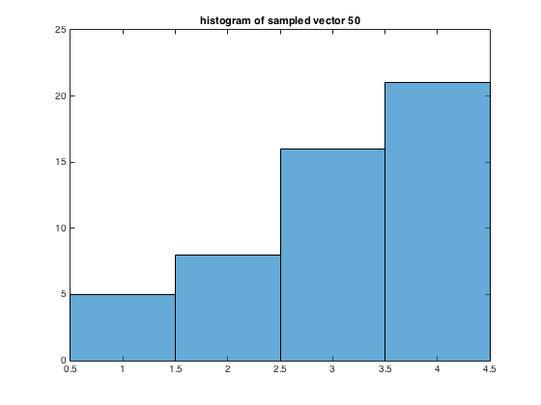

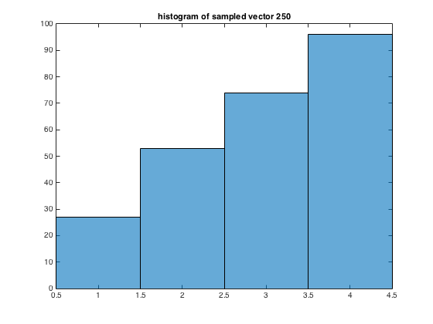

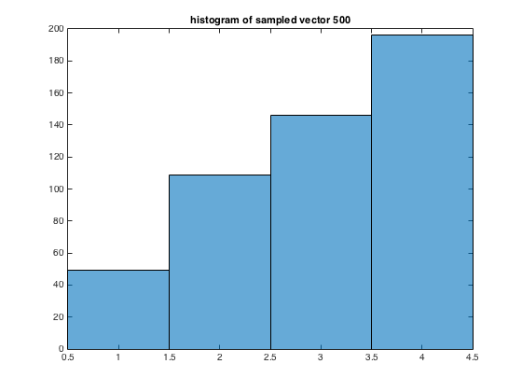

### Part 2.

2. On a single plot, show the training and testing error as a function of iteration t for t = 1, … , T.

**Training and testing error as a function of iteration t**

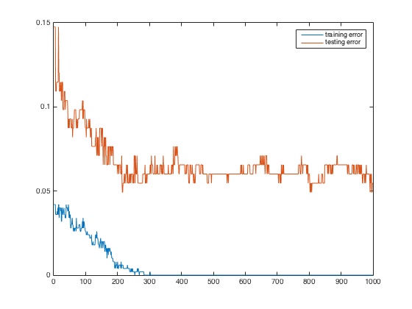

3. What is the testing accuracy for this Bayes classifier without boosting?

Testing accuracy for Bayes classfier without Adaboost is 0.9180

Testing accuracy for Bayes classfier with Adaboost is 0.953

4. Plot and as a function of t on different plots.

**Evolution of in terms of iteration number t**

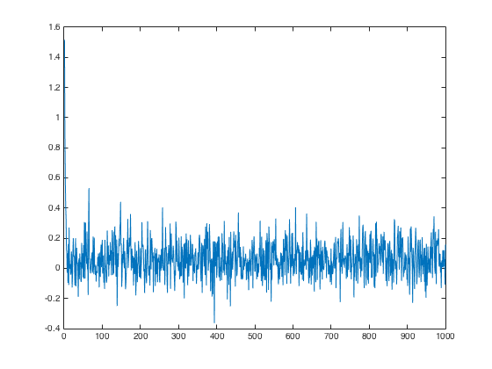

**Evolution of in terms of iteration number t**

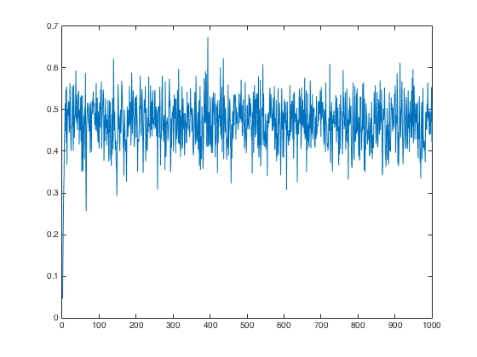

5. Pick 3 data points and plot their corresponding as a function of t on the same plot. Select the points such that there is some variation in these values.

**Evolution of of 3 data points in terms of iteration number t**

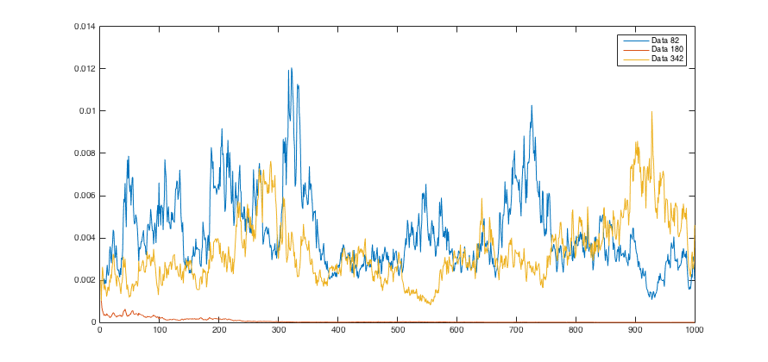

### Part 3.

2. On a single plot, show the training and testing error as a function of iteration t for t = 1, … , T.

**Training and testing error as a function of iteration t**

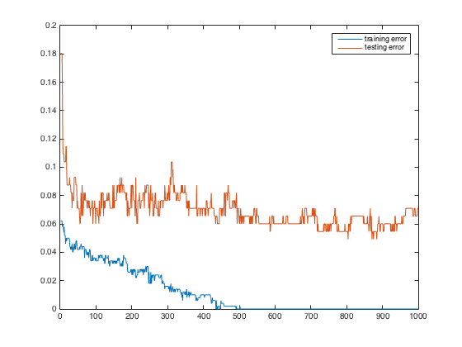

3. What is the testing accuracy of the logistic regression model without boosting?

Testing accuracy for logistic regression model without Adaboost is 0.936.

Testing accuracy for logistic regression model with Adaboost is 0.8251.

4. Plot and as a function of t on different plots.

**Evolution of in terms of iteration number t**

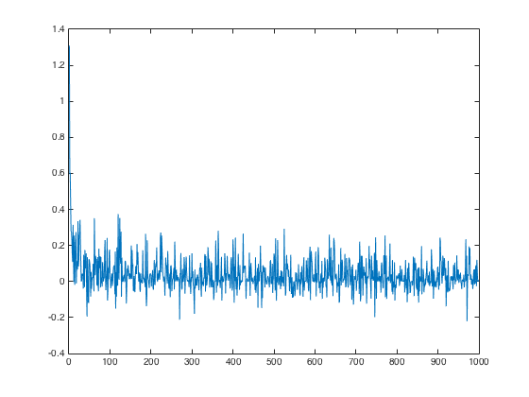

**Evolution of in terms of iteration number t**

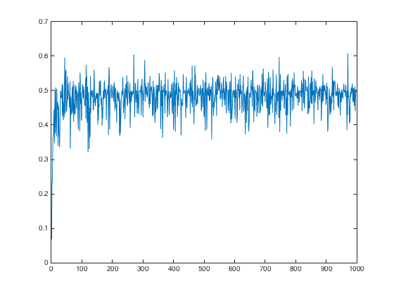

5. Pick 3 data points and plot their corresponding as a function of t on the same plot. Select the points such that there is some variation in these values.

**Evolution of of 3 data points in terms of iteration number t**

