ELEN 4903: Machine Learning

Columbia University, Spring 2016

Homework 4: Due April 15, 2016 by 11:59pm

Yuntong Wang

yw2768

**Problem 1.**

1. For K = 2, 3, 4, 5, plot the value of the K-means objective function per iteration for 20 iterations (the algorithm may converge before that).

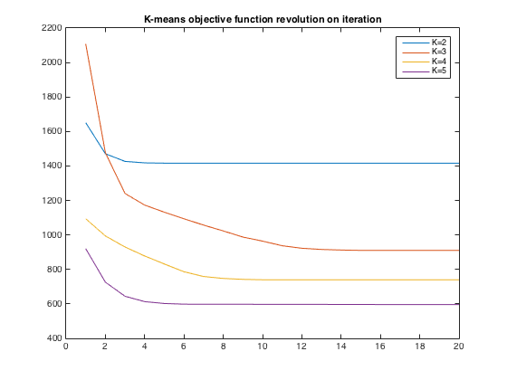

2. For K = 3, 5, plot the 500 data points and indicate the cluster of each for the final iteration by marking it with a color or a symbol.

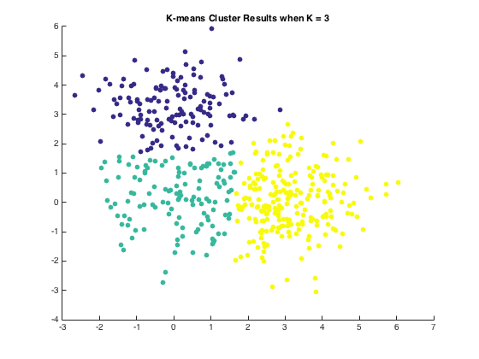

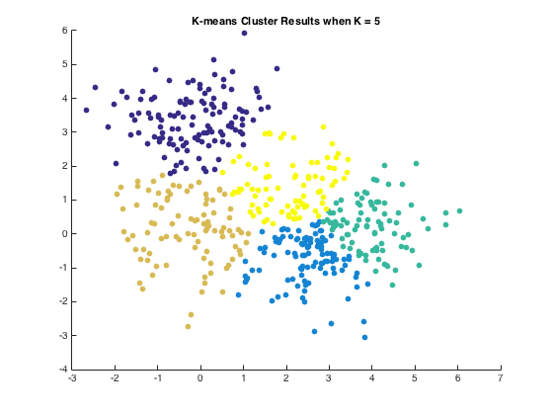

**Problem 2.**

1. Plot the RMSE of your predictions on the held out test set provided for iteration number 2 to 100.

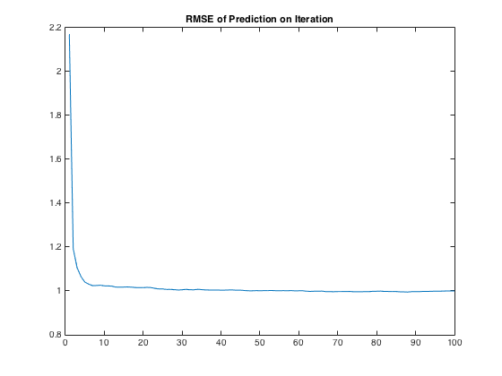

2. On a separate plot, show the log joint likelihood for iterations 2 to 100.

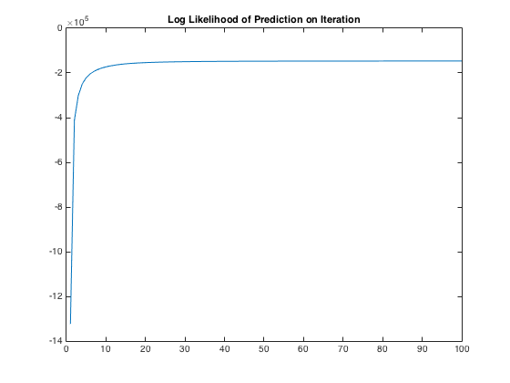

3. After 100 iterations, pick three reasonably well-known movies from the list provided and for each movie find the 5 closest movies according to Euclidean distance using their respective locations vj . List the query movie, the five nearest movies and their distances. A mapping from index to movie is provided with the data.

Query movie: Pulp Fiction (1994)

No. 1 closest movie: Deer Hunter, The (1978), distance: 0.791783

No. 2 closest movie: Raising Arizona (1987), distance: 0.826980

No. 3 closest movie: Jackie Brown (1997), distance: 0.907795

No. 4 closest movie: Trainspotting (1996), distance: 0.918652

No. 5 closest movie: Swingers (1996), distance: 0.921128

Query movie: Forrest Gump (1994)

No. 1 closest movie: Dances with Wolves (1990), distance: 0.537926

No. 2 closest movie: Field of Dreams (1989), distance: 0.658093

No. 3 closest movie: Client, The (1994), distance: 0.709732

No. 4 closest movie: Glory (1989), distance: 0.748582

No. 5 closest movie: Stand by Me (1986), distance: 0.759418

Query movie: Titanic (1997)

No. 1 closest movie: Client, The (1994), distance: 0.867284

No. 2 closest movie: Fugitive, The (1993), distance: 0.869061

No. 3 closest movie: Great Expectations (1998), distance: 0.888748

No. 4 closest movie: Jurassic Park (1993), distance: 0.894321

No. 5 closest movie: Apollo 13 (1995), distance: 0.914937

4. After 100 iterations, perform K-means on the vectors u1,…,uN1 learned by your algorithm. Set K = 20, which is an arbitrary number. The centroids can be interpreted as personality types (as far as movies are concerned).

* Pick the 5 centroids corresponding to the 5 clusters that have the most data. For each cluster selected, give the number of users allocated to that cluster.
* For each of these 5 centroids, list the 10 movies with the largest (most positive) dot product with that centroid. Also give the value of the dot product next to the movie.

No. 1 popular centroid: 0.5746 0.4743 -0.5477 0.9900 -0.5629 -0.0244 -0.0163 0.6061 1.1627 0.5796

The number of users allocated to the centroid: 82

No. 1 popular movie of this centroid: Godfather, The (1972), distance: 4.885317

No. 2 popular movie of this centroid: Schindler's List (1993), distance: 4.632431

No. 3 popular movie of this centroid: Casablanca (1942), distance: 4.572252

No. 4 popular movie of this centroid: Lawrence of Arabia (1962), distance: 4.544643

No. 5 popular movie of this centroid: One Flew Over the Cuckoo's Nest (1975), distance: 4.530663

No. 6 popular movie of this centroid: Godfather: Part II, The (1974), distance: 4.504323

No. 7 popular movie of this centroid: Citizen Kane (1941), distance: 4.474424

No. 8 popular movie of this centroid: Shawshank Redemption, The (1994), distance: 4.453958

No. 9 popular movie of this centroid: Pulp Fiction (1994), distance: 4.443999

No. 10 popular movie of this centroid: Silence of the Lambs, The (1991), distance: 4.440085

No. 2 popular centroid: 0.5595 0.7722 -0.1509 0.8152 -0.8636 -0.6476 0.2387 0.2116 0.7342 0.4623

The number of users allocated to the centroid: 80

No. 1 popular movie of this centroid: L.A. Confidential (1997), distance: 4.448202

No. 2 popular movie of this centroid: Star Wars (1977), distance: 4.427577

No. 3 popular movie of this centroid: Good Will Hunting (1997), distance: 4.374810

No. 4 popular movie of this centroid: As Good As It Gets (1997), distance: 4.351784

No. 5 popular movie of this centroid: Shawshank Redemption, The (1994), distance: 4.302475

No. 6 popular movie of this centroid: Titanic (1997), distance: 4.273922

No. 7 popular movie of this centroid: Apt Pupil (1998), distance: 4.238456

No. 8 popular movie of this centroid: Wag the Dog (1997), distance: 4.224733

No. 9 popular movie of this centroid: Fargo (1996), distance: 4.210373

No. 10 popular movie of this centroid: Usual Suspects, The (1995), distance: 4.206115

No. 3 popular centroid: 0.4313 0.2342 -0.0764 0.9156 -0.6074 -0.6554 -0.0091 -0.0536 1.1474 0.7807

The number of users allocated to the centroid: 68

No. 1 popular movie of this centroid: Good Will Hunting (1997), distance: 4.642554

No. 2 popular movie of this centroid: As Good As It Gets (1997), distance: 4.557078

No. 3 popular movie of this centroid: Schindler's List (1993), distance: 4.499874

No. 4 popular movie of this centroid: Apt Pupil (1998), distance: 4.461279

No. 5 popular movie of this centroid: Dead Man Walking (1995), distance: 4.447042

No. 6 popular movie of this centroid: Shawshank Redemption, The (1994), distance: 4.369652

No. 7 popular movie of this centroid: English Patient, The (1996), distance: 4.354396

No. 8 popular movie of this centroid: Amistad (1997), distance: 4.341302

No. 9 popular movie of this centroid: Full Monty, The (1997), distance: 4.303735

No. 10 popular movie of this centroid: Fargo (1996), distance: 4.262216

No. 4 popular centroid: 0.5158 1.0516 -0.0904 1.0969 -0.5621 -0.3835 -0.1553 0.4263 1.1462 0.4184

The number of users allocated to the centroid: 67

No. 1 popular movie of this centroid: Wrong Trousers, The (1993), distance: 4.641704

No. 2 popular movie of this centroid: Godfather, The (1972), distance: 4.634404

No. 3 popular movie of this centroid: Pulp Fiction (1994), distance: 4.634344

No. 4 popular movie of this centroid: Shawshank Redemption, The (1994), distance: 4.605539

No. 5 popular movie of this centroid: Godfather: Part II, The (1974), distance: 4.603703

No. 6 popular movie of this centroid: Chasing Amy (1997), distance: 4.586262

No. 7 popular movie of this centroid: Wallace & Gromit: The Best of Aardman Animation (1996), distance: 4.572984

No. 8 popular movie of this centroid: Citizen Kane (1941), distance: 4.554002

No. 9 popular movie of this centroid: Schindler's List (1993), distance: 4.548498

No. 10 popular movie of this centroid: Apt Pupil (1998), distance: 4.534231

No. 5 popular centroid: 0.8662 0.8539 -0.1447 0.9822 -0.7224 0.0542 -0.2617 -0.0805 0.8966 0.6004

The number of users allocated to the centroid: 65

No. 1 popular movie of this centroid: Star Wars (1977), distance: 4.571571

No. 2 popular movie of this centroid: Close Shave, A (1995), distance: 4.571103

No. 3 popular movie of this centroid: Wrong Trousers, The (1993), distance: 4.535521

No. 4 popular movie of this centroid: Wallace & Gromit: The Best of Aardman Animation (1996), distance: 4.505720

No. 5 popular movie of this centroid: Casablanca (1942), distance: 4.463125

No. 6 popular movie of this centroid: Beautiful Thing (1996), distance: 4.397647

No. 7 popular movie of this centroid: Cold Comfort Farm (1995), distance: 4.380283

No. 8 popular movie of this centroid: Usual Suspects, The (1995), distance: 4.373759

No. 9 popular movie of this centroid: Princess Bride, The (1987), distance: 4.358973

No. 10 popular movie of this centroid: 12 Angry Men (1957), distance: 4.354052

5. After 100 iterations, perform K-means on the vectors v1,…,vN2 learned by your algorithm. Set K = 20, which is an arbitrary number.

* Pick the 5 centroids corresponding to the 5 clusters that have the most data. For each cluster selected, give the number of movies allocated to that cluster.
* For each of these 5 centroids, list the 10 movies with the smallest Euclidean distance to that centroid. Also give the value of the Euclidean distance next to the movie.

No. 1 popular centroid: 0.7427 0.6447 0.0555 0.9406 -0.8937 -0.3586 0.1290 0.3633 0.7193 0.4757

The number of movies allocated to the centroid: 72

No. 1 closest movie: Kiss the Girls (1997), distance: 0.688779

No. 2 closest movie: Murder in the First (1995), distance: 0.720754

No. 3 closest movie: Truth About Cats & Dogs, The (1996), distance: 0.728488

No. 4 closest movie: Now and Then (1995), distance: 0.733360

No. 5 closest movie: Apollo 13 (1995), distance: 0.736436

No. 6 closest movie: Mrs. Doubtfire (1993), distance: 0.744605

No. 7 closest movie: Client, The (1994), distance: 0.749637

No. 8 closest movie: MatchMaker, The (1997), distance: 0.765032

No. 9 closest movie: Rainmaker, The (1997), distance: 0.786197

No. 2 popular centroid: 0.2605 0.9607 -0.2746 1.0030 -0.6895 -0.3111 -0.2235 0.4509 1.1258 0.4874

The number of movies allocated to the centroid: 69

No. 1 closest movie: Smoke (1995), distance: 0.680785

No. 2 closest movie: Pink Floyd - The Wall (1982), distance: 0.737760

No. 3 closest movie: Trust (1990), distance: 0.740496

No. 4 closest movie: Horseman on the Roof, The (Hussard sur le toit, Le) (1995), distance: 0.789407

No. 5 closest movie: Night on Earth (1991), distance: 0.799507

No. 6 closest movie: Three Colors: White (1994), distance: 0.800610

No. 7 closest movie: Go Fish (1994), distance: 0.834110

No. 8 closest movie: Fear of a Black Hat (1993), distance: 0.839640

No. 9 closest movie: Nobody's Fool (1994), distance: 0.841593

No. 3 popular centroid: 0.7887 0.8500 -0.5039 0.7010 -0.6417 -0.2164 -0.3670 -0.1270 0.8966 0.7125

The number of movies allocated to the centroid: 69

No. 1 closest movie: Muriel's Wedding (1994), distance: 0.809618

No. 2 closest movie: Dead Man Walking (1995), distance: 0.828093

No. 3 closest movie: Ridicule (1996), distance: 0.841611

No. 4 closest movie: Big Night (1996), distance: 0.849971

No. 5 closest movie: Bottle Rocket (1996), distance: 0.927907

No. 6 closest movie: Remains of the Day, The (1993), distance: 0.929740

No. 7 closest movie: Cinema Paradiso (1988), distance: 0.930294

No. 8 closest movie: In the Bleak Midwinter (1995), distance: 0.932149

No. 9 closest movie: Kolya (1996), distance: 0.934061

No. 4 popular centroid: 0.3056 0.1305 -0.4629 0.9211 -0.7288 -0.5465 0.1047 0.0528 1.2089 0.5377

The number of movies allocated to the centroid: 65

No. 1 closest movie: Horseman on the Roof, The (Hussard sur le toit, Le) (1995), distance: 0.747991

No. 2 closest movie: Postino, Il (1994), distance: 0.828093

No. 3 closest movie: Six Degrees of Separation (1993), distance: 0.839267

No. 4 closest movie: Shine (1996), distance: 0.863237

No. 5 closest movie: Nobody's Fool (1994), distance: 0.866704

No. 6 closest movie: Birdcage, The (1996), distance: 0.870074

No. 7 closest movie: Three Colors: White (1994), distance: 0.870972

No. 8 closest movie: Trust (1990), distance: 0.875270

No. 9 closest movie: Streetcar Named Desire, A (1951), distance: 0.961867

No. 5 popular centroid: 0.9440 0.7565 -0.3897 0.8711 -0.4700 -0.0514 -0.2698 0.5625 1.3979 0.1243

The number of movies allocated to the centroid: 63

No. 1 closest movie: Beavis and Butt-head Do America (1996), distance: 0.906344

No. 2 closest movie: Frighteners, The (1996), distance: 0.987641

No. 3 closest movie: Austin Powers: International Man of Mystery (1997), distance: 1.021540

No. 4 closest movie: In the Line of Duty 2 (1987), distance: 1.043768

No. 5 closest movie: Tales from the Crypt Presents: Bordello of Blood (1996), distance: 1.099267

No. 6 closest movie: Tetsuo II: Body Hammer (1992), distance: 1.118190

No. 7 closest movie: April Fool's Day (1986), distance: 1.128640

No. 8 closest movie: Heidi Fleiss: Hollywood Madam (1995) , distance: 1.150258

No. 9 closest movie: Hurricane Streets (1998), distance: 1.153277