Practical Work: Markov Chains

The goal of this practical work is to get you familiar with Markov chains. “Markov_chain_functions.py” is a function file. NEVER compile it directly!
Instead, write all the instructions you need to solve the questions in “Markov_chain.py”.

0) In order to complete this practical work on the Markov chains, it is best to first install Anaconda, which is a useful Python and R distribution.
The instructions for Windows can be found here.





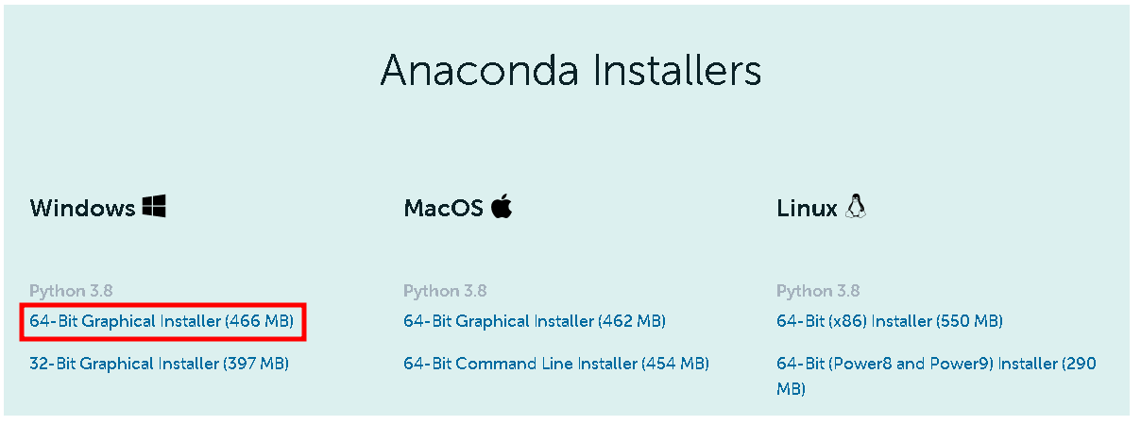

Open the downloaded file and launch the installation.

Once it is installed, open the Anaconda Prompt.

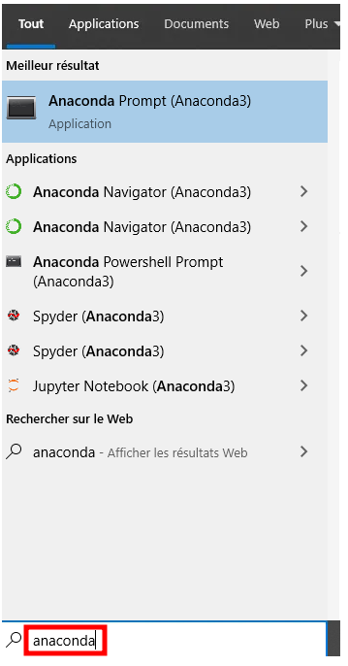

Install ipython as follows:

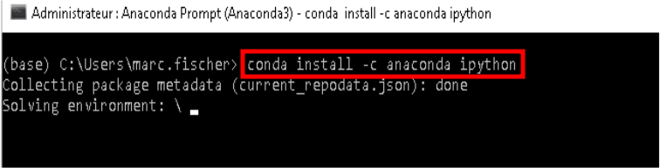

Once this is done, unzip “TP_Markov_Chain_students_2020.zip”.

Determine the address of the directory containing the practical work by right-clicking on a file located in it.

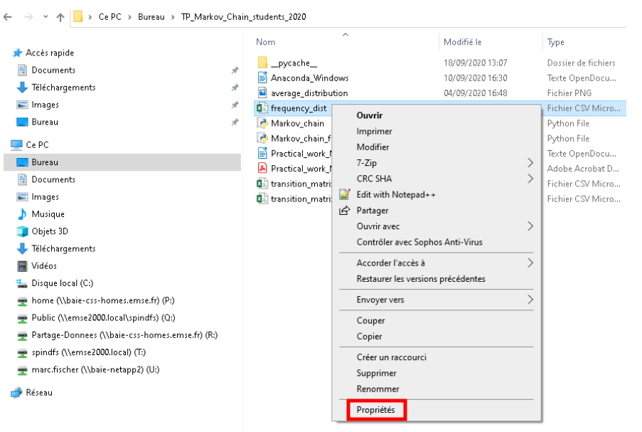

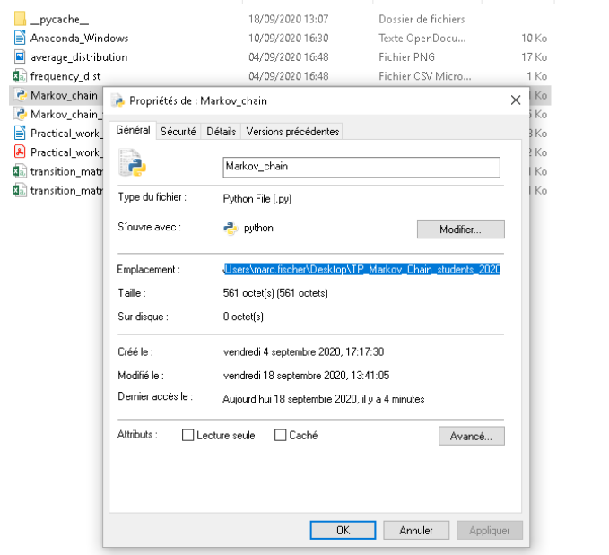

Through the use of “cd [directory]”, change the current directory of the Anaconda Prompt into the folder with the files:

(Of course, you address won’t be the same as mine!)

Download and install then the text editor Notepad++ (choose the newest version).

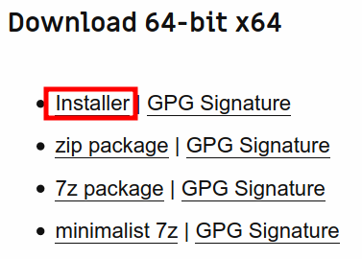
Open the files “Markov_chain.py“ and “Markov_chain_functions.py“ with Notepad++.

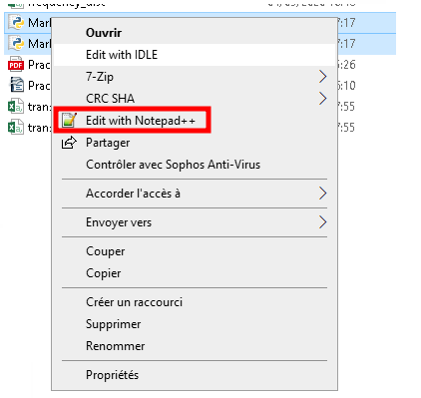

Type this line in “Markov_chain.py”:
print(“this is a test!”);

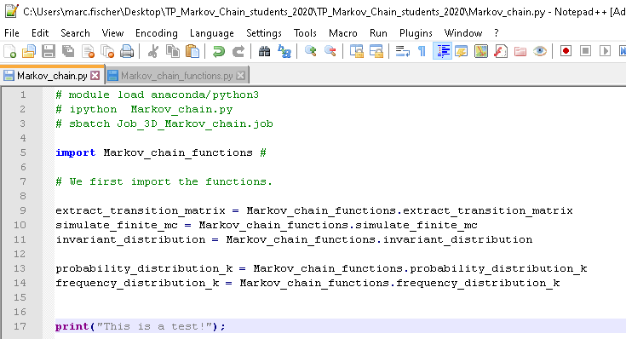

Compile the python file in the Anaconda shell by typing “ipython Markov_chain.py”.

If everything is okay, this should look like this.

In what follows, you’ll answer all questions of this practical work by writing instructions in “Markov_chain.py” and calling functions from “Markov_chain_functions.py“ in it.

Every time, execute the script by typing “ipython Markov_chain.py“ in the Anaconda shell.

I) Read carefully the source file “Markov_chain_functions.py” (including the comments).

2) Let us consider the following transition matrix (see “transition_matrix_q2.csv”).

.

The corresponding state space is I = {0,1,2,3,4,5,6,7,8,9,10,11}.

a) Determine the invariant distribution. Explain what it is.
Compare it with the asymptotic frequency distribution of the Markov chain starting in state 0.

Compare the two histograms.

b) Let us consider here that we always have X(0) = 0.
Determine the probability distribution of X(1), X(2), X(3), X(4), X(5).
Compare it with the frequency distribution obtained with a sufficient sample size.

How well does it correspond to the invariant distribution?

3) Let us now consider this Markov chain:

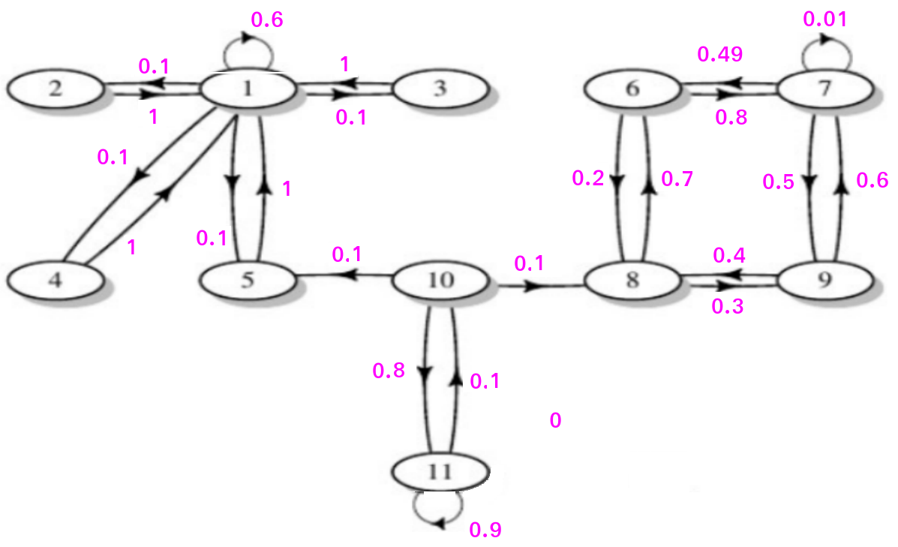

a) Create the transition matrix in the file “transition_matrix.csv“.
We’ll always consider the fact that the Markov chain starts in State 11.

b) Compute the asymptotic probability distribution by simulating Markov chains and determining the frequency distribution of X_{k} when k is large enough.

c) Determine the asymptotic probability distribution without simulating a Markov chain.
Do NOT use the functions “probability_distribution_k” and “frequency_distribution_k“!
Compare it with the results of b).

Let T_{10f} be the time at which the Markov chain leaves state 10 for a state different from state 11.

d) Write a function simulate_ T10f that simulates a random variable following the same distribution as T_{10f}.

e) Compute the asymptotic probability distribution through the simulation of a Markov Chain.
Represent it through a continuous curve rather than through a diagram.

