Report of the TP of machine learning
WANG YUTENG
XU QIAN

1 AND 3 Decide which method to use for clustering and explain why you choose this method.
Show a plot of the resulting clusters.

We use the K-means ,DBSCAN ,HAC for clustering
In the data1:
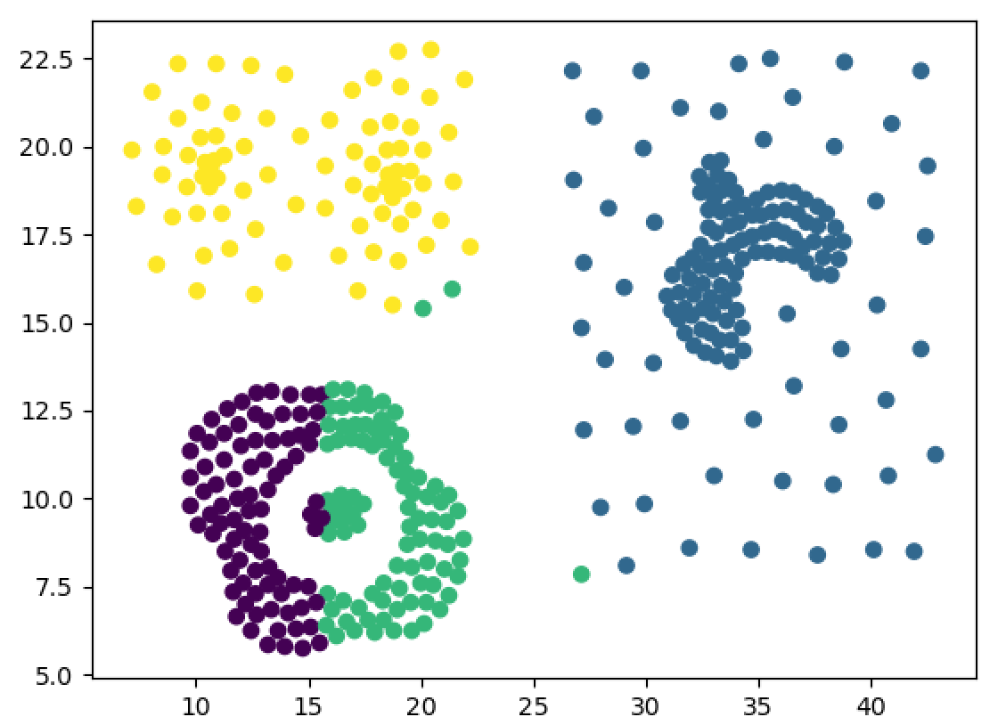
- means
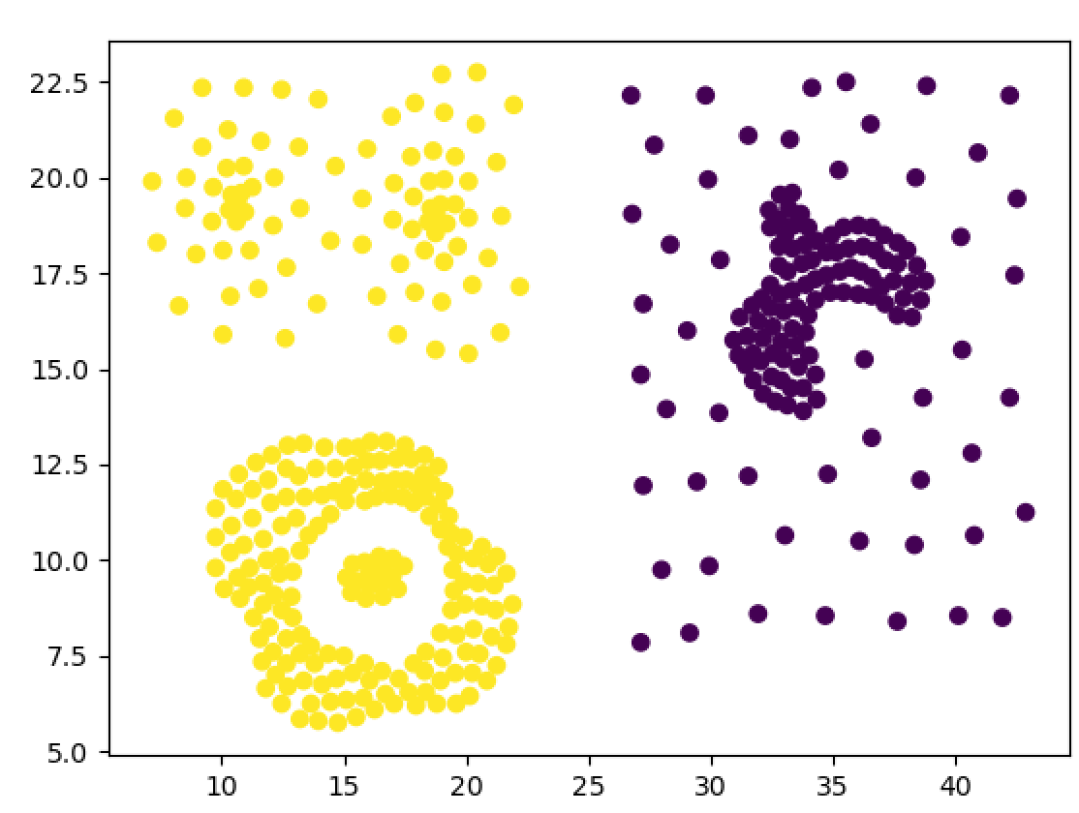
DBSCAN
In the data2:

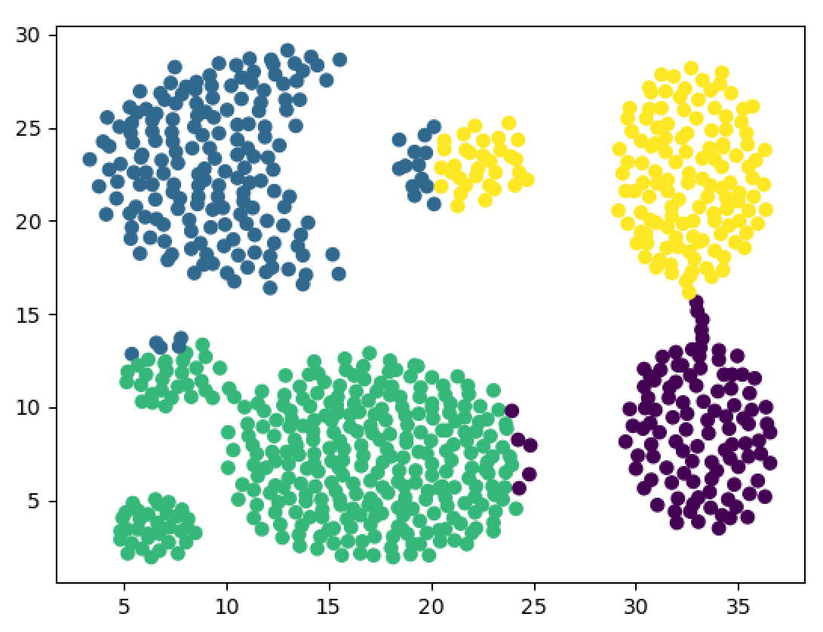
K-Means

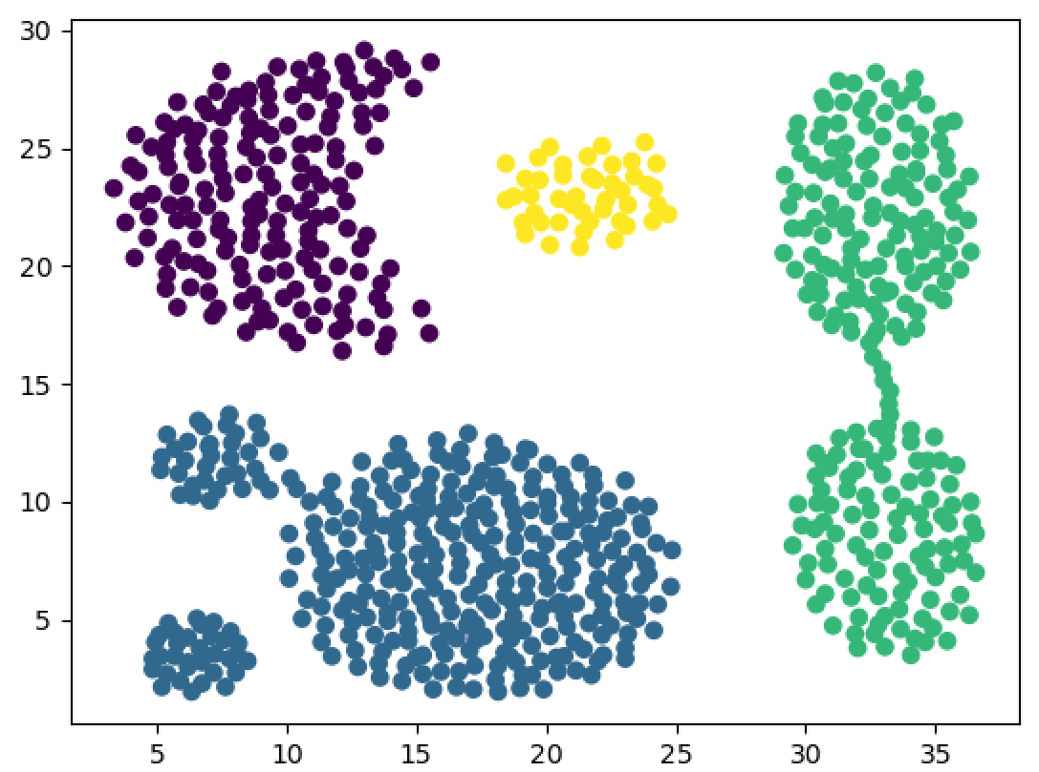
DBSCAN
In the data3:
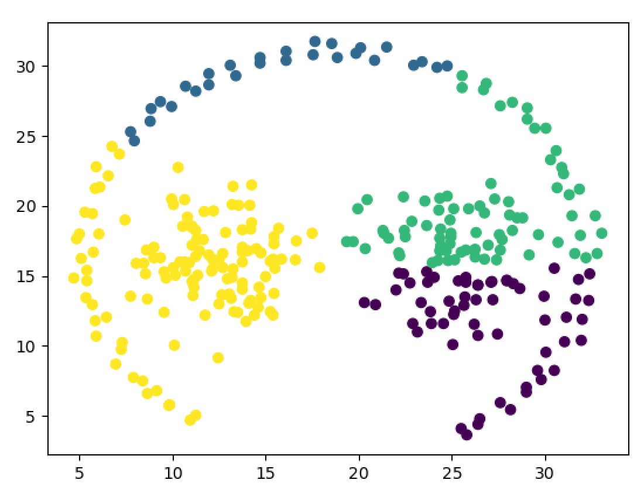
- Means

2 Perform clustering on the data and explain how you did this (why you choose
specific parameters etc.)
In K-means we draw a plot the relations between k and inertia
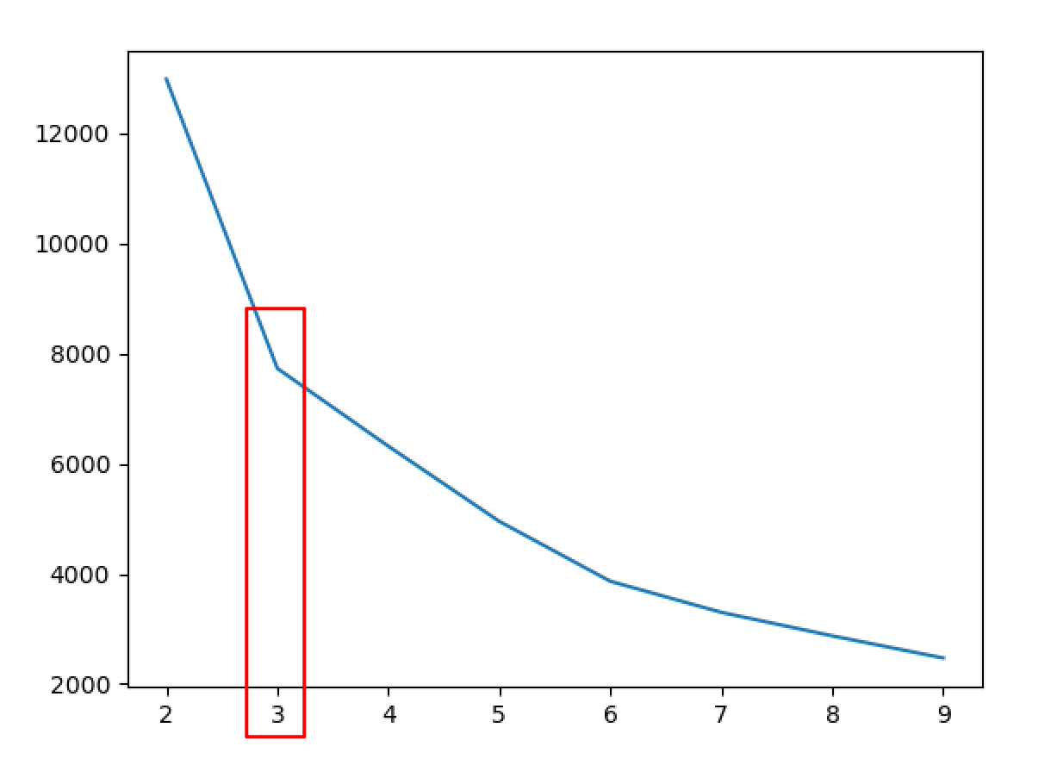
Data1
So we will choose the number of the culsters of 3

In DBSCAN
- eps : The maximum distance between two samples for one to be considered as in the neighborhood of the other.
- min_samples : The number of samples (or total weight) in a neighborhood for a point to be considered as a core point. This includes the point itself.
Date1: eps :5 min_sample :7
Date2 : eps : 4 min_sample : 7

Results:
So in the compare of two method, we can see that DBSCAN is more effective,and it can separate different clusters with the parameters eps and min_exemples

