XdevL SDK 0.5 Manual (Draft)
© 2016 Cengiz Terzibaş

Contents
Introduction 3
Requirements 4
Operating system 4
Compiler 4
Development environments 4
Installation 6
Binary Packages 6
Building from source 6
Setup 10
Setting up the environment variables 10
Programming 13
Creating the core system 13
Command line 15
XdevLCore log messages 16
The main core XML file 16
Build in Interfaces and Plugins 20
I/O Interfaces 20
Network Interfaces 20
Compiling XdevLDemos 21
WindowsXP/Windows Vista 21
Linux 21
Interfaces, Plug-Ins and Modules 22
What are Interfaces? 22
What are XdevL Modules? 22
What is an XdevL Plug-In? 23
Plug-In development 24
Introduction 24
Integrating your existing library 24
Version Numbering 28
Trouble Shooting 30
Acknowledgments 30
Object Oriented Input System (OIS) 30
The OpenGL Extension Wrangler Library (GLEW) 30
OGRE 30
TinyXML 30

Introduction
Hello and welcome to the world of XdevL. Before we start let me give you a short description about what XdevL is:
XdevL is a powerful cross-platform C++ Plug-In/Module oriented programming framework which helps you developing scientific, industrial and game applications.
Sounds cool, deshou :).
(By the way, the name XdevL is an abbreviation and means eXtended device Library.)
Here are some important features it may interesting to you.
- Uses C++11 standard.
- Cross Platform (GNU/Linux, MacOSX and Windows supported. Android and IOS are planed.)
- Supports plugins and modules which makes the system extreme expandable and flexible.
- Shared memory, Semaphore support using XdevLSharedMemory and XdevLSemaphore class.
- Basic threading support thread::Thread and thread::Mutex and thread::ConditionalVariable.
- Xml file parsing (it's the tinyxml project http://www.grinninglizard.com/tinyxml/)
- Extended string/filename parsing.
- Support for fast delegates. (Another way of callback functions).
- Array manipulators.
- Support for different types of control devices like, Keyboard, Mouse and Joystick
- Cross platform 3D rendering using XdevLRAI. One implementation is using OpenGL 3.3+ and Vulkan is planned.
- Audio playback and record using XdevLAudioPlayback and XdevLAudioCapture.
- Bluetooth and Serial port support.
- Networking TCP/UDP.
- File/Folder handling using XdevLFile, XdevLDirectory and XdevLDirectoryWatcher.
- OpenGL context using native version as GLX, WGL, CGL and EGL.
- Support for font rendering using XdevLFont and XdevLRAI
- Image import support for Jpeg, Png, Bmp and TGA files.
In the description above I mentioned the words “real-time application”. Why do I do it? XdevL was developed to fulfill this requirement. If you need a framework which supports user interface oriented objects like buttons, check boxes, tree views, menus etc. then you should probably use GTK+, WxWidgets or QT and not XdevL. You can mix them together if you like. But the whole design (internal and plug-ins) of this framework is adapted for real-time applications.
You will notice that I will talk sometimes about XdevL and XdevLCore. You shouldn’t get confused about that because XdevL is the static library of the whole framework and has some additional features which helps you parsing for example XML files or write threaded applications. XdevLCore itself is a plug-in and is the heart of the whole system. This plug-in manages all other plug-ins and modules. You can plug and unplug plug-ins yes you can even let the plug ins communicate with each other. At least that's the goal of XdevL. Some functionality may not be implemented if you read this documentation.
In this document I will first explain you how to install the XdevLSDK and setup your system. After that the main XML file of the core system will be described in more details because XdevLCore is using it to initialize plug-ins and modules. Using it will make your life easier. Then we will have a look at the plug-ins and modules which are provided with the main SDK and a couple of features will be explained. At the end of this documentation the demo projects will be described. OK, let’s don’t waste time and start with Installing the SDK.

Requirements
Here are a couple of requirements which your system should fulfill to get along with the whole XdevLSDK.

Supported Platforms
First let me show which operating systems are supported:
- GNU/Linux using at least Kernel 3.0+
- Windows XP/Vista, Windows 7/8/10
- MacOSX Lion 10.8.x+

Supported Compiler
Now let me show you which compilers are supported:
- GNU G++ > 4.8.x
- Clang 3.3, 3.5, 3.7
- Visual Studio 2005 + SP1
- Visual Studio 2005 Express + SP1 + Platform SDK
- Visual Studio 2008 + SP1 (not tested but it should work)
- Visual Studio 2010/12/13

Development environments
Everybody has it's own familiar programming environment. That is the reason why XdevLSDK is using CMake. Create the project files you use for your environment. More info about CMake can be found in the internet. Just type in your favorite search maschine 'CMake' :D.
So far so good. Let’s start with obtaining the XdevLSDK.

Installation
In this chapter I will tell you how to install the XdevLSDK into your operating system. Actually there is nothing to install. It's enough just to unzip. But to run XdevL programs you have different possibilities which I will mention later.

Folder structure
Before we start let me explain you the structure of the folders and projects in the SDK.
If you unpack the whole SDK you will see three folders in your XdevLSDK folder:
- XdevL
- XdevLPlugins
- XdevLDemos
- XdevLDocuments
- XdevLUtils

XdevL
Has some useful templates and classes for different usage and mainly to start the XdevLCore plugin system.

XdevLPlugins
Has all plugins, like
- XdevLWindow (X11, Wayland, Cocoa, Windows, SDL)
- XdevLAudioPlayback, XdevLAudioCapture
- XdevLOpenGLContext (GLX, CGL, WGL, EGL)
- XdevLRAI
- XdevLKeyboard, XdevLMouse, XdevLJoystick
- XdevLNetwork
- XdevLOGRE
- XdevLFont
- XdevLBluetooth, XdevLSerial
- XdevLFileSystem
- ...

XdevLDemos
Well as it says. Demos source files to see how to use the XdevLSDK framework.

XdevLDocuments
Well as the title already says. This folder holds everything about documentation. Even this document what you are reading is supposed to be in there.

XdevLUtils
Programs that helps you to create new plugins for XdevL or native project generation for CodeLite for you programs using XdevLSDK framework.

Binary Packages
No binary packages are supported at the moment.

Building from source
In this section I will show you how to build the whole XdevLSDK from the source. I think this is the best way to start messing around with XdevL. Hopefully in later releases binary packages will be supported.

Getting the source
Clone the repository for github.
git clone http://github.com/yaakuro/XdevLSDK.git

Compiling XdevLSDK

GNU/Linux
The easiest way to compile the whole SDK is just to go into the XdevLSDK root folder and type:
cmake -DCMAKE_BUILD_TYPE=Release .
This will build the release version of XdevLSDK.
After that CMake will have created GNU makefiles that we can now use with 'make'. Just type:
make
And the compile process will start.

Dependencies
Well the core itself doesn't really have dependencies. It is using native methods of the OS. Because XdevLSDK supports tons of plugins for different purposes there are dependencies.
Table:
Plugin | Dependency
XdevLWindowX11 | libX11, libXrandr
XdevLWindowWayland | libwayland-dev
XdevLWindowWindow
XdevLWindowCocoa
XdevLWindowSDL | libsdl2

Setup
Before you start developing applications with the XdevLSDK you have to add 2 environment variables to your operating system. This will be used to compile your applications and will be used from the XdevLCore system to find necessary and manually specified plug-ins. You don't have to do it but it will make your life easier if you do it. Believe me.

Setting up the environment variables
In this section I will show you how to add environment variables into your operating system.

GNU/Linux
The easiest way is to open your ~./bashrc file and add the following lines at the end of your file.
export XDEVL_HOME=~/Projects/XdevLSDK/XdevL
export XDEVL_PLUGINS=~/Projects/XdevLSDK/XdevLPlugins

You should the path values of your XdevLSDK installation. The XdevLExternal environment variable is not needed because you can install the necessary packages easily under GNU/Linux systems.
Important Note: The steps in this section are important not only to compile applications which uses the XdevLSDK but also to run XdevL applications. If you use CodeLite for example you have to add these environment variables to the CodeLite environment too in the section Error: Reference source not found.

Microsoft Windows
So let me show you in this section how to set the environment variables under Microsoft Operating systems.

Windows XP
Here are the steps if you want to do that manually.
- Press ‘Windows + Pause/Break’. (open the “System Properties” Dialog box.)
- System Properties Dialog box appears. Select the Advanced Tabulator and click on the Environment Variables button.
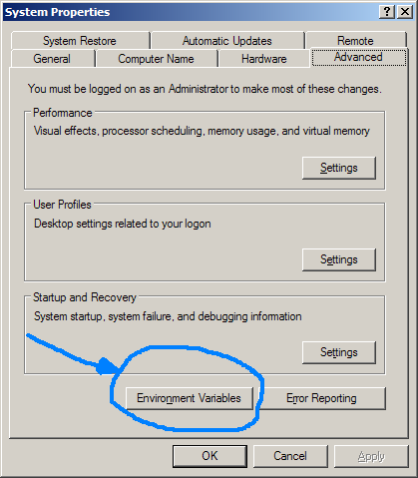
- The new ‘Environment Variables’ dialog box will appear.
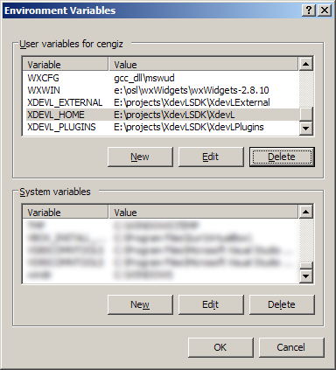
- Click on the ‘New’ button and add the 3 environment variables, XDEVL_HOME, XDEVL_PLUGINS and XDEVL_EXTERNAL with the correct folder names of your XdevLSDK installation.
- Click ‘OK’ and restart your Visual Studio.

Windows Vista/7

- Press ‘Windows + Pause/Break’. (open the “System Properties” Dialog box.)
- On the left side of the dialog box click on the ‘Advanced system settings’ link name. System Properties Dialog box appears. Select the Advanced Tabulator and click on the Environment Variables button.
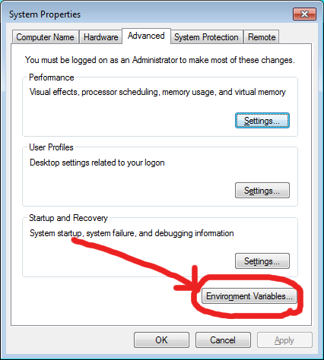
- The new ‘Environment Variables’ dialog box will appear.
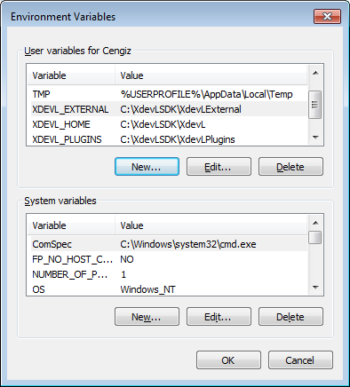
- Click on the ‘New’ button and add the 3 environment variables, XDEVL_HOME, XDEVL_PLUGINS and XDEVL_EXTERNAL with the correct folder names of your XdevLSDK installation.
- Click ‘Ok’ and restart your Visual Studio.

MacOS X
Not supported yet.

Programming
In this section I will show you how to start writing applications using the SDK.

Creating the core system
The first step you have to do is to create an instance of the core system. The core system is the heart of all XdevL applications. To do this you have different createCore functions in the xdl namespace. Here is one of them:

xdl_int createCore(xdl_int argc, xdl_char* argv[], const xdl_char* xmlFilename, XdevLCorePtr& core)

Parameters
argc: This is the argc value of the (C/C++) main function which is the number of arguments passed as the command line for the application.
argv: The argv value of the main function which is a char array holding the argument values.
xmlFilename: A null terminated string which is the file name of the core XML file.
core: A valid XdevLCorePtr object which will hold a valid instance of the core system.
Return
Returns ERR_OK if everything went fine or ERR_ERROR if an error occurred.
Remarks
You can set the first 3 parameters to null but I recommend to pass the command line values to the core because you can change the behavior of your application using the command line. Read more about that in the next section.
This function will create a valid instance of the XdevLCore system. If the function returns ERR_OK the valid instance will be in core. Here a short example how the shortest application can look like:
File: main.cpp
#include <XdevL.h>
int main(int argc, char** argv){
xdl::XdevLCorePtr core;
if(xdl::createCore(argc, argv, "main.xml", core) == xdl::ERR_ERROR){
return -1;
}
return 0;
}

File: main.xml
<?xml version="1.0" encoding="utf-8"?>
<XdevLProperties> </XdevLProperties>
What this example is doing is nothing special. Only creating the core system and shutting down again. The XML file is the same. We don't have specified any information. It is just an empty properties XML file for the core system.

Command line
The fact that you can forward the arguments of the (C/C++) main function to the core system (see createCore functions) gives you additional control about your application after compilation. The system will check which commands are specified and will change the behavior or the running application. You can specify the following commands.
- -cp path_to_the_corefile
Here you can specify where the system should search for the core plug-in. This is the XdevLCore-x.y.z file.
- -pp path_to_the_plugins
Here you can specify in which folder the core system should search for the additional plug-ins.
- -f xmlfile
If you want to use another main XML file and you don't want to compile your application new use this command.
- -v version_number
Here you can specify which version of the core plug-in you wanna use. This should be a 3-digit value separated by “.”. Here for example if you want use the XdevLCore-0.1.2 you should write “-v 0.1.2”)
Important Note: If you pass a command line request to the core system it will ignore some of the requests in the XML file. For example the “-v” command will ignore the “version” attribute of the “<XdevLProperties>” element. The “-f” command will ignore the “xmlFilename” parameter of the xdl::createCore functions.
Example:
Let's say you have compiled your application with the file name coolapp and you have created an new main XML ( newmain.xml) file and want to use that instead of the one you specified in the code. Furthermore your SDK contains a newer version of the XdevLCore plug-in (XdevLCore-0.2.1) and we want to use that instead of the default which has another number and which is in the local folder like our application. The command line to start our application with this properties would look like this:
./coolapp -f newmain.xml -v 0.2.1

XdevLCore log messages
If you start XdevLCore you will see messages on the console. Most of them will be just information’s about the plug-ins or the state of the system. But it will show if a problem is occurred during runtime.

Info Messages
If the system is sending a message the output format is like this:
Module name: Message

Error Messages
The ## at the beginning of a message marks an error which means something failed which can lead to stop the application. Here the output format:
## Module name: Function name: Line: Message
This may occur for example if you request to plug a plug-in which isn't in the file system.

Warning Messages
If something happens but doesn't really infect the procedure of the application you will see a warning message which is marked with !!. Here the format of the Warning:
!! Module Name: Function name: Line: Message
A warning may occur if you requested a feature (for example AntiAliasing in the XdevLOpenGL module) and the system doesn't support it.

The main core XML file
Before you start reading this section I recommend getting familiar working with XML files. You should at least understand what elements, attributes and the content of an XML file is. Check the wiki page http://en.wikipedia.org/wiki/Xml to get more information about this topic. Don't get to much afraid on doing this because XML files are pretty handy and is a standard file format. You have to learn it someday anyway.

Necessary elements for XdevLCore
Before you start the core system you may create a valid XML file which will be used to initialize the system. XdevLCore will use it to plug plug-ins, create modules and/or initialize them. Here is a minimum XML file snippet that you need to have a valid format for XdevLCore:
<?xml version="1.0" encoding="utf-8"?>
<XdevLProperties> </XdevLProperties>
The first line gives information about the XML file which means it's not XdevL related. The system will look for the "<XdevLProperties>" root element. You can use XML files but you don’t have to. But I recommend using them because it will make your life easier.
Important Note: The parsing of the XML file is case sensitive so be careful and check if you're using the names correct if something is not working.

“core_file” attribute
In the “<XdevLProperties>” element you can specify the "core_file" attribute which holds the name and path of the XdevLCore plug-in. If you specify it or not mean that the system will have a different behaviour to find the plug-in.
- If you don't specify this attribute explicitly the system will search in the local folder for the plug-in. If he can't find it there it will check the path specified in the XDEVL_HOME environment variable which can be set in the Operating System.
- If you specify this attribute it will look for the file name you used. If it can't find it the core system will return a error.
Note: The default file name for the XdevLCore depends on the static library (XdevL.a/XdevL.lib) you have used. For example if you have used the XdevLSDK version 0.1.1 the default value will be XdevLCore-0.1.1.

“version” attribute
Another element with the name “version” can be used to plug different version of the XdevLCore plug-in. The default name depends from the static library you have used. If you want to use a different core system you have to use this attribute. The syntax is a string with 3 digit values separated by “.”. Let’s say you want to use the version 0.1.1 of the core system your attribute would look like this:
<?xml version="1.0" encoding="utf-8"?>
<XdevLProperties version="0.1.1"> </XdevLProperties>

Attributes summary
In the following part you see all information about the XdevLProperties element in the core file.
Root element | XdevLProperties
Description | The root element of the XdevL system. You must specify this element otherwise the core system will not start.
Attributes | core_file, version
Child elements | -
Text field | -

Attribute | core_file
Description | Specifies the path and file name of the XdevLCore plug-in.
Value type | String
Value range | -
Default value | -

Attribute | version
Description | Specifies the version of the XdevLCore plug-in.
Value type | String
Value range | -
Default value | 0.1.0 for the XdevLSDK 0.1

How to plug new plug-ins into the XdevLCore system
Before you can do anything special with XdevL you have to plug plug-ins to the system. Either you do that manually using the XdevLCore::plug() function or you do that in the main XML initialization file. In this section I will show you how to use the last method. The extreme flexibility of the system comes from the plug-in written for it. You can tell XdevLCore where that plug-in is and which one of them he should plug. To plug a Plug-In, first you have to add the "<Plugins>" element in the "<XdevLProperties>" section in the main XML file. The core system will check this section which plug-ins he should plug by himself. Here is a snippet of the main XML file:
<?xml version="1.0" encoding="utf-8"?>
<XdevLProperties>
<Plugins>
<Plugin filename="../../XdevLPlugins/lib/XdevLOpenGL"> </Plugin>
</Plugins>
</XdevLProperties>
Now to plug a specific plug-in add the "<Plugin>" element into the "<Plugins>" section and use the filename attribute to tell the name of the plug-in. In the example above you can see how we plug the XdevLOpenGL plug-in into the core system.
Until now we have learned how to plug plug-ins. But the real functionality lies in the Modules itself. As we know, a plug-in is just a container for modules.
We have to instruct XdevLCore that he should create us a specified module within a plug-in and return a valid reference so we can use it. We can do that again manually using the xdl::createModule() function or via the main XML file. The next section will show you how to do that via the XML file.
Note:
Never use the extension of the plug-in file name. This means the real file name for example of the XdevLOpenGL plug-in is XdevLOpenGL.so or XdevLOpenGL.dll. Use only the name without the extension. The system will add the right one during the loading process.

How to create modules
Let's start with the OpenGL plug-in example. Add the "<Modules>" element into the "<XdevLProperties>" section. This instructs the core system that we are going to create modules. Here an example:
<XdevLProperties core_file="../../lib/XdevLCore">
<Plugins>
<Plugin filename="../../XdevLPlugins/lib/XdevLOpenGL"> </Plugin>
</Plugins>
<Modules>
<Module id="MyOpenGL" plugin_name="XdevLOpenGL" module_name="OpenGL"></Module>
</Modules>
</XdevLProperties>
And now if we want to create a module you have to add the "<Module>" element within the "<Modules>" section. You can see the "id" attribute. This is the id that will be used to identify this module in the core system. You will use this to get access to the real instance of this module. The next attribute "plugin_name" tells the core system the name of the plug-in. Do not mix the file name with the name of the plug-in. They are different things. For example the file name of a plug-in could be 'SuperPlugIn' but the internal plug-in name could be 'PlugInNumberOne'. The last attribute "module_name" as the names says is the name of the module which is in the plug-in. The plug-in and Module names should be provided the plug-in manufacturer.

Build in Interfaces and Plugins
The good thing is XdevL comes with build in plugins. You can use those in your application right away without adding it to the core system.

I/O Interfaces
To get access to I/O devices you can use the build in plugins XdevLKeyboardDevice, XdevLMouseDevice and XdevLJoystickDevice.
Before you can use them, which is a limitation at the moment of XdevL. One has to create a window and attach those devices to get a valid I/O device. In later implementation of those build in plugins this limitation will be hopefully eliminated. So let's start. Here are the steps you have to do to create a proper I/O device
- Create a XdevLWindowDevice
- Create an I/O device (XdevL/Keyboard/Mouse/Joystick/Device).
- Attach that I/O device to the window created in the first step.
So let's start creating a XdevLWindowDevice:
xdl::XdevLWindowDevice window = NULL;
window = xdl::createModule<xdl::XdevLWindowDevice*>(core, “XdevLWindowDevice”,
“XdevLWindowDevice”,
“MyWindowDevice”);
if(window == NULL){
std::cerr << “Can not create module.\n”;
return xdl::ERR_ERROR;
}

Keyboard I/O
Here we create a keyboard device and attach it to the window we created above.
xdl::XdevLKeyboardDevice keyboard = NULL;
keyboard = xdl::createModule<xdl::XdevLKeyboardDevice*>(core, “XdevLKeyboardDevice”,
“XdevLKeyboardDevice”,
“MyKeyboardDevice”);
if(keyboard == NULL){
std::cerr << “Can not create module.\n”;
return xdl::ERR_ERROR;
}
if(keyboard->attach(window)!= xdl::ERR_OK){
std::cerr << "Can not attach keyboard to the specified windows.\n”;
return xdl::ERR_ERROR;
}

Mouse I/O
Here we create a mouse device and attach it to the window we created above.
xdl::XdevLMouseDevice mouse = NULL;
mouse = xdl::createModule<xdl::XdevLMouseDevice*>(core, “XdevLMouseDevice”,
“XdevLMouseDevice”,
“MyMouseDevice”);
if(mouse == NULL){
std::cerr << “Can not create module.\n”;
return xdl::ERR_ERROR;
}
if(mouse->attach(window)!= xdl::ERR_OK){
std::cerr << "Can not attach mouse to the specified windows.\n”;
return xdl::ERR_ERROR;
}

Joystick I/O

Network Interfaces

Compiling XdevLDemos
If you have compiled the XdevLDemos all binaries will be in the XdevLDemos/bin folder. Because of the external dependencies like the audio_demo or the ogre_demo which needs OpenAL and OGRE installed on your system you have to do a little work by hand :).

WindowsXP/Windows Vista
In the XdevLExternal folder you find the sub folder lib/. There are a couple of dll's there. You have to copy the necessary dll's into the XdevLDemos/bin folder. For example for the ogre_demo you have to copy at least the OgreMain_d.dll OgreMain.dll into that folder. If you have installed these dll's into your system path PATH you don't need that step. Of course the demo itself will load additional dll's like
- RenderSystem_GL.dll, RenderSystem_GL_d.dll, Plugin_OctreeSceneManager.dll and Plugin_OctreeSceneManager_d.dll As you can see there are two types of each dll, one with the suffix _d and one without. It depends how you compile your program. If you're compiling in Debug mode the Application (XdevLOgre plug-in) will look for the _d version of the dll otherwise it will look for the version without the suffix.
Note:
Check this http://en.wikipedia.org/wiki/Library_(computing)Dynamic_linking page for more information about libraries and for more information about dll's check this http://en.wikipedia.org/wiki/Dynamic-link_library page.

Linux
For the demos you should have installed the OGRE, OpenGL and OpenAL packages. Another step to get the ogre_demo running you must write the right path where the plug-ins for OGRE are. For example in my Ubuntu 8.10 system it is in the /usr/lib/OGRE/ folder. In the ogre_demo.xml change the plug-in path into the right one. Something like this:
// Change from that:
<Plugin>Plugin_OctreeSceneManager</Plugin>
// into this:
<Plugin>/usr/lib/OGRE/Plugin_OctreeSceneManager</Plugin>

Interfaces, Plug-Ins and Modules

What are Interfaces?
An Interface (C++ pure virtual class) separates functions of external communication from the internal operation. This means the user should see and use only those functions which are really necessary. The real implementation is hidden and is stored as a Module (implementation) in a XdevL Plug-In.
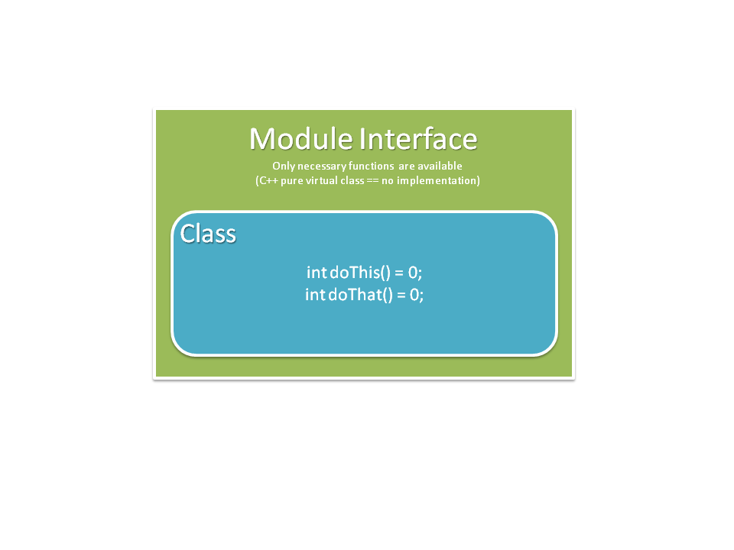

What are XdevL Modules?
In short a Module in XdevL is a C++ class which is the implementation of the Module Interface (see above). The Module developer implements the functionality but the user will never see this implementation and has only access to the functions which are defined by the Modules Interface. Mostly you are only interested in, for example playing a sound without the knowledge about the real programming of audio devices. What you just need is to play a sound.
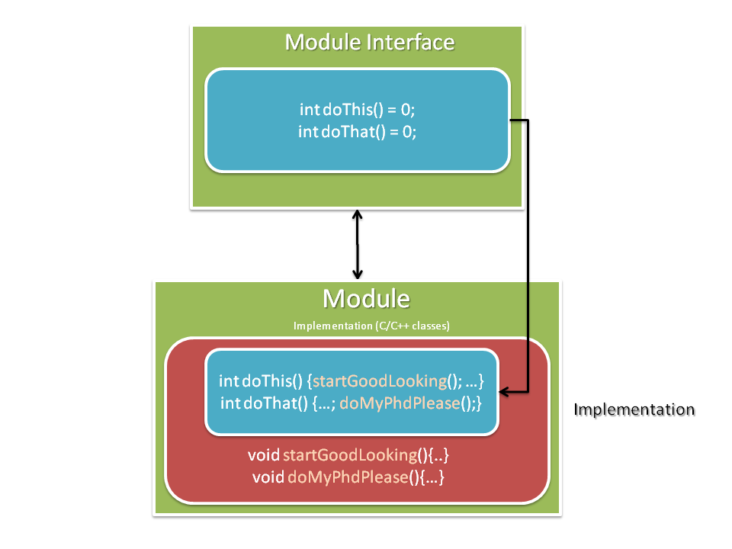
In this picture we see the blue part which is visible for the user. The red part is hidden and stored in the Module. If you request to create a Module a real instance of this class is created but is only accessible via the Modules Interface.

What is an XdevL Plug-In?
Plug-In's usually have the file extension *.so or *.dll (depends on the operating system and/or the compiler and yes they are not called plug-in's I know :) ) which can contain code, data and resources. These can be loaded dynamically (during run-time) and can be used in the host application. For our purpose it's enough to know that XdevL plug-in's contains the Modules (class declarations and definitions). You can see it in the image below. Those Modules have their own Interfaces which can be used by the user. The plug-in itself has an interface for the XdevLCore system.
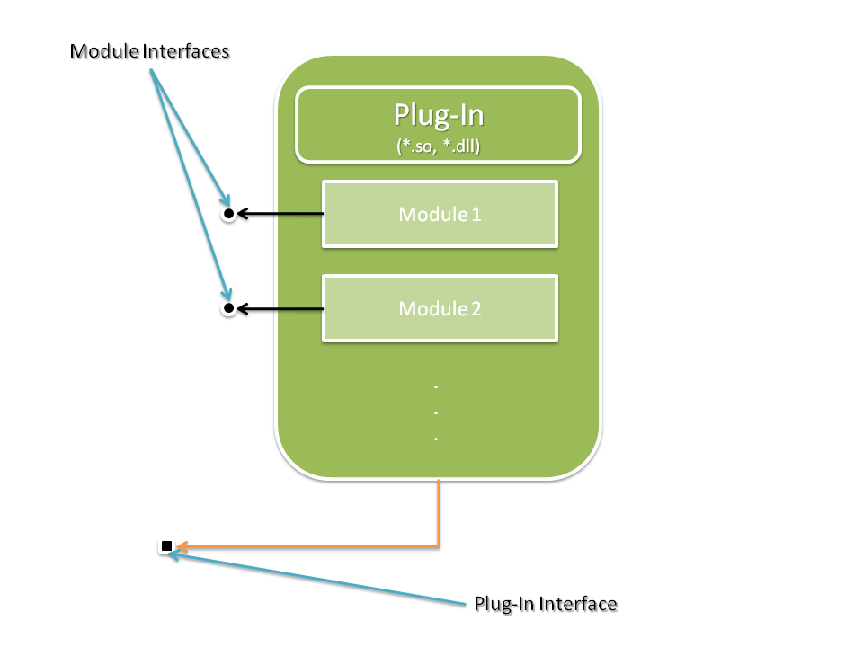

Plug-In development

Introduction
In this chapter I will show you how to develop your own plug-ins for XdevL. It's nothing complicated and it would be great if you provide your libraries as XdevL plug-ins to the community so that every user can benefit from it. Of course the most benefit is for you to have a well developed platform independent plug-in to work with. Before you start reading this section I recommend to read the section above to understand the plug-in and module terms in XdevL. At the beginning it is maybe it is a bit confusing but you will understand that the flexibility of this methods.

Integrating your existing library
All plug-ins must provide 3 functions to work with XdevLCore. They have predefined names. But first we have to include XdevLModule.h:
#include <XdevLModule.h>

In this header file we have all necessary You must define these functions:
// Will be called by the XdevLCore to initialize the plugin.
extern "C" XDEVL_EXPORT xdl::xdl_int _init_plugin(xdl::XdevLPluginCreateParameter* parameter);

// Will be called to shutdown the plugin.
extern "C" XDEVL_EXPORT xdl::xdl_int _shutdown_plugin();

// The XdevLCore system will use this function to create the module instances.
extern "C" XDEVL_EXPORT xdl::xdl_int _create(xdl::XdevLModuleCreateParameter* parameter);

// The XdevLCore system will use this functions to delege module instances.
extern "C" XDEVL_EXPORT void _delete(xdl::XdevLModule* obj);

// A function which returns the plug in information
extern "C" XDEVL_EXPORT xdl::XdevLPluginDescriptor* _getDescriptor();
The first one is used to create a module in a plug-in. For example if you have 2 modules you have to write your _create function so that it provides both modules in the same plug-in.
The second one deletes an already created module and the last one is to get information about the plug-in itself. OK, let's dig into the details of those functions in the next section.

_delete() function.
Let's start with the easiest one. Every created module within the plug-in must be deleted in the same plug-in again. Don't ask for details but on some platforms (OS or compiler) do strange things if you delete the object outside the plug-in (shared object, dynamic library).
The core system will call this function to delete the module if it isn't needed anymore. Because every module is derived from the XdevLModule class it is easy to make one delete method for all kind of modules. The delete function must look like this:
extern "C" XDEVL_EXPORT void _delete(xdl::XdevLModule* obj){
if (obj)
delete obj;
}

Important note: The descriptor of your class must be virtual. This is really important. To understand why you must learn more about programming in C++. Just be sure that your destructor starts with the virtual directive like this:
virtual ~myClassName();

_getDescriptor() function.
Every plug-in needs a plug-in descriptor. In terms of XdevL a plug-in is one file. Usually the file name ends with the extension .so or .dll. On other system it's called shared object or dynamic library.
The core system gets information from the descriptor to manage plug-in's and modules. For example if the user gives the core system the request to update the plug-ins, it will check the patch level of the plug-ins to get the newer one (this will work in later releases of XdevLCore).
Let's have a look at the descriptor xdl::XdevLPluginDescriptor. There are 4 functions.
- xdl::XdevLPluginDescriptor::getName() Returns the name of the plug-in. XdevLCore distinguish plug-ins not over the file extension but rather this returned name.
- xdl::XdevLPluginDescriptor::getNumModules() Returns the number of modules embedded in the plug-in.
- xdl::XdevLPluginDescriptor::getModuleName() Returns the name of a specified module. It's in relation with the getNumModules() function. :).
- xdl::XdevLPluginDescriptor::getVersion() Returns the version of the plug-in. XdevLCore uses this to compare the patch level. If the user specifies to download a new version of the plug-in it will use this. XdevL 0.1 doesn't support this feature.
You have to derive your plug-in descriptor from the xdl::XdevLPluginDescriptor. This would look like this:

static const XdevLString pluginName = {"Plugin Name"};
static const XdevLString vendor = {"Vendor Name"};
static const XdevLString author = {"Author Name"};
static const XdevLString copyright = {"Copyright Holder"};
static const std::vector<XdevLModuleName> moduleNames = {
XdevLModuleName("MyXdevLModuleName")
};
XdevLPluginDescriptor pluginDescriptor {
pluginName,
moduleNames,
PluginsMajorVersion,
PluginMinorVersion,
PluginPatchVersion
};
Fill in the values for your plug-in. That's all. The _getDescriptor() functions should return the pointer to the descriptor instance. You can define a instance in your *.cpp code which would look like this:
static MyXdevLPluginDescriptor myXdevLPluginDescriptor;

.
.
.

extern "C" XDEVL_EXPORT xdl::XdevLPluginDescriptor* _getDescriptor(){
return &m_myXdevLPluginDescriptor;
}

Design your Interface
The time is right to design your interface for your library. Let's say you have a C++ library with three functions and looks like this:
class MyLibrary{
public:
MyLibrary();
~MyLibrary();

int cleanData();
void startCalculation();
void showResult();
};

The first thing you have to do is to decide which functions the user should use to work with your library. For example, you are using the cleanData() internally this means maybe in the startCalculation function. You don't have to call this function explicitly. This means this is something which is not suited as an interface function. But you know that startCalculation() and showResult() are function which all users must use. These two functions are suitable for the interface class. The following code shows how the interface class would look like:
class MyLibraryInterface{
public:
virtual ~MyLibraryInterface() {};

virtual void startCalculation() = 0;
virtual void showResult() = 0;

};

You see that the destructor and the other functions are virtual. This is very important. You can see furthermore that the destructor is already defined (because of {}). This is important too. You have to do it in the same way. And the suspicious =0; thing makes our interface pure virtual. This is important too.
Conclusion: Just add functions into your plug-in interface class which should be used by the user. Don't add functions which are used internally in your library itself. Make a nice and easy to use interface so that everyone can understand it if you provide your plug-in or not.

Creating the module class
Now change your class and derive it from the created XdevLModule class and use your interface as the template parameter, here how it looks like:
#include <XdevLPluginImpl.h>

class MyLibrary : public XdevLModuleImpl<MyLibraryInterface> {
public:
MyLibrary();
virtual ~MyLibrary();

int cleanData();
virtual void startCalculation();
virtual void showResult();
};

You will see that you can't create an instance of the MyLibrary class because you have to declare and define a couple of function. First you have to change your constructor. You should pass the XdevLModuleCreateParameter object to the XdevLModuleImpl constructor.
...
MyLibrary(XdevLModuleCreateParameter* parameter) : XdevLModuleImpl(parameter) {...}
~MyLibrary();

There are a couple of function you can derive in your class to override the XdevLModule or XdevLModule class default functions. The default functions are doing nothing. But they will called sometimes from the XdevLCore system. For example all Modules have to XdevLModule::init() and XdevLModule::shutdown() methods. Every time XdevLCore creates a module it calls the XdevLModule::init() function and every time it deletes a module it calls the XdevLModule::shutdown().
But there is one function you have to add is the XdevLModule::getDescriptor(). This returns the modules descriptor which must be declared. How you do that is up to you but first here an example structure of that descriptor which must be derived from XdevLModuleDescriptor:
// This class describes your module
class MyXdevLModuleDescriptor : public XdevLModuleDescriptor {
public:
virtual ~MyXdevLModuleDescriptor() {}
// Should return the vendor name.
virtual const xdl_char* getVendor() const {
static xdl_char vendor[] = "Your vendor name";
return vendor;
}
// Should return the author name.
virtual const xdl_char* getAuthor() const {
static xdl_char author[] = "Your name";
return author;
}
// Should return the module name.
virtual const xdl_char* getName() const {
static xdl_char name[] = "ModuleName";
return name;
}
// Should return the copyright.
virtual const xdl_char* getCopyright() const {
static xdl_char copyright[] = "(c) 2xxx by me";
return copyright;
}
// Should return a short description.
virtual const xdl_char* getDescription() const {
static xdl_char description[] = "This is a cool XdevL module-";
return description;
}
// Should return the version of your plugin.
virtual void getVersion(xdl_int* major, xdl_int* minor, xdl_int* patch) {
*major = 1;
*minor = 0;
*patch = 0;
}
};

Fill your stuff into the necessary fields. Till here we have just declared our descriptors. You can create a static instance of the descriptor which would look like this:
class MyLibrary : plublic XdevLModuleImpl<MyLibraryInterface> {
public:
MyLibrary();
virtual ~MyLibrary();

static MyXdevLModuleDescriptor m_myModuleDesc;

int cleanData();
virtual void startCalculation();
virtual void showResult();

virtual XdevLModuleDescriptor* getDescriptor() const {
return &m_myModuleDesc;
}
};

You see the getDescriptor() function and it returns only the pointer of the descriptor.

_create() function.
Every time the user creates a module the XdevLCore system looks for the necessary plug-in and looks for the _create function. In this function an instance of the specified module is created. Here a really small "Hello, Plug-in!" example.
extern "C" XDEVL_EXPORT int _create(xdl::XdevLModuleCreateParameter* parameter) {
// Here we create the instance of our class
xdl::XdevLModule* obj = new xdl::MyModule();
if (!obj)
return xdl::ERR_ERROR;

// Now we set the pointer into the parameter. This will be used in the XdevLCore system.
parameter->setModuleInstance(obj);

// Ok we are finished.
return xdl::ERR_OK;
}

As you can see, first we create the instance of the XdevLModule. After that we use the “parameter” parameter from the _create function. We have to set the instance we have created to the parameter with the setModuleInstance() function.
parameter->setModuleInstance(obj);

Now we can return xdl::ERR_OK if everything went smoothly or return a module or plug-in specific

Version Numbering
XdevL's version number has 3 digit numbers: 'major'.'minor'.'patch'
- The 'major' level can have a completely new API architecture and isn't compatible with other 'major' level versions.
- The 'minor' level has additional API functions but the old ones aren't changed.
- The 'patch' level is only a bug fixed version. No API changes are done.
The 0.'x'.'y' series is a special version and will have some changes in the architecture and API.
Here some additional information that can be with the version number:
- Alpha: A really early stage of the library.
- Beta: It's for testing purposes only.
- RC: Release Candidate
- Release: Final version.
- Patch: Only changes in the patch level.
Here an example: XdevLSDK Beta 0.1.2
This is a beta testing version with bug fixes included.

Trouble Shooting
If you have problem under GNU/Linux systems with 64-bit you can try to do the following:
sudo apt-get install libc6-dev-i386

Acknowledgments
XdevL is using Open Source projects. This is the reason why I want to give thanks to all Open Source developers out there.
Here are the projects which are used within the whole XdevLSDK:

The OpenGL Extension Wrangler Library (GLEW)
This project is used in the XdevLOpenGL plug-in. Without this project it would be a pain in the neck to initialize all extensions of different OpenGL versions. Thanks a lot.

SDL2
Thx a lot. The basic functionality was done by using SDL2 (which is a cross platform programming framework too). In later releases of XdevL those plugins will be replaced by native ones.

OGRE
Of course a big thanks to the OGRE team. This project is used in the XdevLOgre plug-in. It's a really, really big and awesome project. I love it.

TinyXML
Furthermore other thanks to the TinyXML project. XdevL is using TinyXML for everything which handles with XML files. I love this project too☺.
I love the idea of the FSF because it gives me the freedom to choose, to learn and make great and better applications with my and the experience of other people. Furthermore I love the idea that maybe someone can benefit and learn from my projects in the same way.

Trouble shooting
Debugging using GDB can be in a 64-bit environment tricky. So if you have problems try this:
LD_PRELOAD=/lib/x86_64-linux-gnu/libpthread.so.0
So the main meaning is to pre-load the pthread library to prevent problems.

