Readme file from Zhihao Wang(zwang238)
- Server was created to host a auction
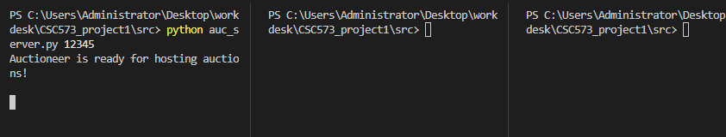
- Client 1 connected as Seller with its role prompt
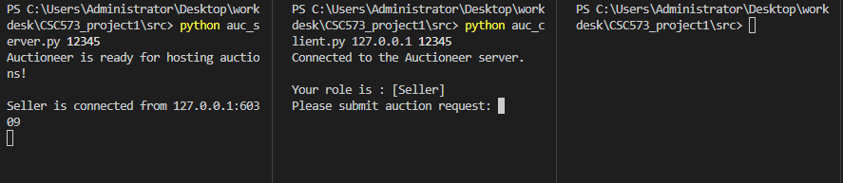
- Client 2 tried to connected during Seller process and shows waiting and close the connection
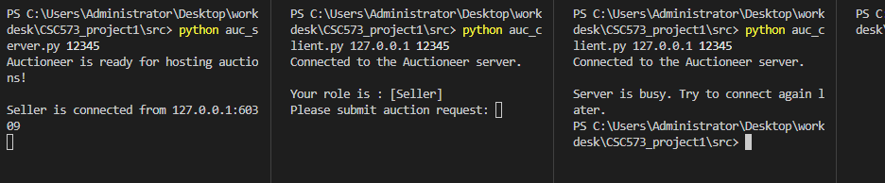
- Seller sends incorrect auction request
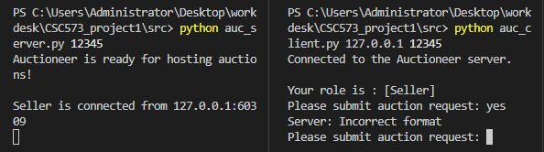

- Seller sends correct auction request and seller receives Auction Start prompt
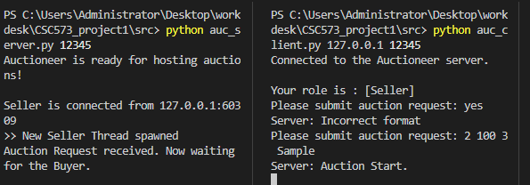
- Buyer 1 is created with role prompt and waiting signal
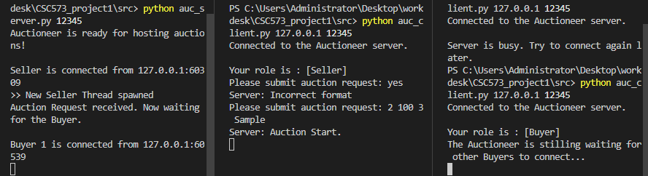
- Buyer 2 is created with role prompt and waiting signal
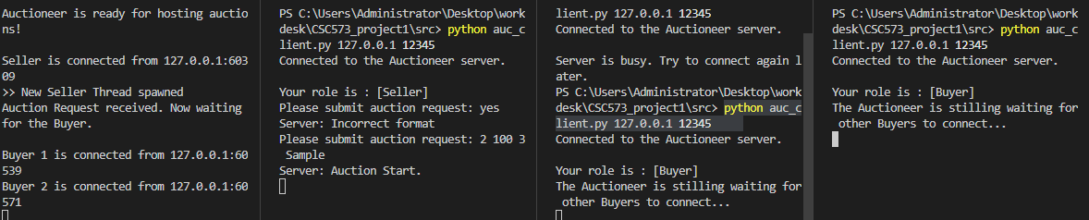
- Buyer 1-N is created with role prompt and waiting signal, and Buy N doesn’t have waiting signal. After that, all buyers receive bidding start prompts
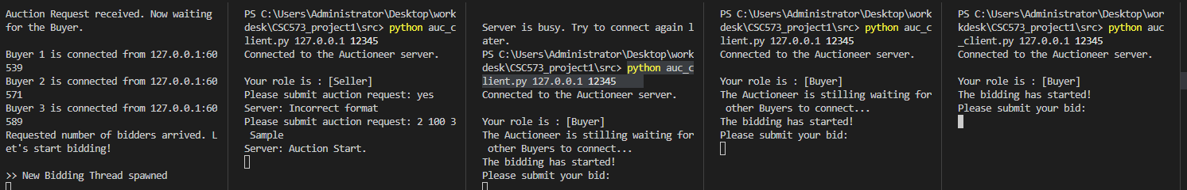

- Another client tries to connect during bidding and shows error message
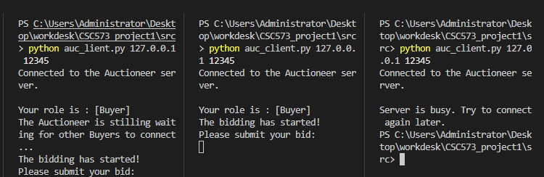
- Buyers try different values and receive feedback, if returns an error message, will ask for one more input
And for those clients have finished bid inputting will show the waiting message.
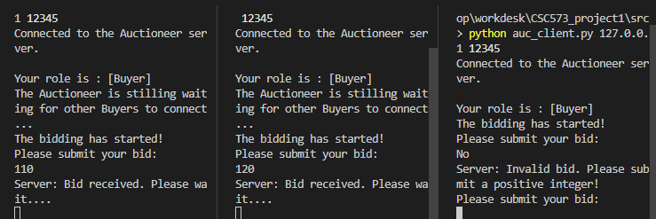
- Auctioneer (internally) displays all bids and auction
- And seller will receive the auction result(hear it is second price)
- Buyers receive auction result as well.
- All sockets are closed.
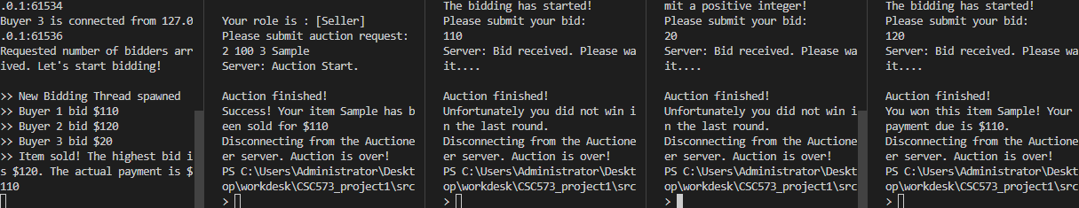
- Another round with a different auction type works
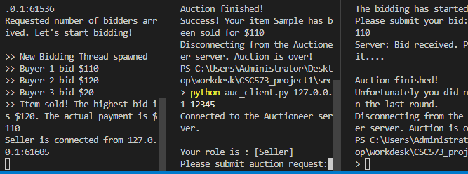
- If price is less than min price, the item will not be sold
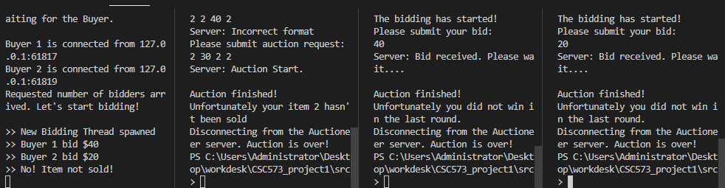

- Detailed description on how to compile
Usage: python auc_client.py <#ip> <#port>
Usage: python auc_server.py <#port>

EXTRA CERDIT:
- To know the true valuation of each Buyer: A second-price auction is better since it encourages truthful bidding.
- In a first-price auction, the highest bidder wins the item and pays the price they bid.Bidders will typically shade their bids below their true valuation. That's because they want to pay less than their valuation to ensure a positive utility, but they also want to outbid others. However, In a second-price auctionBidders have an incentive to bid their true valuations. Here's why: If a bidder bids below their valuation and loses to a bid that was still below their valuation, they would regret not bidding truthfully. If they bid above their true valuation and win, they risk paying more than the item is worth to them. But if they bid their true valuation, they either win and pay less than or equal to what it's worth to them or lose without any regret.
In all, to sell the item for a reasonable price: A second-price auction ensures that the item is sold for the highest bid of the 'losing' bidders. This is likely a reasonable price because it reflects the valuation of the highest-valued buyer who didn't win.
- Assume Buyer A has a true valuation of $110 and Buyer B has a valuation of $150. B will be the winner and pay the price of 100. its utility will be 150-110 = 40.
If b​>v​, it doesn't increase their chances of winning, but they risk overpaying.
If b​<v​ and they win, they'll pay the second-highest bid which could be less than v​ but more than b. But they would regret not bidding their true valuation if the second-highest bid is between b​ and v​.
If b​=v​, and they win, they'll pay the second-highest bid, which is less than their valuation, maximizing their utility.
