Homework 0-7 · Code Grading with LLM-as-a-Judge
代码仓库：https://github.com/wangz61/code-grading-llm-judge
流程：Label Studio 标注参考答案 → 与模型输出合并为 JSONL → OpenAI Evals（model-graded，gpt-4.1 作评委）按 1–5 分评分 → 重复运行 5 次，计算平均分、方差与不确定性，并用单元测试实际运行代码做对照。

1. 需求对照
作业要求 | 实现
Label hw0-07_inputs.csv using Label Studio | pip install label-studio，本地启动；新建项目并导入 5 道题（图 1–5）
Define labeling interface | labelstudio/label_config.xml：显示题目；ideal 多行文本框填写参考答案（必填）；difficulty 单选 easy/medium/hard
Export the file as json file | Label Studio 导出 JSON（labelstudio/export.json，图 6）
Read the output of existing model | convert.py 读取 hw0-07_inputs_model_output.csv（含多行代码单元格）
Create the JSONL by merging the two files | 按任务顺序合并；校验条数、题目文本与函数名一致；输出 data/samples.jsonl
Format: input / ideal / sampled | 每行恰好这三个键（见 3 节）
Design a prompt with the scoring system 5–1 | evals_registry/modelgraded/code_grading.yaml：rubric 5 fully correct … 1 incorrect，先推理再给分（cot_classify）
Create an eval config and run the evaluation | evals_registry/evals/code-grading.yaml；oaieval gpt-4.1-chat code-grading（图 7）
Interpret results (mean, variance, uncertainty) | analyze.py：5 次运行，平均分、题间方差、评委方差、标准误、t 与 bootstrap 95% 置信区间（图 8、5 节）

2. Label Studio 标注
标注界面定义（labelstudio/label_config.xml）：
<View>
<Style>
.task { font-size: 16px; font-weight: 600; padding: 8px 12px; background: #f4f6fa; border-radius: 6px; }
.lsf-textarea, textarea { font-family: Consolas, monospace; }
</Style>
<Header value="Programming task (input)"/>
<View className="task">
<Text name="input" value="$input"/>
</View>
<Header value="Reference solution (ideal): a correct, idiomatic Python implementation"/>
<TextArea name="ideal" toName="input" rows="8" editable="true" maxSubmissions="1" required="true"
placeholder="def ..." showSubmitButton="false"/>
<Header value="Difficulty"/>
<Choices name="difficulty" toName="input" choice="single" showInline="true" required="true">
<Choice value="easy"/>
<Choice value="medium"/>
<Choice value="hard"/>
</Choices>
</View>
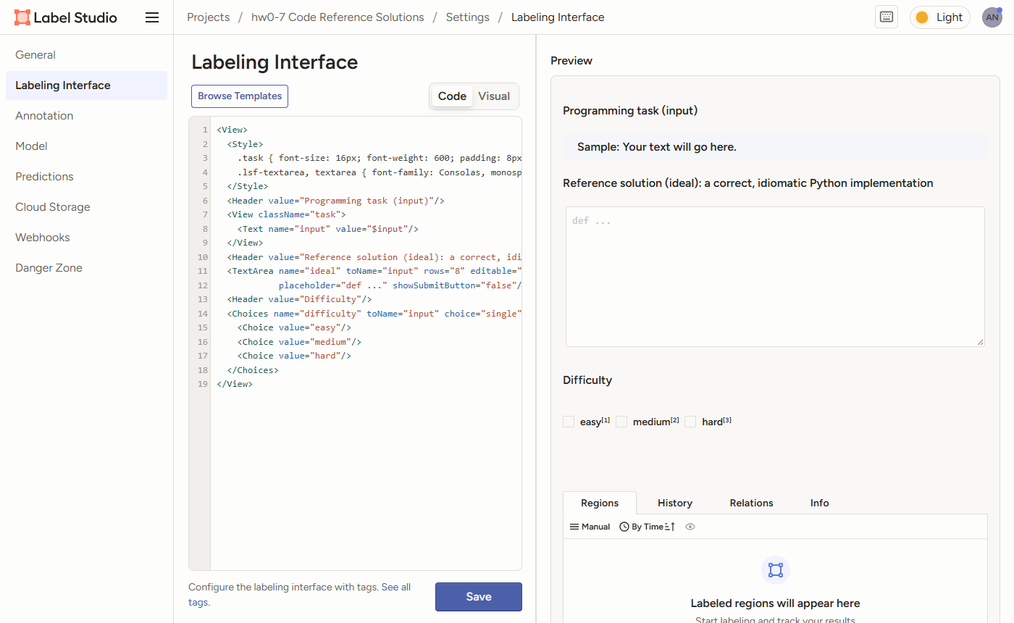
图 1 项目设置中的标注界面（Code 视图 + 预览）
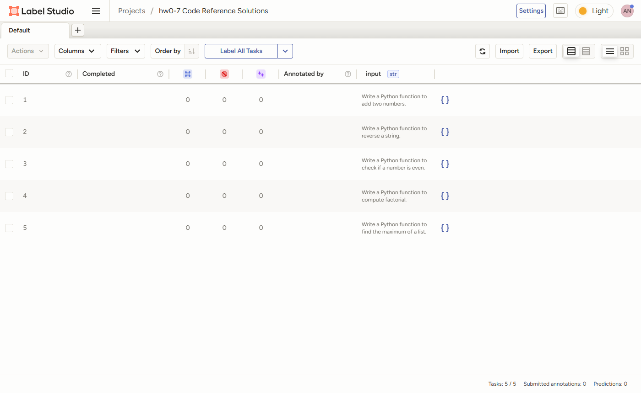
图 2 导入 hw0-07_inputs.csv 后的 5 个任务
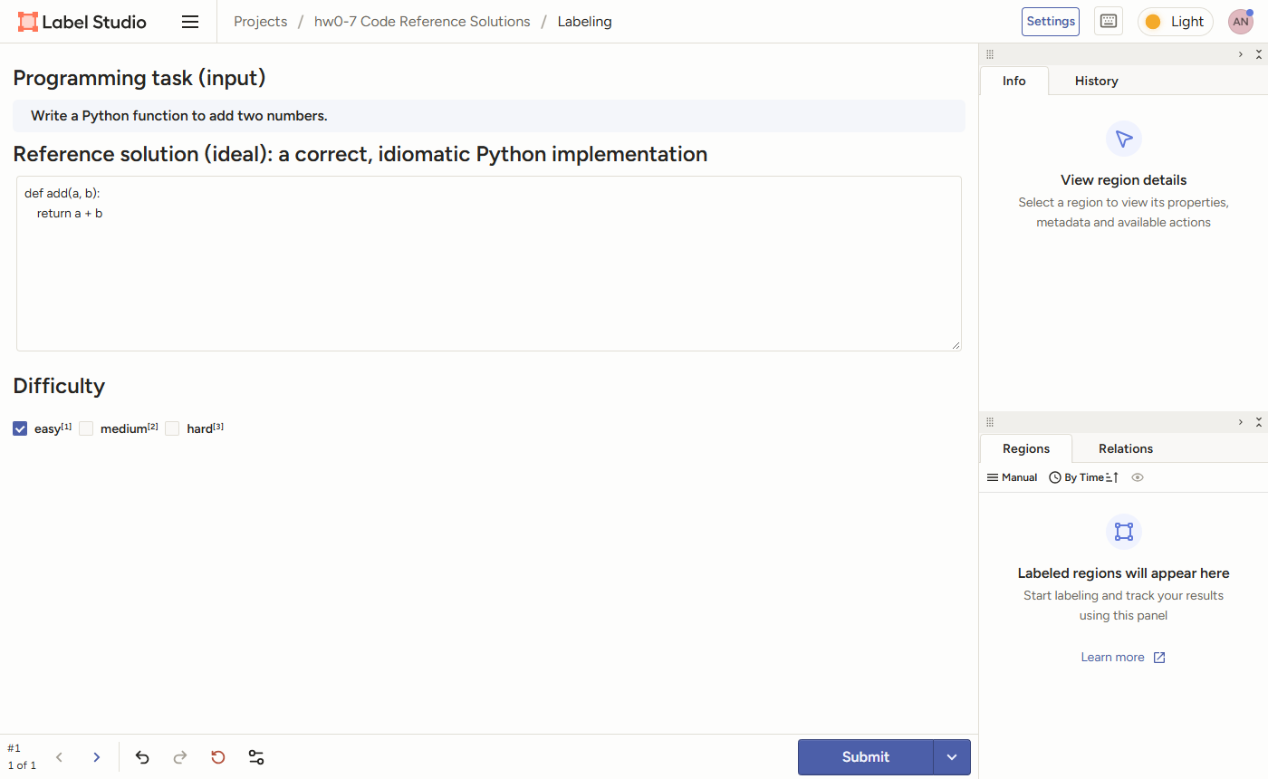
图 3 标注第 1 题：填写参考答案、选择难度，然后 Submit
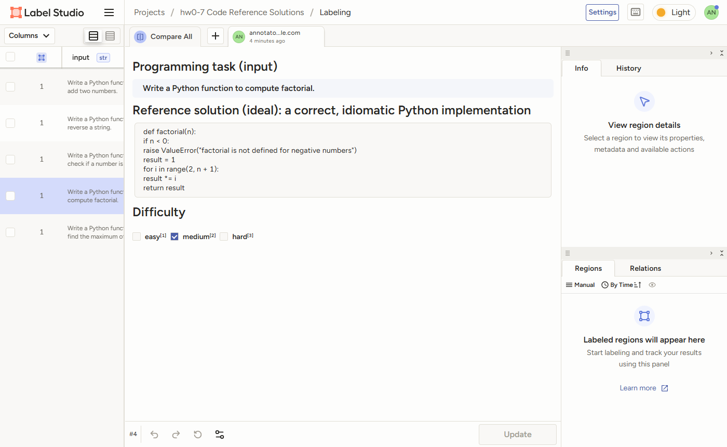
图 4 已提交的 factorial 标注（界面显示时不保留缩进，导出的 JSON 中保留）
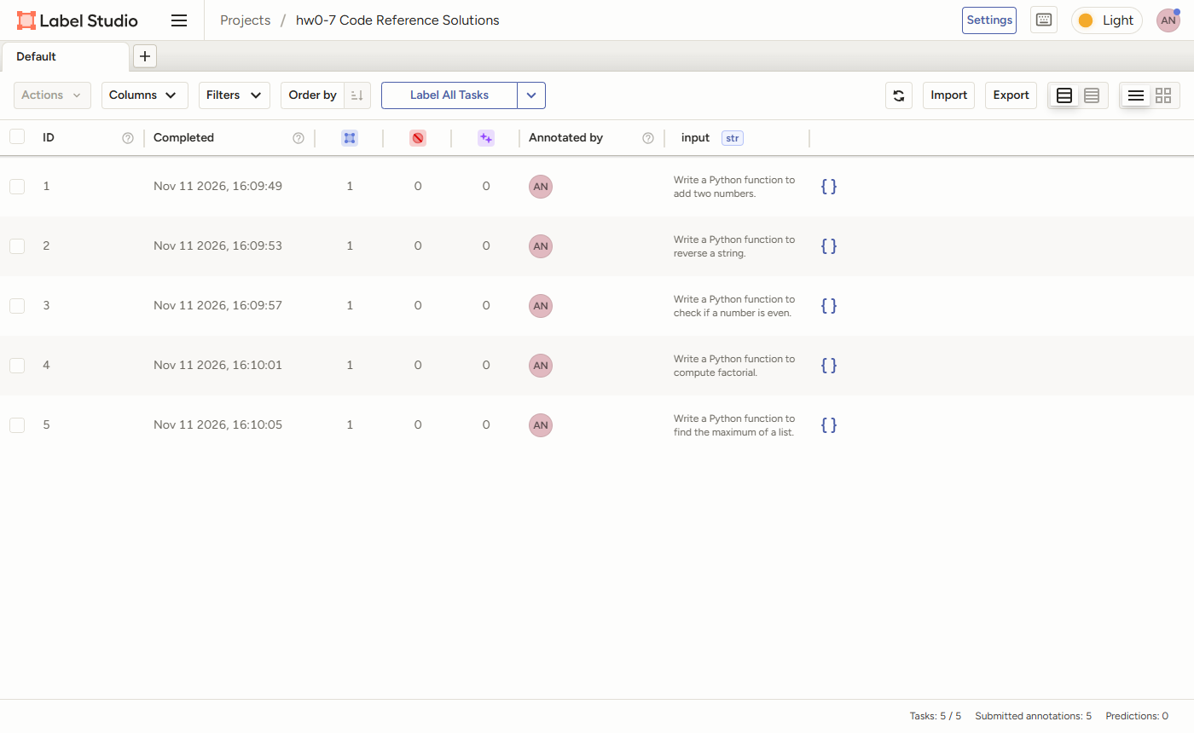
图 5 5 个任务全部完成标注
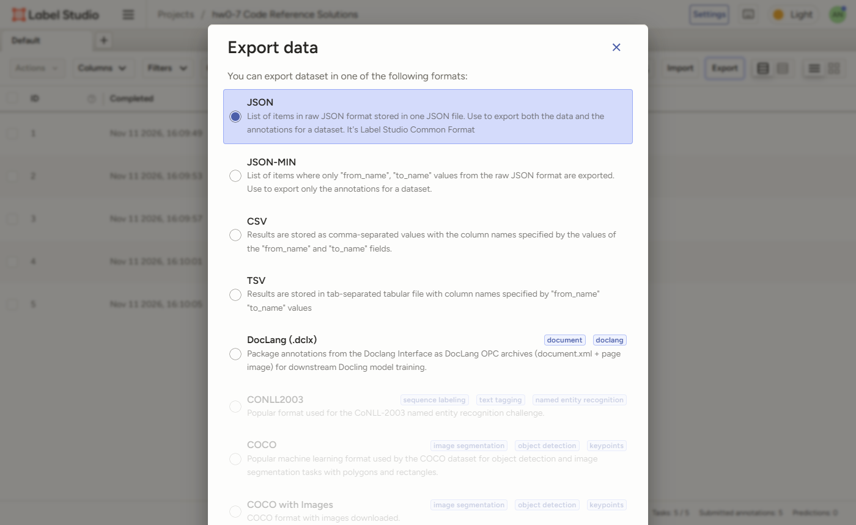
图 6 Export → JSON
参考答案由 Claude 编写，并在 Label Studio 界面中逐条填写提交（labelstudio/annotate_ui.py 驱动浏览器完成与人工相同的操作）。导出 JSON 中一条任务的结构（节选）：
{
"id": 4,
"data": {
"input": "Write a Python function to compute factorial."
},
"annotations": [
{
"result": [
{
"value": {
"choices": [
"medium"
]
},
"id": "1PbdiWB6Ak",
"from_name": "difficulty",
"to_name": "input",
"type": "choices",
"origin": "manual"
},
{
"value": {
"text": [
"def factorial(n):\n if n < 0:\n raise ValueError(\"factorial is not defined for negative numbers\")\n result = 1\n for i in range(2, n + 1):\n result *= i\n return result\n"
]
},
"id": "HWYWXRX9aK",
"from_name": "ideal",
"to_name": "input",
"type": "textarea",
"origin": "manual"
}
]
}
]
}

3. 合并为 JSONL
python convert.py：读取导出 JSON 中每个任务最新一次未取消的标注，取出 ideal；按顺序与模型输出 CSV 的 sampled 合并。合并前检查：条数一致、导出的题目与 hw0-07_inputs.csv 一致、ideal 与 sampled 定义的函数名相同。结果 data/samples.jsonl：
{"input": "Write a Python function to add two numbers.", "ideal": "def add(a, b):\n return a + b", "sampled": "def add(a, b): return a + b"}
{"input": "Write a Python function to reverse a string.", "ideal": "def reverse_string(s):\n return s[::-1]", "sampled": "def reverse_string(s):\n return ''.join(reversed(s))"}
{"input": "Write a Python function to check if a number is even.", "ideal": "def is_even(n):\n return n % 2 == 0", "sampled": "def is_even(n):\n if n % 2 == 0:\n return True\n else:\n return False"}
{"input": "Write a Python function to compute factorial.", "ideal": "def factorial(n):\n if n < 0:\n raise ValueError(\"factorial is not defined for negative numbers\")\n result = 1\n for i in range(2, n + 1):\n result *= i\n return result", "sampled": "def factorial(n):\n result = 1\n for i in range(1, n):\n result *= i\n return result"}
{"input": "Write a Python function to find the maximum of a list.", "ideal": "def find_max(nums):\n if not nums:\n raise ValueError(\"find_max() of an empty list\")\n largest = nums[0]\n for x in nums[1:]:\n if x > largest:\n largest = x\n return largest", "sampled": "def find_max(nums):\n return sorted(nums)[0]"}

4. 评分提示词与 Eval 配置

4.1 评分提示词（modelgraded spec）
要点：角色设定；按行为而非与参考答案的相似度评分；要求在典型输入和题目隐含的边界情况上手动追踪代码；不因题目未要求的输入校验、类型标注扣分；5 档 rubric；两档之间犹豫时取低分。eval_type 为 cot_classify，Evals 会在提示词后要求模型先逐步推理，最后单独一行输出 1–5。input_outputs: {input: sampled} 表示样本中已有输出，Evals 不再生成，直接评分。
code_grading:
prompt: |-
You are a senior Python engineer grading solutions to short programming exercises. Your grades are used to measure how well a model writes code, so be consistent and strict about correctness.
Task: decide how correct the submitted solution is, using the reference solution as one example of a correct answer.
[BEGIN DATA]
************
[Task]: {input}
************
[Reference solution]:
{ideal}
************
[Submitted solution]:
{sampled}
************
[END DATA]
How to judge:
- Judge behaviour, not similarity. A submission that uses a different approach from the reference but returns the right result for every valid input is fully correct.
- Trace the submitted code on a few typical inputs and on the edge cases the task implies (for example 0 or 1 for factorial, an empty or one-character string, negative numbers). Compare the results with what the task asks for.
- Only consider what the task asks for. Do not lower the grade for missing input validation, type hints or docstrings that the task did not request.
Scoring rubric:
5 - fully correct: correct result for all valid inputs, including the implied edge cases; clear code.
4 - correct, minor issues: correct results, but with a minor weakness such as needless verbosity, avoidable inefficiency or unidiomatic style.
3 - partially correct: correct for typical inputs but wrong for an implied edge case, or only part of the task is done.
2 - major issues: the approach is related to the task, but a bug (for example an off-by-one error) makes most results wrong.
1 - incorrect: does not solve the task: computes something else, cannot run, or is missing.
If you are torn between two grades, choose the lower one.
choice_strings: "12345"
choice_scores:
"1": 1
"2": 2
"3": 3
"4": 4
"5": 5
input_outputs:
input: sampled

4.2 Eval 注册
code-grading:
id: code-grading.dev.v0
description: Grade model-written Python functions from 1 to 5 against a human reference solution, with an LLM judge.
metrics: [score]
code-grading.dev.v0:
class: evals.elsuite.modelgraded.classify:ModelBasedClassify
args:
samples_jsonl: code_grading/samples.jsonl
modelgraded_spec: code_grading
eval_type: cot_classify
eval_kwargs:
temperature: 0
max_tokens: 1024
# Same eval with the judge sampled at temperature 1, to measure how much the judge's own randomness moves the scores.
code-grading-t1:
id: code-grading-t1.dev.v0
description: code-grading with the judge at temperature 1 (judge-variance study).
metrics: [score]
code-grading-t1.dev.v0:
class: evals.elsuite.modelgraded.classify:ModelBasedClassify
args:
samples_jsonl: code_grading/samples.jsonl
modelgraded_spec: code_grading
eval_type: cot_classify
eval_kwargs:
temperature: 1
max_tokens: 1024
# Evals only routes model names it already knows to the chat endpoint, so gpt-4.1 is registered explicitly.
gpt-4.1-chat:
class: evals_ext:ChatCompletionFn
args:
model: gpt-4.1

4.3 运行
单次运行：PYTHONPATH=. oaieval gpt-4.1-chat code-grading --registry_path evals_registry --record_path results/run.jsonl。run_eval.py 把它重复 5 次（--seed 1…5），每次的记录文件保存在 results/runs/<eval>/run_N.jsonl。
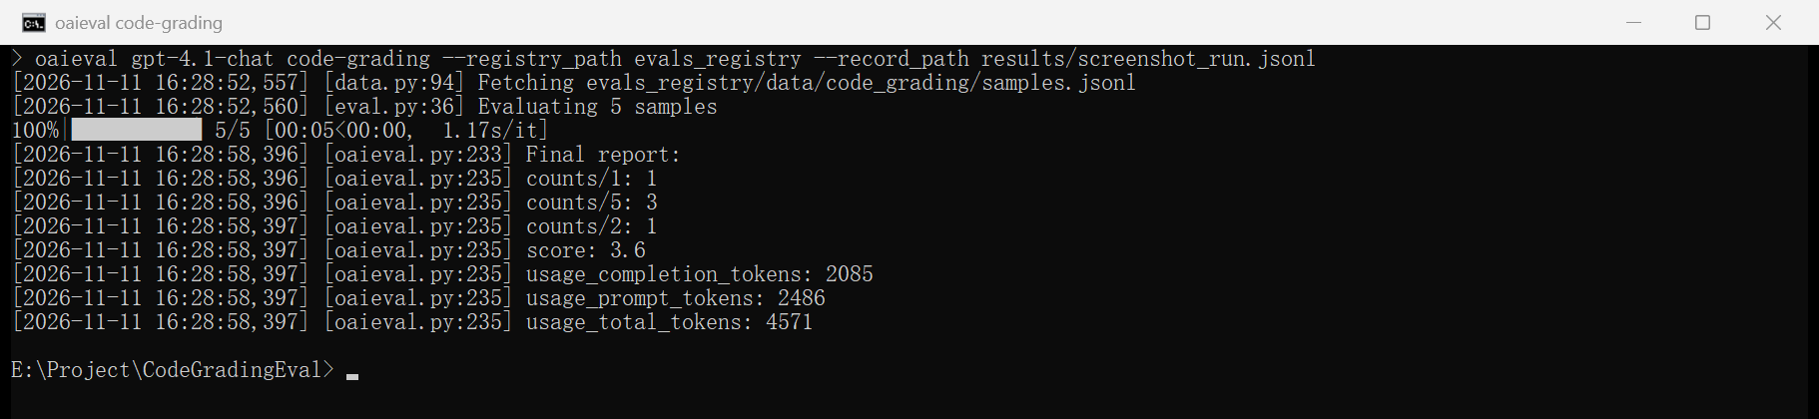
图 7 oaieval 运行结果（Final report：score 为 5 题平均分）
为在 Windows 和新版 openai SDK 上运行做了三处兼容处理：gpt-4.1 不在 Evals 的已知模型列表中，会被发到旧的 completions 接口，因此注册为 chat 完成函数（evals_ext.ChatCompletionFn）；Evals 汇总 token 用量时无法处理新版 SDK 的嵌套 *_details 字段，替换为只累加整数字段；blobfile 不接受 E:\ 这类盘符路径，记录路径改用相对路径。均不影响评分。

5. 结果与解读
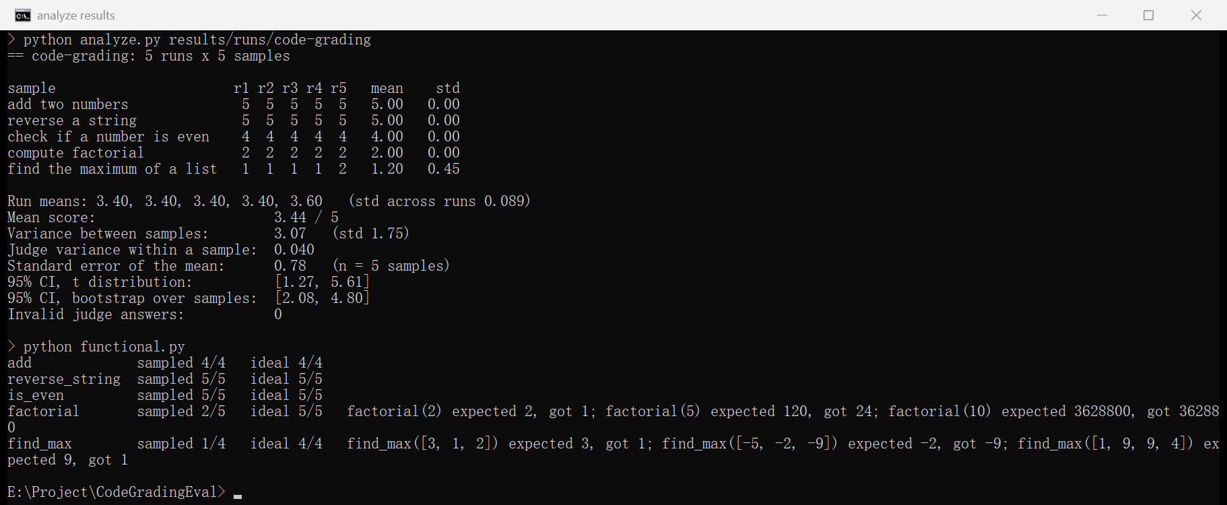
图 8 5 次运行的统计与单元测试对照
指标 | 评委 temperature 0 | 评委 temperature 1
平均分 | 3.44 / 5 | 3.48 / 5
题间方差（标准差） | 3.07（1.75） | 2.85（1.69）
同一题跨运行的评委方差 | 0.040 | 0.060
各次运行平均分 | 3.4, 3.4, 3.4, 3.4, 3.6 | 3.6, 3.4, 3.6, 3.4, 3.4
平均分的标准误（n = 5 题） | 0.78 | 0.76
95% CI（t 分布） | [1.27, 5.00]（上限截到 5） | [1.38, 5.00]
95% CI（bootstrap） | [2.08, 4.80] | [2.16, 4.80]
无效回答 | 0 | 0

题目 | 评委分数 r1–r5 | 单元测试（sampled） | 原因
add | 5 5 5 5 5 | 4/4 | 正确
reverse_string | 5 5 5 5 5 | 5/5 | 正确，写法与参考答案不同
is_even | 4 4 4 4 4 | 5/5 | 结果正确，但 if/else 包装布尔值，略冗长
factorial | 2 2 2 2 2 | 2/5 | range(1, n) 少乘 n，只有 0! 和 1! 正确
find_max | 1 1 1 1 2 | 1/4 | sorted(nums)[0] 返回最小值

• 平均分 3.44 掩盖了两极分布：3 个正确（4–5 分、测试全过），2 个错误（1–2 分）。题间方差 3.07 很大，平均分本身不代表任何一题。
• 不确定性主要来自题目太少，而不是评委。重复评分 5 次，平均分只在 3.4–3.6 之间波动（标准差 0.09），评委方差只有 0.04；但只有 5 道题，平均分的标准误 0.78，95% 置信区间宽约 3 分。要缩小区间，需要更多题目，多跑几次没用。
• temperature 0 也不完全确定：find_max 有 1 次得 2 分；截图那次额外运行中 is_even 得了 5 分。两处都在 rubric 的边界上：sorted(nums)[0] 只差一个下标（应为 [-1]），评委有时认为是「思路相关但有 bug」（2），有时是「算的是别的东西」（1）；if/else 是否算「小问题」也是主观判断。改进办法：在 rubric 里给边界情况举例，或多次评分取中位数。
• 评委与规则检查一致：测试全过的得 4–5 分，大多数测试失败的得 1–2 分。按单元测试的通过率是 3/5。

5.1 评委推理示例（find_max，第 1 次运行）
ness for typical input**:
- For `nums = [1, 2, 3]`, `sorted(nums)` is `[1, 2, 3]`, so `sorted(nums)[0]` is `1`. The maximum should be `3`. This is incorrect.
- For `nums = [5, 2, 9, 1]`, `sorted(nums)` is `[1, 2, 5, 9]`, so `sorted(nums)[0]` is `1`. The maximum should be `9`. This is incorrect.
2. **Correctness for edge cases**:
- For a single-element list, e.g., `[7]`, `sorted(nums)[0]` is `7`, which is correct.
- For an empty list, `sorted([])[0]` will raise an `IndexError`, not a `ValueError` as in the reference, but the main issue is with the main logic.
3. **What does the code actually do?**
- It returns the minimum element of the list, not the maximum.
4. **Does it solve the task?**
- No, it does not find the maximum of the list. It finds the minimum.
5. **Is the approach related to the task?**
- The function is related to the task in that it processes the list and returns a value from it, but it returns the wrong value.
6. **Does it work for any valid input?**
- No, it gives the wrong result for all lists with more than one element.
7. **Does it run?**
- Yes, it runs for non-empty lists, but gives the wrong result.
Conclusion:
- The code does not solve the task; it computes something else (the minimum).
- According to the rubric, this is a "1 - incorrect: does not solve the task: computes something else, cannot run, or is missing."
1
1

6. 自动化测试
test_pipeline.py::test_real_export_converts_to_three_key_jsonl PASSED
test_pipeline.py::test_multiline_csv_cells_are_read_whole PASSED
test_pipeline.py::test_latest_annotation_wins_and_cancelled_ignored PASSED
test_pipeline.py::test_tasks_are_ordered_by_id PASSED
test_pipeline.py::test_merge_errors[no-annotation] PASSED
test_pipeline.py::test_merge_errors[empty-ideal] PASSED
test_pipeline.py::test_merge_errors[count-mismatch] PASSED
test_pipeline.py::test_merge_errors[wrong-tasks] PASSED
test_pipeline.py::test_merge_errors[misaligned] PASSED
test_pipeline.py::test_functional_check_matches_known_bugs PASSED
test_pipeline.py::test_functional_check_handles_broken_code PASSED
test_pipeline.py::test_read_record PASSED
test_pipeline.py::test_summary_statistics PASSED
test_pipeline.py::test_invalid_answers_count_as_lowest_grade PASSED
test_pipeline.py::test_t95_table PASSED
test_pipeline.py::test_eval_config PASSED
test_pipeline.py::test_usage_patch_ignores_nested_details PASSED
============================= 17 passed in 4.04s ==============================

7. 代码

convert.py
"""Merge the Label Studio export (input + ideal) with the model outputs (sampled) into an eval JSONL.
python convert.py
python convert.py --export labelstudio/export.json --outputs data/hw0-07_inputs_model_output.csv
"""
from __future__ import annotations
import argparse
import csv
import json
import re
import shutil
import sys
from pathlib import Path
ROOT = Path(__file__).parent
EXPORT = ROOT / "labelstudio" / "export.json"
INPUTS = ROOT / "data" / "hw0-07_inputs.csv"
OUTPUTS = ROOT / "data" / "hw0-07_inputs_model_output.csv"
JSONL = ROOT / "data" / "samples.jsonl"
REGISTRY_COPY = ROOT / "evals_registry" / "data" / "code_grading" / "samples.jsonl"
class ConvertError(ValueError):
pass
def read_column(path: Path, column: str) -> list[str]:
with open(path, encoding="utf-8-sig", newline="") as f:
rows = list(csv.DictReader(f))
if rows and column not in rows[0]:
raise ConvertError(f"{path.name}: no column {column!r} (found {list(rows[0])})")
return [r[column].strip() for r in rows]
def labelled(export: list[dict]) -> list[dict]:
"""One {input, ideal, difficulty} per task, in task order, from each task's latest submitted annotation."""
out = []
for task in sorted(export, key=lambda t: t["id"]):
anns = [a for a in task.get("annotations", []) if not a.get("was_cancelled")]
if not anns:
raise ConvertError(f"task {task['id']} ({task['data'].get('input')!r}) has no annotation")
ann = max(anns, key=lambda a: a.get("updated_at") or a.get("created_at") or "")
fields = {r["from_name"]: r["value"] for r in ann["result"]}
text = fields.get("ideal", {}).get("text", [])
ideal = "\n".join(text).strip("\n")
if not ideal.strip():
raise ConvertError(f"task {task['id']} has an empty ideal")
out.append({"input": task["data"]["input"].strip(), "ideal": ideal,
"difficulty": (fields.get("difficulty", {}).get("choices") or [None])[0]})
return out
def function_name(code: str) -> str | None:
m = re.search(r"^\s*def\s+(\w+)\s*\(", code, re.M)
return m.group(1) if m else None
def merge(labels: list[dict], sampled: list[str], inputs: list[str] | None = None) -> list[dict]:
if len(labels) != len(sampled):
raise ConvertError(f"{len(labels)} labelled tasks but {len(sampled)} model outputs")
if inputs is not None and [l["input"] for l in labels] != inputs:
raise ConvertError("exported tasks are not the tasks in hw0-07_inputs.csv, in the same order")
rows = []
for i, (label, out) in enumerate(zip(labels, sampled), 1):
ref, got = function_name(label["ideal"]), function_name(out)
if ref and got and ref != got:
raise ConvertError(f"row {i}: ideal defines {ref}() but sampled defines {got}(); files are misaligned")
rows.append({"input": label["input"], "ideal": label["ideal"], "sampled": out})
return rows
def write_jsonl(rows: list[dict], path: Path) -> None:
path.parent.mkdir(parents=True, exist_ok=True)
with open(path, "w", encoding="utf-8", newline="\n") as f:
for row in rows:
f.write(json.dumps(row, ensure_ascii=False) + "\n")
def main(argv=None) -> int:
ap = argparse.ArgumentParser(description=__doc__, formatter_class=argparse.RawDescriptionHelpFormatter)
ap.add_argument("--export", type=Path, default=EXPORT)
ap.add_argument("--inputs", type=Path, default=INPUTS)
ap.add_argument("--outputs", type=Path, default=OUTPUTS)
ap.add_argument("--out", type=Path, default=JSONL)
args = ap.parse_args(argv)
try:
labels = labelled(json.loads(args.export.read_text(encoding="utf-8")))
rows = merge(labels, read_column(args.outputs, "sampled"), read_column(args.inputs, "input"))
except ConvertError as err:
print(f"error: {err}", file=sys.stderr)
return 1
write_jsonl(rows, args.out)
REGISTRY_COPY.parent.mkdir(parents=True, exist_ok=True)
shutil.copyfile(args.out, REGISTRY_COPY)
print(f"wrote {len(rows)} samples to {args.out} (copied to {REGISTRY_COPY.relative_to(ROOT)})")
for label in labels:
print(f" [{label['difficulty']}] {label['input']}")
return 0
if __name__ == "__main__":
sys.exit(main())

run_eval.py
"""Run the OpenAI Evals model-graded eval several times and keep every record file.
python run_eval.py # code-grading (judge at temperature 0), 5 runs
python run_eval.py --eval code-grading-t1 --runs 5
"""
from __future__ import annotations
import argparse
import os
import shutil
import subprocess
import sys
from pathlib import Path
ROOT = Path(__file__).parent
REGISTRY = ROOT / "evals_registry"
def oaieval() -> str:
exe = shutil.which("oaieval", path=str(Path(sys.executable).parent)) or shutil.which("oaieval")
if not exe:
raise SystemExit("oaieval not found: pip install evals")
return exe
def main(argv=None) -> int:
ap = argparse.ArgumentParser(description=__doc__, formatter_class=argparse.RawDescriptionHelpFormatter)
ap.add_argument("--eval", default="code-grading")
ap.add_argument("--judge", default="gpt-4.1-chat", help="completion function used as the judge")
ap.add_argument("--runs", type=int, default=5)
args = ap.parse_args(argv)
if not os.environ.get("OPENAI_API_KEY"):
raise SystemExit("set OPENAI_API_KEY first")
out = ROOT / "results" / "runs" / args.eval
out.mkdir(parents=True, exist_ok=True)
for i in range(1, args.runs + 1):
record = out / f"run_{i}.jsonl"
record.unlink(missing_ok=True)
# blobfile (used by Evals to write records) rejects Windows drive paths, so pass paths relative to ROOT.
cmd = [oaieval(), args.judge, args.eval, "--registry_path", REGISTRY.relative_to(ROOT).as_posix(),
"--record_path", record.relative_to(ROOT).as_posix(), "--seed", str(i)]
print(f"[{i}/{args.runs}] " + " ".join(Path(c).name if c == cmd[0] else c for c in cmd), flush=True)
env = {**os.environ, "PYTHONPATH": str(ROOT)} # so the registry can import evals_ext
proc = subprocess.run(cmd, cwd=ROOT, env=env, capture_output=True, text=True, encoding="utf-8", errors="replace")
(out / f"run_{i}.log").write_text(proc.stdout + proc.stderr, encoding="utf-8")
if proc.returncode != 0:
print(proc.stdout[-2000:] + proc.stderr[-4000:], file=sys.stderr)
return proc.returncode
report = [l for l in (proc.stdout + proc.stderr).splitlines() if "Final report" in l or l.strip().startswith(("score", "counts/"))]
print(" " + " | ".join(l.split("]")[-1].strip() for l in report[-8:]), flush=True)
return 0
if __name__ == "__main__":
sys.exit(main())

analyze.py
"""Summarise OpenAI Evals record files: mean score, variance and uncertainty.
python analyze.py # every eval under results/runs/
python analyze.py results/runs/code-grading
"""
from __future__ import annotations
import json
import random
import statistics as st
import sys
from dataclasses import dataclass
from pathlib import Path
ROOT = Path(__file__).parent
# Two-sided 95% critical values of Student's t, by degrees of freedom.
T95 = {1: 12.706, 2: 4.303, 3: 3.182, 4: 2.776, 5: 2.571, 6: 2.447, 7: 2.365, 8: 2.306, 9: 2.262, 10: 2.228,
15: 2.131, 20: 2.086, 30: 2.042}
def t95(df: int) -> float:
return T95.get(df) or T95[max(k for k in T95 if k <= df)] if df >= 1 else float("nan")
@dataclass
class Judgement:
index: int # position of the sample in samples.jsonl
choice: str # "1".."5" or "__invalid__"
score: float | None
reasoning: str # the judge's full answer
def read_record(path: Path) -> list[Judgement]:
"""Parse one oaieval record file. Sample ids look like '<eval>.<split>.<version>.<index>'."""
metrics, answers = {}, {}
for line in path.read_text(encoding="utf-8").splitlines():
if not line.strip():
continue
event = json.loads(line)
sid = event.get("sample_id")
if sid is None:
continue
idx = int(sid.rsplit(".", 1)[1])
if event.get("type") == "metrics":
metrics[idx] = event["data"]
elif event.get("type") == "sampling":
sampled = event["data"].get("sampled")
answers[idx] = sampled[0] if isinstance(sampled, list) else str(sampled)
return [Judgement(i, str(m["choice"]), m.get("score"), answers.get(i, "")) for i, m in sorted(metrics.items())]
@dataclass
class Summary:
runs: int
samples: int
run_means: list[float]
per_sample: list[list[float]] # per_sample[i] = scores of sample i across runs
invalid: int
@property
def sample_means(self) -> list[float]:
return [st.mean(s) for s in self.per_sample]
@property
def mean(self) -> float:
return st.mean(self.sample_means)
@property
def between_variance(self) -> float:
"""Variance of the per-sample mean scores: how much the test cases differ from each other."""
return st.variance(self.sample_means) if self.samples > 1 else 0.0
@property
def judge_variance(self) -> float:
"""Average within-sample variance across runs: the judge's own randomness."""
return st.mean(st.variance(s) for s in self.per_sample) if self.runs > 1 else 0.0
@property
def stderr(self) -> float:
return (self.between_variance / self.samples) ** 0.5
@property
def t_interval(self) -> tuple[float, float]:
half = t95(self.samples - 1) * self.stderr
return self.mean - half, self.mean + half
def bootstrap_interval(self, reps: int = 10000, seed: int = 0) -> tuple[float, float]:
rng = random.Random(seed)
means = self.sample_means
boots = sorted(st.mean(rng.choices(means, k=len(means))) for _ in range(reps))
return boots[int(0.025 * reps)], boots[int(0.975 * reps) - 1]
def summarise(runs: list[list[Judgement]]) -> Summary:
n = len(runs[0])
if any(len(r) != n for r in runs):
raise ValueError("runs graded different numbers of samples")
invalid = sum(j.score is None for r in runs for j in r)
# An invalid answer scores as 1 (the lowest grade), so a broken judge can't inflate the mean.
per_sample = [[float(r[i].score) if r[i].score is not None else 1.0 for r in runs] for i in range(n)]
run_means = [st.mean(float(j.score) if j.score is not None else 1.0 for j in r) for r in runs]
return Summary(len(runs), n, run_means, per_sample, invalid)
def load_runs(folder: Path) -> list[list[Judgement]]:
files = sorted(folder.glob("run_*.jsonl"), key=lambda p: int(p.stem.split("_")[1]))
return [read_record(p) for p in files]
def report(name: str, s: Summary, labels: list[str] | None = None) -> str:
labels = labels or [f"sample {i}" for i in range(s.samples)]
width = max(len(l) for l in labels)
lines = [f"== {name}: {s.runs} runs x {s.samples} samples", "",
f"{'sample':<{width}} " + " ".join(f"r{i + 1}" for i in range(s.runs)) + " mean std"]
for label, scores in zip(labels, s.per_sample):
sd = st.stdev(scores) if len(scores) > 1 else 0.0
lines.append(f"{label:<{width}} " + " ".join(f"{x:>2.0f}" for x in scores) + f" {st.mean(scores):.2f} {sd:.2f}")
lo, hi = s.t_interval
blo, bhi = s.bootstrap_interval()
lines += [
"",
"Run means: " + ", ".join(f"{m:.2f}" for m in s.run_means)
+ (f" (std across runs {st.stdev(s.run_means):.3f})" if s.runs > 1 else ""),
f"Mean score: {s.mean:.2f} / 5",
f"Variance between samples: {s.between_variance:.2f} (std {s.between_variance ** 0.5:.2f})",
f"Judge variance within a sample: {s.judge_variance:.3f}",
f"Standard error of the mean: {s.stderr:.2f} (n = {s.samples} samples)",
f"95% CI, t distribution: [{lo:.2f}, {hi:.2f}]",
f"95% CI, bootstrap over samples: [{blo:.2f}, {bhi:.2f}]",
f"Invalid judge answers: {s.invalid}",
]
return "\n".join(lines)
def main(argv=None) -> int:
argv = sys.argv[1:] if argv is None else argv
folders = [Path(a) for a in argv] or sorted(p for p in (ROOT / "results" / "runs").iterdir() if p.is_dir())
samples = [json.loads(l) for l in (ROOT / "data" / "samples.jsonl").read_text(encoding="utf-8").splitlines() if l]
labels = [s["input"].replace("Write a Python function to ", "").rstrip(".") for s in samples]
texts = []
for folder in folders:
runs = load_runs(folder)
if not runs:
continue
s = summarise(runs)
texts.append(report(folder.name, s, labels))
summary = {"eval": folder.name, "runs": s.runs, "samples": s.samples, "mean": s.mean,
"between_variance": s.between_variance, "judge_variance": s.judge_variance,
"stderr": s.stderr, "t_interval": s.t_interval, "bootstrap_interval": s.bootstrap_interval(),
"run_means": s.run_means, "per_sample": s.per_sample, "invalid": s.invalid}
(folder / "summary.json").write_text(json.dumps(summary, indent=2), encoding="utf-8")
text = "\n\n".join(texts)
print(text)
(ROOT / "results" / "analysis.txt").write_text(text + "\n", encoding="utf-8")
return 0
if __name__ == "__main__":
sys.exit(main())

functional.py
"""Rule-based cross-check: execute each solution against unit tests, so the judge's grades can be compared with behaviour."""
from __future__ import annotations
import json
import multiprocessing as mp
from dataclasses import dataclass
from pathlib import Path
ROOT = Path(__file__).parent
# Test cases by function name: (args, expected). They cover typical inputs and the edge cases each task implies.
TESTS: dict[str, list[tuple[tuple, object]]] = {
"add": [((2, 3), 5), ((-1, 1), 0), ((0, 0), 0), ((0.5, 0.25), 0.75)],
"reverse_string": [(("abc",), "cba"), (("",), ""), (("a",), "a"), (("racecar",), "racecar"), (("ab cd",), "dc ba")],
"is_even": [((4,), True), ((7,), False), ((0,), True), ((-2,), True), ((-3,), False)],
"factorial": [((0,), 1), ((1,), 1), ((2,), 2), ((5,), 120), ((10,), 3628800)],
"find_max": [(([3, 1, 2],), 3), (([-5, -2, -9],), -2), (([7],), 7), (([1, 9, 9, 4],), 9)],
}
@dataclass
class Result:
function: str | None
passed: int
total: int
failures: list[str]
@property
def rate(self) -> float:
return self.passed / self.total if self.total else 0.0
def _run(code: str, out) -> None:
namespace: dict = {}
try:
exec(compile(code, "<solution>", "exec"), namespace)
except Exception as err: # noqa: BLE001 - any failure to load the code is a result
out.put(("load", repr(err)))
return
funcs = [k for k, v in namespace.items() if k in TESTS and callable(v)]
if not funcs:
out.put(("load", "no known function defined"))
return
name = funcs[0]
results = []
for args, expected in TESTS[name]:
try:
got = namespace[name](*args)
results.append((", ".join(map(repr, args)), repr(expected), repr(got), got == expected))
except Exception as err: # noqa: BLE001
results.append((", ".join(map(repr, args)), repr(expected), repr(err), False))
out.put((name, results))
def check(code: str, timeout: float = 5.0) -> Result:
"""Run `code` in a separate process (so a hang or crash cannot take the caller down) and score it."""
queue = mp.Queue()
proc = mp.Process(target=_run, args=(code, queue))
proc.start()
proc.join(timeout)
if proc.is_alive():
proc.terminate()
return Result(None, 0, 1, ["timed out"])
name, payload = queue.get()
if name == "load":
return Result(None, 0, 1, [payload])
failures = [f"{name}({a}) expected {e}, got {g}"
for a, e, g, ok in payload if not ok]
return Result(name, sum(ok for *_, ok in payload), len(payload), failures)
def check_file(path: Path) -> list[dict]:
rows = [json.loads(line) for line in path.read_text(encoding="utf-8").splitlines() if line.strip()]
out = []
for row in rows:
s, i = check(row["sampled"]), check(row["ideal"])
out.append({"input": row["input"], "function": s.function or i.function,
"sampled_passed": s.passed, "sampled_total": s.total, "sampled_failures": s.failures,
"ideal_passed": i.passed, "ideal_total": i.total})
return out
if __name__ == "__main__":
for r in check_file(ROOT / "data" / "samples.jsonl"):
print(f"{r['function']:<15} sampled {r['sampled_passed']}/{r['sampled_total']} "
f"ideal {r['ideal_passed']}/{r['ideal_total']} {'; '.join(r['sampled_failures'])}")

evals_ext.py
"""Completion function for OpenAI Evals that sends any model name to the chat endpoint.
Evals sends model names it does not know (such as gpt-4.1) to the legacy completions endpoint, and the built-in
OpenAIChatCompletionFn cannot be used from the registry because the registry passes it a `registry` argument.
"""
from evals.completion_fns.openai import OpenAIChatCompletionFn
class ChatCompletionFn(OpenAIChatCompletionFn):
def __init__(self, model: str, registry=None, **kwargs):
super().__init__(model=model, **kwargs)
def _patch_token_usage() -> None:
"""oaieval sums every usage field, but newer openai SDKs include nested *_details objects, which crash the sum.
Replace the summary with one that only adds the integer counters. Grading results are unaffected.
"""
import evals.cli.oaieval as cli
def add_token_usage_to_result(result, recorder):
totals: dict[str, int] = {}
for event in recorder.get_events("sampling"):
for key, value in dict(event.data.get("usage") or {}).items():
if isinstance(value, int):
totals[key] = totals.get(key, 0) + value
for key, value in totals.items():
result[f"usage_{key}"] = value
cli.add_token_usage_to_result = add_token_usage_to_result
_patch_token_usage()

labelstudio/setup_project.py
"""Create the Label Studio project, import the tasks, and export the annotations, via the REST API.
python labelstudio/setup_project.py create # project + labeling interface + import hw0-07_inputs.csv
python labelstudio/setup_project.py export # write labelstudio/export.json
Reads LS_URL (default http://localhost:8080) and LS_TOKEN from the environment or labelstudio/.env.local.
"""
from __future__ import annotations
import json
import os
import sys
from pathlib import Path
import requests
HERE = Path(__file__).parent
ROOT = HERE.parent
TITLE = "hw0-7 Code Reference Solutions"
def settings() -> tuple[str, dict]:
env = {}
local = HERE / ".env.local"
if local.exists():
env = dict(line.split("=", 1) for line in local.read_text().split() if "=" in line)
url = os.environ.get("LS_URL", env.get("LS_URL", "http://localhost:8080")).rstrip("/")
token = os.environ.get("LS_TOKEN", env.get("LS_TOKEN"))
if not token:
raise SystemExit("set LS_TOKEN")
return url, {"Authorization": f"Token {token}"}
def find_project(url, headers) -> dict | None:
resp = requests.get(f"{url}/api/projects", headers=headers, params={"title": TITLE}, timeout=30)
resp.raise_for_status()
body = resp.json()
projects = body["results"] if isinstance(body, dict) else body
return next((p for p in projects if p["title"] == TITLE), None)
def create() -> int:
url, headers = settings()
if (project := find_project(url, headers)) is not None:
print(f"project {project['id']} already exists: {url}/projects/{project['id']}")
return 0
config = (HERE / "label_config.xml").read_text(encoding="utf-8")
resp = requests.post(f"{url}/api/projects", headers=headers, timeout=30, json={
"title": TITLE,
"description": "Write a correct reference solution (ideal) for each programming task.",
"label_config": config,
"show_skip_button": False,
})
resp.raise_for_status()
project = resp.json()
with open(ROOT / "data" / "hw0-07_inputs.csv", "rb") as f:
imp = requests.post(f"{url}/api/projects/{project['id']}/import", headers=headers, timeout=60,
files={"file": ("hw0-07_inputs.csv", f, "text/csv")})
imp.raise_for_status()
print(f"created project {project['id']} with {imp.json().get('task_count')} tasks: {url}/projects/{project['id']}")
return 0
def export(out: Path = HERE / "export.json") -> int:
url, headers = settings()
project = find_project(url, headers)
if project is None:
raise SystemExit("project not found; run create first")
resp = requests.get(f"{url}/api/projects/{project['id']}/export", headers=headers, timeout=60,
params={"exportType": "JSON", "download_all_tasks": "true"})
resp.raise_for_status()
tasks = resp.json()
out.write_text(json.dumps(tasks, indent=2, ensure_ascii=False), encoding="utf-8")
done = sum(bool(t.get("annotations")) for t in tasks)
print(f"exported {len(tasks)} tasks ({done} annotated) to {out}")
return 0 if done == len(tasks) else 1
if __name__ == "__main__":
action = sys.argv[1] if len(sys.argv) > 1 else "create"
sys.exit({"create": create, "export": export}[action]())

labelstudio/annotate_ui.py
"""Enter the reference solutions through the Label Studio web UI (the same steps an annotator takes), with screenshots.
python labelstudio/annotate_ui.py
It drives Microsoft Edge with Playwright: log in, open the labeling stream, and for each task type the
reference solution into the `ideal` text area, choose a difficulty and press Submit.
"""
from __future__ import annotations
import os
import sys
from pathlib import Path
from playwright.sync_api import sync_playwright
ROOT = Path(__file__).parent.parent
SHOTS = ROOT / "docs"
URL = os.environ.get("LS_URL", "http://127.0.0.1:8080")
EMAIL = os.environ.get("LS_EMAIL", "annotator@example.com")
PASSWORD = os.environ.get("LS_PASSWORD", "hw07-annotator")
# Reference solutions, written for this homework (task text -> (ideal, difficulty)).
IDEALS = {
"Write a Python function to add two numbers.": (
"def add(a, b):\n return a + b", "easy"),
"Write a Python function to reverse a string.": (
"def reverse_string(s):\n return s[::-1]", "easy"),
"Write a Python function to check if a number is even.": (
"def is_even(n):\n return n % 2 == 0", "easy"),
"Write a Python function to compute factorial.": (
"def factorial(n):\n"
" if n < 0:\n"
" raise ValueError(\"factorial is not defined for negative numbers\")\n"
" result = 1\n"
" for i in range(2, n + 1):\n"
" result *= i\n"
" return result", "medium"),
"Write a Python function to find the maximum of a list.": (
"def find_max(nums):\n"
" if not nums:\n"
" raise ValueError(\"find_max() of an empty list\")\n"
" largest = nums[0]\n"
" for x in nums[1:]:\n"
" if x > largest:\n"
" largest = x\n"
" return largest", "easy"),
}
def main() -> int:
SHOTS.mkdir(exist_ok=True)
with sync_playwright() as p:
browser = p.chromium.launch(channel="msedge", args=["--no-proxy-server"])
page = browser.new_page(viewport={"width": 1400, "height": 860})
page.goto(f"{URL}/user/login/", wait_until="domcontentloaded")
page.fill("input[name=email]", EMAIL)
page.fill("input[name=password]", PASSWORD)
page.click("button[type=submit]")
page.wait_for_url(lambda u: "login" not in u, timeout=30000)
page.goto(f"{URL}/projects/1/data", wait_until="domcontentloaded")
page.wait_for_timeout(3000)
page.screenshot(path=str(SHOTS / "1-tasks-imported.png"))
page.goto(f"{URL}/projects/1/data?labeling=1", wait_until="domcontentloaded")
done = 0
for _ in range(len(IDEALS) + 1):
try:
page.wait_for_selector("textarea", timeout=15000)
except Exception: # noqa: BLE001 - no more tasks in the stream
break
page.wait_for_timeout(800)
task = next((t for t in IDEALS if page.get_by_text(t, exact=True).count()), None)
if task is None:
break
ideal, difficulty = IDEALS[task]
box = page.locator("textarea").first
box.click()
box.fill(ideal)
box.press("End")
page.locator(".lsf-choices").get_by_text(difficulty).first.click()
page.wait_for_timeout(600)
if done == 0:
page.screenshot(path=str(SHOTS / "2-labeling.png"))
page.get_by_test_id("bottombar-submit-button").click()
page.wait_for_timeout(2500)
done += 1
print(f"submitted: {task} [{difficulty}]")
page.goto(f"{URL}/projects/1/data", wait_until="domcontentloaded")
page.wait_for_timeout(3000)
page.screenshot(path=str(SHOTS / "3-all-labelled.png"))
browser.close()
print(f"{done} tasks submitted")
return 0 if done == len(IDEALS) else 1
if __name__ == "__main__":
sys.exit(main())

