**Name: Zanning Wang**

**zID: z5224151**

**COMP9101 Ass04**

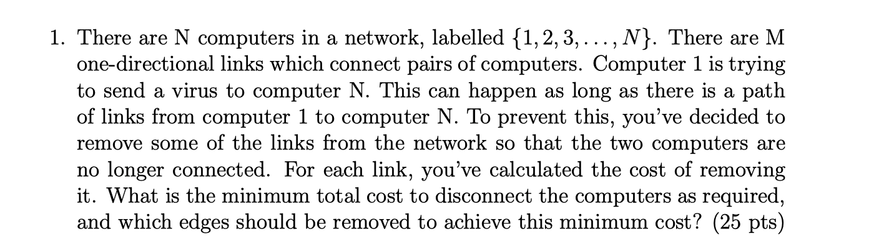

**Q1.**

We can solve this kind of problem with the idea of maximum flow problem. The minimum cost to disconnect the necessary computer is equivalent to calculate the min cut for this graph. For current graph, the source is the computer 1, the target computer is the computer N, each edge capacity is the cost of removing each edge. By using the maximum flow algorithm, We can calculate the min cut to get the minimum cost to cut the connection between computer 1 and N.

The number of vertex is V, therefore the time complexity of this algorithm is O(V^3).