**Exercise1：**

**1、**

the IP address of [www.koala.com.au](http://www.koala.com.au) is **104.18.61.21** and **104.18.60.21**

The reason why a website has many IP addresses is that there may many servers contain the the same website in different regions, even one server down, the website can be browsed from another server.

**2、**

127.0.0.1 is localhost

The special about this address is 127.x.x.x is loopback address, which is mainly used for network software testing and local inter-process communication.

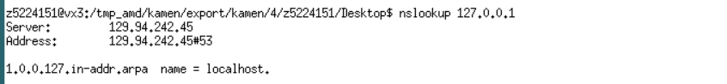

**Exercise2:**

[**www.getfittest.com.au**](http://www.getfittest.com.au) **and**

[**www.hola.hp**](http://www.hola.hp) **and**

[**www.kremlin.ru**](http://www.kremlin.ru/) **are not reachable by using ping.**







**The other websites are all reachable.**

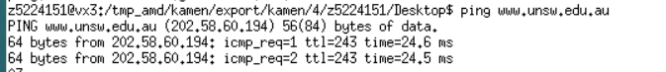





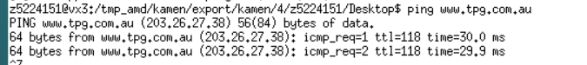



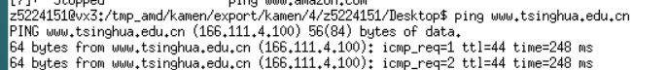

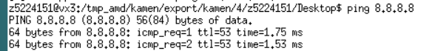

The reason why [www.getfittest.com.au](http://www.getfittest.com.au) and [www.hola.hp](http://www.hola.hp) cannot be reachable using ping is that the domain name may be wrong or the domain are expired, thus these two websites cannot be browsed from web browser.

The reason why [www.kremlin.ru](http://www.kremlin.ru) cannot be reachable by ping is because this site disabled ICMP responses or enabled ICMP filtering to protect the server and host, therefore the website can still be browsed by web browser.

**Exercise3:**

**1、**

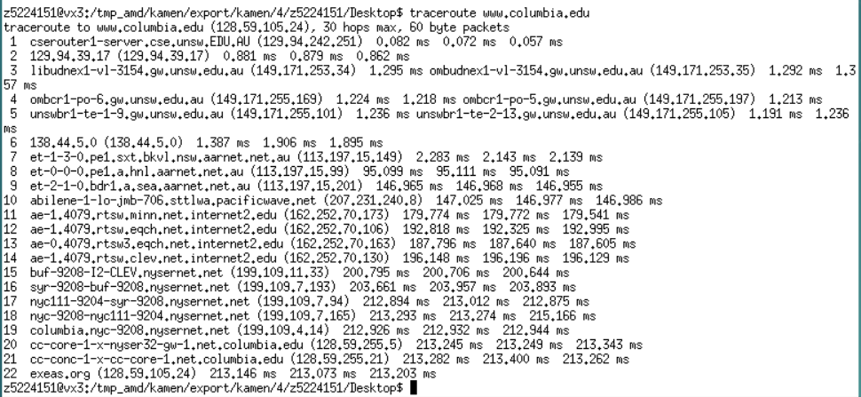

**There are 22 routes between my workstation and** [**www.columbia.edu**](http://www.columbia.edu)

**By using whois command, there are 5 routes are part of UNSW network**

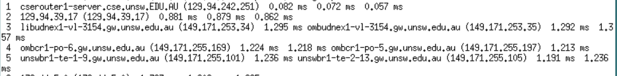

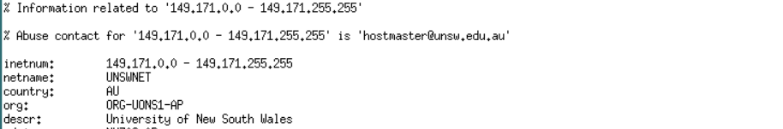

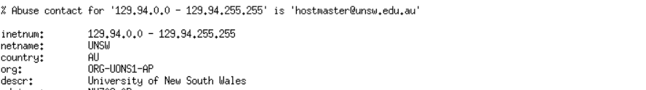

The ping between seventh routes and the eighth routes are increasing sharply, thus packets may cross the Pacific Ocean.



**2、**







At route 138.44.5.0 the paths divide to three different routes.

The detail of this IP address as below:



[www.ucla.edu](http://www.ucla.edu)

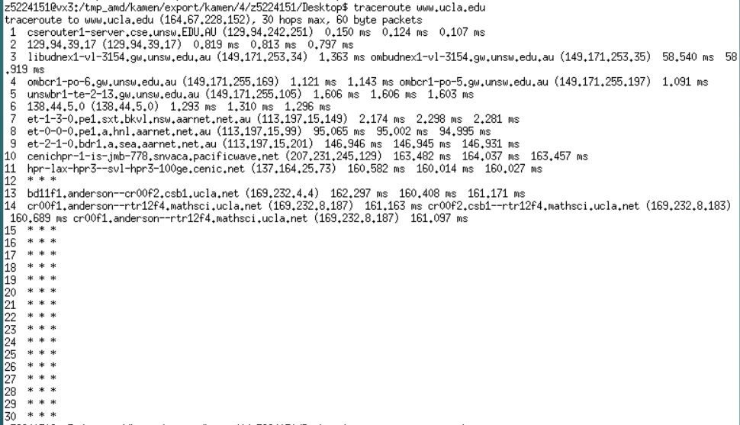

Distance: **7209.7 miles, with 15 hops**

[www.u-tokyo.ac.jp](http://www.u-tokyo.ac.jp/)

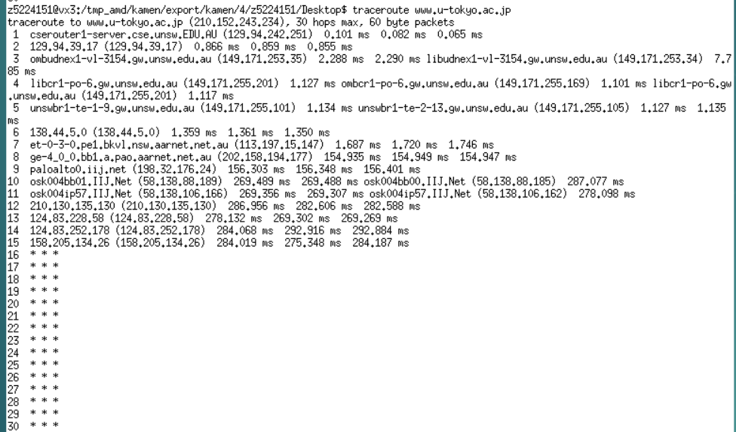

Distance: **4335.6 miles, with 16 hops**

[www.lancaster.ac.uk](http://www.lancaster.ac.uk)

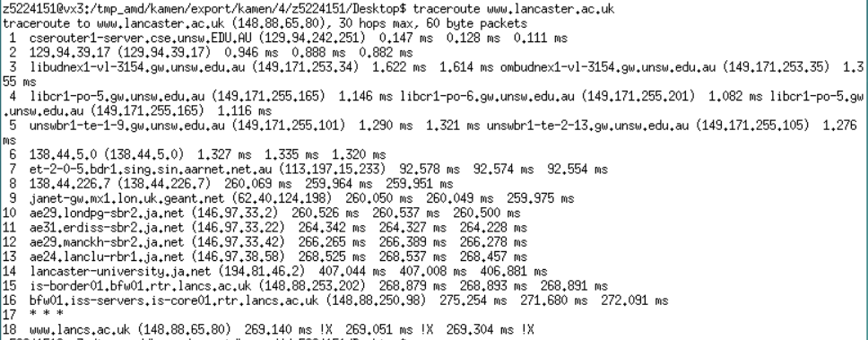

Distance: **10063.9 miles, with 18hops**

In conclusion, we can find the hops on each path doesn’t proportional the physical distance.

**3、**

(i) <http://www.speedtest.com.sg/tr.php>

From [The Singapore Broadband Speed Test](http://www.speedtest.com.sg/) service to my machine.

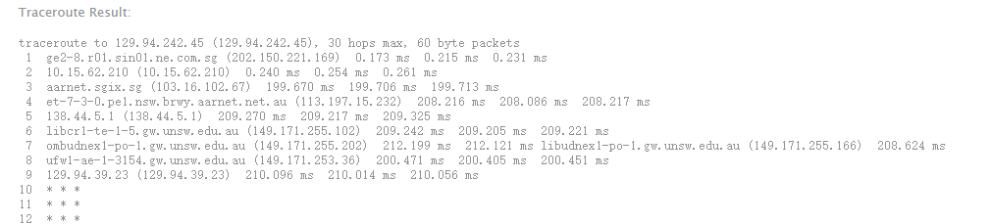

From my machine to [The Singapore Broadband Speed Test](http://www.speedtest.com.sg/) service.

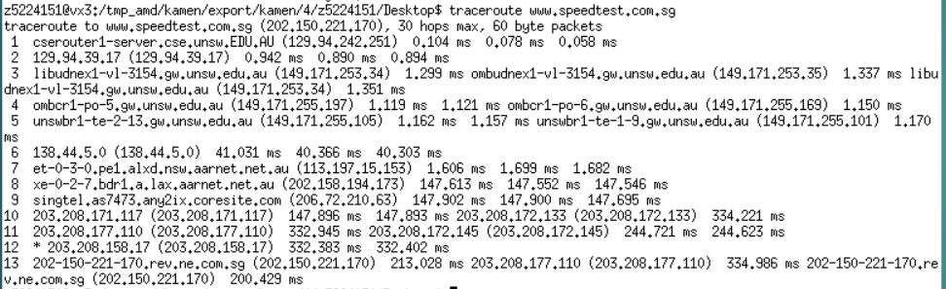

From <https://www.telstra.net/cgi-bin/trace>service to my machine.

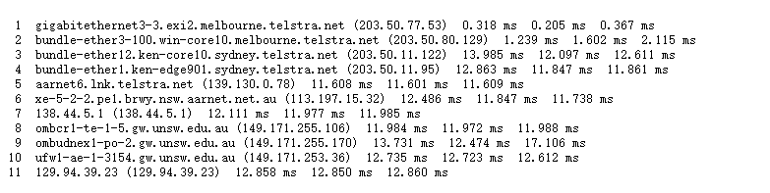

From my machine to <https://www.telstra.net/cgi-bin/trace> service.

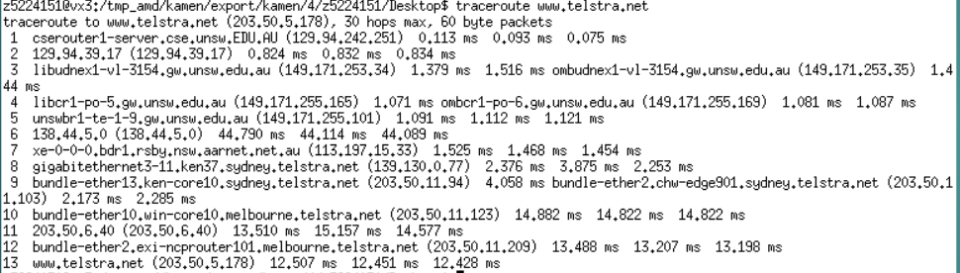

The IP address of  <http://www.speedtest.com.sg/tr.php> is 202.150.221.170



The IP address of <https://www.telstra.net/cgi-bin/trace> is 203.50.5.178

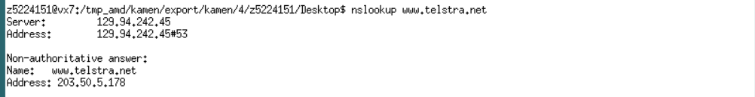

The reverse path may go through the same routes, but they go through the different IP address, the main reason is loading balance, the route may distribute different IP address at different time to achieve the best transmission effect.

**Exercise4:**

**1、**

the reason why y-axis values are greater than 2 is that

(1) the physical distance we get from Google Maps is the same as the sum of distance of each routes, which means the actual distance is much longer than the physical distance, and therefore the delay will get increased.

(2) the actual speed of data transmission is the same as the speed of light, due to the congestion of server or any other reasons, the speed of transmission will get slower, which will also cause the RTT increasing.

The distance from UNSW to UQ server is **1131.5km**

**T1 = 1131500 / 3*108 =0.00377s = 3.77ms**

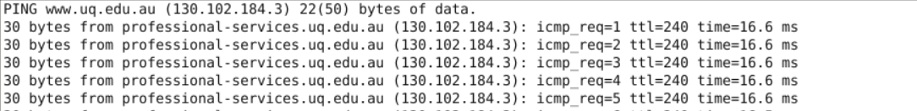

**RTT = 16.6 ms**

**RTT / T1 = 4.4 > 2**

The distance from UNSW to DLSU server is **6286.6km**

**T2 = 6286600 / 3*108 =0.02095s = 20.95ms**

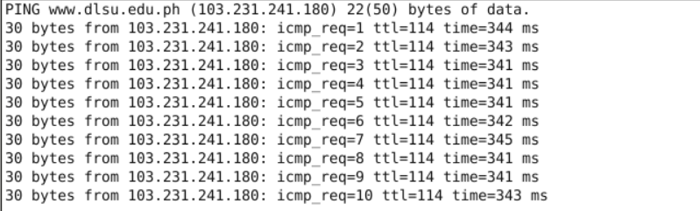

**RTT = 341 ms**

RTT/ T2 = 16.2 > 2

The distance from UNSW to TU-berlin server is **16105.3km**

**T3 = 16105300 / 3*108 =0.05368s = 53.68ms**

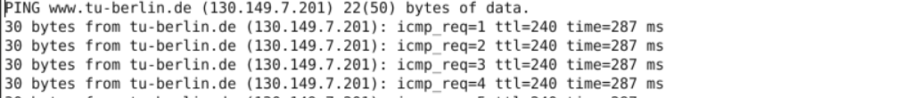

**RTT = 287 ms**

**RTT / T3 = 5.34 > 2**

**2、**

The delay to destination vary over time, the reasons may be the congestion of server network, for example, at rush hours, the server we want to connect is overloaded or the bandwidth is not enough, therefore the delay will significantly increase compare to other time in a day.

**3、**

By using whois command, we can find that the server of website [www.epfl.ch](http://www.epfl.ch) is in U.S., not in Switzerland.

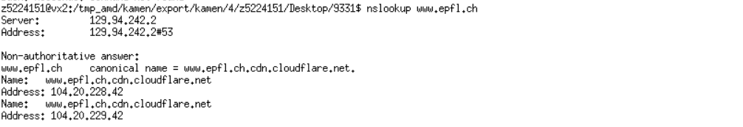

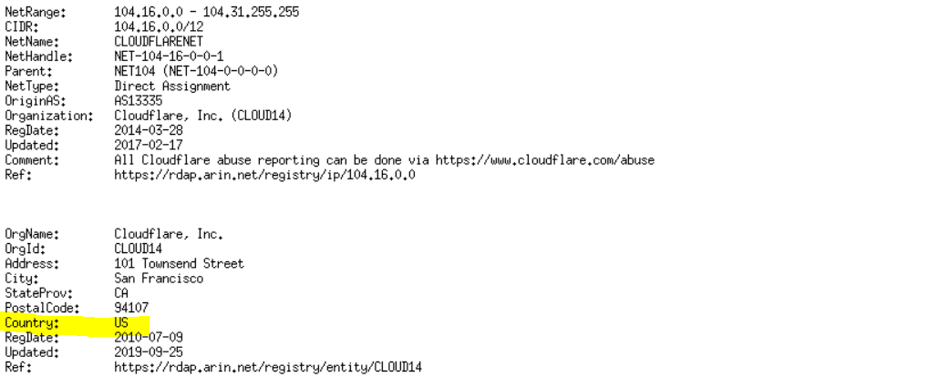

**4、**

Transmission delay depends on packet size, dtrans = L/R, the longer of the packet, the more delay may cause.

Processing delay also rely on the packet size, during processing of a packet, routers need time to check bit-level errors and determining where the next destination.

The other two delays: propagation delay and queuing delay have nothing to do with packet size.

The propagation delay depends on length of physical link and propagation speed in medium.

The queuing delay depends on congestion of router.