# Lab2

Z5224151 ZANNING WANG

**Exercise3:**

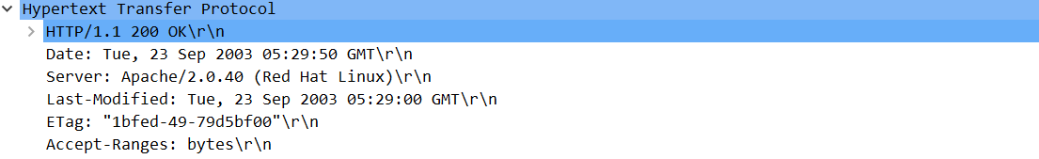

**Q1:**

The status code is 200, and the phase is ok, which means the request is successful and the information is contained in response packet.

**Q2:**

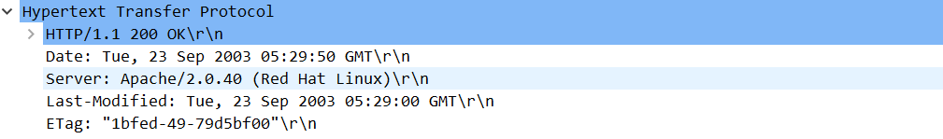

The html file was modified at Date: Tue, 23 Sep 2003 05:29:00 GMT.

The response time from HEADER is: Tue, 23 Sep 2003 05:29:50 GMT.

The difference between two time is, the Last-modified time infer to when the time the html was last changed, and the Date time means when the response was generated and sent to client from server.

**Q3:**

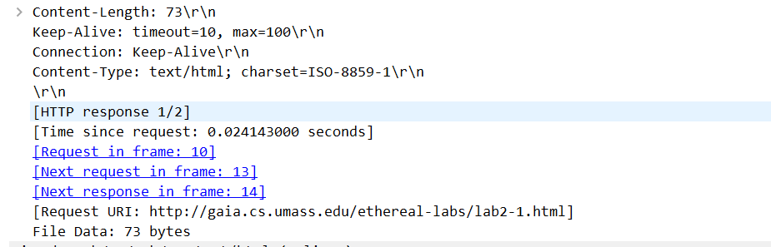

The connection between the browser and the server is persistent. The connection: keep alive show above.

**Q4:**

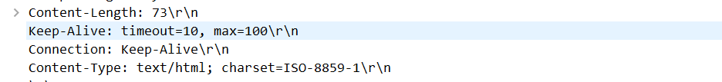

The length of packet returned from browser is 73bytes.

**Q5:**

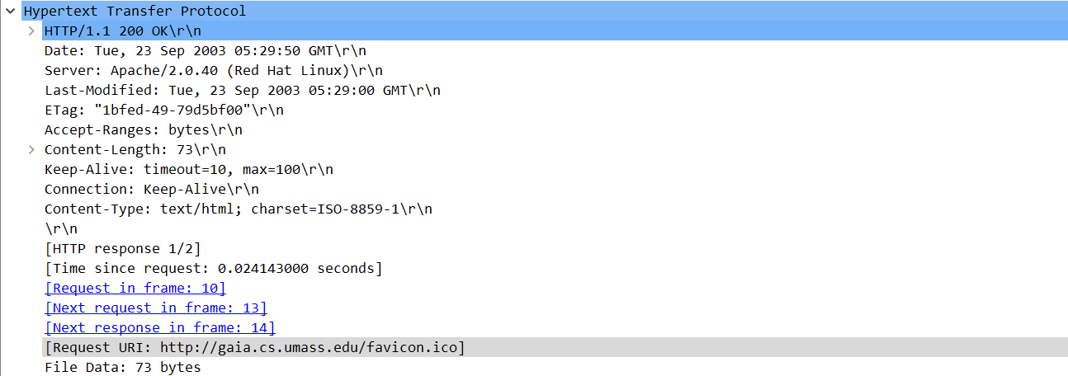

The data contain inside response packet is txt/html.

**Exercise 4:**

**Q1:**

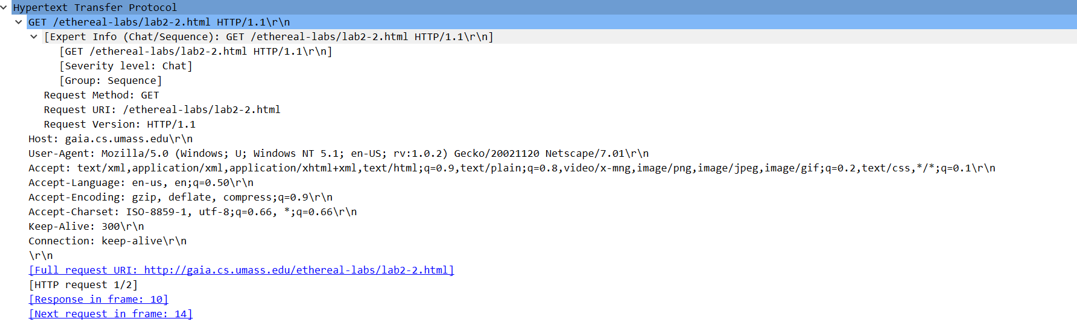

There is no “IF-MODIFIED-SINCE” line in the HTTP GET.

**Q2:**

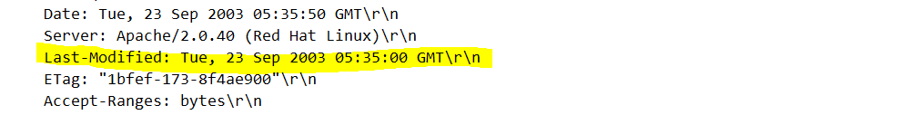

Yes, the time that the file was modified show above.

**Q3:**

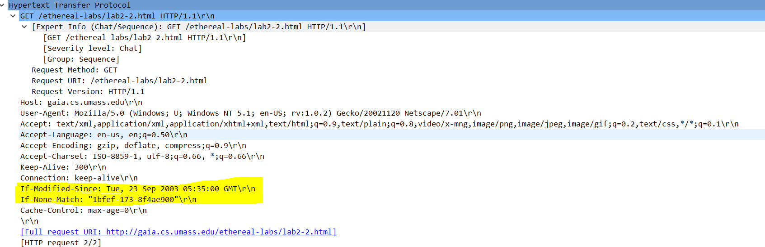

Yes, there is an “IF-MODIFIED-SINCE:” and “IF-NONE-MATCH” lines in the HTTP GET.

**Q4:**

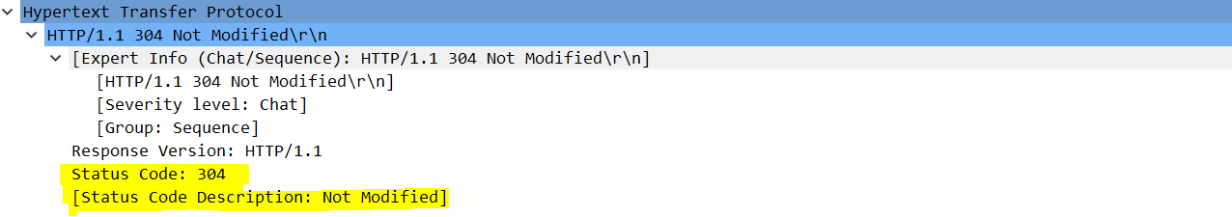

The status code is 304, the phase returned is “Not Modified”

The server didn’t return the contents of the file, because the content didn’t modify since Tue, 23 Sep 2003 05:35:53 GMT. Therefore, the server cannot return the content to the client.

**Q5:**



The Etag filed shows above. Etag was called Entity tag which is used to check the resource ask from server whether change or not, because every time the server give back a Etag, the next time the client ask for this source, the server will check the Etag. If the Etag was the same, the server will response 304 to make full use of bandwidth.

And this value didn’t change since the 1 st response message was received.