**z5224151 ZANNING WANG**

**Lab3**

**Exercise3：**

**Q1：**

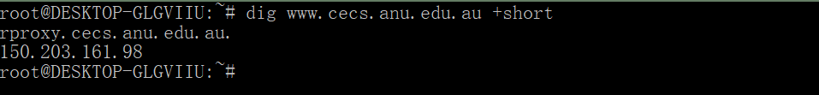

The IP Address of [www.cece.anu.edu.au](http://www.cece.anu.edu.au) is 150.203.161.98



The question type is A.

**Q2:**



The canonical name is: rproxy.cecs.anu.edu.au.

The benefits of Alias analysis is: the server in the actual operation process, sometimes involves the replacement of IP address, if you use type A record , when changing the server IP, the IP also needs corresponding changes. But with the use of the alias analysis, due to using the second-level domain name, even point to server IP changes, do not need to modify.

**Q3:**

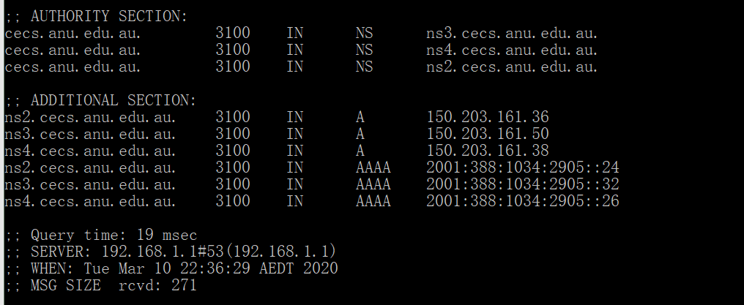

In two sections, it also contain the TTL which is 3100, and the type in authority is NS; there are three domain server show above;

In additional section it contains the IP address of the domain server in authority section, the type AAAA is the IPv6 address for this domain server.

**Q4:**

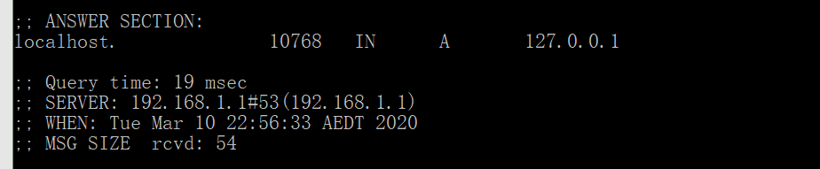

The IP of localhost is 192.168.1.1

**Q5:**

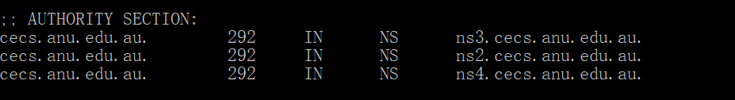

The nameserver show above.

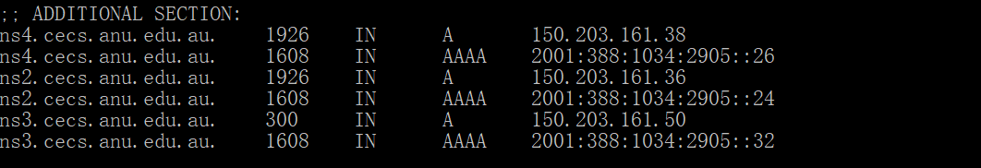

And their IP address are 150.203.161.38; 150.203.161.36; 150.203.161.50 respectively.

The type of query is NS.

**Q6:**



The DNS name is **webserver.seecs.nust.edu.pk.**

The query is : dig -x 111.68.101.54 +short

The type of query is PTR DNS

**Q7:**

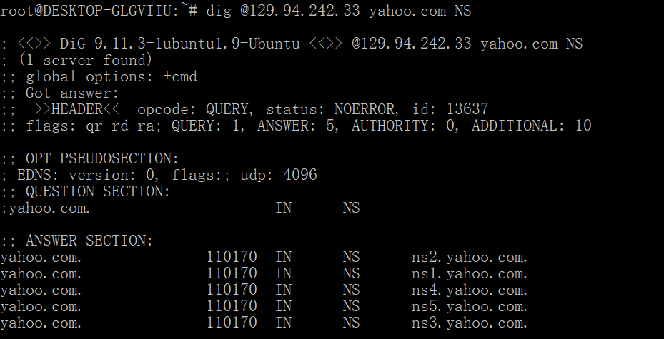

The answer show above, we didn’t get the authoritative answer because in the flags of this query, there isn’t contain ‘aa’, which means the CSE server has only authority on CSE domain instead yahoo.com domian

**Q8:**

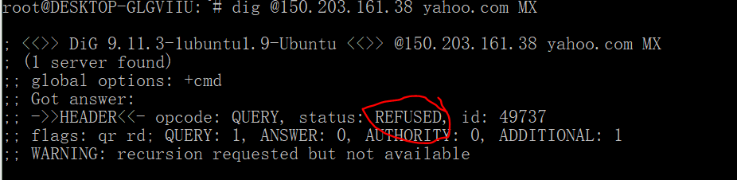

The status is refused, the nameserver in Q5 didn’t return any mail server for Yahoo Mail.

**Q9:**

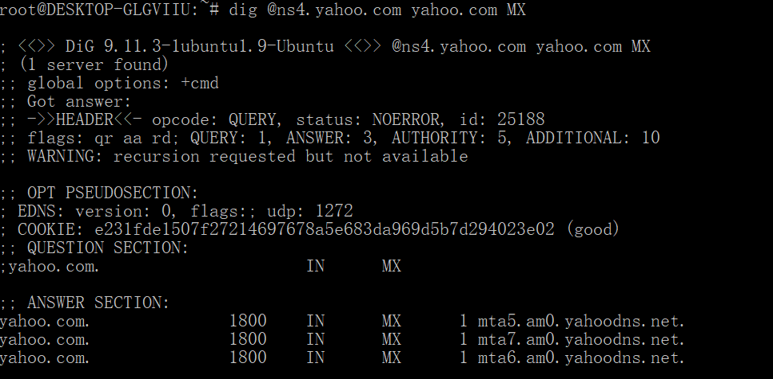

The type of this query is MX.

**Q10:**

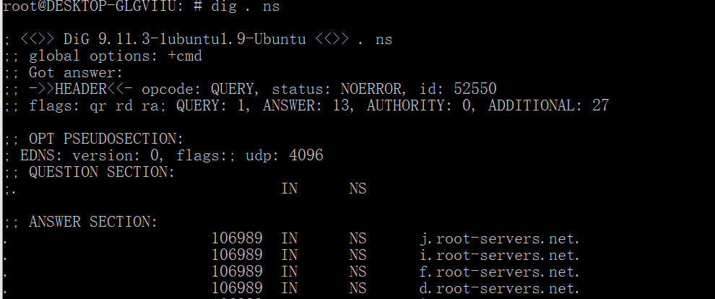

First, we should get the root domain.The root server shows above.

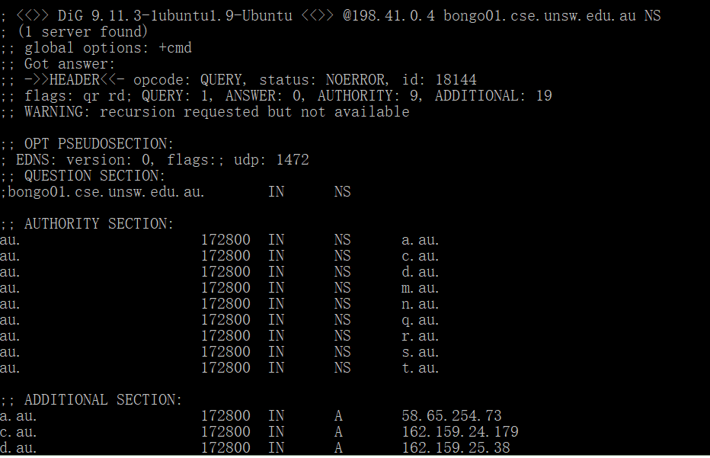

Then choose 198.41.0.4 to get au nameserver, The au server shows above.

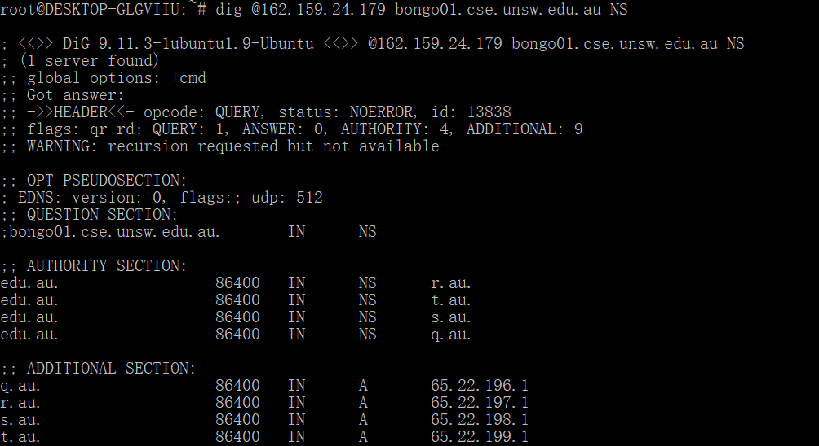

Then we use 162.159.24.179 to get the edu.au nameserver, The edu.au server shows above.

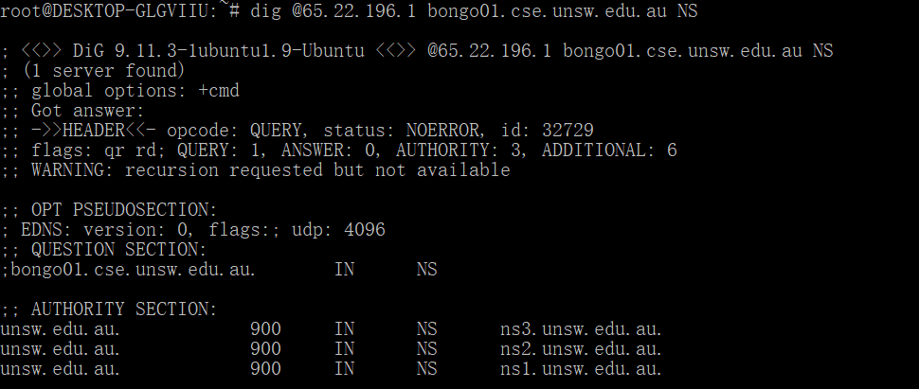

Then we use 65.22.196.1 to get the unsw.edu.au nameserver. The unsw.edu.au server shows above.

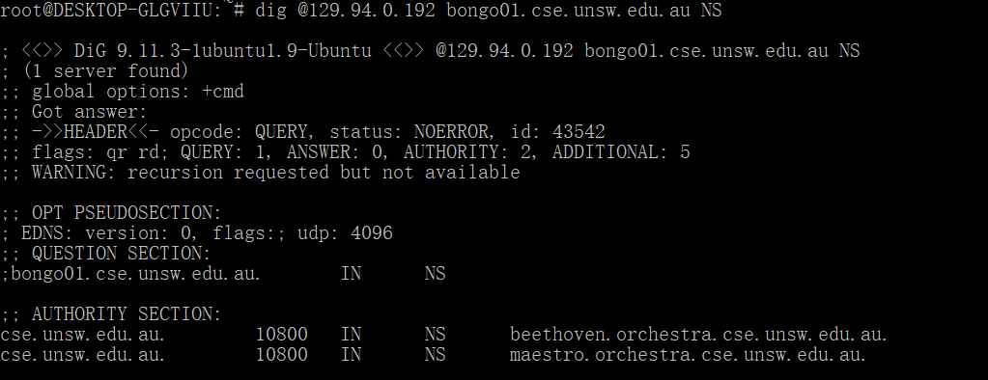

Finally, we use 129.94.0.192 to get the bongo01 nameserver. The cse.unsw.edu.au server shows above

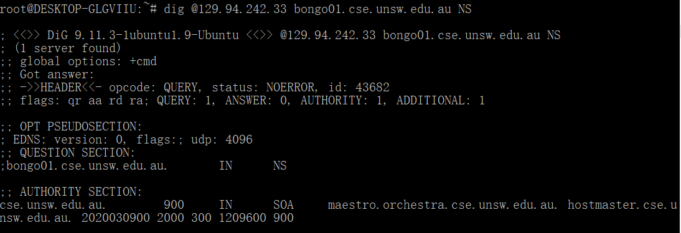

The nameservers of bongo01 shows above.

There are 6 DNS servers we query to get the authoritative answer.

**Q11:**

One physical machine can have several names and IP addresses according to the demands.