SAMRI2: Adapting SAM2 for 3D MRI Segmentation with Global Volume Tokens
Zhao Wang¹, Wei Dai¹, Hongfu Sun², Craig Engstrom³, and Shekhar S. Chandra¹
¹School of Electrical Engineering and Computer Science, The University of Queensland, Brisbane, Australia
²School of Engineering, University of Newcastle, Australia
³School of Human Movement and Nutrition Sciences, The University of Queensland, Australia
zhao.wang1@uq.edu.au

Abstract—Foundation models such as SAM2 have transformed natural-image and video segmentation, and recent work has begun adapting them to medical imaging. These adaptations, however, are largely general-purpose models spanning diverse medical imaging modalities (CT, ultrasound, endoscopy, and others), with MRI treated as one modality among many; large-scale, MRI-specific modeling and benchmarking remain limited, even though MRI’s low soft-tissue contrast leaves many boundaries effectively invisible on individual slices. We present SAMRI2, a benchmark and method for 3D MRI segmentation with SAM2. The SAMRI2 benchmark is the largest MRI-only evaluation to date — 10,392 volumes from 34 datasets (27 public, 7 in-house) spanning 12 anatomical domains and 10+ sequences, with explicit seen/unseen splits. Freezing the image encoder and fine-tuning only the lightweight decoder and memory modules raises mean Dice from 0.58 (zero-shot SAM2) to 0.76, far surpassing recent SAM-based medical models (SAMed-2 0.69, Medical-SAM2 0.49, SAM-Med3D 0.37) with strong statistical significance. To target invisible boundaries, we introduce Global Volume Tokens (GVT): persistent memory tokens trained with a Truncated Signed Distance Field (TSDF) shape-prior objective that is discarded at inference (zero added cost). GVT with TSDF priors attains the best accuracy (0.78) and lowest variance across all 34 datasets and, uniquely, shows no drop on 8 held-out datasets (0.79 unseen vs. 0.78 seen); per-sequence analysis confirms the prior helps most where per-slice contrast is weakest. We will release the benchmark, code, and models in this paper.
Keywords—Medical image segmentation, MRI, SAM2, foundation model adaptation, 3D segmentation, benchmark

Introduction
Magnetic resonance imaging (MRI) segmentation underpins many clinical and research workflows, yet it remains difficult: signal intensities are non-uniform, tissue contrast varies with the acquisition protocol, and many diagnostically important structures are small or weakly delineated. Expert manual delineation is accurate but slow and costly to scale, while conventional supervised networks typically require retraining on freshly annotated data whenever the target structure or protocol changes, limiting their reach across the many anatomies and sequences seen in practice. Promptable foundation models such as the Segment Anything Model (SAM) [1] suggest an alternative, segmenting arbitrary targets from simple user prompts without per-target retraining, although SAM itself is trained on natural images and transfers poorly to medical data.
Medical adaptations such as MedSAM [3], which fine-tunes SAM on over one million medical image-mask pairs, and SAMRI [28], which specialises SAM for MRI and achieves stronger accuracy on MRI data, substantially reduce this domain gap; both, however, remain 2D, slice-based models: applied to a 3D MRI volume they segment each slice independently and ignore through-plane continuity. SAM2 [2] extends the architecture from static images to video, processing a sequence of frames through a streaming memory mechanism that propagates predictions across frames via a memory bank of recently processed features. This design naturally maps to 3D volumetric data through the “slice-as-frame” paradigm — treating each slice of a 3D volume as a video frame. Several concurrent works demonstrated this paradigm for medical imaging: Yu et al. [18] first applied SAM2’s video predictor to 3D MRI knee segmentation, while Shen et al. [19] established the practical pipeline of bidirectional propagation from a center slice. Despite this architectural alignment, SAM2 struggles with medical imaging out-of-the-box due to the fundamental domain gap between natural video and medical scans, and its memory bank has a finite capacity that loses information from distant slices in long volumes.
Building on this slice-as-frame paradigm established by prior work [18], [19], we address two open problems. First, existing SAM2 medical evaluations each cover only a few organs or a single modality, and no large-scale, MRI-specific benchmark exists. Second, while SAM2’s memory bank provides local inter-slice coherence, it lacks a mechanism for global volumetric context — information from the entire volume that could guide segmentation of ambiguous slices. Recent memory improvements such as SLM-SAM2 [20] (short-long memory banks) and SAMed-2 [7] (confidence-driven memory with temporal adapters) address memory quality but still operate within a local temporal window. We propose Global Volume Tokens (GVT) to inject whole-volume geometric priors into SAM2’s memory bank, trained via a Truncated Signed Distance Field (TSDF) auxiliary objective that encodes boundary distance fields rather than redundant binary masks.
Our contributions are: (1) SAMRI2-Bench, the largest MRI-only SAM2 benchmark — 10,392 volumes from 34 datasets (27 public, 7 in-house), 12 anatomical domains, and 10+ sequences, with seen/unseen splits for zero-shot evaluation; (2) an efficient MRI adaptation of SAM2 that freezes the image encoder and fine-tunes only the lightweight decoder and memory modules, lifting mean Dice from 0.58 (SAM2 zero-shot) to 0.76 and already outperforming recent SAM-based medical models by large, statistically significant margins; (3) Global Volume Tokens (GVT) with a Truncated Signed Distance Field (TSDF) shape prior — the first study of compact, persistent whole-volume memory tokens for SAM2; we compare training these tokens with segmentation loss alone, auxiliary mask reconstruction, and a TSDF shape prior, and show the TSDF prior is the most effective, giving the best accuracy (0.78) and lowest variance at zero inference overhead; and (4) robust generalization and mechanistic analysis — our model transfers to held-out datasets with no performance drop, and per-sequence analysis shows the shape prior contributes exactly where image boundaries are weakest.

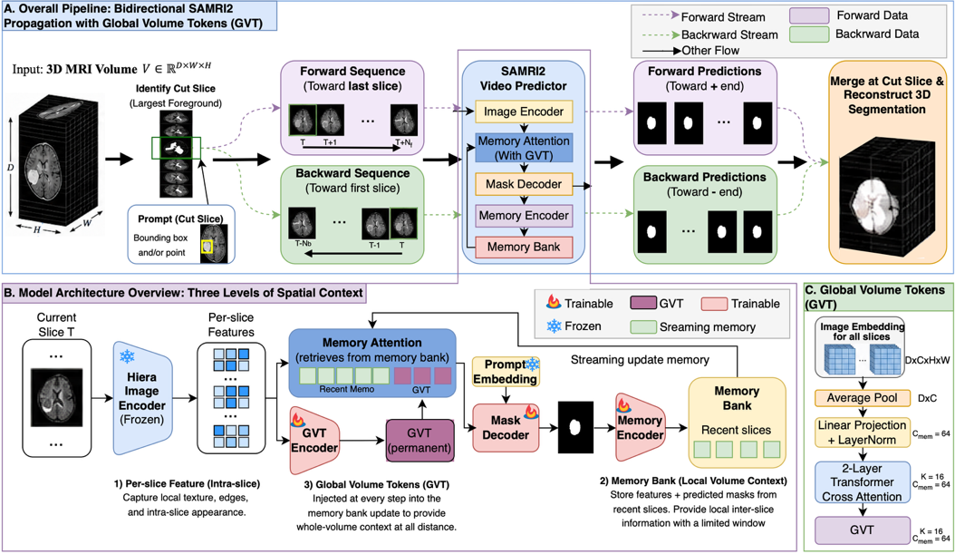
- Overall SAMRI2 pipeline. (A) A 3D MRI volume is split at the cut slice (largest foreground) into forward and backward sub-sequences, each processed by the SAMRI2 video predictor with GVT injection, then merged to reconstruct the full 3D segmentation. (B) Model architecture and three levels of spatial context: (1) per-slice features from the frozen Hiera image encoder capture intra-slice texture; (2) the memory bank stores recent slice features and predictions for local inter-slice coherence; (3) Global Volume Tokens (GVT) compress all slice embeddings into K=16 persistent tokens providing whole-volume context at every propagation step. (C) GVT encoder architecture: slice embeddings are spatially pooled and passed through cross-attention layers to produce K=16 compact tokens that encode global volumetric context.

Related Work

SAM2 for 3D Medical Segmentation
Building on the slice-as-frame paradigm established by Yu et al. [18] and Shen et al. [19] (see Section I), subsequent works have extended SAM2 adaptation for medical volumes: MedSAM2 [4] fine-tuned SAM2 on 455K+ medical image-mask pairs across CT, PET, and MRI; SAMed-2 [7] introduced temporal adapters with 3D convolutions in the Hiera encoder and a confidence-driven memory mechanism; and RevSAM2 [21] proposed reverse propagation for self-correction. These works validate SAM2’s memory mechanism for medical volumes but are predominantly evaluated on CT or limited MRI subsets. No prior work provides a comprehensive, MRI-focused benchmark at the scale we propose.

Memory Mechanisms and Global Context
SAM2’s memory bank stores features from recently processed frames and provides local inter-slice coherence, but its finite capacity means distant-slice information is gradually evicted in long volumes. SLM-SAM2 [20] addresses this with separate short-term and long-term memory banks, achieving +7% Dice improvement and 60% reduction in correction time. MedSAM-2 [22] introduces a self-sorting memory bank that dynamically selects informative embeddings based on confidence and dissimilarity rather than temporal order. SAMed-2 [7] further refines memory retrieval with confidence-driven replacement, filtering low-quality entries. However, all these approaches operate within a local temporal window and lack access to information about the full volume. The notion of compressing global context into a compact set of learnable tokens has precedent in MRI analysis: Bran Lorenzana et al. [29] introduced global image tokens to capture whole-image structure beyond local patches in transformer-based reconstruction. Our Global Volume Tokens extend this idea to volumetric segmentation, addressing this gap by providing persistent whole-volume context at every propagation step (Section III-C).

3D Architectures and SAM Adaptation
Traditional 3D segmentation methods such as nnU-Net [5] and SwinUNETR [6] achieve strong task-specific performance but lack the generalisation capabilities of foundation models, requiring retraining for every new task or anatomical target. Efficient task-specific networks remain widely used for 3D MRI segmentation, including the compact context-aggregation model CAN3D [30] and its kaleidoscope-based variant KAN3D [31] for data-scarce knee MRI, alongside anomaly-aware networks that explicitly handle pathological bone and cartilage appearance [32]. Several works adapt SAM for 3D input: MA-SAM [8] introduces modality-agnostic 3D adapters, 3DSAM-adapter [9] provides holistic 2D-to-3D adaptation, Medical-SAM-Adapter [10] uses Space-Depth Transposition, SAM-Med3D [11] builds a native 3D architecture, and 3DMedSAM [23] replaces SAM’s 2D patch embedding with a 3D module. SAM2-UNet [24] discards SAM2’s memory mechanism entirely, using only the Hiera encoder with a U-Net decoder — achieving strong results but sacrificing inter-slice propagation. In contrast, our approach preserves SAM2’s streaming memory and augments it with global volumetric context through GVT, requiring no architectural modification to the core model beyond the lightweight GVT encoder.

Distance-Based Auxiliary Objectives
Signed distance fields (SDFs) replace a binary mask with each pixel's signed distance to the nearest object boundary (positive inside, negative outside), providing a dense, geometry-aware target that emphasises boundary localisation rather than per-pixel occupancy. Building on this idea, FocusSDF [25] introduces an adaptive SDF loss with exponential boundary weighting that outperforms standard distance-transform losses across architectures; FlowSDF [26] embeds SDF representations in a flow-matching framework for probabilistic segmentation, yielding smoother and more coherent boundaries; and TokenSeg [27] combines boundary-aware token compression with SDF supervision for efficient 3D segmentation. A common limitation, however, is that these methods regress the full, unbounded distance field, so much of the learning signal is spent on voxels far from the boundary that carry little localisation information, while large distance values can dominate the loss. A truncated SDF (TSDF) addresses this by clamping distances beyond a narrow band around the boundary, concentrating the representation on the boundary region that matters most; we therefore adopt a TSDF as the shape-prior objective for our Global Volume Tokens (Section III-C).

Method

Problem Formulation
Given a 3D MRI volume V ∈ R ^{(D×H×W)}, we treat it as a D-frame video sequence where each slice along the primary axis corresponds to a single frame. To enable bidirectional propagation, we identify the cut slice [19] — the slice containing the largest foreground area for the target structure — which provides the clearest view of the target shape and yields the highest single-slice prediction confidence, offering optimal conditions for subsequent slice propagation. We split the volume into two sub-sequences: a forward sequence (slices from the cut slice toward one end) and a backward sequence (slices from the cut slice toward the other end). Each sub-sequence is processed independently by SAMRI2’s video predictor (fine-tuned from SAM2), with the cut slice serving as the prompted frame in both. During training, a bounding box prompt derived from the ground truth mask on the cut slice initialises the segmentation; at inference, bounding boxes and/or point prompts are provided by the user or an upstream detection model. SAMRI2 propagates predictions outward from this anchor slice through its streaming memory mechanism: for each subsequent frame, the memory attention module retrieves stored features from recently processed slices to condition current-frame predictions. After both sub-sequences are processed, their predictions are merged back at the cut slice to reconstruct the full 3D segmentation volume, with the original NIfTI spatial metadata preserved.

Architecture
Following the parameter-efficient strategy introduced in our prior 2D MRI adaptation SAMRI [28], we use frozen-encoder fine-tuning: the image (Hiera) encoder is kept frozen and only the decoder and memory modules are trained (the mask decoder, memory encoder, and memory attention module). Because the encoder is frozen, its embeddings are pre-computed once for the entire training set (~3.3 TB), avoiding repeated encoder forward passes and substantially reducing training cost. Our framework operates on three complementary levels of spatial context. (1) Per-slice features: the frozen Hiera encoder extracts 2D spatial features for each individual slice, capturing global context within that slice (a transformer attends across the whole slice) while remaining blind to other slices. (2) Memory bank (local volume context): SAM2’s streaming memory mechanism stores features from recently processed slices and their predicted masks, enabling the memory attention module to condition current-frame predictions on neighbouring slices. This provides coherence across neighbouring slices along the volume axis (local in the volumetric sense, not within a slice), but is limited by the memory bank’s finite capacity — in long volumes (100+ slices), information from distant slices is gradually lost as older entries are evicted. (3) Global Volume Tokens (Section III-C): to provide whole-volume context that persists regardless of propagation distance, we introduce learnable GVT tokens that compress the entire volume’s encoder features into a compact global representation. These tokens are injected as persistent entries in the memory bank, ensuring every slice has access to the full volumetric context during propagation.

Training Strategy with GVT
All models are trained with the standard SAM2 per-slice Dice + Focal loss [16] (L_{DiceFocal}) as the sole segmentation objective, following SAM2’s original 2D training paradigm. The training mix consists of 80% volumetric sequences (full 3D processing with memory propagation) and 20% 2D slice batches; the 2D batches preserve strong per-slice segmentation, which supplies the reliable prompted-slice predictions that condition the subsequent volumetric propagation. We use AdamW [17] with learning rate 5e-6, weight decay 0.1, batch size 2, and AMP float16 precision.
We design a progressive series of ablations to study how Global Volume Tokens (GVT) should be trained: (a) 2D-slice baseline — the standard SAMRI2 frozen-encoder fine-tuning without GVT; (b) GVT-v1 — GVT encoder added, trained solely through segmentation loss backpropagation (no auxiliary objective); (c) GVT-v2 — adds an auxiliary reconstruction decoder (BCE + Dice loss) that reconstructs a low-resolution 3D binary mask; (d) GVT-v3 — replaces the binary mask target with a TSDF auxiliary objective that encodes geometric boundary information.
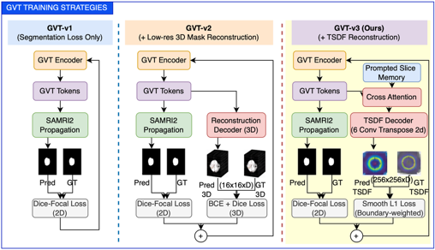
- GVT training strategies. GVT-v1 trains tokens solely through standard SAM2 segmentation loss backpropagation. GVT-v2 adds an auxiliary reconstruction decoder (BCE + Dice loss) that reconstructs a low-resolution (16×16×D) 3D binary mask. GVT-v3 replaces the binary mask target with a Truncated Signed Distance Field (TSDF) at 256×256 resolution, using cross-attention between GVT tokens and prompted slice memory features, followed by 6-stage ConvTranspose2d upsampling. The TSDF decoder is used only during training; at inference, only the GVT tokens are retained.
GVT Encoder Architecture. To capture whole-volume context beyond SAM2’s finite memory window, we propose Global Volume Tokens (GVT). The GVT module compresses the entire volume’s encoder features into K compact tokens that are injected as persistent entries in SAM2’s memory bank, providing global volumetric context at every slice during propagation.
The GVT encoder takes pre-computed Hiera encoder features F ∈ R ^{(D×C×H’×W’)} from all D slices as input. First, spatial average pooling collapses each slice’s spatial dimensions to produce a sequence of D slice-level feature vectors (D×C). A linear projection maps these to the memory dimension C_{mem}=64, followed by LayerNorm and sinusoidal positional encoding that encodes each token’s relative position along the volume axis. A 2-layer Transformer cross-attention module (Perceiver-style) then compresses this D-length sequence into K=16 learnable query tokens at dimension C_{mem}=64. These K tokens summarise the entire volume’s content and are concatenated with the regular memory entries at every propagation step. Because they are persistent, GVT tokens ensure that even the most distant slices in a long volume have access to the same global representation.
GVT-v1 relies solely on gradients from the segmentation loss to train the tokens. Without direct supervision, the tokens converge to features redundant with what SAM2’s memory bank already captures. GVT-v2 adds an auxiliary reconstruction decoder (BCE + Dice loss) that reconstructs a low-resolution (16×16) 3D binary mask, explicitly forcing the tokens to encode volumetric shape. However, this binary target is architecturally identical to what SAM2’s mask decoder already computes, so the tokens remain redundant by design.
GVT-v3: TSDF Auxiliary Objective. GVT-v3 addresses this redundancy by replacing the binary mask target with a Truncated Signed Distance Field (TSDF) — a continuous distance-to-boundary field that encodes geometric boundary information at every voxel rather than binary occupancy. For each slice, the TSDF target is computed at 256×256 resolution with truncation radius τ=32 pixels, using the sign convention of positive inside and negative outside the structure boundary. The TSDF decoder is conditioned on both the GVT tokens and the prompted slice memory features: cross-attention with Q=GVT tokens and K/V=prompted slice memory features (extracted from SAM2’s memory encoder on the prompted frame) fuses global shape context with label-specific appearance. This is followed by 6-stage ConvTranspose2d upsampling from 4×4 to 256×256. The loss is SmoothL1 with boundary-focused weighting that upweights voxels near |TSDF|≈0 (the actual boundary shell), plus label-size normalisation for small targets. Critically, the prompted slice memory features serve as a natural label identifier — they encode the target organ’s appearance from the prompted frame, allowing the same GVT architecture to generalise across all anatomical structures without a learned label embedding table.
Unlike binary masks where small targets (3–10% of slice area) cause 90%+ background dominance, every voxel in the TSDF carries informative distance values, and the truncation concentrates model capacity on the boundary shell where segmentation accuracy matters most. The TSDF decoder is used only during training; at inference, the GVT tokens are injected into the memory bank without any auxiliary decoding, adding zero computational overhead to the propagation loop. The total training loss for GVT-v3 is L = L_{DiceFocal} + λ_{tsdf} · L_{TSDF} with λ_{tsdf}=1.0.

Experiments and Results

Dataset
The SAMRI2 benchmark comprises 10,392 3D MRI
volumes from 34 datasets (27 public, 7 in-house) spanning 12 anatomical domains. By comparison, prior SAM2 medical studies are evaluated on far fewer datasets—for example, a single knee-MRI dataset [18], or BraTS plus four Medical Segmentation Decathlon tasks [19]—so no existing study assesses SAM2 on MRI at this scale. We partition the 34 datasets into 26 seen and 8 unseen datasets; each dataset is split 80/10/10 into train/validation/test. Models are trained and validated only on the seen datasets’ train/validation subsets and evaluated on the test subsets of both the seen and unseen datasets, the latter measuring zero-shot generalization to datasets unseen during training. Table I summarizes the benchmark by anatomical domain; the complete list of all 34 datasets with per-dataset sequence, volume count, and seen/unseen split is provided in the supplementary material.
- SAMRI2 Benchmark Summary by Anatomical Domain
Domain | # DS | # Vol. | Sequences
Brain | 8 | 5,520 | FLAIR, T1, T1CE, ADC, DWI, T2
Prostate | 7 | 2,234 | ADC, T2
Knee/MSK | 8 | 1,053 | FLASH, PD, T2, DESS, TSE
Cardiac | 3 | 340 | Cine, LGE
Whole-body | 1 | 263 | Mixed
Hippocampus | 1 | 260 | T1
Vestibular | 1 | 227 | T1CE
Hip | 1 | 211 | T2
Spine | 1 | 172 | T2
Abdominal | 1 | 60 | T1
Shoulder | 1 | 45 | T2
Gynecology | 1 | 7 | T2
Total | 34 | 10,392 | 10+ MRI sequences

Implementation Details
All experiments use the SAM2.1 Hiera-Small backbone with pre-computed embeddings. Training runs on three AMD MI300X GPUs with AMP float16 precision. Models are trained for 50 epochs, as we observe a stable validation curve after 30 epochs, making 50 epochs sufficient for model comparison and ablation analysis. We report mean 3D Dice Similarity Coefficient (± standard deviation across 34 datasets) as the primary metric, complemented by Hausdorff Distance (HD) and Mean Surface Distance (MSD). Concretely, for each dataset we take the median Dice across its volumes and report the mean and standard deviation of these per-dataset medians. Statistical significance is assessed with two-sided paired Wilcoxon signed-rank tests, with pairs matched per evaluated instance and reported at the per-sample (n≈3,376), per-dataset (n=34), and per-label (n=49) levels.

Main Results
Table II presents the main comparison results across all 11 evaluated models. All four SAM2 model sizes achieve similar zero-shot performance (mean Dice 0.56–0.58), confirming that model capacity is not the bottleneck. Among existing SAM-based medical methods, SAMed-2 performs best (0.69±0.15), followed by Medical-SAM2 (0.49±0.22) and SAM-Med3D (0.37±0.21). Our best model, SAMRI2-GVT-v3 with TSDF shape priors, achieves the best mean accuracy and the lowest variance across all methods. SAMRI2-GVT-v3 outperforms every external method and all four zero-shot SAM2 sizes with strong statistical significance across all three metrics and all aggregation levels (paired Wilcoxon, p≤2.9×10⁻⁵; e.g., dataset-level Dice vs. SAMed-2 p=2.9×10⁻⁵, win-rate 85%; vs. SAM2-Small p=1.2×10⁻¹⁰, win-rate 100%), confirming that MRI-specific fine-tuning is the decisive factor.
- Main Comparison Results (Mean ± Std across 34 Datasets)
Method | Dice ↑ | HD ↓ | MSD ↓
SAM-Med3D [11] | 0.37±0.21 | 29.04±16.70 | 6.39±2.78
Medical-SAM2 [22] | 0.49±0.22 | 33.51±21.81 | 5.92±4.26
SAMed-2 [7] | 0.69±0.15 | 22.28±18.82 | 2.91±1.62
SAM2-Tiny | 0.57±0.23 | 27.79±20.19 | 6.73±5.07
SAM2-Small | 0.58±0.24 | 28.24±20.42 | 6.32±4.46
SAM2-Base+ | 0.56±0.24 | 29.95±21.39 | 6.23±4.22
SAM2-Large | 0.56±0.24 | 30.22±20.87 | 7.83±5.43
SAMRI2-2dloss | 0.76±0.17 | 14.21±12.32 | 2.39±1.70
SAMRI2-GVT-v1 | 0.76±0.16 | 14.46±10.09 | 2.33±1.15
SAMRI2-GVT-v2 | 0.77±0.16 | 13.94±10.34 | 2.25±1.40
SAMRI2-GVT-v3 (Ours) | 0.78±0.14 | 13.85±9.01 | 2.11±0.96

SAM2 Scale Analysis
The aim of this analysis is to justify our backbone choice. SAM2’s encoder scale has little effect on zero-shot MRI accuracy: across the four SAM2 sizes (Table III), a 5.8× increase in parameters (38.9M to 224.4M) brings no improvement — all four variants fall within a narrow 0.56–0.58 mean Dice band, and the two largest models are in fact marginally worse, indicating that the extra capacity trained on natural video transfers poorly to MRI. We therefore avoid a large backbone and fine-tune from SAM2-Small, whose zero-shot accuracy is the best (0.58) at near-minimal parameter cost (46.0M, versus 224.4M for Large), giving the best accuracy–efficiency trade-off for fine-tuning. This size-insensitivity also supports our frozen-encoder design: since a larger encoder does not help, we freeze the Hiera encoder and adapt only the decoder and memory modules.
- SAM2 Zero-Shot Performance by Model Size
Model | Params | Mean Dice
sam2_tiny | 38.9M | 0.571
sam2_small | 46.0M | 0.583
sam2_b+ | 80.8M | 0.564
sam2_large | 224.4M | 0.558

GVT Analysis
The lower rows of Table II report our Global Volume Token variants. While GVT-v1 (naïve concatenation) shows no improvement and GVT-v2 (reconstruction auxiliary loss) only a marginal one over the baseline, GVT-v3 with TSDF shape priors achieves consistent gains across all metrics (Dice 0.78±0.14, HD 13.85±9.01, MSD 2.11±0.96), demonstrating that structured geometric priors can guide global tokens to encode meaningful volumetric information. The gain over the strong SAMRI2-2dloss baseline is small but statistically significant on Dice at the per-sample (p=9.8×10⁻¹⁴, n=3,376) and per-label (p=4.1×10⁻³, win-rate 71%) levels; at the coarser per-dataset level (n=34) the difference does not reach significance (p=0.22). GVT-v3 also significantly exceeds the naïve GVT-v1 on Dice at all levels (p≤1.1×10⁻²), while being statistically indistinguishable from GVT-v2 (p=0.22–0.60), its advantage over v2 lying in mean accuracy and reduced variance rather than a significant per-sample shift.
Component-wise, GVT-v1 tokens, trained with segmentation loss alone, are redundant with the memory bank and slightly degrade HD. Adding the reconstruction decoder (v2) recovers HD and marginally improves Dice, confirming that explicit shape supervision helps tokens encode useful information — but the binary mask target is architecturally redundant with SAM2’s own mask decoder. GVT-v3 replaces the target with TSDF boundary geometry, achieving the best performance across all three metrics with the lowest Dice standard deviation in Table II (±0.14 vs. ±0.17 for the baseline). This steady decrease, from 0.17 to 0.14, reflects increasingly consistent predictions, supporting the hypothesis that geometric boundary priors provide genuinely complementary information to SAM2’s memory mechanism.

Per-Domain Highlights
Performance varies substantially across anatomical structures. Fig. 3 compares GVT-v3 against zero-shot SAM2 (Small) and the strongest external method (SAMed-2) across the 10 domain groups: GVT-v3 leads in 9 of 10, with a large margin over zero-shot SAM2 and a consistent edge over SAMed-2 (only the multi-organ abdominal case favours SAMed-2). SAMRI2-GVT-v3 reaches high accuracy on well-defined structures and, more importantly, rescues low-contrast targets that zero-shot SAM2 largely misses: white-matter hyperintensities improve from 0.09 to 0.54 and the hippocampus from 0.65 to 0.84 over zero-shot SAM2-Small. A few small, diffuse structures (e.g., scapula cartilage, non-enhancing tumour) remain difficult for all methods.
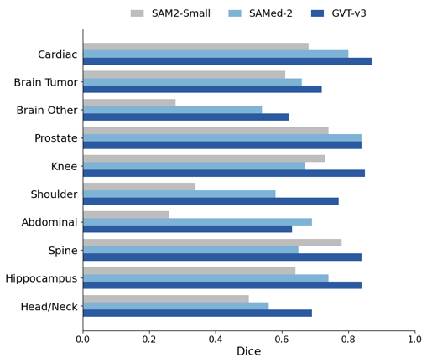
- Per-domain Dice for SAMRI2-GVT-v3 versus zero-shot SAM2 (Small) and the strongest external method (SAMed-2); mean of per-dataset medians. GVT-v3 leads in 9 of 10 domain groups, trailing only SAMed-2 on the multi-organ abdominal case. Domains follow a 10-category analysis grouping of the 12 dataset domains in Table I.

Per-MRI-Sequence Analysis
As a shape prior, GVT-v3 should contribute exactly where image evidence is weakest, so its effect should track imaging contrast. Fig. 4 confirms this: across 11 single-sequence categories (2,156 samples), GVT-v3’s gains concentrate on low-contrast sequences with diffuse boundaries (T1 +0.043, FLASH +0.024; T1/FLASH pooled +0.035 mean Dice, p=1.4×10⁻⁶), and it is, as expected, neutral-to-slightly-negative on high-contrast sequences whose boundaries are already sharp (DESS −0.019, T1CE −0.033). This sequence dependence is direct evidence for the invisible-boundary motivation behind the TSDF objective.

Zero-Shot Generalization to Unseen Datasets
Because the 8 unseen datasets contribute no training data, their test subsets probe generalization to datasets absent from training. Fig. 5 compares seen- and unseen-dataset performance for all models. SAMRI2-GVT-v3 attains the highest unseen Dice (0.79) and is the only strong model with no generalization gap (+0.01 relative to seen data), together with the tightest variance (±0.08); by contrast SAMed-2 (−0.07) and the SAMRI2-2dloss baseline (−0.04) both degrade on unseen data. On the unseen datasets GVT-v3 significantly exceeds SAMed-2 (paired Wilcoxon p=0.016)
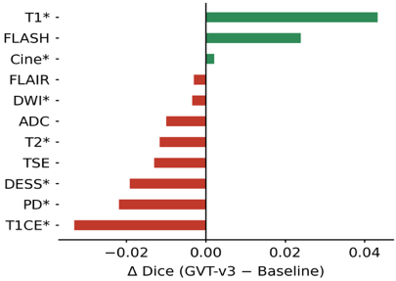
- Per-MRI-sequence improvement of SAMRI2-GVT-v3 over the baseline (median Dice difference). Green: improvement; red: regression; * marks p<0.05 (paired Wilcoxon). Single-sequence subset (2,156 samples).
and zero-shot SAM2 (p=0.008); its edge over the fine-tuned baseline is positive but not significant at n=8. GVT-v3’s gains on MSK-FLASH (0.38→0.71) and MSK-Shoulder (0.59→0.72) show the TSDF shape prior transfers robustly to unseen data.
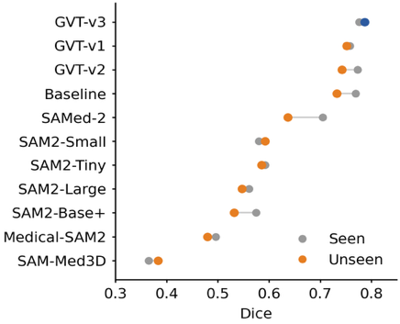
- Zero-shot generalization: per-model seen vs. unseen Dice (mean across datasets). SAMRI2-GVT-v3 (highlighted) shows no generalization gap. Seen: 26 datasets used for training/validation; unseen: 8 datasets excluded from training.

Efficiency
Table IV reports the parameter overhead of the GVT variants. All variants add less than 1.5% to the trainable parameters, and the auxiliary decoders (mask reconstruction for GVT-v2, TSDF for GVT-v3) are used only during training and discarded at inference. At test time, GVT introduces only K=16 persistent memory tokens, computed once per volume, leaving per-slice inference essentially unchanged.
- Efficiency Comparison of GVT Variants
Variant | GVT Params | Aux Decoder | Total Overhead
Baseline | - | - | 0
GVT-v1 | ~120K | - | <0.9%
GVT-v2 | ~120K | ~85K | <1.5%
GVT-v3 | ~120K | ~30K | <1.1%

Qualitative Results
Fig. 6 compares SAMRI2-GVT-v3 against zero-shot SAM2 (Small), SAM-Med3D, Medical-SAM2, and SAMed-2. Successful cases are shown in triplanar (axial, coronal, sagittal) views for liver, spleen, and cartilage; GVT-v3 produces the most complete and boundary-accurate masks (e.g., liver 0.94 and spleen 0.95), recovering structure that the zero-shot and external models under-segment or miss. The failure cases, shown as single slices, illustrate that all methods, including GVT-v3, struggle on extremely small or diffuse targets, such as a scattered brain tumour and a thin cartilage, where every model attains low and closely clustered Dice, reflecting genuine task difficulty rather than a model-specific weakness. Additional qualitative examples across more anatomical domains are provided in the supplementary material.

Discussion
The success of frozen-encoder fine-tuning can be attributed to the massive domain gap between natural video and MRI: while the frozen Hiera encoder provides useful general visual features, the decoder components require substantial adaptation to interpret medical image characteristics. Importantly, the frozen-encoder approach preserves the encoder’s generalization capability while adapting the prediction pathway to medical imaging.
The finding that model size does not matter for zero-shot medical performance is notable. All SAM2 variants, from Tiny to Large, achieve similarly low zero-shot accuracy, suggesting that the bottleneck is not how well the model "sees" the image (the frozen encoder already extracts strong general features) but how well the decoder and memory interpret those features for the medical domain; in short, teaching the decoder to interpret well-extracted features matters more than enlarging the encoder to "see" better. Among existing SAM-based medical methods, SAMed-2’s relatively strong performance confirms the value of adapter-based fine-tuning, while Medical-SAM2 and SAM-Med3D show that alternative adaptation strategies yield lower accuracy on our diverse benchmark.
The progression from GVT-v1 to v3 reveals important insights about global context integration in SAM2’s memory architecture. Naïve token concatenation (v1) and reconstruction-based auxiliary losses (v2) yield little or no improvement over the baseline because spatial average pooling creates tokens redundant with existing memory features, and the memory attention’s softmax competition causes per-frame memories to dominate. GVT-v3’s TSDF shape priors succeed by encoding boundary geometry rather than appearance — information that is complementary to per- frame features and survives attention competition. The improvement is modest but consistent across all metrics and datasets, with notably reduced variance. Paired Wilcoxon tests confirm this gain is statistically significant on Dice at the per-sample and per-label levels but not at the per-dataset level (n=34 lacks the power to resolve a sub-0.01 median shift); we therefore position GVT-v3 as the lowest-variance, best-mean model rather than claiming a large dataset-level improvement over the fine-tuned baseline.
Future work should explore gated attention mechanisms that bypass softmax competition, directly modulating features rather than competing for attention weight, potentially amplifying GVT-v3’s gains. Additionally, frozen-encoder fine-tuning caps performance — encoder adaptation may unlock further gains. Small lesion segmentation remains an open challenge (e.g., adrenal Dice ≤0.10), and comparison with fully-supervised 3D methods such as nnU-Net is needed to contextualize the results.
The two failure modes in Fig. 6 — fragmented ground truth collapsed into a single contiguous mask (reflecting SAM2’s bias toward smooth, connected predictions), and over-segmentation from oversized box prompts propagating through the memory bank — motivate scatter-aware prompting and tighter prompt-region handling as future work.

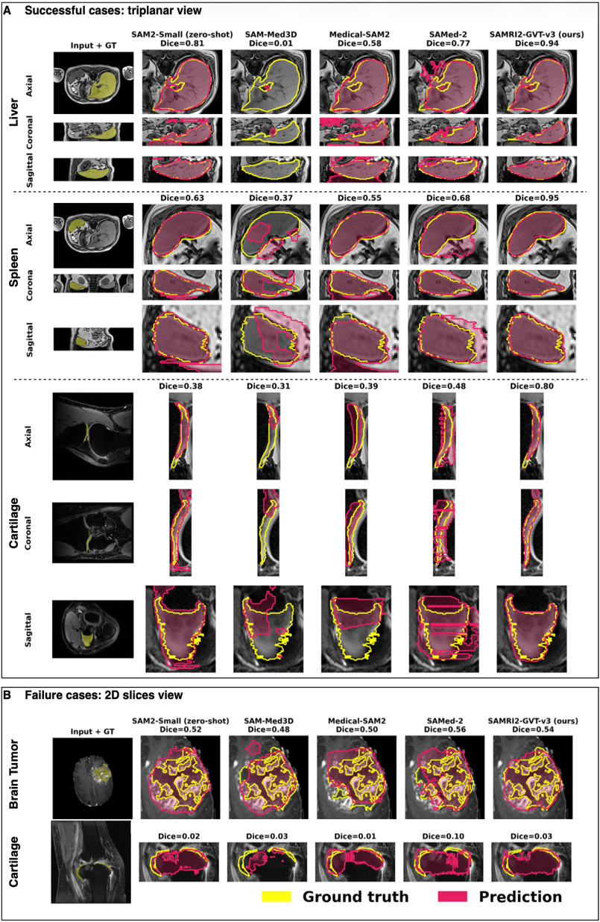
- Qualitative segmentation results. Top rows A: representative successful cases shown in triplanar (axial, coronal, sagittal) views, with ground-truth and predicted masks overlaid. Bottom rows B: two characteristic failure modes — (i) a brain tumour whose ground truth is highly fragmented, which almost all models instead predict as a single contiguous region; and (ii) a thin cartilage whose bounding-box prompt spans a large area, producing an over-segmentation on the prompted slice that then propagates into an incorrect 3D volume.

Conclusion
We present SAMRI2, a comprehensive benchmark and method for adapting SAM2 to 3D MRI segmentation. Our best model, SAMRI2-GVT-v3 with TSDF shape priors, achieves 0.78±0.14 mean Dice, 13.85±9.01 HD, and 2.11±0.96 MSD across 34 diverse datasets, substantially outperforming three existing SAM-based medical segmentation methods. We demonstrate that TSDF-guided Global Volume Tokens provide consistent improvements where simpler token formulations fall short, pointing toward structured geometric priors as a principled approach for global context integration. The SAMRI2 benchmark, comprising 10,392 volumes across 12 anatomical domains, provides a standardized evaluation framework for future MRI segmentation research.

References
- A. Kirillov et al., “Segment anything,” in Proc. ICCV, 2023.
- N. Ravi et al., “SAM 2: Segment anything in images and videos,” arXiv:2408.00714, 2024.
- J. Ma et al., “Segment anything in medical images,” Nature Communications, vol. 15, 2024.
- J. Ma et al., “Segment anything in medical images and videos: Benchmark with application to echocardiography segmentation,” arXiv, 2025.
- F. Isensee et al., “nnU-Net: a self-configuring method for deep learning-based biomedical image segmentation,” Nature Methods, vol. 18, pp. 203–211, 2021.
- A. Hatamizadeh et al., “Swin UNETR: Swin transformers for semantic segmentation of brain tumours in MRI images,” in BrainLes, MICCAI, 2022.
- Z. Cheng et al., “SAMed-2: Adapting SAM2 for medical image segmentation,” in Proc. MICCAI, 2025.
- C. Chen et al., “MA-SAM: Modality-agnostic SAM adaptation for 3D medical image segmentation,” Medical Image Analysis, vol. 98, 2024.
- S. Gong et al., “3DSAM-adapter: Holistic adaptation of SAM from 2D to 3D for promptable medical image segmentation,” Medical Image Analysis, vol. 98, 2024.
- J. Wu et al., “Medical SAM adapter: Adapting segment anything model for medical image segmentation,” Medical Image Analysis, vol. 102, 2024.
- S. Wang et al., “SAM-Med3D: Towards general-purpose segmentation models for volumetric medical images,” arXiv, 2024.
- F. Milletari et al., “V-Net: Fully convolutional neural networks for volumetric medical image segmentation,” in Proc. 3DV, 2016.
- A. Jaegle et al., “Perceiver: General perception with iterative attention,” in Proc. ICML, 2021.
- B. H. Menze et al., “The multimodal brain tumor image segmentation benchmark (BRATS),” IEEE TMI, vol. 34, no. 10, 2015.
- J. Wasserthal et al., “TotalSegmentator: Robust segmentation of 104 anatomic structures in CT images,” Radiology: AI, vol. 5, no. 5, 2023.
- T.-Y. Lin et al., “Focal loss for dense object detection,” in Proc. ICCV, 2017.
- I. Loshchilov and F. Hutter, “Decoupled weight decay regularization,” in Proc. ICLR, 2019.
- A. S. Yu et al., “Novel adaptation of video segmentation to 3D MRI: Efficient zero-shot knee segmentation with SAM2,” arXiv:2408.04762, 2024.
- C. Shen et al., “Interactive 3D medical image segmentation with SAM 2,” arXiv:2408.02635, 2024.
- Y. Chen et al., “SLM-SAM 2: Short-long memory SAM 2 for medical image segmentation,” arXiv:2505.01854, 2025.
- Y. Bai et al., “RevSAM2: Reverse propagation for medical image segmentation,” arXiv:2409.04298, 2024.
- J. Zhu et al., “Medical SAM 2: Segment medical images as video via segment anything model 2,” arXiv:2408.00874, 2024.
- A. H. Abdusalamov et al., “3DMedSAM: Cross-dimensional adaptation of SAM for volumetric medical image segmentation,” Biocybernetics and Biomedical Eng., 2024.
- H. Xiong et al., “SAM2-UNet: Segment anything 2 makes strong encoder for natural and medical image segmentation,” arXiv:2408.08870, 2024.
- U. Shafique et al., “FocusSDF: Boundary-aware learning via signed distance supervision,” arXiv:2511.11864, 2025.
- F. Bogensperger et al., “FlowSDF: Flow matching for medical image segmentation using distance transforms,” Int. J. Computer Vision, 2025.
- Z. Zeng et al., “TokenSeg: Efficient 3D medical image segmentation via hierarchical visual token compression,” Int. J. Computer Vision, 2025.
- Z. Wang et al., “SAMRI: Segment any MRI,” arXiv:2510.26635, 2025.
- M. Bran Lorenzana et al., “Transformer compressed sensing via global image tokens,” in Proc. IEEE ICIP, 2022, pp. 3011–3015.
- W. Dai et al., “CAN3D: Fast 3D medical image segmentation via compact context aggregation,” Medical Image Analysis, vol. 82, art. 102562, 2022.
- B. Woo et al., “Semantic segmentation of 3D medical images through a kaleidoscope: Data from the Osteoarthritis Initiative,” in Proc. MIDL, PMLR, vol. 227, 2023, pp. 905–917.
- B. Woo et al., “Automated anomaly-aware 3D segmentation of bones and cartilages in knee MR images from the Osteoarthritis Initiative,” Medical Image Analysis, vol. 93, art. 103089, 2024.

