|  |  |
| --- | --- |
| IEEE TRANSACTIONS ON PATTERN ANALYSIS AND MACHINE INTELLIGENCE, VOL. 26, NO. 7, JULY 2004 | 935 |

A New Way to Detect Arrows in Line Drawings

Laurent Wendling and Salvatore Tabbone

Abstract—A new way of detecting arrows in line drawings is proposed in this paper. We provide a set of criteria which are aggregated using the Choquet integral. These criteria are defined from the geometric properties of an arrow. Experimental results on two kinds of line-drawing documents show the interest of our approach.

Index Terms—Arrow symbol recognition, geometric properties, criteria aggregation, Choquet integral.

1. INTRODUCTION

DESPITE the large amount of technical documentation floating around, there have been relatively few accurate studies focused only on the detection of arrows in line drawings. It is well-known that such a symbol brings precious information for the under-standing of the document under consideration (objects pointed out, associated text boxes, etc.). In many recognition systems, it is important to have an accurate and powerful operator related to the retrieval of such a symbol.

An arrow is a particularly important symbol in the set of symbols contained in documents. In order to spot it, efficient ways for recognizing symbols [1], or at least for identifying symbol signatures are required. The large variability of symbols encoun-tered in technical drawings requires to use invariant descriptors for identification and recognition, and hence to find efficient and useful invariants [2]. Furthermore, approaches based on feature descriptors [3], [4] are sensitive to noise and are not robust to occlusions. A polygonal approximation of the objects [5] could be a solution to this problem. However, it induces loss of information, which may result in lower recognition rates. Dori and Velkovitch

1. have proposed a method for the location of dimensioning text from engineering drawings based on arrowhead recognition [7]. The results provided are interesting as in [8], but are application dependent and require arrows to have few distortions and to belong to a standard type as ISO or ANSI. In structural pattern recognition, field methods are usually based on graph matching to identify handwriting symbols in graphic documents [9], [10], [11]. In these approaches, some rules are defined from structural primitives of features with an associate cost function. Nevertheless, the methods are generally sensitive to noise and deformations. Valveny and Marti [12] have proposed a deformable template matching. Such an approach is based on a probabilistic model composed of lines. Nonetheless, this method is dedicated to symbols described by a set of segments and it is not easy to extend to manage binary objects. Moreover, the graph matching on large documents may require a lot of computing to take into account objects (subgraph matching) with occlusions.

A new way to detect arrows in line drawings is proposed. Our approach allows us to find an arrow even if parts of the symbol are occluded. The definition of a new arrow representation is proposed in Section 2. In Section 3, the identification step of arrows is presented. The aggregation of criteria and the general description of our method are given in Section 4. Experimental studies using real data are provided in Section 5.

. The authors are with LORIA, Campus Scientifique, BP 239, 54 506 Vandoeuvre-les-Nancy Cedex, France.

E-mail: {wendling, tabbone}@loria.fr.

Manuscript received 27 Jan. 2003; revised 8 Oct. 2003; accepted 30 Nov.

2003.

Recommended for acceptance by T. Tan.

For information on obtaining reprints of this article, please send e-mail to:

tpami@computer.org, and reference IEEECS Log Number 118191.

1. ARROW PROPERTIES

We provide in this section several properties which are necessary for the understanding of the paper. The Euclidean affine plane is referred to as a directional orthogonal frame ðO; ~x;~yÞ. In this paper, a right built arrow is assumed to be the union of two geometric parts: an isocel triangle T —defined by three points Aðxa ;yaÞ, Bðxb;yb Þ,

and Cðxc ;ycÞ—linked to a rectangle R ¼ ðEðxe ;ye Þ Fðxh ;yh ÞGðxg;yg ÞHðxf ;yf ÞÞ. We set c ¼ dðA; BÞ and a ¼ dðA; CÞ ¼ dðB; CÞ, where d is the

Euclidean distance (see Fig. 1). The description of an arrow is defined as follows:

[P1] An isocel triangle (not equilateral) has a unique angle bisector, passing by C, which splits it into two symmetric parts. This bisector is also the median of the rectangle in an arrow.

Now, let us consider point A. Secða; cÞ is assumed to be the sector defined from the segments ½A; C& and ½A; B&, which includes

* from A. We set AB ¼ arctanðyB yA=xB xAÞ þ k , with xB

xA ¼6 0 and k 2 IN, the angle between ðA; BÞ and ðO; xÞ and

AC ¼ arctanðyC yA=xC xAÞ þ k , with xC xA 6¼ 0 and k 2 IN,

the angle between ðA; CÞ and ðO; xÞ. As a triangle is a convex polygon, we have for any segment joining two points in T , every point on the segment must also lie within T . This is generalized to:

[P2] Let us take the pencil of lines, noted LA ¼ DA 2½0; &, including

A. VA ¼ fIAg 2½ AB ; AC & is set as the definition of T from A in which IA is the segment beared by pencil of lines contained in Secða; cÞ.

Let us note CA the circle centered in A of radius r ¼ maxða; cÞ. All the segments IA, verifying [P2], are included in CA (Fig. 1). The same method is followed to define VB. VC includes also the

definition of R (that is using CC centered in C of radius

r ¼ maxða; dðC; F ÞÞ). In this case, T and R are completely

described (ðCEF GHÞ is convex). To summarize, VA, VB, and VC represent the signatures which can be achieved by drawing pencils of lines from A, B, and C in the frame. In image processing VA, VB, and VC are computed from raster data and afterwards compared with their theoretical approximation function. The definition of such functions is presented below.

Let us consider any triangle T 0, which consists of three points, not aligned: X1, X2, and X3. X1 is assumed to be the origin of the orthogonal frame and 0 and 00 the angles described by the segments ½X1; X2& and ½X1; X3 & from this frame. We also set x ¼ dðX1; X2Þ and y ¼ dðX1; X3Þ. The aim is to define an other definition SX of the signature VX described above. Let f be the function allowing to define the new representation of ½X2; X3 & from X1 into VX considering all the distances between the points of the

|  |  |  |  |  |  |  |  |
| --- | --- | --- | --- | --- | --- | --- | --- |
| segment and X1. | | |  |  | SX1 ð Þ : ½ 0; 00& ! IRþ, |  |  |
| The continuous | | | function | | associated to |  |
| VX1 , is given by: | | |  |  |  |  |  |
| f | ð | ; < x; y; 0 | ; 00 > |  | x y sinð 0 þ 00Þ | : |  |
|  |  |  | Þ ¼ x sinð0Þ y sinð 00Þ | | |  |

Let us now consider the points A, B, and C of the triangle T . The continuous function SAð Þ : ½ AB; AC& ! IRþ, associated to VA, is:

SAð Þ ¼ fð ; < a; c; AB; AC >Þ.

The continuous function SBð Þ : ½ BC; BA& ! IRþ, associated to VB—in this case, the orthogonal frame is referred to as

BðxB; yBÞ—corresponds to: SBð Þ ¼ fð ; < b; c; BC; BA >Þ.

The continuous function SC ð Þ : ½ CA; CB& ! IRþ is defined as follows:

If R is an empty rectangle: SC ð Þ ¼ fð ; < a; a; CA; CB >Þ, where

CA CB.

Else (R ¼6 ;), five triangles are processed: a0 ¼ dðC; EÞ ¼ dðC; HÞ, a00 ¼ dðC; F Þ ¼ dðC; GÞ and the expression of SC ð Þ is given by (see Fig. 2):

0162-8828/04/$20.00 2004 IEEE Published by the IEEE Computer Society

936 IEEE TRANSACTIONS ON PATTERN ANALYSIS AND MACHINE INTELLIGENCE, VOL. 26, NO. 7, JULY 2004

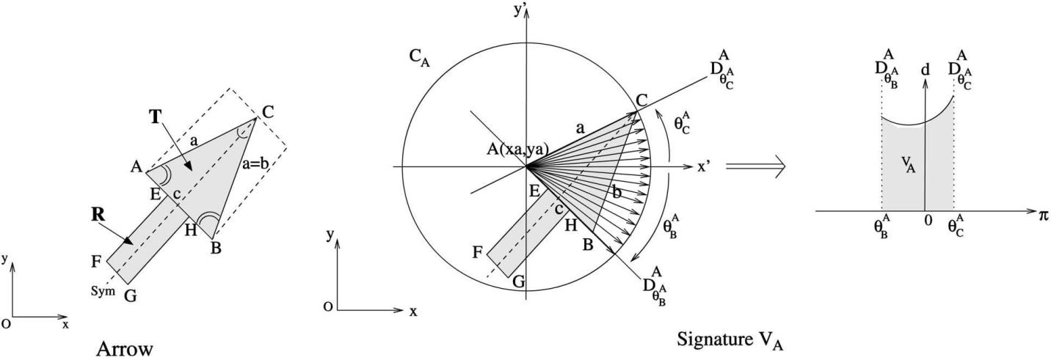

Fig. 1. Discrete signature of an arrow.

|  |  |  |  |  |  |  |  |  |  |  |  |  |  |  |  |  |  |  |  |  |  |  |  |  |  |  |  |  |  |  |  |  |  |  |  |  |  |  |  |  |  |  |  |  |  |  |  |  |  |  |
| --- | --- | --- | --- | --- | --- | --- | --- | --- | --- | --- | --- | --- | --- | --- | --- | --- | --- | --- | --- | --- | --- | --- | --- | --- | --- | --- | --- | --- | --- | --- | --- | --- | --- | --- | --- | --- | --- | --- | --- | --- | --- | --- | --- | --- | --- | --- | --- | --- | --- | --- |
|  |  |  |  | 8 | AC< EC | | | | | | | fð ; < a; a0; AC; EC >Þ | | | | | | | | | | | | |  |  |  |  |  |  |  | [P7] SC is a symmetric map. That is | | | | | | | | | | | | | | IC | 2 VC , there exists a unique | | |  |
|  |  |  |  | > |  |  |  |  |  |  |  |  |  |  |  |  |  |  |  |  |  |  |  |  |  |  |  |  |  |  | I 0 |  |  | such that Symmetric I | | | | | | | | | |  | I 80. There also exists a unique I | | | | |  |
|  |  |  |  | > |  |  |  |  |  |  |  |  |  |  |  |  |  |  |  |  |  |  |  |  |  |  |  |  |  |  |  | V |  |  |
|  |  |  |  | > |  | C |  |  |  | C | |  |  |  |  | C | |  |  |  | C | |  |  |  |  |  |  |  |  | C |  | C |  |  |  |  |  |  |  |  |  | C |  | C |  |  |  | C |  |
|  |  |  |  | > |  | < | | | f ; < a0; a00; | | | |  | ; | | > | |  |  |  |  |  |  | 2 |  |  |  | |  |  |  |  | ð | Þ ¼ |  |  |  |  |
|  |  |  |  | > |  |  |  |  |  |  |  |  |  |  |  |  |  |  |  |  |  |  |  |  |  |  |  |  |  |  |  |  |  |
|  |  |  |  | > |  |  |  |  |  |  |  |  |  |  |  |  |  |  |  |  |  |  |  |  |  |  |  |  |  |  |  |  |  |  | ð |  |  |  | Þ ¼ | |  |  |  |  |  |  |  |  |  |  |
|  |  |  |  | > |  |  |  |  |  |  |  | ð |  |  |  |  |  |  |  |  |  |  |  |  | Þ | | |  |  |  |  |  |  |  | IC | | | IC . | | |  |  |  |  |  |  |  |
|  |  |  |  | > |  | E |  |  | F | |  |  |  | E | |  |  |  | F | |  |  |  |  |  | such that Symmetric | | | | |  |  |  |  |  |  |  |  |  |
|  |  |  |  | > |  |  |  |  |  |  |  |  |  |  |  |  |  |  |  |  |  |  |  |  |  |  |  |  |  |  |  |  |  |  |  |  |  |  |  |  |  |  |  |
| SC |  |  |  | > |  |  | < | | |  |  | f ; < a00; a00; | | | | |  |  |  | ; | |  |  | > | | |  |  |  |  |  | At last, it is easy to show that the signatures V and S keep | | | | | | | | | | | | | | | | | |  |
|  |  | > | C | C | | C | | | C |  |  |  |  |  |  |  |  |  |  |  |  |  |  |  |  |  |  |  |  |  |  |  |  |  |
|  |  |  |  | > |  |  |  |  | ð |  |  |  |  |  |  |  |  |  |  | Þ |  |  |  |  |  |  |  |  |  |  |  |  |  |  |  |  |  |  |  |  |  |  |  |
|  | ð Þ ! < | | | |  | F |  |  | G | |  |  |  |  | F | | |  |  | G | |  |  |  |  |  |  | fundamental geometric properties, useful in a pattern recognition | | | | | | | | | | | | | | | | | | |  |
|  |  |  |  | > |  | C |  |  |  | C | |  |  |  |  | C | |  |  |  | C | |  |  |  |  |  |  |  |  | process such as scale, translation, and rotation. | | | | | | | | | | | | | | | | |  |  |  |
|  |  |  |  | > |  |  |  |  |  |  |  |  |  |  |  |  |  |  |  |  |  |  |  |  |  |  |
|  |  |  |  | > | < | | | | |  |  | f ; < a00; a0; ; > | | | | | | | | | | | | | |  |  |  |  |  |  |  |  |  |  |  |  |  |  |  |  |  |  |  |  |  |  |  |  |  |
|  |  |  |  | > |  |  |  |  |  |  |  |  |  |  |  |  |  |  |  |  |  |  |  |  |  |  |  |  |  |  |  |
|  |  |  |  | > |  |  |  |  |  |  |  | ð |  |  |  |  |  |  |  |  |  |  |  |  |  | Þ | |  |  |  |  |  |  |  |  |  |  |  |  |  |  |  |  |  |  |  |  |  |  |  |
|  |  |  |  | > |  |  |  |  |  |  |  |  |  |  |  |  |  |  |  |  |  |  |  |  |  |  |  |  |  |  |  |  |  |  |  |  |  |  |  |  |  |  |  |  |  |  |
|  |  |  |  | > |  |  |  |  |  | H | |  |  |  |  | G | | |  |  | H | |  |  |  |  |  |  |  |  |  |  |  |  |  |  |  |  |  |  |  |  |  |  |  |  |  |  |  |  |
|  |  |  |  | > G | | |  |  |  |  |  |  |  |  |  |  |  |  |  |  |  |  |  |  |  |  |  |  |  |  |  |  |  |  |  |  |  |  |  |  |  |  |  |
|  |  |  |  | > |  | H |  |  |  |  | B |  | 0 |  | H | |  |  |  | B | |  |  |  |  |  |  |  |  |  |  |  |  |  |  |  |  |  |  |  |  |  |  |  |  |  |  |  |  |  |
|  |  |  |  | > |  | C |  |  |  |  | C | ð |  |  | C | |  |  |  | C | |  |  | Þ | |  |  |  |  |  |  |  |  |  |  |  |  |  |  |  |  |  |  |  |  |  |  |  |  |  |
|  |  |  |  | : |  |  | < |  | |  |  |  |  |  |  |  |  |  |  |  |  |  |  |  |  |  |  |  |  |  |  |  |  |  |  |  |  |  |  |  |  |  |  |  |  |  |
|  |  |  |  | > |  |  |  | f ; < a ; a; ; > : | | | | | | | | | | | | | | | |  |  |  | 3 |  | TRIPLET IDENTIFICATION | | | | | | | | | | | |  |  |  |  |  |  |
|  |  |  |  | > |  |  |  |  |  |  |  |  |  |  |  |  |  |  |  |  |  |  |  |  |  |  |  |  |  |  |  |  |  |  |  |  |  |
| In the continuous case, it is easy to check that all the couples of | | | | | | | | | | | | | | | | | | | | | | | | | | | | | | | Due to noise and digitalization, a binary test is not suitable to check | | | | | | | | | | | | | | | | | | |  |
| signatures Vi | | and Si | | | are equivalent: | | | | | | | |  |  |  |  |  |  |  |  |  |  |  |  |  |  |  |  |  |  | the geometric properties of an arrow using real data. So, the | | | | | | | | | | | | | | | | | | |  |
| [P3] VA , SA, VB , SB, and VC , SC . | | | | | | | | | | | | |  |  |  |  |  |  |  |  |  |  |  |  |  |  |  |  |  |  | definition of discrete criteria is needed. The location of triplets of | | | | | | | | | | | | | | | | | | |  |
|  |  |  |  |  |  |  |  |  |  |  |  |  |  |  |  |  |  | points required for the calculation of such criteria is also presented. | | | | | | | | | | | | | | | | | | |  |
| Now, we can consider the global signature S associated to an | | | | | | | | | | | | | | | | | | | | | | | | | | | | | | |  |
| arrow as a union of signatures: Let t be a translation of , then | | | | | | | | | | | | | | | | | | | | | | | | | | | | | | | 3.1 | | Criteria | |  |  |  |  |  |  |  |  |  |  |  |  |  |  |  |  |
| SðT ABC Þ ¼ SA [ t ðSC Þ [ SB is a complete signature of T . More- | | | | | | | | | | | | | | | | | | | | | | | | | | | | | | |  |  |  |  |  |  |  |  |  |  |  |  |  |  |  |  |
| Let p be the number of bins, that is, the number of angles | | | | | | | | | | | | | | | | | | |  |
| over, S is unique and we can deduce from [P3] the following | | | | | | | | | | | | | | | | | | | | | | | | | | | | | | | considered, of a signature. Each discrete signature is assumed to be | | | | | | | | | | | | | | | | | | |  |
| definition: Let t be a translation of , then V | | | | | | | | | | | | | | T ABC | | | | Þ ¼ | | | | | VA | | | | [ | t | VC | Þ [ | circular, i.e.: V pþi ¼ V i (the signatures are 2 periodic). Let us now | | | | | | | | | | | | | | | | | | |  |
| VB is a complete signature of T (V , T ). | | | | | | | | | | | | |  | ð |  |  |  |  |  |  |  |  | ð | consider a numeric definition of five normalized criteria (Table 1). | | | | | | | | | | | | | | | | | | |  |
|  |  |  |  |  |  |  |  |  |  |  |  |  |  |  |  |  |  |  |
|  |  |  |  |  |  |  |  |  |  |  |  |  |  |  |  |  |  |  | The | | criteria | Sym for symmetry | | | | | | | | | | | is | calculated | to have an | |  |
| So, the mathematical prototypes of signatures which define an | | | | | | | | | | | | | | | | | | | | | | | | | | | | | | | approximation | | | | which | |  |  | combine [P6] and [P7]. Sym is maximal | | | | | | | | | | |  |
| arrow from three edges of an isocel triangle T are set. | | | | | | | | | | | | | | | | | | | | | | | | |  |  |  |  |  |  |  |  |  |
|  |  |  |  |  |  | when the angle t corresponds to the axis of symmetry of the | | | | | | | | | | | | | | | | | | |  |
| If the shape of V is close to the one of S, we can assume that an | | | | | | | | | | | | | | | | | | | | | | | | | | | | | | |  |
| signature. From [P5], the cardinality of VA is close to the one of VB | | | | | | | | | | | | | | | | | | |  |
| arrow is recognized. Furthermore, we can draw the | | | | | | | | | | | | | | | | | | | | | | | | | | | following | | | |  |
| (see criterion Card). An assessment of the degree of nonoverlap is | | | | | | | | | | | | | | | | | | |  |
|  |  |  |  |  |  |  |  |  |  |  |  |  |  |  |  |  |  |  |  |  |  |  |  |  |  |  |  |  |  |  |  |
| properties based on the structure of an arrow to be checked. Since | | | | | | | | | | | | | | | | | | | | | | | | | | | | | | | required to check [P4] (see | | | | | | | | | | | |  |  |  |  |  |  |  |  |
|  |  |  |  |  |  |  |  |  |  |  |  |  |  |  |  |  |  |  |  |  |  |  |  |  |  |  |  |  |  |  | Over). Let K be the common area | | | | | | |  |
| three angles specify a triangle only modulo a scale size [13], there is | | | | | | | | | | | | | | | | | | | | | | | | | | | | | | | carried out from the scans performed from A, B and C during the | | | | | | | | | | | | | | | | | | |  |
| no overlap from the main parts of the signature: | | | | | | | | | | | | | | | | | |  |  | VC | | |  |  |  |  | . |  |  |  | definition of VA, VB and VC . The Heron formula [13] is used to | | | | | | | | | | | | | | | | | | |  |
| [P4] VA |  | t | VC |  |  | VB t | | | VC | | | c , VA | |  | VB |  |  |  |  |  |  |  |  |  |  |  | calculate the area: H ¼ | | | | | |  | pﬃﬃﬃﬃﬃﬃﬃﬃﬃﬃﬃﬃﬃﬃﬃﬃﬃﬃﬃﬃﬃﬃﬃﬃﬃﬃﬃﬃﬃﬃﬃﬃﬃﬃﬃﬃﬃﬃﬃﬃﬃﬃﬃﬃðÞðÞðÞ where | | | | | | | | | |  | ¼ 2 ða þ b þ |  |
| \ ð Þ ¼ \ ð Þ ¼ f g | | | | | | | | | | | | |  | \ \ ¼ ; | | | | | | | | | | | | | |  |  |  |  |  |  |  |  |  |  |  |  | s s | |  | a s | | b | s | c | s | 1 |  |
|  |  |  |  |  |  |  |  |  |  |  |  |  |  |  |  |
|  |  |  |  | cÞ is the semiperimeter. By definition, if the triplet describes a | | | | | | | | | | | | | | | | | | |  |
| Since the triangle associated to the arrow is isocel: | | | | | | | | | | | | | | | | | | | | | | | |  |  |  |  |  |  |  |  |
| [P5] jVAj ¼ jVBj (j:j the area of the signature). | | | | | | | | | | | | | | | | |  |  |  |  |  |  |  |  |  |  |  |  |  |  | triangle | | | in the | image, | | | | | the | |  | value | | of | K must be | | close to the | |  |
|  |  |  |  |  |  |  |  |  |  |  |  |  |  | calculation of the Heron’s formula H. The numerical signature V | | | | | | | | | | | | | | | | | | |  |
| We consider now the symmetric aspect of the signature (see [P1]): | | | | | | | | | | | | | | | | | | | | | | | | | | | | | | |  |
| [P6] There exists a symmetry, such that SymmetricðSAÞ ¼ SB. | | | | | | | | | | | | | | | | | | | | | | | | | | | | | |  | given by the triplet | | | | | | of | | | points is | | | | | matched with its theoretical | | | | |  |

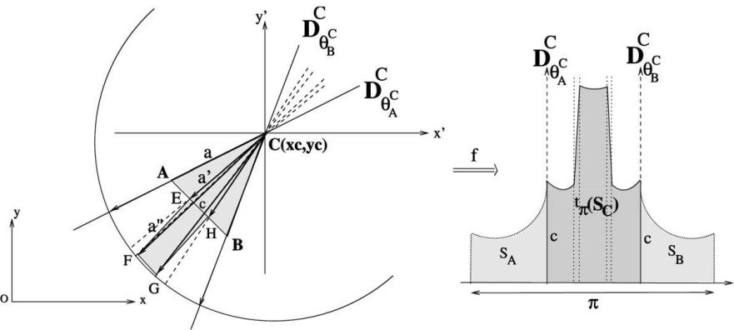

Fig. 2. Signature SC ð Þ.

|  |  |
| --- | --- |
| IEEE TRANSACTIONS ON PATTERN ANALYSIS AND MACHINE INTELLIGENCE, VOL. 26, NO. 7, JULY 2004 | 937 |

TABLE 1

List of Criteria to Be Checked

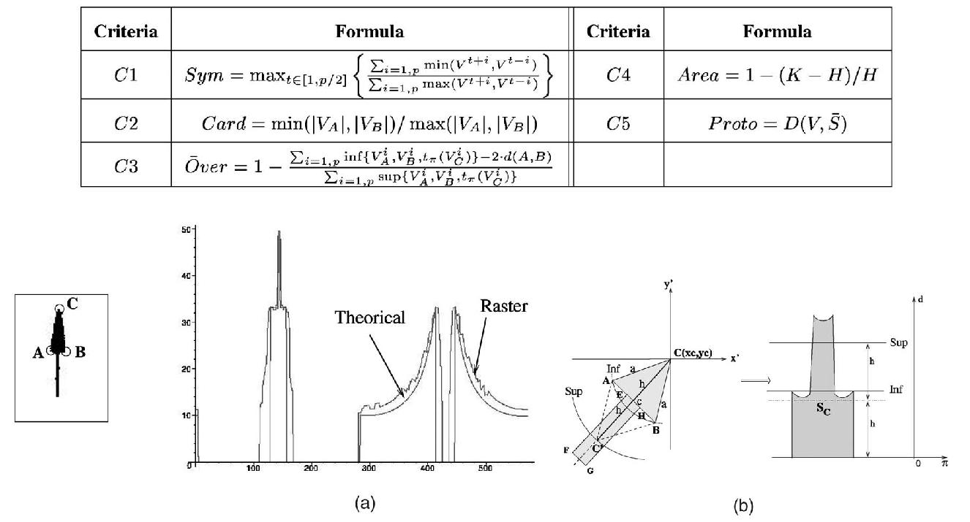

Fig. 3. Signature estimation. (a) Signatures of a noisy arrow. (b) Rectangle estimation.

|  |  |  |
| --- | --- | --- |
| prototype S in order to check [P3] (see | criterion P roto). We |  |
| consider a discretization of S, denoted with |  |  |
| S, and D is a distance, |  |

denoted with jj:jj1. Obviously, other formulae can be used to define such criteria. Nevertheless, the calculation of the features is essentially based on the maximizing of the classical Tanimoto index (min over max), which gives generally accurate results in pattern recognition applications and requires low processing time.

3.2 Cardinal Lists

Four scans of the plane from the four cardinal directions are enough to locate any point of the triplet because the triangle is supposed to be isocel and acute from the point C. Let L ¼ fL1; L2; L3; L4g be the four lists of points found. Let Iij be the value of the point of coordinate ði; j Þ in an image I to be checked. A point added to a list Lu verifies this property: Lu ¼ Lu [ fði; jÞg iff Iij ¼ 1 ^ 8t 6¼ u; ði; jÞ 62 Lt. A pencil of segments is drawn from each candidate point. All the points belonging to the segments and “seen”1 by the selected point are removed to reduce the size of the lists. The image is restored after each scan. For efficiency reasons, Bresenham’s algorithm [14] is used, as it is a fast method which minimizes errors in drawing lines on integer grid points.

3.3 Triplet Checking

The aim is to define a set of triplets to assess from the four lists of points. It is possible to consider all the configurations of points. Nevertheless, the processing time can be high using large documents and many configurations are inconsistent. So, we have imposed some basic constraints to drastically decrease the number of choices:

. Each triplet of points should be in the same connected component.

. Each point of the triplets should be “seen” by the others (or at least from one).

. The selected points belong to distinct lists.

When a triplet is set, three combinations of points are assessed using the Choquet integral (see Section 3) to determine which point is the more possible head of the arrow. If the triplet is recognized as an arrow, the points are removed from the cardinal lists (except for the occlusions).

3.4 Discrete Signature Estimation

Since line drawings are often noisy, the starting areas correspond-ing to A, B, and C are adjusted within a circle with radius r (here, r is set to 1). We select the better starting points which maximize the main aspect of the signature. Fig. 3a shows a degraded arrow and the superimposed signatures reached from the local points found. The shape of the raster signature is close to its theoretical approximation.

The length of the spike (coming from VC ) corresponds to queue of the arrow which can be very long. We notice that the longer the rectangle is, the less the accuracy between the two signatures is. For the calculation of the criterion C5, we need to estimate the rectangle (EFGH). According to our model, an arrow without a rectangle is assumed to be a degenerated arrow and should have a lower recognition rate. For this reason, two boundaries (Inf and Sup) are set for the size of the rectangle (see Fig. 3b). If no rectangle is found, the estimation of the theoretical signature is assumed to be the same as that of a minimal rectangle signature (Inf) with a width of ½AB&=2. The size of superior boundaries Sup is set by default as been twice the height of the triangle (see the rhombus ðCBC0AÞ on Fig. 3b).

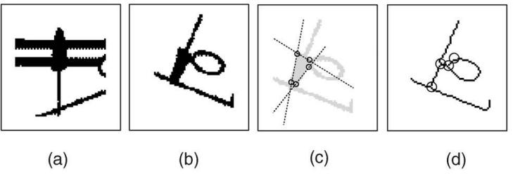

1. We mean by “seen” that the segment which links these two points

remain entirely in the connected component, including the pairwise points. Fig. 4. Occluded arrows.

938 IEEE TRANSACTIONS ON PATTERN ANALYSIS AND MACHINE INTELLIGENCE, VOL. 26, NO. 7, JULY 2004

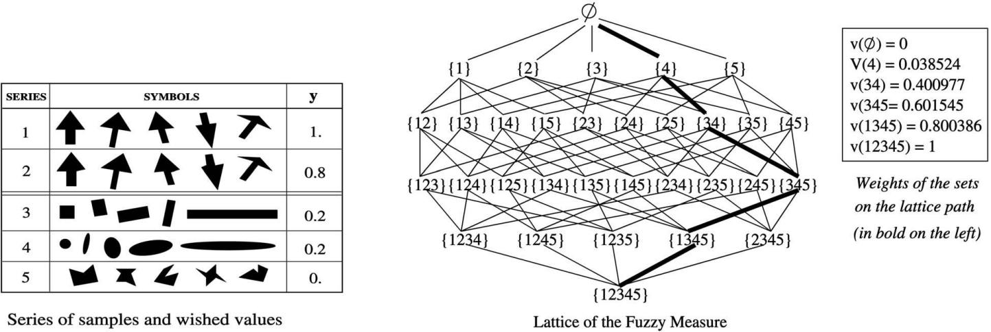

Fig. 5. Fuzzy measure defintion.

3.5 Robustness to Occlusions

When three edges of the triangle are clearly found from the cardinal lists step (in this case, there is no occlusion points in the vicinity of the three edges), our approach allows to find correctly an arrow even if parts of the symbol are occluded (see Fig. 4a). Additive data do not interfere with the general structure of the final signature.

In addition to the cardinal lists, we set a list of occlusion points to deal with degenerate cases. We consider an arrow as being degenerated when it is linked to a another symbol or a character or a line in a document (see Fig. 4b). The occlusion points are defined from skeletonization and pruning steps [15]. In this case, we consider more than three points (see Fig. 4c) and the new three edges of the triangle are defined from the intersection lines passing by points provided by the triplet checking step and the occlusion list.

1. ARROW RECOGNITION

4.1 Choquet Integral

A first idea to merge the criteria defined previously may be to use a weighted sum. We can directly think that [C1], [C3], and [C5] are the main criteria, but which is the most important? Furthermore, all criteria should contribute as they are all defined from the basic structure of an arrow. Such a dependence cannot be taken into account using classical combinations. So, we have based our

TABLE 2

Importance of Criteria and Interaction between Them

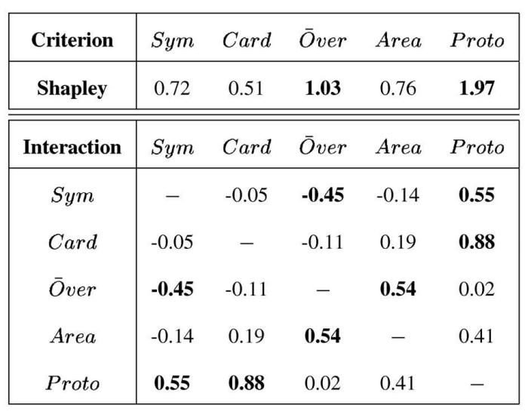

aggregation on the Choquet integral concept which is a general-ization of Lebesgue integral and whose use was proposed by many authors (see [16], [17]). Let N ¼ f1; 2; . . . ; ng be a finite set of

* criteria—n ¼ 5 in our study—and let A ¼ fxigi¼1;l be a finite set of
* alternatives. Let v be a fuzzy measure on N such that [18], [19]:

vð;Þ ¼ 0, vðNÞ ¼ 1, and S T ) vðSÞ vðT Þ. Let us now consider an alternative xi ¼ ðxi1; . . . ; xinÞ where xi is an n-dimensional input vector containing the degree of satisfaction of object i with respect to criteria 1 to n [17]. 8v 2 PN , i.e., the power of N (number of subsets of

* ), the Choquet integral of x 2 IRn is defined by:

Xn

CvðxÞ :¼ xðjÞ½vðAðjÞÞ vðAðjþ1ÞÞ&;

j¼1

where ð:Þ is a permutation of N such that xð1Þ . . . xðnÞ and AðjÞ ¼ fðjÞ; . . . ; ðnÞg represents the ½j::n& associated criteria in increasing order.

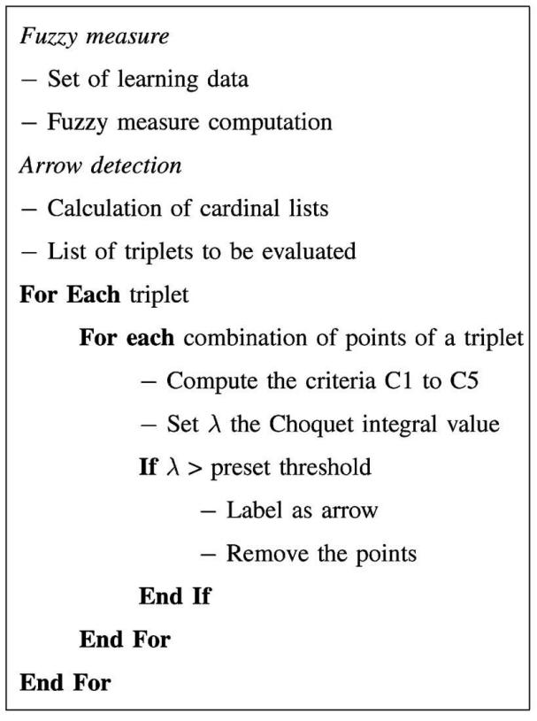

Fig. 6. Overall description of our method.

|  |  |
| --- | --- |
| IEEE TRANSACTIONS ON PATTERN ANALYSIS AND MACHINE INTELLIGENCE, VOL. 26, NO. 7, JULY 2004 | 939 |

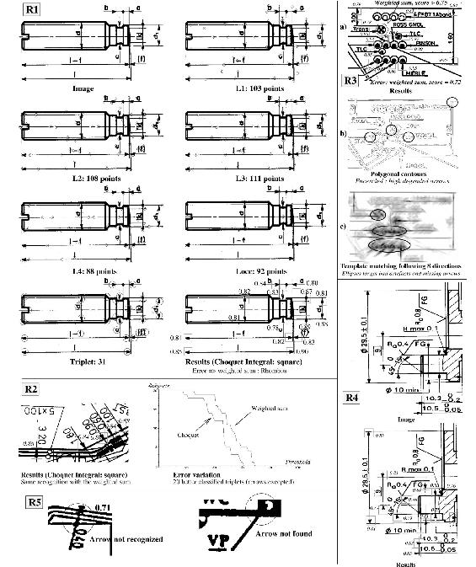

Fig. 7. Engineering drawings.

4.2 Fuzzy Measure

The calculation of the Choquet integral requires the definition of a fuzzy measure. That is, the assessment of any set v of PN with N ¼ 5 criteria in our study. By definition, vð;Þ ¼ 0 and vðf1; . . . ; NgÞ ¼ 1. There exists several ways to automatically set the 2N 2 remaining values [16], [18]. The main problem is to give a value to the sets having more than three elements while keeping the monotonicity

property of the integral. We consider here the definition of the fuzzy measure from a set of learning data. Fig. 5 presents five series of discrete samples. The value y represents the wished value after the calculation of the Choquet integral on all the examples of the series from the five criteria defined previously. Suppose that ðxi; yiÞi¼1;m are m learning data where xi is an alternative and yi is the global evaluation of object i. Then, the best fuzzy measure is identified in

A N fxi;xj g

X ðAÞ ¼

940 IEEE TRANSACTIONS ON PATTERN ANALYSIS AND MACHINE INTELLIGENCE, VOL. 26, NO. 7, JULY 2004

such a way that E2 ¼ Pmi¼1ðCvðxiÞ yiÞ2 is minimized. Generally, the problem is translated to another minimization problem which is usually solved using the Lemke method. Grabisch [16] has shown that such an approach may be inconsistent using a low number of samples—ill-conditioned matrices—and the constraint matrix be-comes parser when the set of alternatives grows causing bad behaviors of the algorithm. To overcome these problems, an optimal approach based on a gradient algorithm with constraints, which is an extension of the Muroshi and Sugeno’s method [18], has been proposed in [20]. First, the fuzzy measure coefficients are set to a weighted sum. The modification of the weights is done following the path (fuzzy measure represented by a lattice of weighted sets as in Fig. 5) defined by the values of each learning data (criteria and input). Such an approach, used here, is fast and keeps the monotonicity even if the number of data is weak. The algorithm is described in the reference [20] and its implementation is easy.

An example is provided here to show the decomposition of the Choquet integral. The calculation of the criteria on the arrow of

|  |  |  |  |
| --- | --- | --- | --- |
| Fig. 3 gives | the following alternative: Sym ¼ 0:87, Card ¼ 0:85, | |  |
|  | Area ¼ 1, and P roto ¼ 0:88. The calculation | of |  |
| Over ¼ 0:94, |  |
| Choquet integral gives a high score of recognition (see Fig. 5 | | for |  |
| the weights of the sets): | |  |  |

Cv ¼ 1: vð4Þ þ 0:94 ½vð34Þ vð4Þ& þ 0:88 ½vð345Þ vð34Þ&

* 0:87 ½vð1345Þ vð345Þ& þ 0:85 ½vð12345Þ vð1345Þ& ¼ 0:91:

Significant criteria as well as both negative and positive interaction

effects can be established from the values of the sets. The importance

of each criterion [16] is based on the definition proposed by Shapley

|  |  |  |  |  |
| --- | --- | --- | --- | --- |
| in game theory [21] and puts back to fuzzy measure context by | | | | |
| Murofushi and Soneda [22]: ðxiÞ = | | |  | A N fxi g XðAÞ vðA [ |
| fxigÞ vðAÞ with XðAÞ ¼ ðjNj jjNjj! | | Þ j | j . The Shapley value is | |
|  | A | 1 ! | AP! |  |

scaled by 5 (the number of criteria) and, so, an importance index greater than 1 describes an attribute more important than the

average. Table 2 shows that the main criteria are and

Over P roto

(and not Sym!).

Such a definition has been extended in [22] to measure the interaction index between criteria as follows (values in ½ 1; 1&):

IðvÞðxi; xjÞ ¼ P X ðAÞIðvÞðxi; xjjAÞ with:

ð jNj jAj 2Þ! jAj!

ðjNj 1Þ!

and

IðvÞðxi; xjjAÞ ¼ vðA [ fxi; xjgÞ vðA [ fxigÞ vðA [ fxjgÞ þ vðAÞ:

Both negative and positive correlations exist between criteria; in

particular, between , , , and Card Proto Sym Proto Over Area

(negative). According to the learning samples used to Sym Over

define the fuzzy measure, we set a threshold of 0.75 to consider if a

triplet is recognized or not as an arrow after the calculation of the

Choquet integral. To summarize, we give the overall algorithm of

our approach in Fig. 6.

1. EXPERIMENTAL RESULTS

Our approach has been applied on several types of line drawings and the obtained results are satisfactory. The method has required four seconds on the line drawings in Fig. 7 (R1) and 17 seconds in Fig. 7 (R4) without code optimization. The definition of the cardinal lists and the recognition step depend on the number of triplets and are linear in time processing. So, our approach is amenable to parallel processings. Moreover, the learning of the

fuzzy measure (around 2”30s to learn the data) is independant of the application and performed only once.

Fig. 7 (R1) shows the application of our approach for an engineering drawing. The circles in images L1; L2; L3; L4 corre-sponds to the points of the cardinal lists. The list of occluded points is referred to Locc. The image Triplet provides the location of the triplets selected from the triplet checking step. The last image shows the detected arrows (identified by square boxes) and their associated score. To have an idea of Choquet integral interest, we have compared our approach with the classical weighted sum defined from the Shapley values. In this respect, we notice that the character f is recognized as an arrow (see the rhombus in Fig. 7 (R1)) using a classical weighted sum. The graph given in Fig. 7 (R2) shows the error rate of symbols classified as arrow. We notice from the graph that the aggregation is more discriminant using Choquet integral rather than the classical weighted sum. Such a result is confirmed by the experiment in Fig. 7 (R3a) where several symbols are misclassified or not recognized using the weighted sum. Fig. 7 (R4) shows the robustness of our approach on other distorted arrows. We notice that when the data are too noisy or when the arrows are too thin or very occluded, our method will obviously provide less accurate results (see Fig. 7 (R5)). We have also compared our approach with polygonal and template matching approaches. To better vizualize the problem, the correlation image is provided in Fig. 7 (R3b). Black areas correspond to a high correlation. We can remark that, in many configurations these approaches do not work (see the elements encircled in Fig. 7 (R3b and R3c).

1. CONCLUSION

In this paper, we have shown that the definition of angular and theoretical signatures and the aggregation of geometric criteria using the Choquet integral allow to achieve a robust detection of arrows. Currently, we focus on a subpixel definition to decrease the aliasing resulting from Bresenham’s algorithm in order to increase the accuracy of our method. The extraction of text boxes in line drawings from the set of detected arrows is also under consideration. Finally, we want to generalize our approach to other families of symbols having well-known geometric properties.

ACKNOWLEDGMENTS

The authors are thankful for the many constructive and detailed comments and suggestions provided by the reviewers of this paper, which helped improve its organization and content.

REFERENCES

1. L.P. Cordella and M. Vento, “Symbol Recognition in Documents: A Collection of Techniques?” Int’l J. Document Analysis and Recognition, vol. 3, no. 2, pp. 73-88, 2000.
2. J. Wood, “Invariant Pattern Recognition: A Review,” Pattern Recognition, vol. 29, no. 1, pp. 1-17, 1996.
3. S.O. Belkasim, M. Shridar, and M. Ahmadi, “Pattern Recognition with Moment Invariants: A Comparative Study and New Results,” Pattern Recognition, vol. 24, pp. 1117-1138, 1991.
4. F. Ghorbel, “A Complete Invariant Description for Gray Level Images by Harmonic Analysis Approach,” Pattern Recognition Letters, vol. 15, pp. 1043-1051, 1994.
5. M. Maes, “Polygonal Shape Recognition Using String-Matching Techni-ques,” Pattern Recognition, vol. 24, no. 5, pp. 433-440, 1991.
6. D. Dori and Y. Velkovitch, “Segmentation and Recognition of Dimension-ing Text from Engineering Drawings,” Computer Vision and Image Under-standing, vol. 69, no. 2, pp. 196-201, 1998.
7. I. Chai and D. Dori, “Extraction of Text Boxes from Engineering Drawings,”

Proc. SPIE/IS&T Symp. Electronic Imaging Science and Technology, Conf. Character Recognition and Digitizer Technologies, pp. 38-49, 1992.

1. G. Priestnall, R.E. Marston, and D.G. Elliman, “Arrowhead Recognition During Automated Data Capture,” Pattern Recognition Letters, vol. 17, no. 3, pp. 277-286, 1996.

IEEE TRANSACTIONS ON PATTERN ANALYSIS AND MACHINE INTELLIGENCE, VOL. 26, NO. 7, JULY 2004 941

1. C. Ah-Soon and K. Tombre, “Architectural Symbol Recognition Using a Network of Constraints,” Pattern Recognition Letters, vol. 22, no. 2, pp. 231-248, 2001.
2. B.T. Messmer and H. Bunke, “Automatic Learning and Recognition of Graphical Symbols in Engineering Drawings,” Graphics Recognition: Methods and Applications, R. Kasturi and K. Tombre, eds., pp. 123-134, Springer-Verlag, 1996.
3. C. Tappert, C. Suen, and T. Wakahara, “The State of the Art in Online Handwriting Recognition,” IEEE Trans. Pattern Analysis and Machine Intelligence, vol. 12, pp. 787-808, 1990.
4. E. Valveny and E. Martı´, “Learning of Structural Descriptions of Graphics Symbols Using Deformable Template Matching,” Proc. Sixth Int’l Conf. Document Analysis and Recognition, pp. 455-459, 2001.
5. E.W. Weissten, CRC Concise Encyclopedia of Mathematics. Chapman & Hall/ CRC, 1999.
6. J.E. Bresenham, “Algorithm for Computer Control of a Digital Plotter,” IBM Systems J., vol. 4, no. 1, pp. 25-30, 1965.
7. C.P. Lai and R. Kasturi, “Detection of Dimension Sets in Engineering Drawings,” Proc. Second Int’l Conf. Document Analysis and Recognition,
   1. 606-613, 1993.
8. M. Grabisch, “The Application of Fuzzy Integral in Multicriteria Decision Making,” European J. Operational Research, vol. 89, pp. 445-456, 1995.
9. J.-L. Marichal and M. Roubens, “Determination of Weights of Interacting Criteria from a Reference Set,” European J. Operational Research, vol. 124, no. 3, pp. 641-650, 2000.
10. T. Murofushi and M. Sugeno, “An Interpretation of Fuzzy Measure as an Integral with Respect to a Fuzzy Measure,” Fuzzy Sets and Systems, vol. 29,
    1. 201-227, 1989.
11. M. Sugeno, “Fuzzy Measures and Fuzzy Integrals—A Survey,” Fuzzy Automata and Decision Processes, M.M. Gupta, G.N. Saridis, and B. Gains, eds., North-Holland, 1977.
12. M. Grabisch, “A New Algorithm for Identifying Fuzzy Measures and Its Application to Pattern Recognition,” Proc. Seventh IEEE Int’l Conf. Fuzzy Systems, vol. 1, pp. 145-150, 1995.
13. L. Shapley, “A Value for N-Person Games,” Contributions to the Theory of Games, Annals of Math. Studies, H. Khun and A. Tucker, eds., vol. 2, pp. 307-317, Princeton Univ. Press, 1953.
14. T. Murofushi and S. Soneda, “Techniques for Reading Fuzzy Measure (III): Interaction Index,” Proc. Ninth Fuzzy System Symp., pp. 693-696, 1993.

* For more information on this or any other computing topic, please visit our Digital Library at www.computer.org/publications/dlib.