- 脚本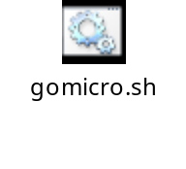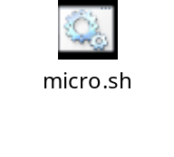
- 创建镜像：
docker run -it -v /opt:/wz -p 8080:8080 -p 8081:8081 -p 8082:8082 --name gomicro centos:latest /sbin/init
-v是将主机的/opt目录映射到容器的/wz目录，所有在主机的/opt下载资源可以给容器使用
2、进入镜像
docker exec -it gomicro /bin/bash
3、安装golang
在主机：
wget https://studygolang.com/dl/golang/go1.9.2.linux-amd64.tar.gz
tar zxvf go1.9.2.linux-amd64.tar.gz
在容器：
mv go /usr/local/
cd /;mkdir Golang
cd Golang;mkdir src;mkdir pkg;mkdir bin
在/etc/profile文件尾部添加下面内容：
export GOROOT=/usr/local/go
export GOBIN=$GOROOT/bin
export GOPKG=$GOROOT/pkg/tool/linux_amd64
export GOARCH=amd64
export GOOS=linux
export GOPATH=/Golang
export PATH=$PATH:$GOBIN:$GOPKG:$GOPATH/bin
source /etc/profile
注意：解压文件时遇到系统时间不对的问题：
安装ntpdate工具
# yum -y install ntp ntpdate
设置系统时间与网络时间同步
# ntpdate cn.pool.ntp.org
将系统时间写入硬件时间
# hwclock --systohc
[root@a3bb11f6b1fa Golang]# go version
go version
go1.9.2 linux/amd64
- 安装micro环境
  - 依赖
yum install -y git wget
  - 依赖 etcd(服务发现)
go get -u -v github.com/coreos/etcd
(如果失败，就到github上直接下载移动到指定目录：src/github.com/coreos/etcd/)
cd etcd;./build;./bin/etcd &
  - Go micro
go get -u -v github.com/micro/go-micro
go get -u -v github.com/micro/protobuf/{proto,protoc-gen-go}
(https fetch failed: Get https://golang.org/x/net)想办法在github上下载
cd /Golang/src/golang.org/x/
git clone https://github.com/golang/text.git
git clone https://github.com/golang/net.git
git clone https://github.com/golang/crypto.git
  - Toolkit
go get -u -v github.com/micro/micro
go get -u -v github.com/micro/go-plugins
  - 例子
go get -u -v github.com/micro/examples
  - 运行例子适配etcd.
/Golang/src/github.com/micro/examples/greeter/
    - micro
cd /Golang/src/github.com/micro/micro
vim plugins.go 添加
package main
import _ "github.com/micro/go-plugins/registry/etcdv3"
go build -i -o micro ./main.go ./plugins.go
go install
后台运行
micro --registry=etcdv3 --registry_address=127.0.0.1:2379 api &
    - api
cd /Golang/src/github.com/micro/examples/greeter/api
vim plugins.go 添加
package main
import _ "github.com/micro/go-plugins/registry/etcdv3"
go build -i -o api ./api.go ./plugins.go (名字和目录一致)
go install
后台运行
api --registry=etcdv3 --registry_address=127.0.0.1:2379 &

    - srv
cd /Golang/src/github.com/micro/examples/greeter/srv
vim plugins.go 添加
package main
import _ "github.com/micro/go-plugins/registry/etcdv3"
go build -i -o srv ./main.go ./plugins.go
go install

go build 报错：
(cannot find google.golang.org/grpc)
mkdir google.golang.org;cd google.golang.org
git clone https://github.com/grpc/grpc-go.git
mv grpc-go grpc
git clone https://github.com/google/go-genproto.git
mv go-genproto genproto
进入srv
然后重新go build;go install
后台运行
srv --registry=etcdv3 --registry_address=127.0.0.1:2379 &
    - 查看服务发现
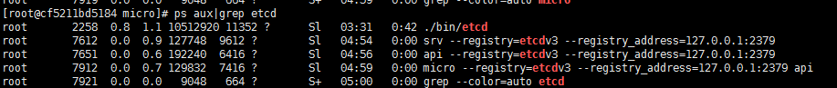
    - 访问
curl http://localhost:8080/greeter/say/hello?name=John
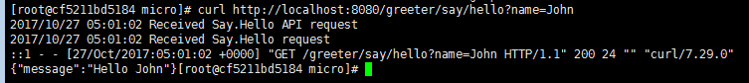

- 将被安装好的环境打包
docker export gomicro > gomicro.tar
- 将环境导入成镜像
docker import gomicro.tar gomicro
docker images
docker run -it -v /opt:/wz -p 8080:8080 -p 8081:8081 -p 8082:8082 --name gomicro gomicro /sbin/init

