运行日志
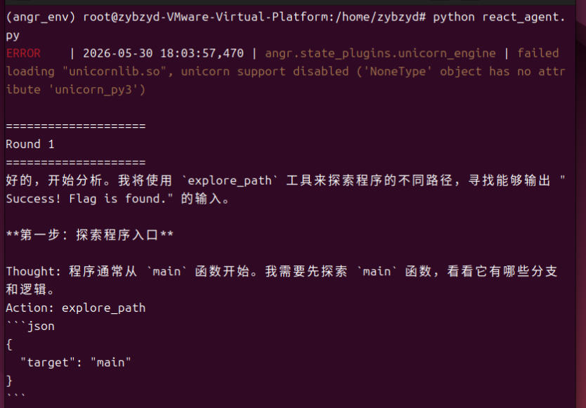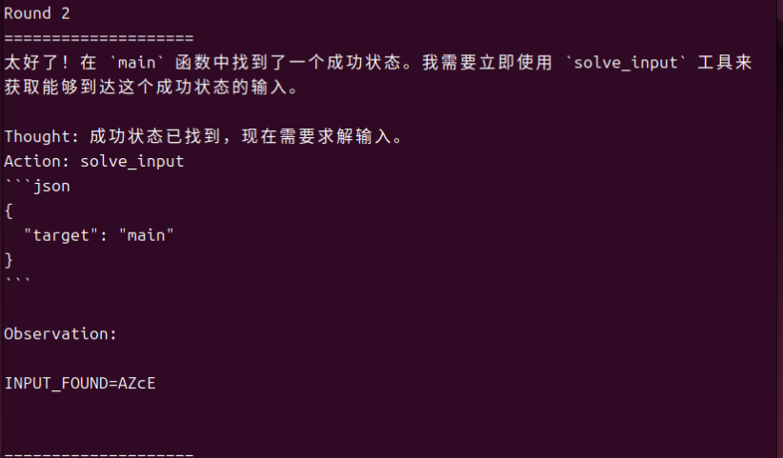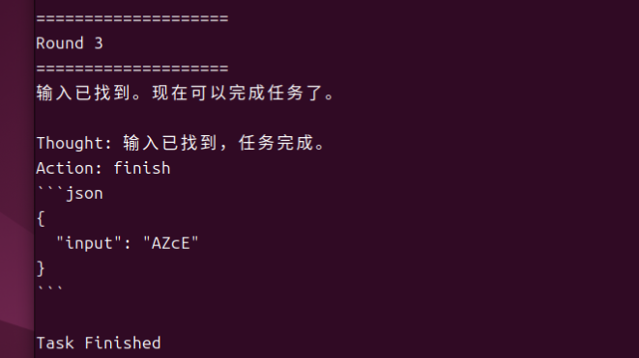
(angr_env) root@zybzyd-VMware-Virtual-Platform:/home/zybzyd# python react_agent.py
ERROR | 2026-05-30 18:03:57,470 | angr.state_plugins.unicorn_engine | failed loading "unicornlib.so", unicorn support disabled ('NoneType' object has no attribute 'unicorn_py3')

====================
Round 1
====================
好的，开始分析。我将使用 `explore_path` 工具来探索程序的不同路径，寻找能够输出 "Success! Flag is found." 的输入。

**第一步：探索程序入口**

Thought: 程序通常从 `main` 函数开始。我需要先探索 `main` 函数，看看它有哪些分支和逻辑。
Action: explore_path
```json
{
"target": "main"
}
```
WARNING | 2026-05-30 18:03:59,558 | angr.simos.simos | stdin is constrained to 5 bytes (has_end=True). If you are only providing the first 5 bytes instead of the entire stdin, please use stdin=SimFileStream(name='stdin', content=your_first_n_bytes, has_end=False).
WARNING | 2026-05-30 18:03:59,868 | angr.storage.memory_mixins.default_filler_mixin | The program is accessing memory with an unspecified value. This could indicate unwanted behavior.
WARNING | 2026-05-30 18:03:59,868 | angr.storage.memory_mixins.default_filler_mixin | angr will cope with this by generating an unconstrained symbolic variable and continuing. You can resolve this by:
WARNING | 2026-05-30 18:03:59,868 | angr.storage.memory_mixins.default_filler_mixin | 1) setting a value to the initial state
WARNING | 2026-05-30 18:03:59,868 | angr.storage.memory_mixins.default_filler_mixin | 2) adding the state option ZERO_FILL_UNCONSTRAINED_{MEMORY,REGISTERS}, to make unknown regions hold null
WARNING | 2026-05-30 18:03:59,868 | angr.storage.memory_mixins.default_filler_mixin | 3) adding the state option SYMBOL_FILL_UNCONSTRAINED_{MEMORY,REGISTERS}, to suppress these messages.
WARNING | 2026-05-30 18:03:59,868 | angr.storage.memory_mixins.default_filler_mixin | Filling memory at 0x7ffffffeff53 with 5 unconstrained bytes referenced from 0x500010 (strlen+0x0 in extern-address space (0x10))
WARNING | 2026-05-30 18:03:59,869 | angr.storage.memory_mixins.default_filler_mixin | Filling memory at 0x7ffffffeff70 with 8 unconstrained bytes referenced from 0x500010 (strlen+0x0 in extern-address space (0x10))

Observation:

SUCCESS_STATE_FOUND=True
FOUND_STATES=1

====================
Round 2
====================
太好了！在 `main` 函数中找到了一个成功状态。我需要立即使用 `solve_input` 工具来获取能够到达这个成功状态的输入。

Thought: 成功状态已找到，现在需要求解输入。
Action: solve_input
```json
{
"target": "main"
}
```

Observation:

INPUT_FOUND=AZcE

====================
Round 3
====================
输入已找到。现在可以完成任务了。

Thought: 输入已找到，任务完成。
Action: finish
```json
{
"input": "AZcE"
}
```

Task Finished

思考题
在本实验中，LLM 主要承担决策与编排的角色，而 angr 负责底层符号执行。LLM 根据当前 Observation 判断下一步应该调用哪个工具，例如在发现成功状态后调用输入求解工具，在尚未发现目标状态时继续进行路径探索。LLM 本身不直接求解程序约束，而是负责组织分析流程并选择合适的工具。
纯符号执行在面对复杂程序时容易产生路径爆炸问题，大量分支会导致状态空间迅速增长。LLM 可以利用语义信息和任务目标，对搜索方向进行引导。例如本实验中，目标明确为到达输出“Success! Flag is found.”的路径，并尽量避免进入包含“trapped”或死循环的路径。通过将这些目标和约束显式地提供给 LLM，Agent 能够优先选择更有价值的探索方向，从而减少无效路径搜索，提高分析效率。

