测试报告

1 测试概述
本次测试会涉及到从句类型、比较句、动名词、不定式、词汇检测、情态动词检测、完成时检测、词性检测、句子类型检测、虚拟语气检测。对于每一个类型都会从边界条件，句子边界和性能三个角度进行测试。

2 单一语法类型测试结果

2.1 动名词

2.1.1 典型测试用例
编号 | 句子 | Json格式结果
1 | I enjoy swimming. | 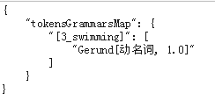
2 | Auto-stor uses a re-direct method via symbolic links that is adequate for viewing files , but slow when retrieving them . | 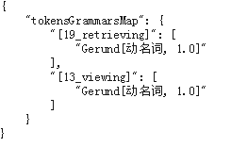
3 | I am not happy. | {}

2.1.2 性能
句子平均长度 | 性能 | 说明
22 | 716.589/秒 | 无

2.2 词性检测

2.2.1 典型测试用例
编号 | 句子 | Json格式结果
1 | Shall we watch the baseball game on TV? | 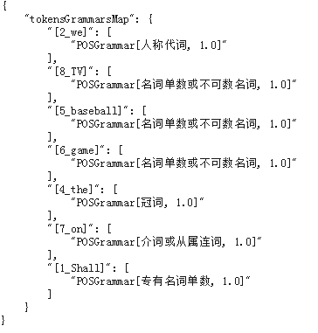
2 | It is a dangerous road to take through the mountains . | 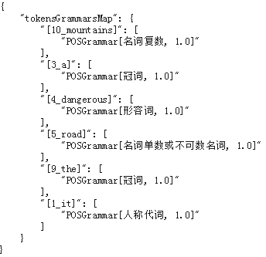
3 | hey , hey , hey , slow down now . | 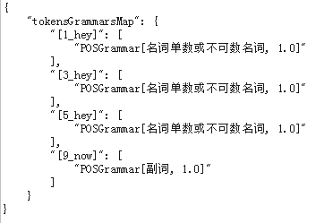

2.2.2 性能
句子平均长度 | 性能(句子数量/秒) | 说明
22 | 694.107 | 无

2.3 情态动词

2.3.1 典型测试用例
编号 | 句子 | Json格式结果
1 | You can enter if you have a ticket. | 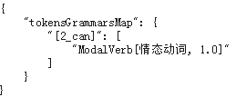
3 | May I use your bathroom? | 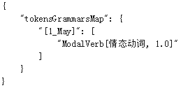
4 | I must attend the meeting. | 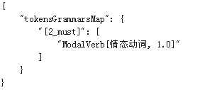
5 | You should exercise every day. | 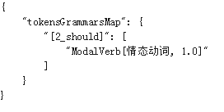
6 | I will do my best in my new job. | 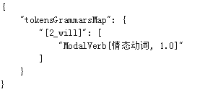
7 | Shall I buy some milk? | 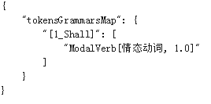

2.3.2 性能
句子平均长度 | 性能 | 说明
22 | 746.937/秒 | 无

2.4 完成时检测

2.4.1 典型测试用例
编号 | 句子 | Json格式结果
1 | I have known Paul since we were children. | 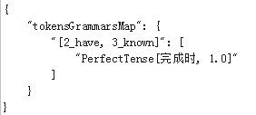
3 | He hasn't been here since last night. | 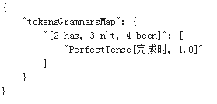
4 | Have you been here since last night? | 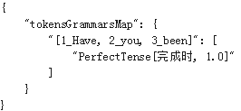
5 | I haven’t yet decided whether I will attend the party. | 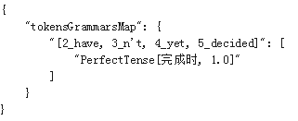
6 | My father has given up alcohol. | 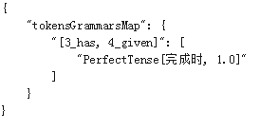
7 | Henry has just finished his homework. | 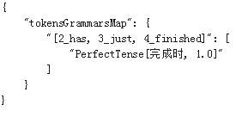
8 | The man had run away when the police arrived. | 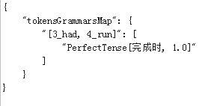

2.4.2 性能
句子平均长度 | 性能 | 说明
22 | 697.252/秒 | 无

2.5 词汇检测

2.5.1 典型测试用例
编号 | 句子 | Json格式结果
1 | I enjoy swimming. | 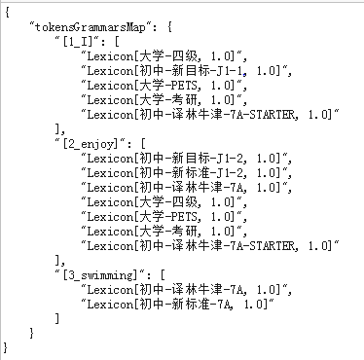
2 | Auto-stor uses a re-direct method via symbolic links that is adequate for viewing files , but slow when retrieving them .
3 | well , the one thing we might have to slow down is a commitment we made | 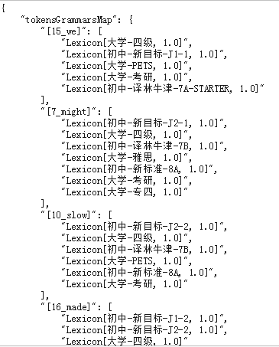

2.5.2 性能
句子平均长度 | 性能 | 说明
22 | 1223.739/秒 | 无

2.6 句子类型检测

2.6.1 典型测试用例
编号 | 句子 | Json格式结果
1 | What a beautiful stone this is! | 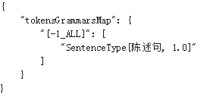
2 | Are you hungry? | 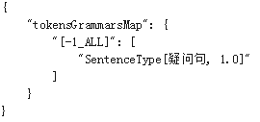
3 | My sister is a college student. | 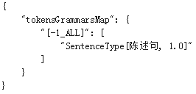

2.6.2 性能
句子平均长度 | 性能 | 说明
22 | 1027.524/秒 | 无

2.7 虚拟语气检测

2.7.1 典型测试用例
编号 | 句子 | Json格式结果
1 | It will take time to have its full impact. | 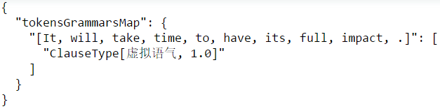
2 | I wish I hadn’t bought such an expensive bag. | 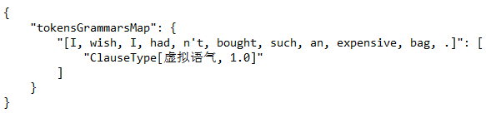
3 | I wish my father would give up smoking. | 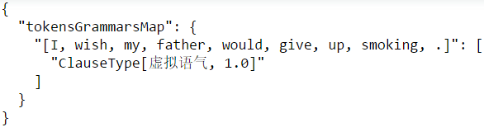
4 | If you were to present her with a bunch of roses, she would be pleased. | 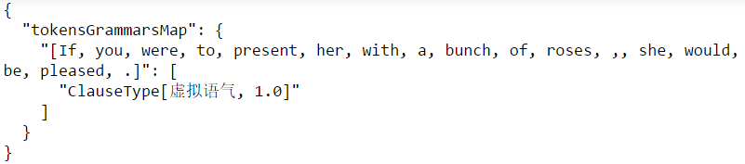
5 | Were I you, I would ask her a date. | 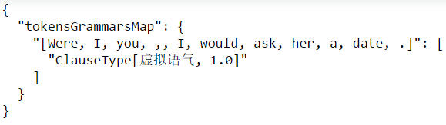
6 | Living in this country, she would have lived a happy life. | 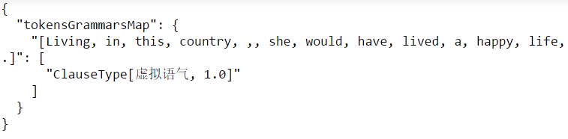
7 | It's about time you apologized to her for what you did. | 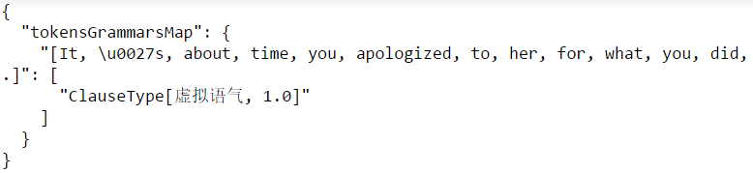
8 | Even if he were here, he could not solve the problem. | 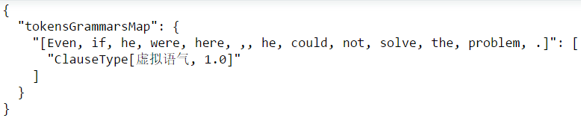
9 | I would rather you hadn't treated the beggar like that. | 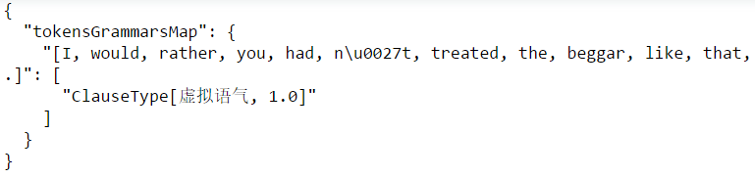
10 | I was ill, but i wish I had attended my friend's birthday party last night. | 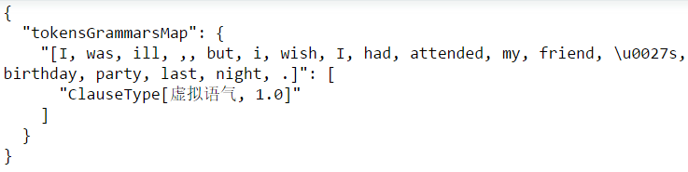
11 | But for your help, we couldn’t have succeeded. | 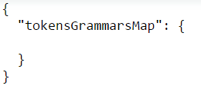
12 | The proposal that he should be dismissed was supported at the meeting. | 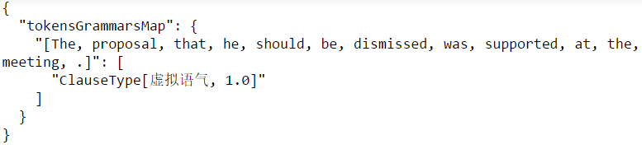
13 | It is time we started. | 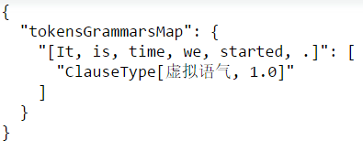
14 | Without electricity, human life would be quite difficult today. | 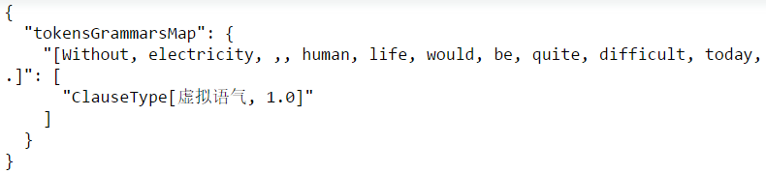
15 | Mike’s father, as well as his mother, insisted he stay home. | 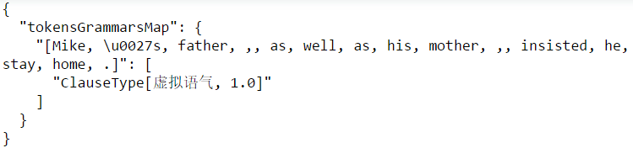
16 | Should he agree to go there, we would send him there. | 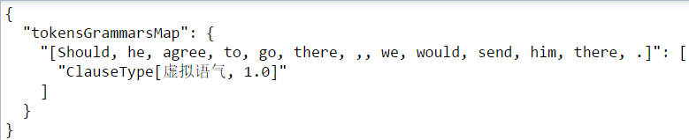
17 | You could have passed this exam. | 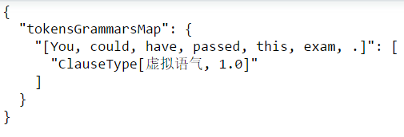
18 | Though he should often be late, he is a good student. | 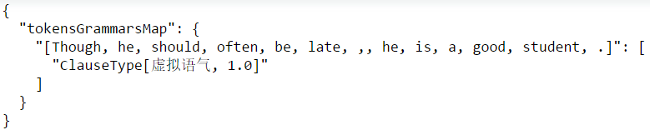
19 | I was astonished that he should not answer such an easy question. | 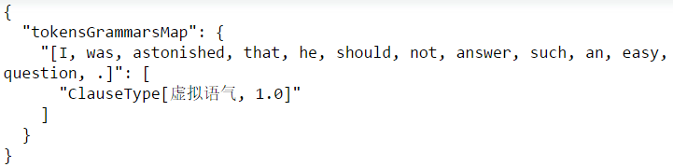
20 | I consider it vital that he should think deeply before acting. | 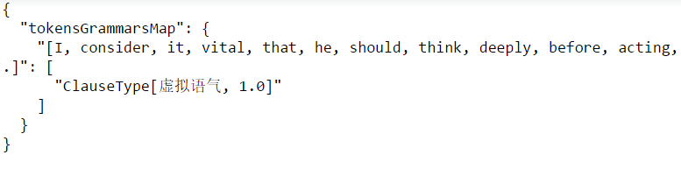

2.7.2 性能
句子平均长度 | 性能 | 说明
22 | 5.5/秒 | 无

2.8 从句类型检测

2.8.1 典型测试用例
编号 | 句子 | Json格式结果
1 | That he is still alive is a wonder. | 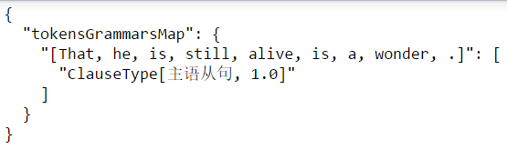
2 | When we arrive doesn’t matter. | 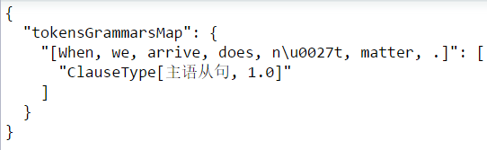
3 | What we need is money. | 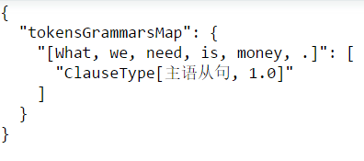
4 | What’s done is done. | 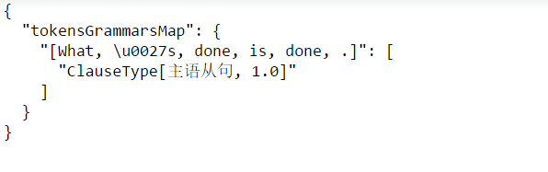
5 | What make the river more beautiful are the lotus plants growing in the water. | 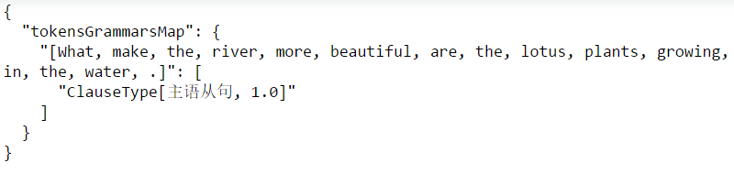
6 | What struck me was that they have all suffered a lot. | 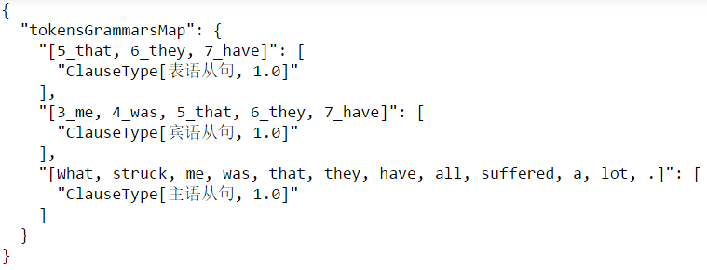
7 | I didn’t know whether they liked the place. | 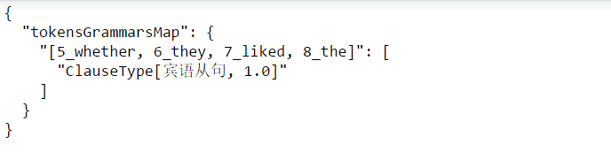
8 | Tomorrow at this time we’ll know who is elected. | 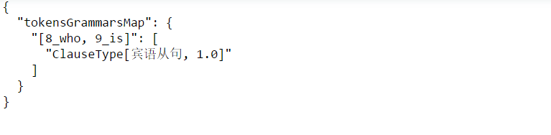
9 | We didn’t know why he had answered in that fashion. | 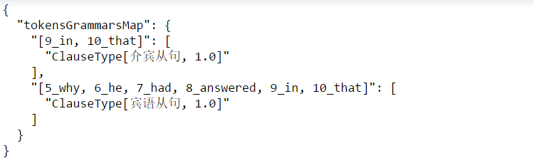
10 | He asked why he had to go alone. | 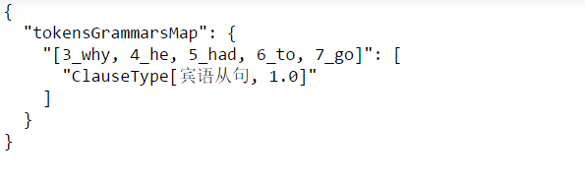
11 | Give it to whoever you like. | 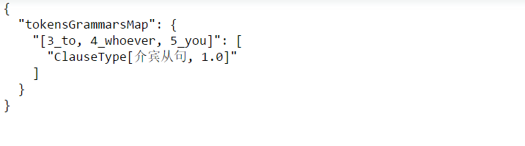
12 | My suggestion is that we should tell him. | 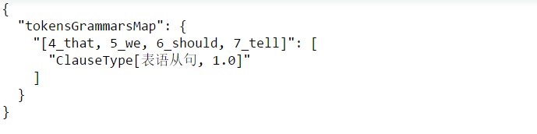
13 | The question is whether the film is worth seeing. | 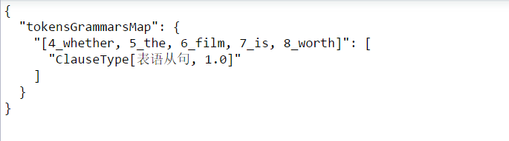
14 | The problem is how we can find him. | 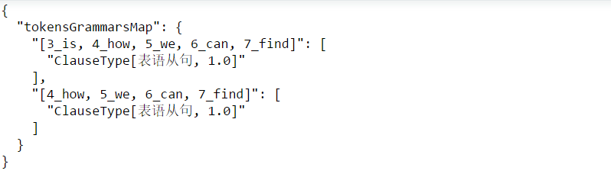
15 | Fame and personal gain is what they’re after. | 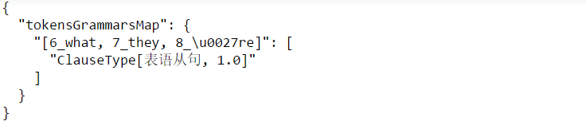
16 | Now it was as though she had known Millie for years. | 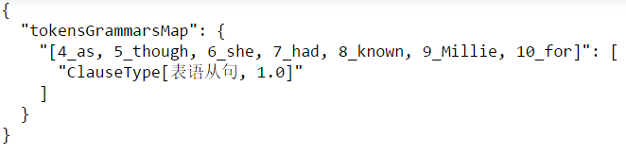
17 | The boys who are playing football are from Class One. | 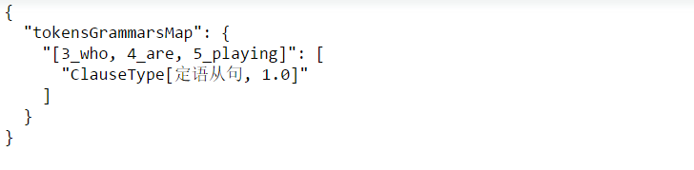
18 | Yesterday I helped an old man who lost his way. | 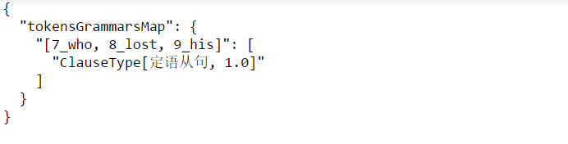
19 | Mr. Liu is the person (whom) you talked with on the bus. | 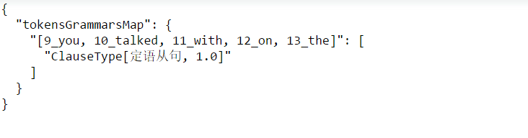
20 | Mr. Ling is just the boy whom I want to see. | 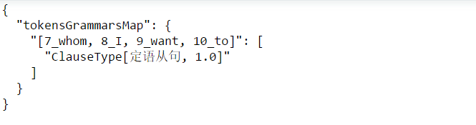
21 | When you think you know nothing, then you begin to know something. | 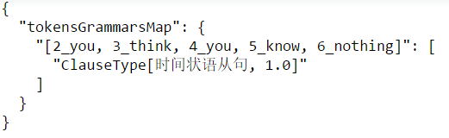
22 | You can feel the air moving as your hand pushes through it. | 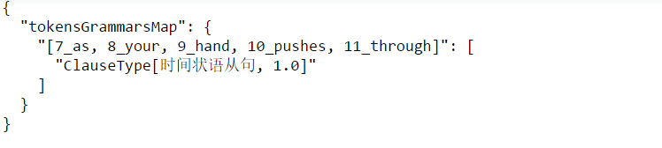
23 | Where there is a will, there is a way. | 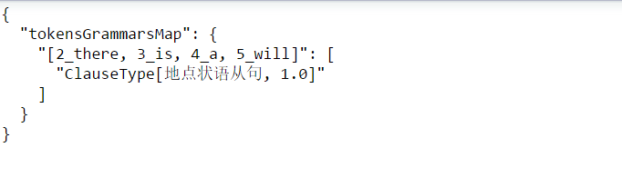
24 | Go back where you came from. | 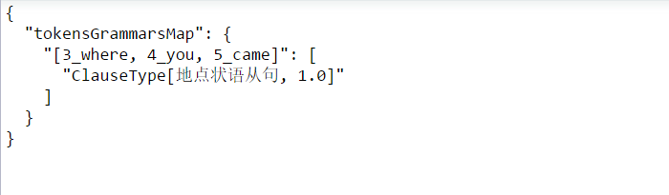
25 | With a car，a person can go where he pleases and when he pleases. | 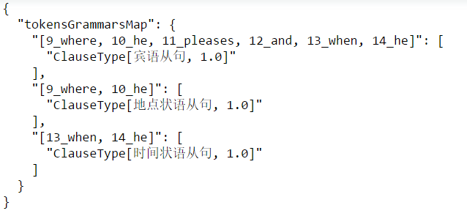
26 | I want you get out. | 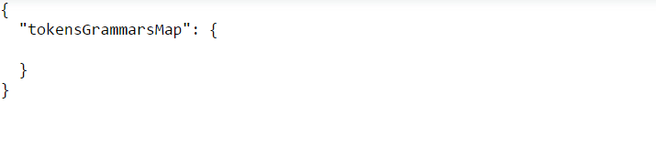
27 | The woolly shrank because it was washed badly. | 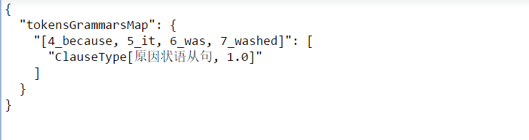
28 | You shouldn’t get angry just because some people speak ill of you. | 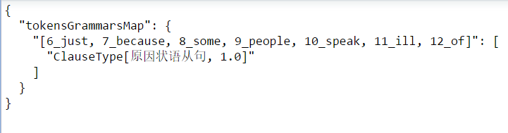
29 | If you fail in the exam,you will let him down. | 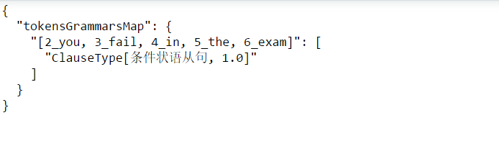
30 | Unless it rains,the game will be played. | 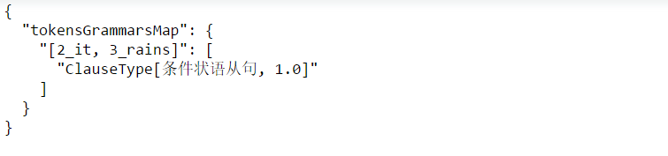
31 | I will remains firm though I must lower my physical sights. | 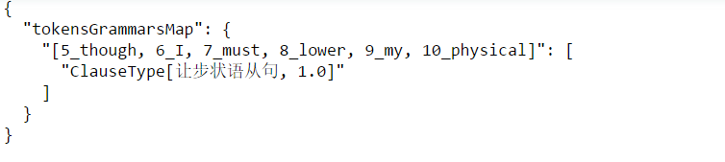
32 | He gave me so little time that it was impossible for me to finish the work on time. | 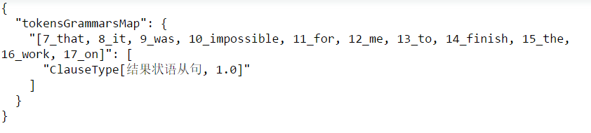
33 | It was so hot a day that they wanted to go swimming. | 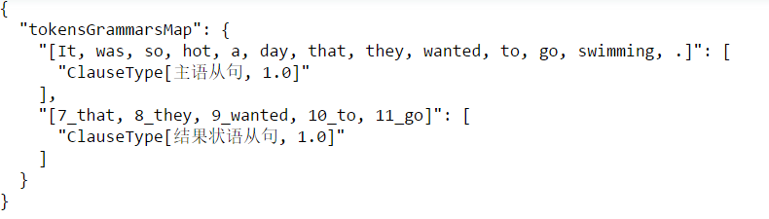
34 | The boy is so young that he can't go to school. | 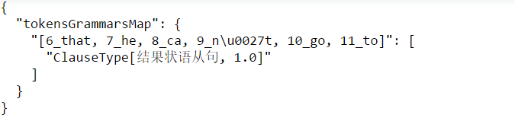
35 | The wind was so strong that he could hardly move forward. | 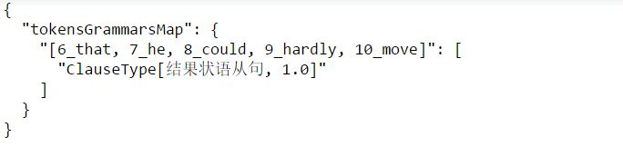
36 | Nine is to three what three is to one. | 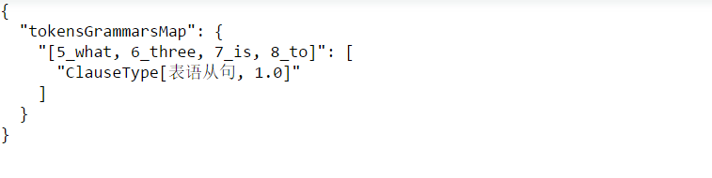
37 | Jack is not more diligent than John. | 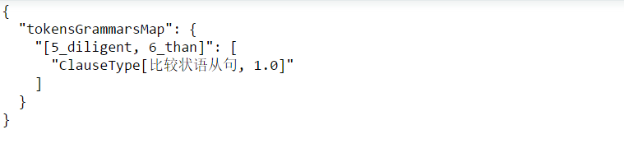
38 | Some people are happy in proportion as they are noticed. | 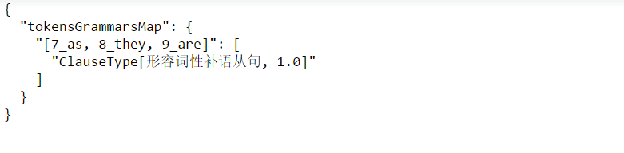
39 | He does not work as hard as his brother. | 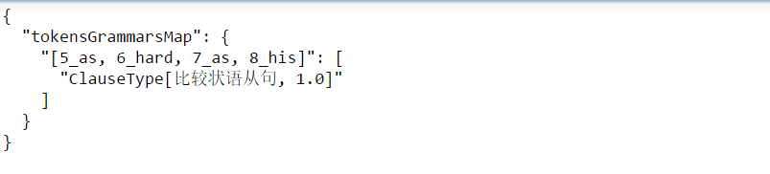

2.8.2 性能
句子平均长度 | 性能 | 说明
22 | 3.33/秒 | 无

2.9 比较句检测

2.9.1 典型测试用例
编号 | 句子 | Json格式结果
1 | She is more beautiful than her elder sister. | 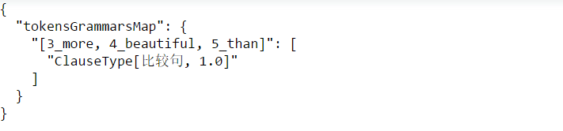
2 | His strength is superior to mine. | 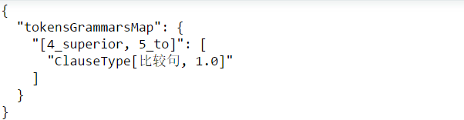
3 | There are as many people learning English in China as there are people in the United States. | 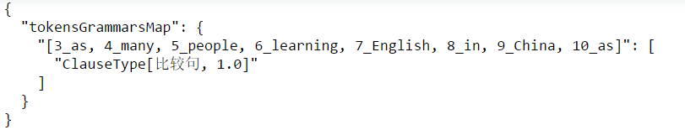
4 | It's him as large as life and twice as natural. | 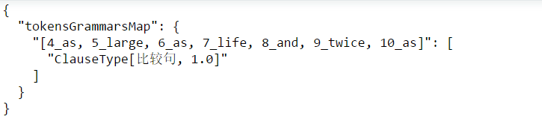
5 | Judy goes to the movies as often as Sara does. | 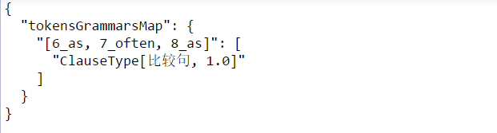
6 | He was tired enough to make ten errors in as many pages. | 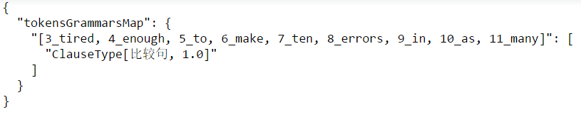
7 | As many as 100 people were killed in the air crash. | 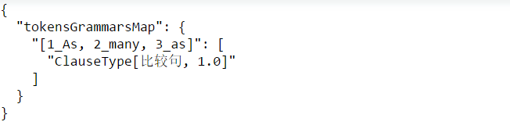
8 | Comets are just as much members of the sun’s family as (are) the other planets. | 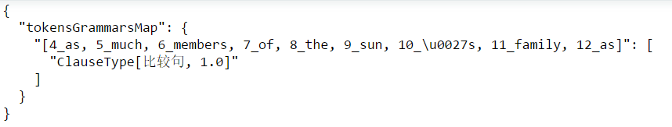
9 | Writing is just as important as reading. | 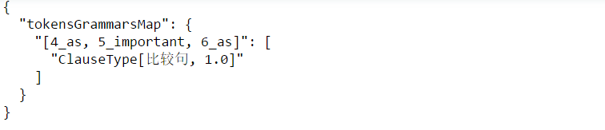
10 | Colored people are by no means inferior to white people. | 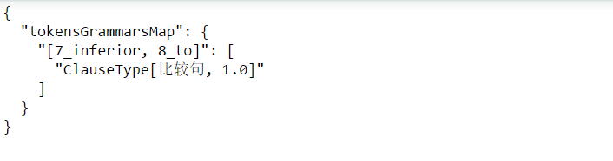

2.9.2 性能
句子平均长度 | 性能 | 说明
22 | 5.88/秒 | 无

2.10 不定式检测

2.10.1 典型测试用例
编号 | 句子 | Json格式结果
1 | My sister is a college student. | 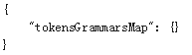
2 | My son needs to see a dentist. | 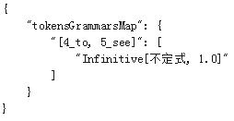
3 | I’m looking for someone to help me with my work. | 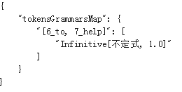

2.10.2 性能
句子平均长度 | 性能 | 说明
22 | 998.705/秒 | 无

3 集成测试
略

