测试报告

1 测试概述
本次测试会涉及到从句类型、比较句、动名词、不定式、词汇检测、情态动词检测、完成时检测、词性检测、句子类型检测、虚拟语气检测。对于每一个类型都会从边界条件，句子边界和性能三个角度进行测试。

2 单一语法类型测试结果

2.1 动名词

2.1.1 典型测试用例
编号 | 句子 | Json格式结果
1 | I enjoy swimming. | 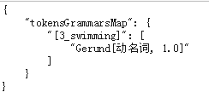
2 | Auto-stor uses a re-direct method via symbolic links that is adequate for viewing files , but slow when retrieving them . | 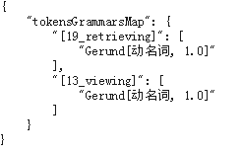
3 | I am not happy. | {}

2.1.2 性能
句子平均长度 | 性能 | 说明
22 | 716.589/秒 | 无

2.2 词性检测

2.2.1 典型测试用例
编号 | 句子 | Json格式结果
1 | Shall we watch the baseball game on TV? | 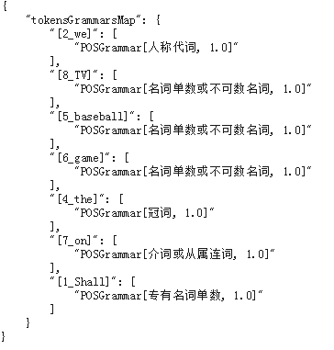
2 | It is a dangerous road to take through the mountains . | 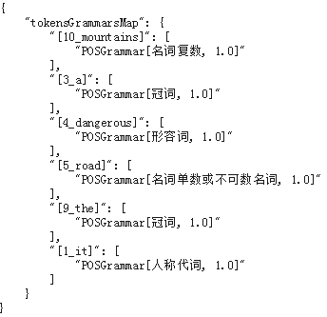
3 | hey , hey , hey , slow down now . | 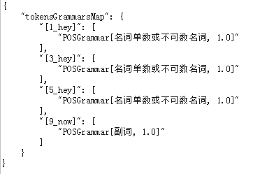

2.2.2 性能
句子平均长度 | 性能(句子数量/秒) | 说明
22 | 694.107 | 无

2.3 情态动词

2.3.1 典型测试用例
编号 | 句子 | Json格式结果
1 | You can enter if you have a ticket. | 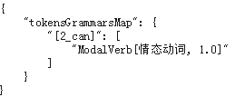
3 | May I use your bathroom? | 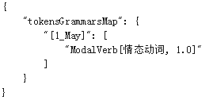
4 | I must attend the meeting. | 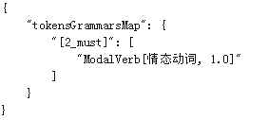
5 | You should exercise every day. | 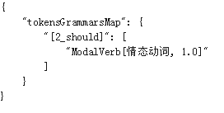
6 | I will do my best in my new job. | 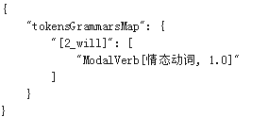
7 | Shall I buy some milk? | 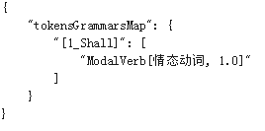

2.3.2 性能
句子平均长度 | 性能 | 说明
22 | 746.937/秒 | 无

2.4 完成时检测

2.4.1 典型测试用例
编号 | 句子 | Json格式结果
1 | I have known Paul since we were children. | 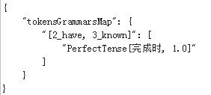
3 | He hasn't been here since last night. | 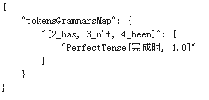
4 | Have you been here since last night? | 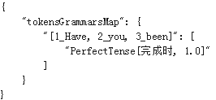
5 | I haven’t yet decided whether I will attend the party. | 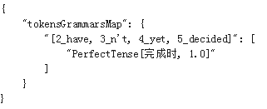
6 | My father has given up alcohol. | 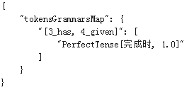
7 | Henry has just finished his homework. | 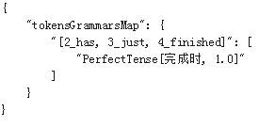
8 | The man had run away when the police arrived. | 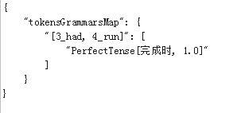

2.4.2 性能
句子平均长度 | 性能 | 说明
22 | 697.252/秒 | 无

2.5 词汇检测

2.5.1 典型测试用例
编号 | 句子 | Json格式结果
1 | I enjoy swimming. | 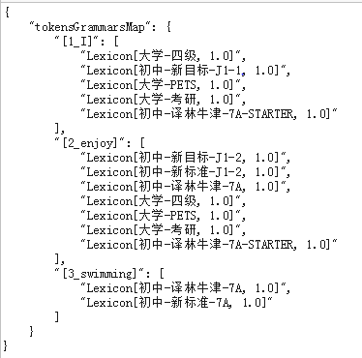
2 | Auto-stor uses a re-direct method via symbolic links that is adequate for viewing files , but slow when retrieving them .
3 | well , the one thing we might have to slow down is a commitment we made | 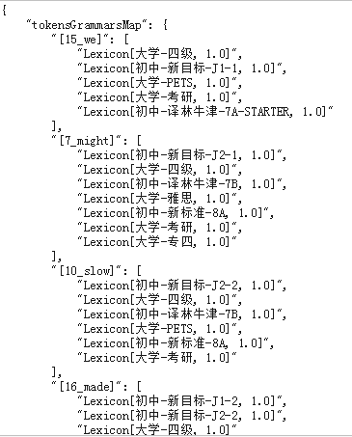

2.5.2 性能
句子平均长度 | 性能 | 说明
22 | 1223.739/秒 | 无

2.6 句子类型检测

2.6.1 典型测试用例

2.6.2 性能

2.7 虚拟语气检测

2.7.1 典型测试用例

2.7.2 性能

2.8 从句类型检测

2.8.1 典型测试用例

2.8.2 性能

2.9 比较句检测

2.9.1 典型测试用例

2.9.2 性能

2.10 不定式检测
2.10.1 典型测试用例
2.10.2 性能

3 集成测试

