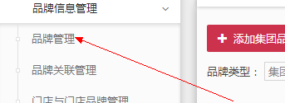

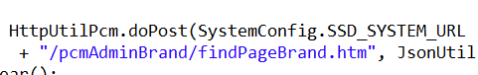

1. /pcmAdminBrand/findPageBrand.htm

调用的admin

2. 创建品牌// 下发门店品牌数据(增量)

String url = PropertyUtil.getSystemUrl("pcm-syn") + "pcmSynBrand/pushBrand.htm";

HttpUtil.doPost(url, json);

3.

|  |
| --- |
| cms_cdn_path=/pcm-admin-sdc/common/flushCdn.htm  cms_cnd_url = http://10.6.2.43:8043/pcm-admin-sdc/common/flushCdn.htm |