How to install ISO using BMC

-v0.1 2017.4.24 Sherlock init

This doc helps to show how to install ISO by BMC web interface.

- Access BMC web page(BMC IP of redhat board: 10.16.186.169)
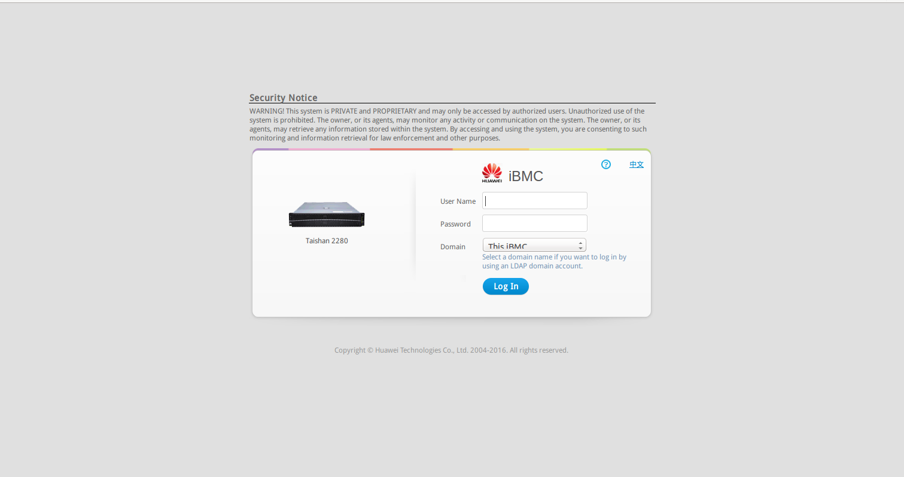
User name: root
Password: Huawei12#$

- Access BMC web interface, access “Remote”
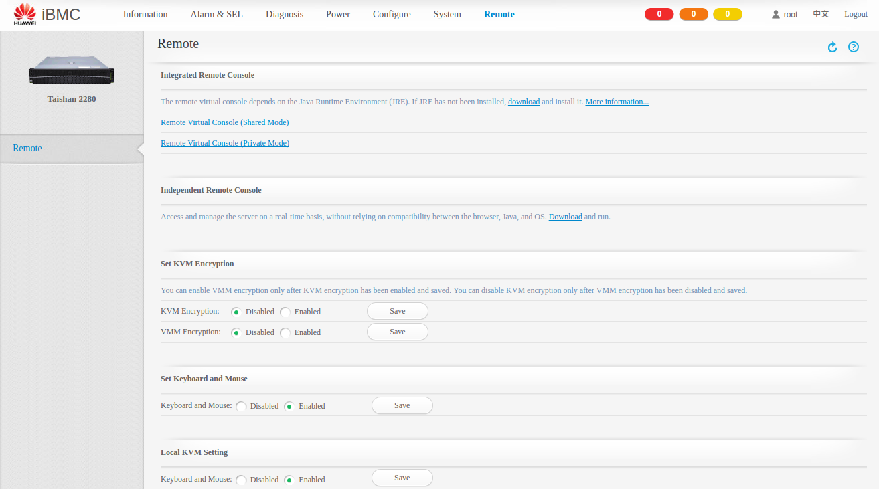

- click “Remote Virtual Cosole (Private Mode)”in above picture, then you need download a file named “kvm.jnlp”

- Download JRE as showed in “download” in Integrated Remote console in above picture.
(e.g. I downloaded “linux x64” in https://www.java.com/en/download/linux_manual.jsp)

- Run above_package/bin/javaws your_path/kvm.jnlp, then you will get:
(NOTE: every time you use Remote Virtual Console, you need download the new kvm.jnlp and run this command)
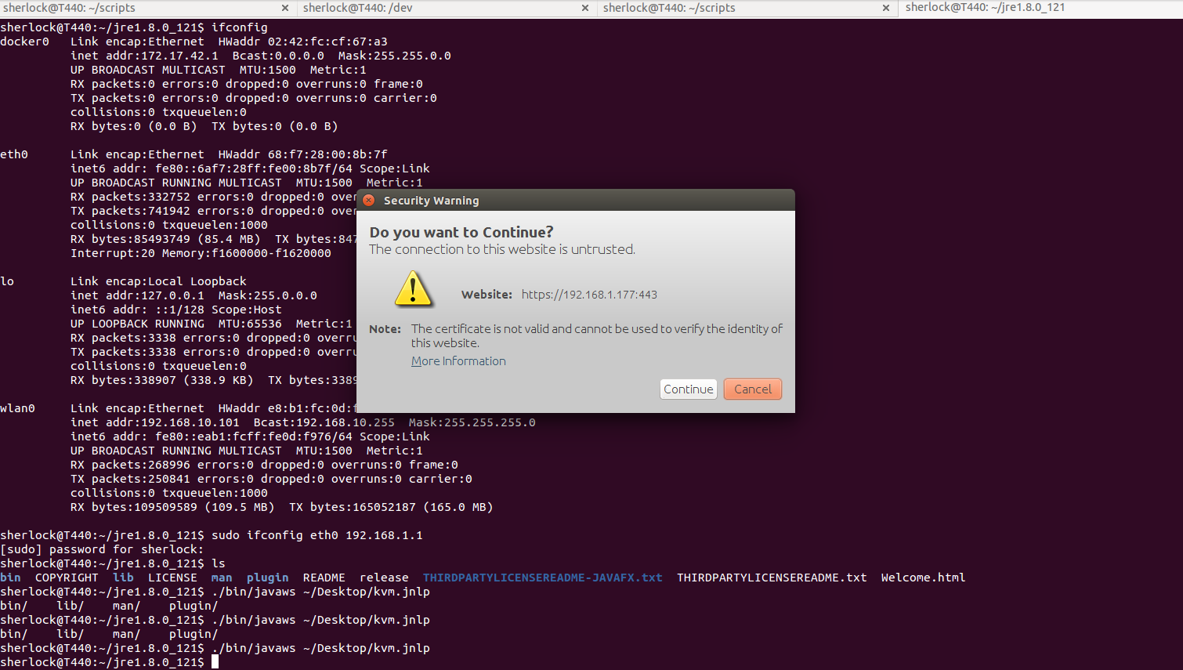
- Click continue:
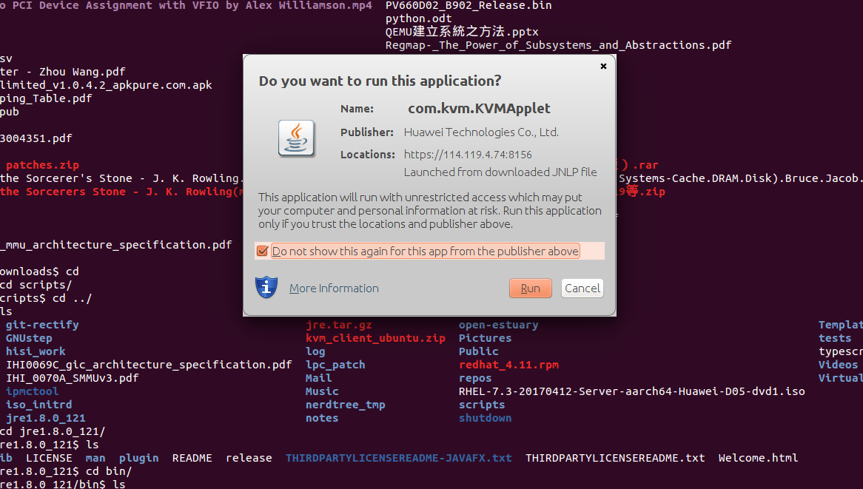
- Click run:
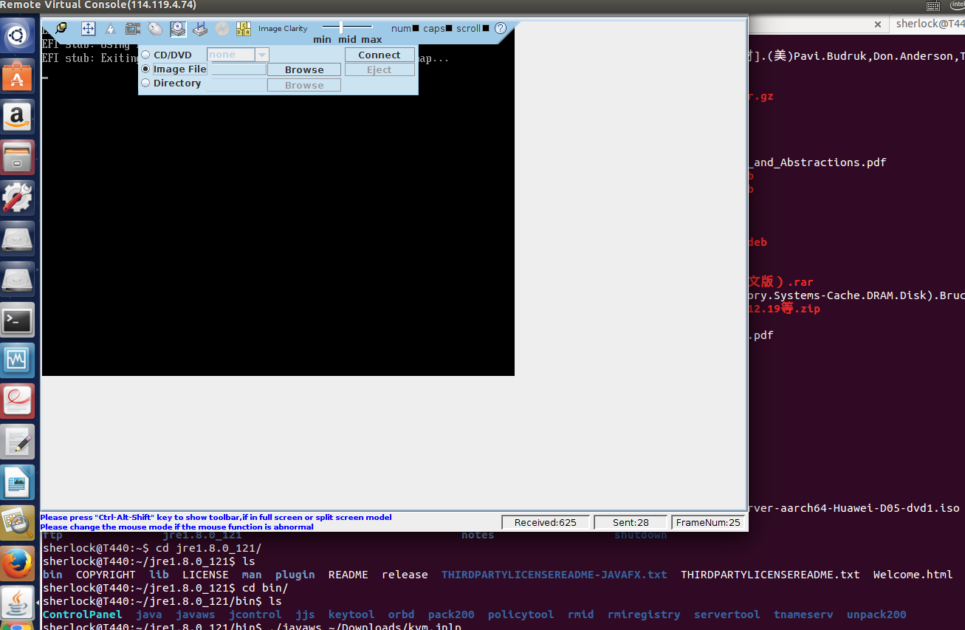
- Click browse to choose your ISO and click connect.
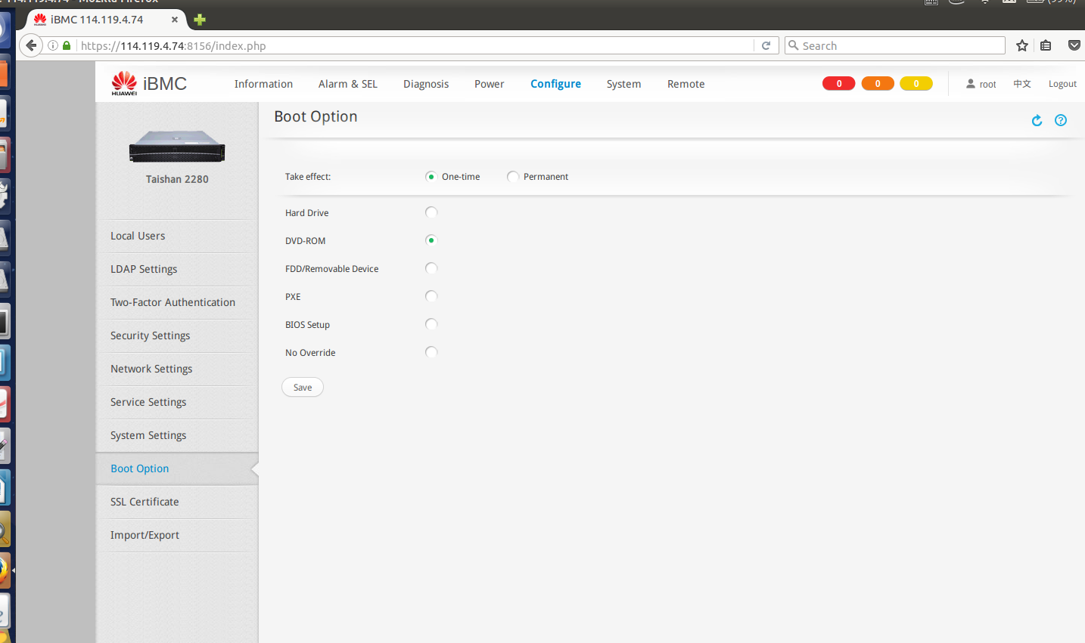
- Change boot option to DVD-ROM
- Reset system by click

and choose “Forced System Reset ” in below picture:
- Use console or ipmi to access serial console, e.g. :

ipmitool -H 192.168.1.177 -I lanplus -U root -P Huawei12#$ sol activate

or

console xxx

