- perf stat: obtain event counts
- perf record: record events for later reporting
- perf report: break down events by process, function, etc.
- perf annotate: annotate assembly or source code with event counts
- perf top: see live event count
- sudo perf stat -a ls
- sudo perf stat -e page-faults ls 或者是自己的程序 （perf list 列出支持的事件）
- sudo perf stat -p 9220 -a

- perf record -e cycles, cpu-clock, task-clock ls
- perf report -i perf.data (可以改变数据输出的形式)
- perf record /bin/ls
- perf annotate -d /bin/ls （显示perf.data has no sample, 编译是也加了-ggdb选项啊？）
- perf top

- perf stat -e raw_syscalls:sys_enter ls
- perf record -e raw_syscalls:sys_enter ls
- perf report

- sudo perf record -e cycles -g ./a.out
- sudo perf report -g
问题：1. wait_time_long()有，但是wait_time_short()没有？ 2. 在report的子命令中，无法用annotate看详细的反汇编执行时间，没有提供vmlinux 路径，这个不懂？ 3. annotate *** 都是一样的结果

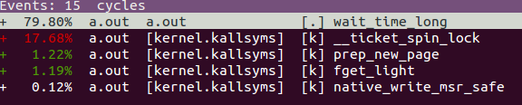
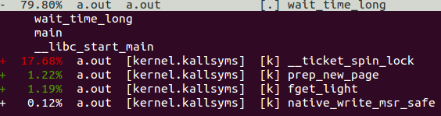
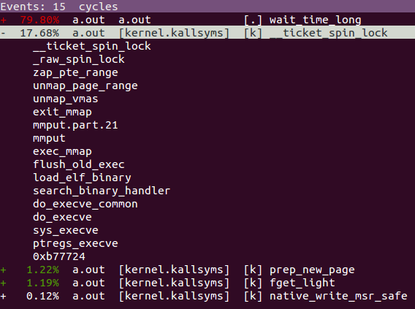

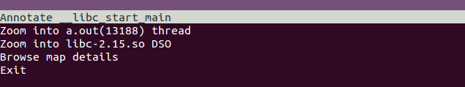

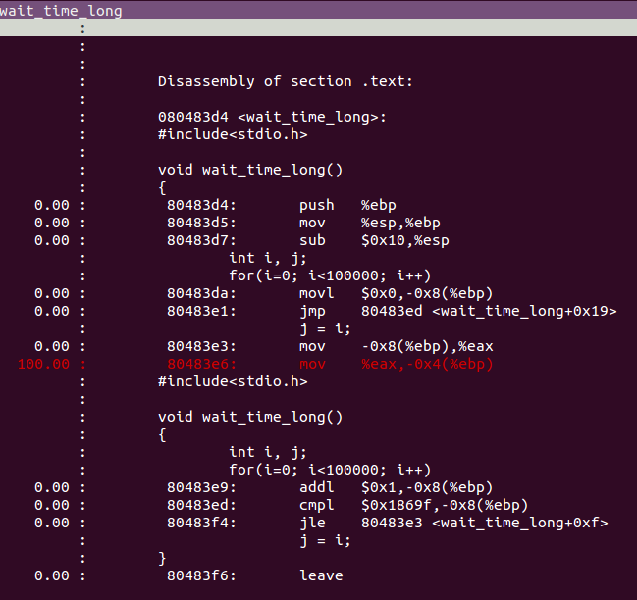
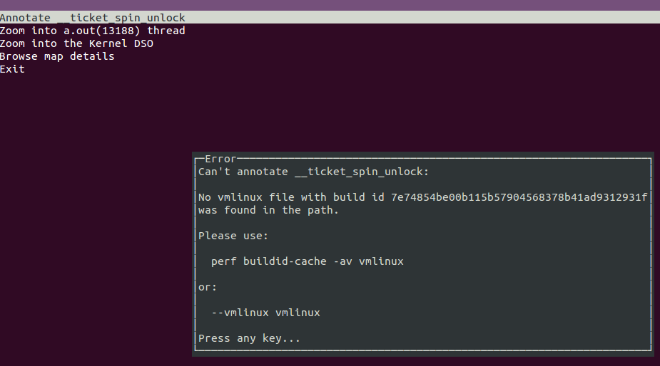
perf top :

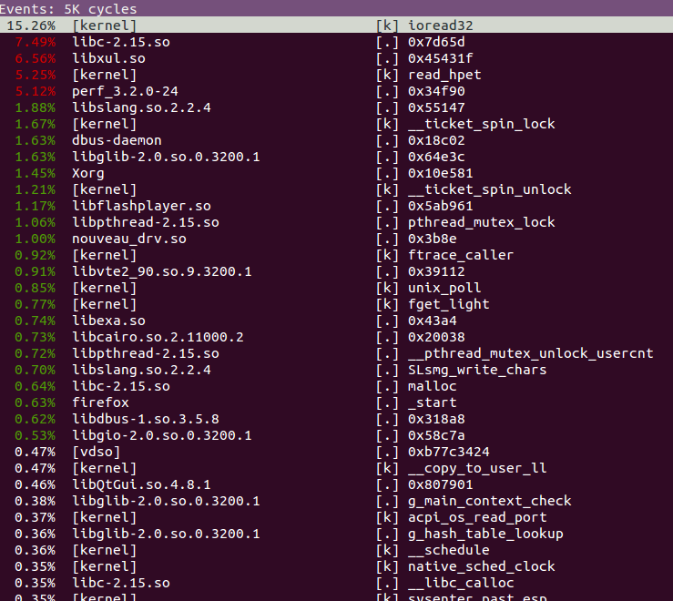
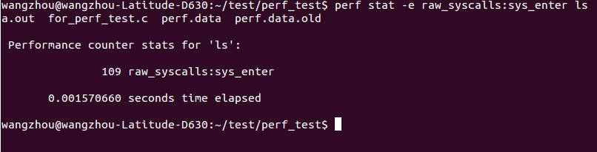
看看内核的--vmlinux 选项支持内核符号annotate的原理，估计perf lock, perf 跟踪内核tracepoints, probe 跟踪点等等不能使用都和这个选项有关系（明确原理和具体命令操作）#

pytyon提纲：
概述及注意
  - 粗糙的c++：编写迅速，功能
  - 缩进，c++（面向对象，函数初值，构造析构），注释语句，模块使用和原理
物理行与逻辑行，帮助

简单语法介绍
  - 数据对象：元组，序列，字符串，列表，字典（c++的思想理解，一切理解成对象）
  - list 列表：
shoplist = ['apple', 'mango', 'carrot', 'banana']
shoplist.len()...(sort,append,del,print)
del shoplist[0] print a
__func和一般函数的区别？？

help(list) shoplist.sort.__doc__
  - 元组：固定
zoo = ('wolf', 'elephant', 'penguin')
new_zoo = ('monkey', 'dolphin', zoo)
结果是多少：len(new_zoo) new_zoo new_zoo[2] new_zoo[2][2]？
Myempty = () 一个空的元组 singleton = (2,) 有一个元素的元组

print '%s is %d years old' % (name, age)
print '%s and %s' %a, %b 不对！！！
print 'Why is %s playing with that python?' % name

  - 字典 dict：
ab = {'Swaroop': 'swaroopch@byteofpython.info',
'Larry' : 'larry@wall.org',
'Matsumoto' : 'matz@ruby-lang.org',
'Spammer' : 'spammer@hotmail.com'
}
print "Swaroop's address is %s" % ab['Swaroop']
ab['Guido'] del ab['Spammer']

>>> ab.items()
[('Swaroop', 'swaroopch@byteofpython.info'), ('Matsumoto', 'matz@ruby-lang.org'), ('Larry', 'larry@wall.org'), ('Spammer', 'spammer@hotmail.com')]
所以：for name, address in ab.items():
if 'Guido' in ab: print 1

  - 序列：列表，元组，字符串 主要用法：索引，切片
shoplist = ['apple', 'mango', 'carrot', 'banana']
# Indexing or 'Subscription' operation
print 'Item 0 is', shoplist[0]
print 'Item 1 is', shoplist[1]
print 'Item 2 is', shoplist[2]
print 'Item 3 is', shoplist[3]
print 'Item -1 is', shoplist[-1]
print 'Item -2 is', shoplist[-2]
# Slicing on a list
print 'Item 1 to 3 is', shoplist[1:3]
print 'Item 2 to end is', shoplist[2:]
print 'Item 1 to -1 is', shoplist[1:-1]
print 'Item start to end is', shoplist[:]
# Slicing on a string
name = 'swaroop'
print 'characters 1 to 3 is', name[1:3]
print 'characters 2 to end is', name[2:]
print 'characters 1 to -1 is', name[1:-1]
print 'characters start to end is', name[:]

  - 参考
#!/usr/bin/python
# Filename: reference.py
print 'Simple Assignment'
shoplist = ['apple', 'mango', 'carrot', 'banana']
mylist = shoplist # mylist is just another name pointing to the same object!
del shoplist[0]
print 'shoplist is', shoplist
print 'mylist is', mylist
# notice that both shoplist and mylist both print the same list without
# the 'apple' confirming that they point to the same object
print 'Copy by making a full slice'
mylist = shoplist[:] # make a copy by doing a full slice
del mylist[0] # remove first item
print 'shoplist is', shoplist
print 'mylist is', mylist
# notice that now the two lists are different
  - 字符串对象
#!/usr/bin/python
# Filename: str_methods.py
name = 'Swaroop' # This is a string object
if name.startswith('Swa'):
print 'Yes, the string starts with "Swa"'
if 'a' in name:
print 'Yes, it contains the string "a"'
>>> a = "wangzhou"
>>> a.find("zh")
>>> delimiter = '_*_'
>>> mylist = ['Brazil', 'Russia', 'India', 'China']
>>> print delimiter.join(mylist)
Brazil_*_Russia_*_India_*_China

  - 面向对象，异常，标准库
  - 对象，类（数据，方法）
  - 初始化
  - 继承
  - 异常
  - 标准库

  - 模块
from import （as）
import (as)
原理
  - 几个例子
1. 一个演进版的python程序
2. 提取中文字符
3. 面向对象的例子

参考资料：简明python教程 http://woodpecker.org.cn/abyteofpython_cn/chinese/index.html
注意其中结尾的学习资源

VFS
驱动细节(vfs，驱动，设备怎么串起来)(以自己的学习思路来讲)

- 第一个驱动程序(insmod, rmmod)
- 写相关的函数，熟悉基本构架
- 质疑：系统是怎么调用到read函数的，看VFS，整理整个思路
|->在深入linux设备驱动内核机制中有详细讲解
驱动模型

struct inode 和 struct file 结构：

