四年级英语单元测试卷
人教版（PEP）四年级上册 · Unit 6
班级：__________ 姓名：__________ 日期：__________ 用时：______ 分钟 得分：________
满分 100 分，建议用时 40 分钟。听力部分请用手机扫描二维码，每段会读两遍，只能听、不显示原文。

一、听力（每题 3 分，共 30 分）
请扫描下面的二维码听录音（第一次扫码需要联网，之后可以重复听）。先看题，再听，听的时候不要看原文。
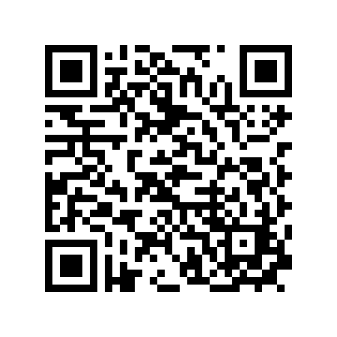  第 1 段（1–5 题） | 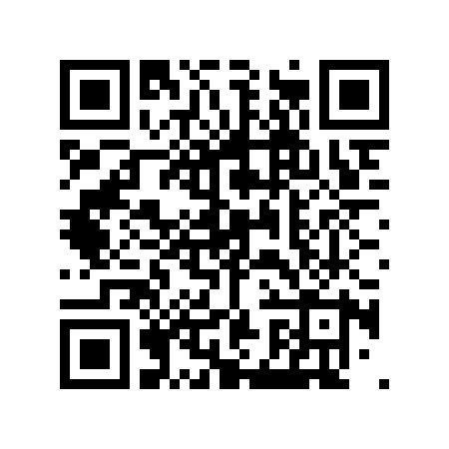  第 2 段（6–10 题）
第 1 段
1. How is the weather?
A. Snowy. B. Sunny. C. Hot.
2. What does Ben wear?
A. A coat, a sweater and gloves. B. A T-shirt. C. A dress.
3. How many socks does Ben wear?
A. One. B. Two. C. Three.
4. It ____ today.

5. Ben wears gloves and a ____.

第 2 段
6. How many seasons are there?
A. Three. B. Four. C. Five.
7. How is autumn?
A. Cool. B. Hot. C. Cold.
8. What does Amy like to do in autumn?
A. Walk in the park. B. Swim. C. Make a snowman.
9. Spring is ____.

10. The ____ fall from the trees.

二、词汇（每题 2 分，共 16 分）
（一）写出下面单词或短语的中文意思。
11. sweater ______________
12. spring ______________
13. coat ______________
14. winter ______________
（二）根据中文意思写出英文单词或短语。
15. 衬衫 ______________
16. 短袜 ______________
17. 秋天 ______________
18. 夏天 ______________
三、阅读（每题 3 分，共 54 分）
Passage A What to Wear
Mum: It is cold today. Which coat do you want to wear?
Amy: The red one, Mum.
Mum: Put on your gloves, too.
Amy: OK. Can I wear my new dress?
Mum: No. It is too cold for a dress. Wear your sweater.
Amy: All right.
选择题
19. How is the weather?
A. Hot. B. Cold. C. Warm.
20. Which coat does Amy want?
A. The red one. B. The blue one. C. The black one.
21. What does Mum say about the dress?
A. It is too cold for a dress. B. It is too big. C. It is dirty.
判断正误（对选 T，错选 F）
22. Amy wears a red coat.
（ ） T / F
23. Amy wears the new dress.
（ ） T / F
24. Mum tells Amy to wear gloves.
（ ） T / F
选词填空（每词限用一次）
词库：coat gloves dress sweater
25. Which ____ do you want to wear?

26. Put on your ____, too.

27. Wear your ____.

Passage B My Favourite Season
My favourite season is autumn. It is cool and sunny. Leaves are yellow and red, and they fall down from the trees. I collect leaves with my friends.
In autumn, my family also gets together for the Mid-Autumn Festival. We eat mooncakes. Then we look at the moon.
选择题
28. What is the writer's favourite season?
A. Autumn. B. Spring. C. Summer.
29. What colour are the leaves?
A. Yellow and red. B. Green. C. White.
30. What do they eat at the festival?
A. Mooncakes. B. Noodles. C. Ice cream.
判断正误（对选 T，错选 F）
31. Autumn is cool and sunny.
（ ） T / F
32. The writer collects leaves alone.
（ ） T / F
33. They look at the moon after eating.
（ ） T / F
选词填空（每词限用一次）
词库：autumn leaves together moon
34. My favourite season is ____.

35. I collect ____ with my friends.

36. My family gets ____.

参考答案（家长用） 四年级英语 · Unit 6

一、听力
1. A（Snowy.） 2. A（A coat, a sweater and gloves.） 3. B（Two.） 4. snows 5. sweater / coat 6. B（Four.） 7. A（Cool.） 8. A（Walk in the park.） 9. warm 10. leaves
听力原文（家长参考）：
第 1 段 Winter Clothes：Dad: Ben, it snows today. What do you wear? Ben: I wear my coat, my sweater and my gloves. Dad: What about your socks? Ben: I wear two socks, Dad. It is very cold!
第 2 段 The Seasons：There are four seasons. Spring is warm. Summer is hot. Autumn is cool. Winter is cold. In autumn, the leaves fall from the trees. I like to walk in the park and look at them.
二、词汇
11. 毛衣 12. 春天 13. 大衣；外套 14. 冬天
15. shirt 16. sock 17. autumn 18. summer
三、阅读
19. B（Cold.） 20. A（The red one.） 21. A（It is too cold for a dress.） 22. T 23. F 24. T 25. coat 26. gloves 27. sweater 28. A（Autumn.） 29. A（Yellow and red.） 30. A（Mooncakes.） 31. T 32. F 33. T 34. autumn 35. leaves 36. together

