七年级英语单元测试卷
人教版 七年级上册 · Starter Unit 2
班级：__________ 姓名：__________ 日期：__________ 用时：______ 分钟 得分：________
满分 88 分，建议用时 40 分钟。听力部分请用手机扫描二维码，每段会读两遍，只能听、不显示原文。

一、听力（每题 2 分，共 20 分）
请扫描下面的二维码听录音（第一次扫码需要联网，之后可以重复听）。先看题，再听，听的时候不要看原文。
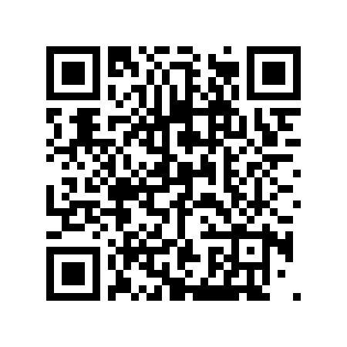  第 1 段（1–5 题） | 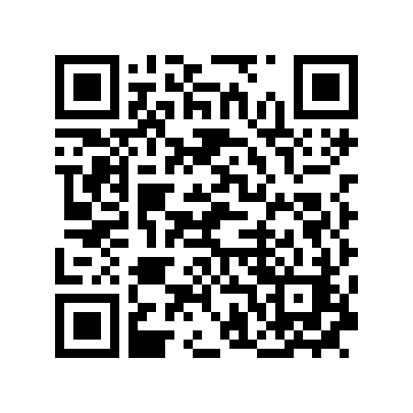  第 2 段（6–10 题）
第 1 段
1. What colour is the schoolbag?
A. Blue. B. Red. C. Green.
2. How many books are there in the bag?
A. One. B. Two. C. Three.
3. What colour is the bottle?
A. Blue. B. Red. C. Yellow.
4. Mary has a ____ in her bag.

5. Her mother says, "Keep it ____."

第 2 段
6. What's wrong with Jack's room?
A. It is messy. B. It is small. C. It is new.
7. Where's the English book?
A. On the bed. B. On the desk. C. Under the desk.
8. Where's the bottle?
A. On the bed. B. Under the desk. C. In the bag.
9. The bottle is under the ____.

10. Mom says, "Let's keep it ____."

二、词汇（每题 2 分，共 8 分）
（一）写出下面单词或短语的中文意思。
11. thing ______________
12. key ______________
（二）根据中文意思写出英文单词或短语。
13. 橡皮 ______________
14. 瓶子 ______________
三、阅读（每题 3 分，共 60 分）
Passage A What's This in English?
In our English class, we play a guessing game. Mr. Hu puts a thing in a box. We ask, "What's this in English?" He gives hints: "It's small. You can open the door with it."
Tina says, "It's a key!" "Yes! K-E-Y," says Mr. Hu. The next thing is bigger. "You can drink water from it." "It's a bottle!" We love this game.
选择题
15. Where does Mr. Hu put the thing?
A. On the desk. B. In a box. C. In a bag. D. In the key.
16. What is the first thing?
A. A bottle. B. A box. C. A key. D. A door.
17. What can you do with a bottle?
A. Open a door. B. Drink water from it. C. Write with it. D. Read it.
18. Who guesses "key"?
A. Mr. Hu. B. Tina. C. The class. D. Tom.
判断正误（对选 T，错选 F）
19. The key is big.
（ ） T / F
20. The class loves the game.
（ ） T / F
21. The second thing is a pen.
（ ） T / F
选词填空（每词限用一次）
词库：puts open love drink guess
22. Mr. Hu ____ a thing in a box.

23. You can ____ the door with a key.

24. We ____ this game.

Passage B At the Shop
Kate: Excuse me, do you have an eraser?
Clerk: Yes, we do. Here you are.
Kate: How much is it?
Clerk: It's two yuan.
Kate: OK. Here's two yuan. Thank you!
Clerk: You're welcome.
选择题
25. What does Kate want to buy?
A. A bottle. B. A key. C. An eraser. D. A ruler.
26. How much is it?
A. One yuan. B. Two yuan. C. Three yuan. D. Ten yuan.
27. Who says "Here you are"?
A. Kate. B. The clerk. C. Kate's mother. D. Nobody.
28. Where are they?
A. In a shop. B. At school. C. At home. D. In a park.
判断正误（对选 T，错选 F）
29. The eraser is five yuan.
（ ） T / F
30. Kate says thank you.
（ ） T / F
31. The clerk has no eraser.
（ ） T / F
选词填空（每词限用一次）
词库：much have welcome here yuan
32. Do you ____ an eraser?

33. How ____ is it?

34. You're ____.

参考答案（家长用） 七年级英语 · Starter Unit 2

一、听力
1. A（Blue.） 2. B（Two.） 3. B（Red.） 4. key 5. safe 6. A（It is messy.） 7. A（On the bed.） 8. B（Under the desk.） 9. desk 10. tidy
听力原文（家长参考）：
第 1 段 My Schoolbag：Hi, I'm Mary. This is my schoolbag. It's blue. In my schoolbag, there are two books, a key and a water bottle. The bottle is red. My mother gives me the key. She says, "Keep it safe."
第 2 段 Tidy Up the Room：Mom: Jack, your room is messy. Let's keep it tidy. Jack: OK, Mom. Where's my English book? Mom: It's on the bed. Jack: And my bottle? Mom: It's under the desk. Jack: Thanks, Mom. Mom: You're welcome. Now put the things in the right places.
二、词汇
11. 东西；事情 12. 钥匙；关键
13. eraser 14. bottle
三、阅读
15. B（In a box.） 16. C（A key.） 17. B（Drink water from it.） 18. B（Tina.） 19. F 20. T 21. F 22. puts 23. open 24. love 25. C（An eraser.） 26. B（Two yuan.） 27. B（The clerk.） 28. A（In a shop.） 29. F 30. T 31. F 32. have 33. much 34. welcome

