七年级英语单元测试卷
人教版 七年级上册 · Unit 1
班级：__________ 姓名：__________ 日期：__________ 用时：______ 分钟 得分：________
满分 100 分，建议用时 40 分钟。听力部分请用手机扫描二维码，每段会读两遍，只能听、不显示原文。

一、听力（每题 2 分，共 20 分）
请扫描下面的二维码听录音（第一次扫码需要联网，之后可以重复听）。先看题，再听，听的时候不要看原文。
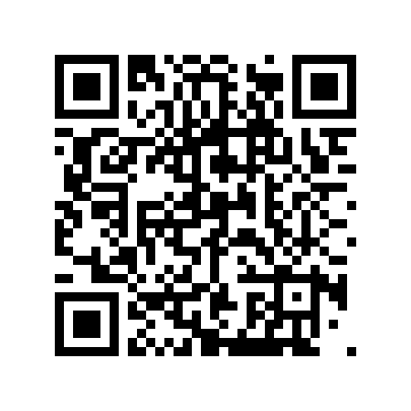  第 1 段（1–5 题） | 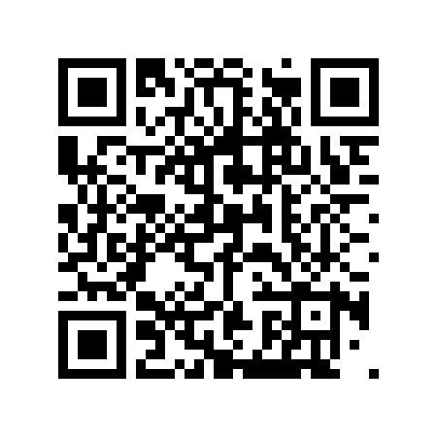  第 2 段（6–10 题）
第 1 段
1. Who is Jane?
A. Kate's mother. B. Kate's twin sister. C. Kate's teacher.
2. What does Kate like?
A. The guitar. B. Tennis. C. Football.
3. Are Kate and Jane in the same class?
A. Yes, they are. B. No, they are not. C. We do not know.
4. Jane likes the ____.

5. Their class teacher is Mr. ____.

第 2 段
6. What is Sam's full name?
A. Sam Brown. B. Sam Green. C. Green Sam.
7. How old is Sam?
A. Eleven. B. Twelve. C. Thirteen.
8. What is Sam's hobby?
A. Playing tennis. B. Playing the guitar. C. Reading.
9. Sam is from the ____.

10. Sam's last name is ____.

二、词汇（每题 2 分，共 20 分）
（一）写出下面单词或短语的中文意思。
11. each ______________
12. would ______________
13. tennis ______________
14. country ______________
15. same ______________
（二）根据中文意思写出英文单词或短语。
16. 完整的 ______________
17. 需要 ______________
18. 年级 ______________
19. 吉他 ______________
20. 错误 ______________
三、阅读（每题 3 分，共 60 分）
Passage A The Twins
Tom and Tim are twins. They look the same, but they have different hobbies. Tom plays the guitar and Tim plays tennis. They are in the same class, Class 4. Their classmates often make mistakes about their names.
Ms. Hu, their class teacher, says, "Tom wears a red cap. Tim wears a blue one." Now everyone knows who is who.
选择题
21. What do Tom and Tim look like?
A. Different. B. The same. C. Old. D. Tall.
22. What does Tim play?
A. The guitar. B. Tennis. C. Football. D. Basketball.
23. Who is Ms. Hu?
A. Their mother. B. Their classmate. C. Their class teacher. D. Their sister.
24. How does Ms. Hu tell the twins apart?
A. By their hobbies. B. By their caps. C. By their names. D. By their classes.
判断正误（对选 T，错选 F）
25. Tom and Tim are in different classes.
（ ） T / F
26. The classmates often make mistakes about the names.
（ ） T / F
27. Tim wears a red cap.
（ ） T / F
选词填空（每词限用一次）
词库：twins same plays wears teacher
28. Tom and Tim are ____.

29. Tom ____ the guitar.

30. Tom ____ a red cap.

Passage B A Hot Pot Dinner
Sam is a new classmate from the UK. Today he visits Lin Tao's home. Lin Tao's mom makes hot pot and Mapo tofu. "Would you like some Mapo tofu, Sam?" asks Mom. "Yes, please! But is it hot?" "A little," says Lin Tao. Sam likes it very much.
"I'd like to visit China more," says Sam. "Maybe we can go to Beijing. We can eat Beijing roast duck and visit the Great Wall," says Lin Tao.
选择题
31. Where is Sam from?
A. China. B. The UK. C. Canada. D. Beijing.
32. What does Lin Tao's mom make?
A. Beijing roast duck. B. Hot pot and Mapo tofu. C. Noodles. D. Cakes.
33. Is the Mapo tofu hot?
A. No, not at all. B. A little. C. Very, very hot. D. We do not know.
34. What does Lin Tao say they can do in Beijing?
A. Play tennis. B. Eat Beijing roast duck and visit the Great Wall. C. Make friends. D. Buy a guitar.
判断正误（对选 T，错选 F）
35. Sam is Lin Tao's cousin.
（ ） T / F
36. Sam likes the Mapo tofu.
（ ） T / F
37. Sam has no wish to visit China.
（ ） T / F
选词填空（每词限用一次）
词库：from makes visit hot would
38. Sam is ____ the UK.

39. Lin Tao's mom ____ hot pot and Mapo tofu.

40. Sam says, "I'd like to ____ China more."

参考答案（家长用） 七年级英语 · Unit 1

一、听力
1. B（Kate's twin sister.） 2. B（Tennis.） 3. A（Yes, they are.） 4. guitar 5. Zhang / zhang 6. B（Sam Green.） 7. B（Twelve.） 8. B（Playing the guitar.） 9. UK / uk / U.K. 10. Green / green
听力原文（家长参考）：
第 1 段 My Twin Sister：Hi, I'm Kate. I have a twin sister, Jane. We look the same, but we are different. I like tennis. Jane likes the guitar. We are in the same class, but we sit in different rows. Our class teacher is Mr. Zhang. He is kind.
第 2 段 An Information Card：Teacher: Sam, please tell me about you for the information card. Sam: OK. My full name is Sam Green. Teacher: How old are you? Sam: I'm twelve. Teacher: What's your hobby? Sam: I like playing the guitar. Teacher: Which country are you from? Sam: I am from the UK. Teacher: Thank you, Sam.
二、词汇
11. 每个；各自 12. 想（用于礼貌地邀请或向某人提供某物）；将会 13. 网球；网球运动 14. 国家 15. 相同的
16. full 17. need 18. grade 19. guitar 20. mistake
三、阅读
21. B（The same.） 22. B（Tennis.） 23. C（Their class teacher.） 24. B（By their caps.） 25. F 26. T 27. F 28. twins 29. plays 30. wears 31. B（The UK.） 32. B（Hot pot and Mapo tofu.） 33. B（A little.） 34. B（Eat Beijing roast duck and visit the Great Wall.） 35. F 36. T 37. F 38. from 39. makes 40. visit

