七年级英语单元测试卷
人教版 七年级上册 · Unit 4
班级：__________ 姓名：__________ 日期：__________ 用时：______ 分钟 得分：________
满分 100 分，建议用时 40 分钟。听力部分请用手机扫描二维码，每段会读两遍，只能听、不显示原文。

一、听力（每题 2 分，共 20 分）
请扫描下面的二维码听录音（第一次扫码需要联网，之后可以重复听）。先看题，再听，听的时候不要看原文。
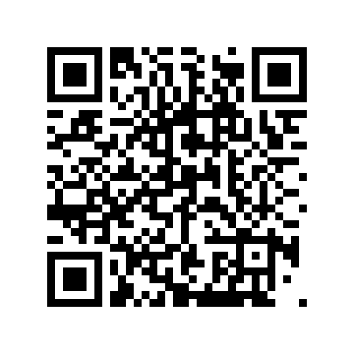  第 1 段（1–5 题） | 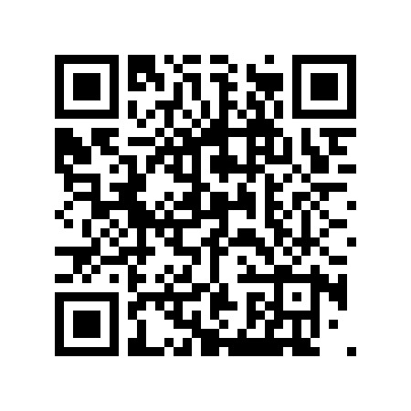  第 2 段（6–10 题）
第 1 段
1. What does Nick play?
A. The piano. B. The guitar. C. The drums.
2. What does Nick want to be?
A. A scientist. B. A singer. C. A teacher.
3. What does Nick's sister want to be?
A. A singer. B. A doctor. C. A scientist.
4. Nick wants to be a ____ in the future.

5. His sister says science is like ____.

第 2 段
6. What is the answer?
A. Ten. B. Twelve. C. Fourteen.
7. What does Kim add?
A. Eight and four. B. Ten and two. C. Six and four.
8. What is Kim not good at?
A. Math. B. French. C. History.
9. The answer is ____.

10. The teacher can help Kim with ____.

二、词汇（每题 2 分，共 20 分）
（一）写出下面单词或短语的中文意思。
11. singer ______________
12. history ______________
13. magic ______________
14. useful ______________
15. life ______________
（二）根据中文意思写出英文单词或短语。
16. 两个 ______________
17. 如同 ______________
18. 上午 ______________
19. 原因 ______________
20. 记住 ______________
三、阅读（每题 3 分，共 60 分）
Passage A Two Dreams
Mia loves music. She plays two instruments, the piano and the guitar, and she is good at singing. She wants to be a singer in the future.
Her brother Leo likes science. He is good at math. He wants to be a scientist. "Science is like magic," he says. Both of them study hard at school.
选择题
21. What does Mia play?
A. The drums. B. The piano and the guitar. C. Only the guitar. D. The violin.
22. What does Mia want to be?
A. A scientist. B. A teacher. C. A singer. D. A doctor.
23. What does Leo like?
A. Music. B. Science. C. History. D. French.
24. What does Leo say about science?
A. It is boring. B. It is like magic. C. It is hard. D. It is useless.
判断正误（对选 T，错选 F）
25. Mia is good at singing.
（ ） T / F
26. Leo is not good at math.
（ ） T / F
27. Mia and Leo both study hard.
（ ） T / F
选词填空（每词限用一次）
词库：instruments singer scientist magic both
28. Mia plays two ____.

29. She wants to be a ____ in the future.

30. Science is like ____.

Passage B A Busy Tuesday
Tuesday is a busy day for me. At 8:00 a.m., we have history. We remember dates and events, and it is hard. At 10:00 a.m., we have biology. I like it very much.
At 2:00 p.m., we have IT. We work out problems with computers. It is exciting. After school, at 4:30 p.m., I practise my instrument for half an hour.
选择题
31. What is the first class on Tuesday?
A. Biology. B. IT. C. History. D. French.
32. When is the biology class?
A. At 8:00 a.m. B. At 10:00 a.m. C. At 2:00 p.m. D. At 4:30 p.m.
33. What does the writer do in IT class?
A. Remember dates. B. Play the guitar. C. Work out problems with computers. D. Study plants.
34. What does the writer do at 4:30 p.m.?
A. Has lunch. B. Practises an instrument. C. Goes to bed. D. Watches TV.
判断正误（对选 T，错选 F）
35. The writer thinks history is easy.
（ ） T / F
36. The writer likes biology very much.
（ ） T / F
37. The IT class is in the morning.
（ ） T / F
选词填空（每词限用一次）
词库：remember biology work exciting practise
38. We ____ dates and events in history.

39. We ____ out problems with computers.

40. I ____ my instrument for half an hour.

参考答案（家长用） 七年级英语 · Unit 4

一、听力
1. B（The guitar.） 2. B（A singer.） 3. C（A scientist.） 4. singer 5. magic 6. B（Twelve.） 7. A（Eight and four.） 8. B（French.） 9. twelve / 12 10. French / french
听力原文（家长参考）：
第 1 段 My Future：I'm Nick. I like music. I play the guitar and I am good at singing. I want to be a singer in the future. My sister wants to be a scientist. She says science is like magic.
第 2 段 A Math Problem：Teacher: Can you work out this problem, Kim? Kim: Let me think. Is the answer twelve? Teacher: Yes! How did you do it? Kim: I added eight and four. Teacher: Good. You are really good at math. Kim: Thanks. But I'm not good at French. Teacher: Don't worry. I can help you with it.
二、词汇
11. 歌手 12. 历史；历史课 13. 魔法；魔力；魔术；有魔力的；有神奇力量的 14. 有用的；有益的 15. 生活；生命
16. both 17. as 18. AM (a.m.) 19. reason 20. remember
三、阅读
21. B（The piano and the guitar.） 22. C（A singer.） 23. B（Science.） 24. B（It is like magic.） 25. T 26. F 27. T 28. instruments 29. singer 30. magic 31. C（History.） 32. B（At 10:00 a.m.） 33. C（Work out problems with computers.） 34. B（Practises an instrument.） 35. F 36. T 37. F 38. remember 39. work 40. practise

