七年级英语期中综合测试卷
人教版 七年级上册 · 期中（Starter 至 Unit 3）
班级：__________ 姓名：__________ 日期：__________ 用时：______ 分钟 得分：________
满分 100 分，建议用时 60 分钟。听力部分请用手机扫描二维码，每段会读两遍，只能听、不显示原文。

一、听力（每题 2 分，共 20 分）
请扫描二维码听录音（第一次扫码需要联网）。先看题，再听，听的时候不要看原文。
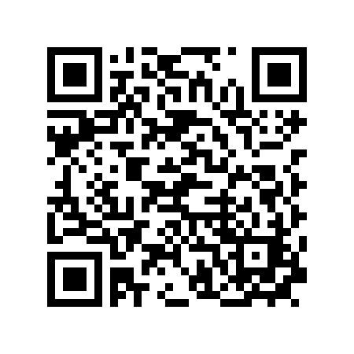  第 1 段（1–5 题） | 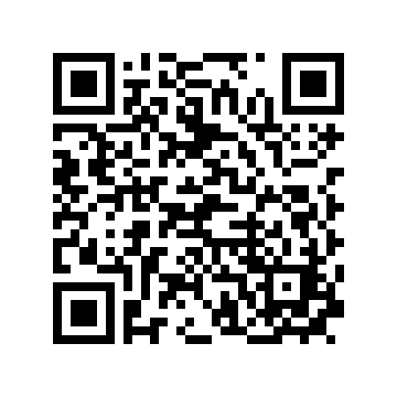  第 2 段（6–10 题）
第 1 段
1. What is the girl's last name?
A. White. B. Wright. C. Wait.
2. Which class is Lily in?
A. Class 3. B. Class 4. C. Class 5.
3. Who is Mr. Li?
A. A student. B. Lily's friend. C. A teacher.
4. Lily is in Class ____.

5. Lily spells her last name W-____-I-T-E.

第 2 段
6. Where is the teachers' office?
A. Across from the dining hall. B. Next to the gym. C. In the hall.
7. Where is the gym?
A. Next to the sports field. B. In front of the office. C. In the middle of the school.
8. Is the office near the gym?
A. Yes, it is. B. No, it is not. C. We do not know.
9. The office is across from the dining ____.

10. The gym is next to the sports ____.

二、词汇（每题 2 分，共 20 分）
（一）写出下面单词或短语的中文意思。
11. flag ______________
12. section ______________
13. sound ______________
14. would ______________
15. seat ______________
（二）根据中文意思写出英文单词或短语。
16. 年级 ______________
17. 瓶子 ______________
18. 大多数 ______________
19. 网球 ______________
20. 建筑物 ______________
三、阅读（每题 3 分，共 60 分）
Passage A A Smart Classroom
Our classroom is special. There is a smart whiteboard at the front. It is like a big screen. Teachers can put up pictures and videos on it. At the back of the classroom, there are two bookcases with many books.
Each student has a locker and a drawer. I keep my sports clothes in the locker and my pens in the drawer. In the corner, there is a plant. Our modern classroom is amazing.
选择题
21. Where is the smart whiteboard?
A. At the back. B. At the front. C. In the corner. D. In a locker.
22. What can teachers do on the whiteboard?
A. Sleep. B. Put up pictures and videos. C. Cook food. D. Wash clothes.
23. Where are the bookcases?
A. At the front. B. In the middle. C. At the back of the classroom. D. In the corner.
24. Where does the writer keep the pens?
A. In the locker. B. In the drawer. C. On the whiteboard. D. In the corner.
判断正误（对选 T，错选 F）
25. The whiteboard is like a big screen.
（ ） T / F
26. There are two lockers in the classroom.
（ ） T / F
27. There is a plant in the corner.
（ ） T / F
选词填空（每词限用一次）
词库：smart back locker drawer corner
28. There is a ____ whiteboard at the front.

29. I keep my sports clothes in the ____.

30. In the ____, there is a plant.

Passage B A New Class
Mr. Wang: Hello, class! I'm Mr. Wang. I'm your new class teacher.
Class: Hello, Mr. Wang!
Mr. Wang: What's your name, boy?
Tom: My name is Tom Smith.
Mr. Wang: How do you spell your last name?
Tom: S-M-I-T-H, Smith.
Mr. Wang: Thank you, Tom. And what's your name, girl?
Anna: I'm Anna Brown.
Mr. Wang: Nice to meet you, Anna.
Anna: Nice to meet you, too.
选择题
31. Who is Mr. Wang?
A. A new student. B. The new class teacher. C. Tom's father. D. Anna's friend.
32. How does Tom spell his last name?
A. S-M-I-T. B. S-M-I-T-H. C. S-N-I-T-H. D. S-M-Y-T-H.
33. What is the girl's full name?
A. Anna Smith. B. Tom Brown. C. Anna Brown. D. Brown Anna.
34. Who says "Nice to meet you, too"?
A. Mr. Wang. B. Tom. C. The class. D. Anna.
判断正误（对选 T，错选 F）
35. Mr. Wang is a new student.
（ ） T / F
36. Tom's last name is Smith.
（ ） T / F
37. Anna meets Mr. Wang for the first time.
（ ） T / F
选词填空（每词限用一次）
词库：name spell teacher meet class
38. Mr. Wang is the new class ____.

39. How do you ____ your last name?

40. Nice to ____ you.

参考答案（家长用） 七年级英语 · 期中综合

一、听力
1. A（White.） 2. B（Class 4.） 3. C（A teacher.） 4. 4 / four 5. H / h 6. A（Across from the dining hall.） 7. A（Next to the sports field.） 8. B（No, it is not.） 9. hall 10. field
听力原文（家长参考）：
第 1 段 Meeting the Teacher：Mr. Li: Good morning! What's your name? Lily: Good morning, Mr. Li. My name is Lily White. Mr. Li: How do you spell "White"? Lily: W-H-I-T-E. Mr. Li: Thank you. Are you in Class 3? Lily: No, I'm in Class 4. Mr. Li: OK. Welcome to our school! Lily: Thank you.
第 2 段 Where Is the Office?：Boy: Excuse me, Ms. Lin. Where is the teachers' office? Teacher: It is across from the dining hall. Boy: Is it near the gym? Teacher: No. The gym is next to the sports field. Boy: Thank you. Teacher: You're welcome.
二、词汇
11. 旗；旗帜 12. 部分；地区 13. 听起来；好像；声音；响声 14. 想（用于礼貌地邀请或向某人提供某物）；将会 15. 座位
16. grade 17. bottle 18. most 19. tennis 20. building
三、阅读
21. B（At the front.） 22. B（Put up pictures and videos.） 23. C（At the back of the classroom.） 24. B（In the drawer.） 25. T 26. F 27. T 28. smart 29. locker 30. corner 31. B（The new class teacher.） 32. B（S-M-I-T-H.） 33. C（Anna Brown.） 34. D（Anna.） 35. F 36. T 37. T 38. teacher 39. spell 40. meet

