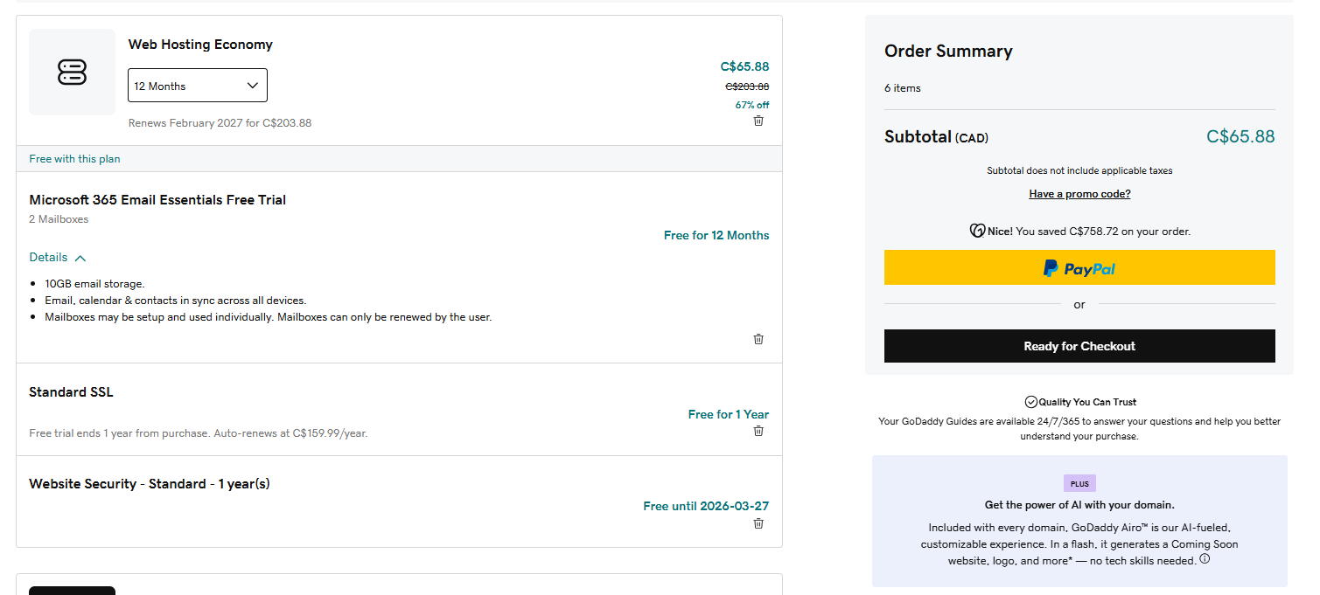
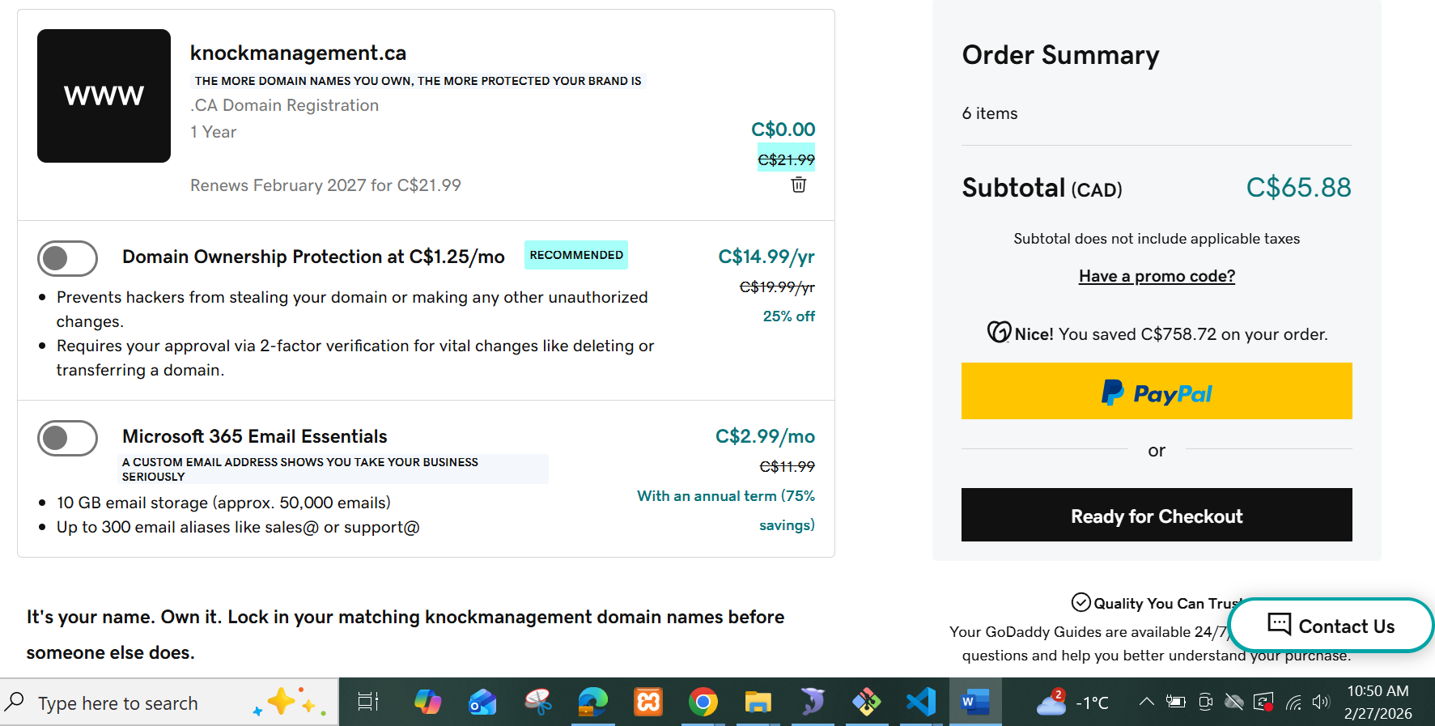
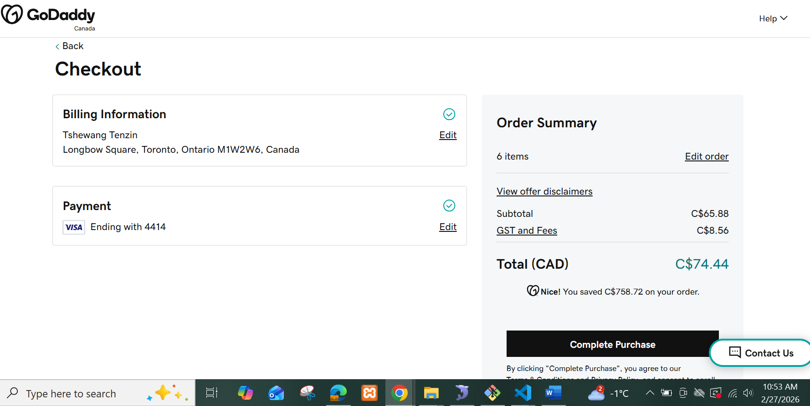
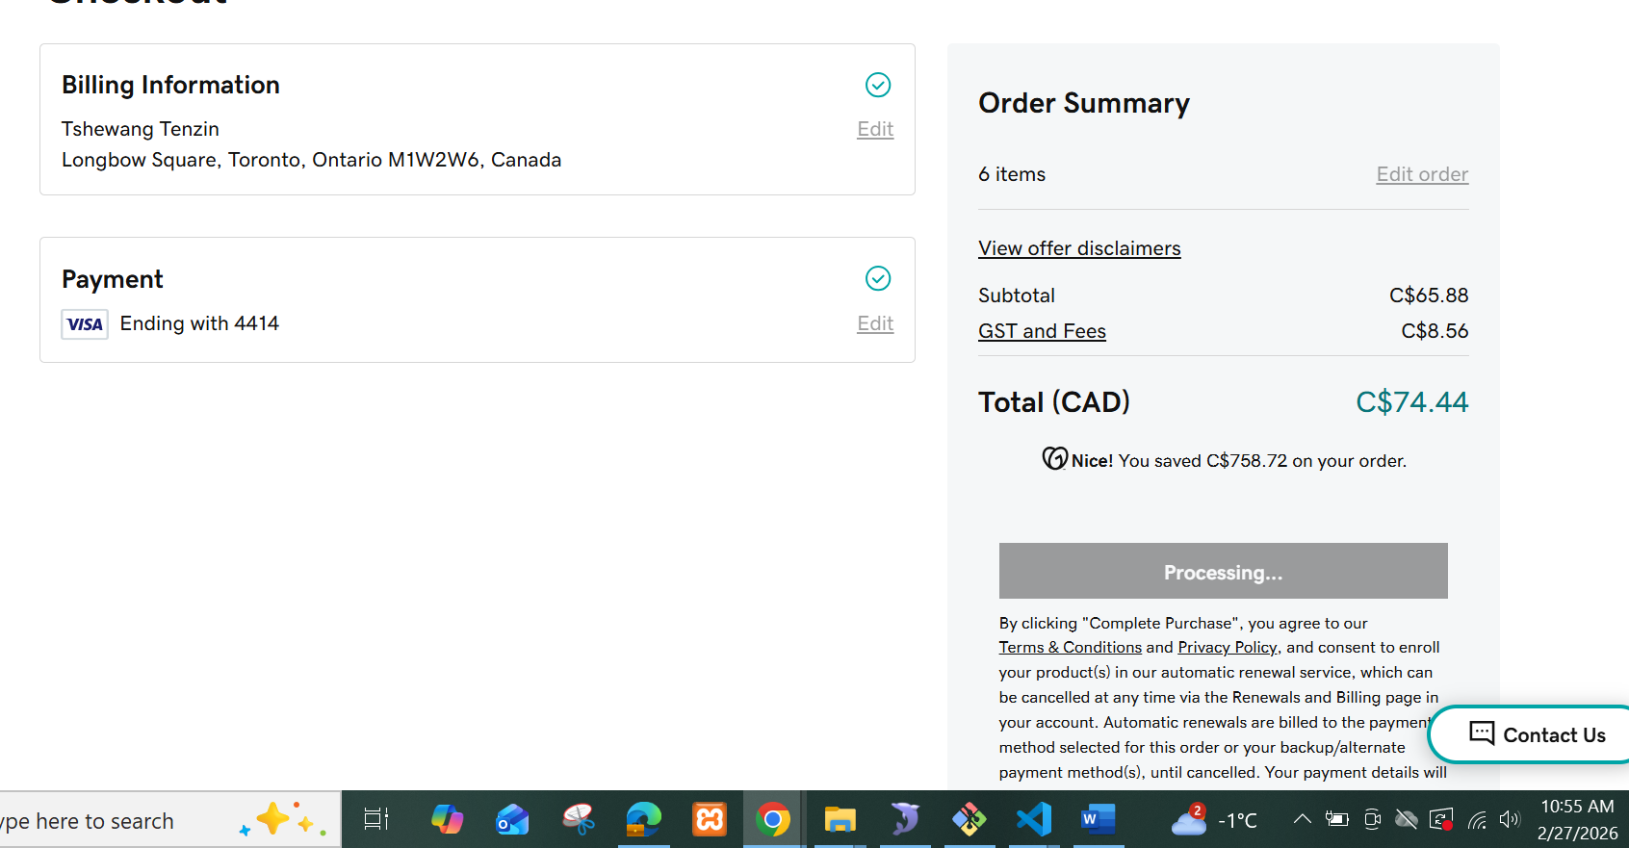
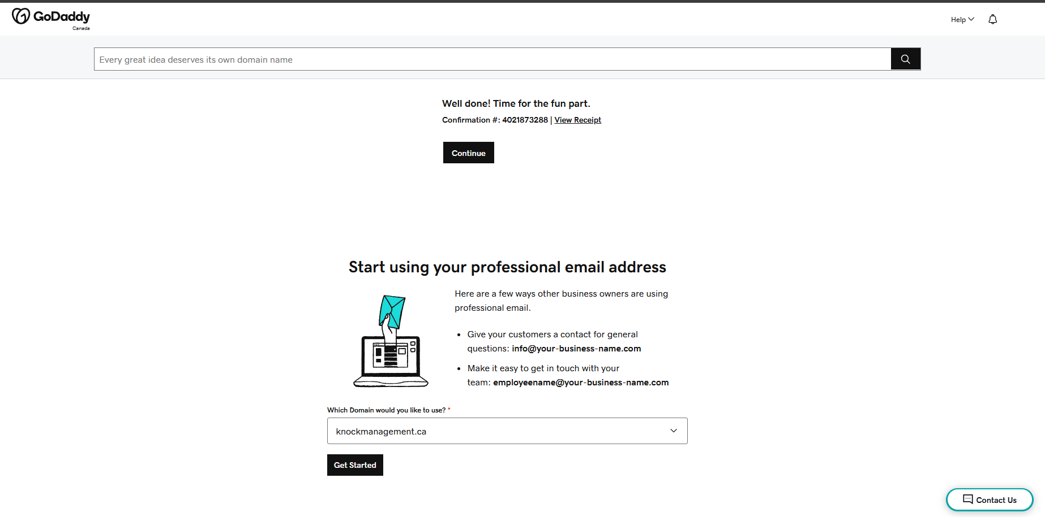

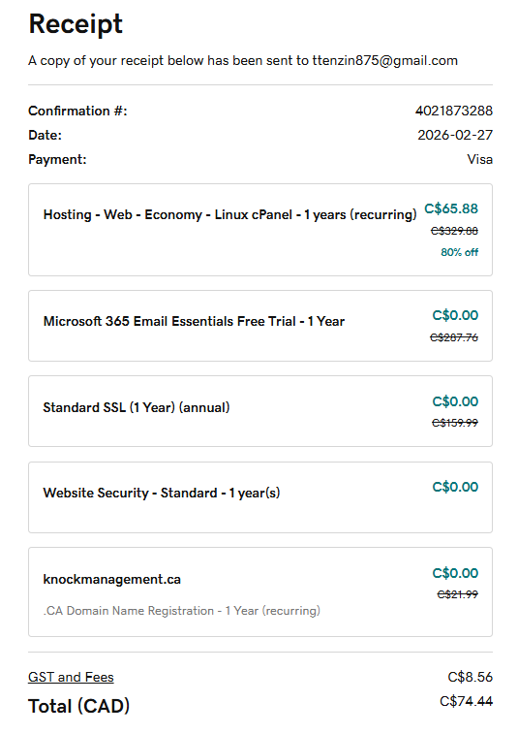

Items | Today 2026 | Next year-2027
Webhosting: | $65.88 – 67% off | 203.88
Email | Free | ?
Standard SSL | Free | C$159.99
knockmanagement.ca | Free | C$21.99
GST and Fees | C$8.56 | ?
Total | C$65.88 | ?

Database:
Name: knockmanagement
User: knockmanagement
Password: vOIGg{gyOm*(

Complete dashboard,
Email integration
Testimony
Social links
SEO

