1) Run the app

To run the app, type in a command window (cmd.exe) opened in the containing folder, the following command :

java -jar ./ZM_Vul_Prediction2.jar

2) Choosing DL

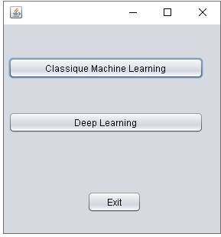

Click here to lunch experiments using DL techniques

2) Choose MLP

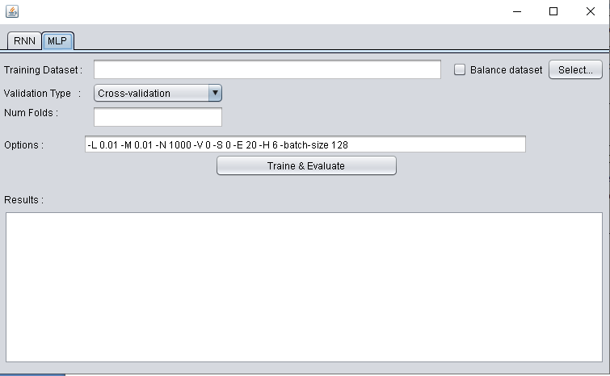

Click here to choose MLP (Multi Layers Perceptrone) model, RNN model is not implemented in this version

3) Setting-up the experiment :

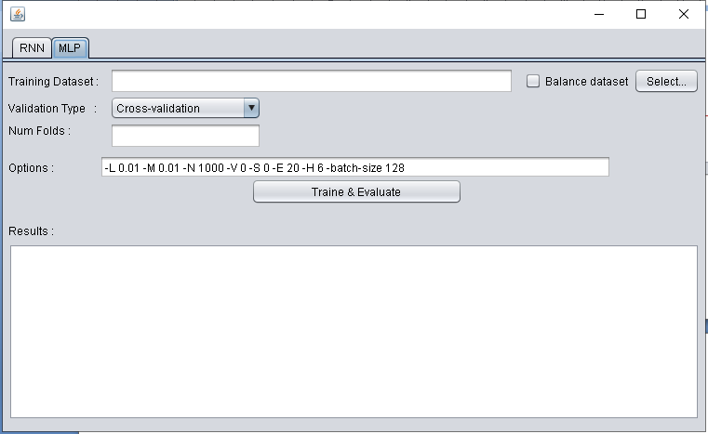

This text area, show the results

This text field contains the options for training the DNN , the important parameters are:

* L : the learning rate ( 0.01)
* M : the momentum (0.01).
* H : number of hidden layers (‘6’ means 1 HL with 6 neurons, ‘6,2’ means 2 HL the first with 6 neurons and the second with 2 neurons, ‘5,8,7’ means 3 HL the first with 5 neurons and the second with 8 neurons and the third with 7 neurons ),
* N : the number of epochs to train through (number of iterations).

Click here to lunch the experiment (train and test the DNN)

Check this, to balance the data

Click here to select the dataset file (.arff)

Folds number of the cross-validation ( 3 or 10)