第3天

网页
- html标签（网页中内容）
- css（样式）
- JavaScript js（动态效果）
html浏览器直接解释执行

网页的基本结构
<!doctype html>
<html>
<head></head> 设置网页编码格式，网页属性，标题等
<body></body> 网页内容
</html>

<!DOCTYPE html>
<html>
<head>
<title>网页</title>
</head>
<body>
网页制作
<a href="http://www.baidu.com">百度一下</a>
</body>
</html>

创建maven的web工程
mavenweb工程的目录结构
src
main
java
resources
webapp （前端的内容）
WEB-INF
web.xml
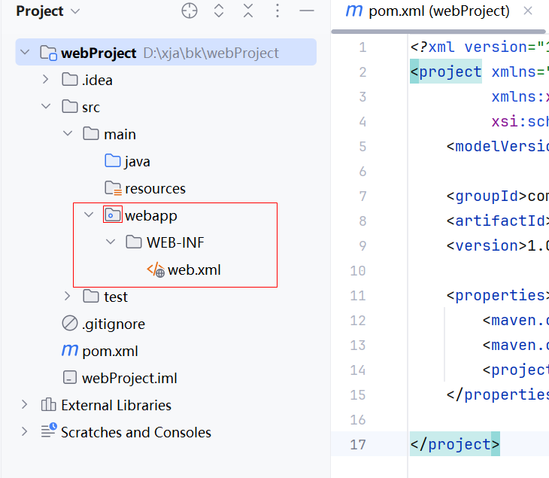

配置tomcat
把tomcat的压缩包解压到磁盘的根目录（尽量不要有中文路径）
1、配置tomcat之后
2、把项目打包成war包
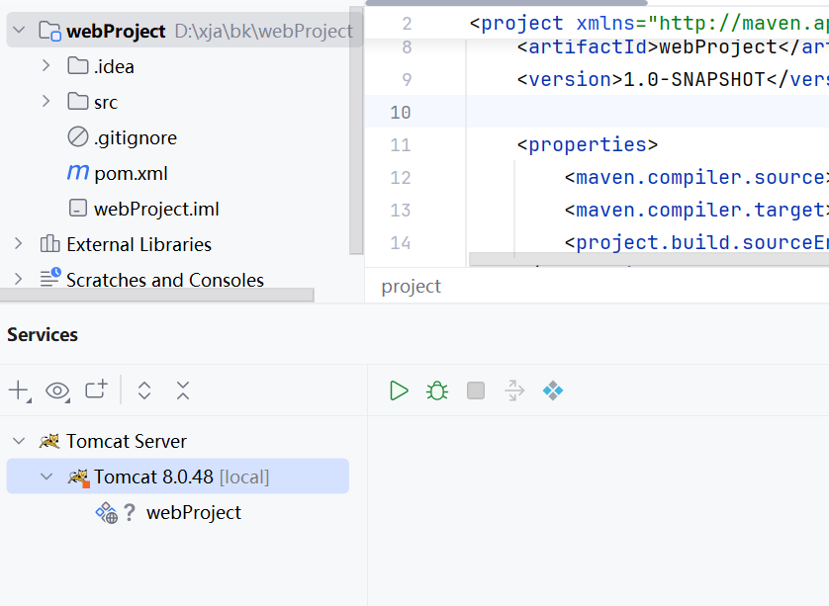
web应用程序默认访问index.jsp或者index.html

创建Servlet
导入Servlet相关的jar，pom.xml
<!--servlet-->
<dependency>
<groupId>javax.servlet</groupId>
<artifactId>javax.servlet-api</artifactId>
<version>4.0.1</version>
</dependency>
<!--jsp-->
<dependency>
<groupId>javax.servlet.jsp</groupId>
<artifactId>javax.servlet.jsp-api</artifactId>
<version>2.3.1</version>
</dependency>
<!--jstl-->
<dependency>
<groupId>jstl</groupId>
<artifactId>jstl</artifactId>
<version>1.2</version>
</dependency>

- login.jsp页面
<%--提交到服务器的路径：相对路径，绝对路径--%>
<form action="login" method="post">
用户名：<input type="text" name="uname"><br>
密码：<input type="password" name="pwd"><br>
<input type="submit" value="登录">
</form>

- 在Controller层创建LoginServlet类
package com.zz.controller;
import javax.servlet.ServletException;
import javax.servlet.annotation.WebServlet;
import javax.servlet.http.HttpServlet;
import javax.servlet.http.HttpServletRequest;
import javax.servlet.http.HttpServletResponse;
import java.io.IOException;
//@WebServlet配置当前Servlet处理请求路径的映射规则
@WebServlet("/login")//可以处理到login的请求
public class LoginServlet extends HttpServlet {
//建议可以处理两种请求方式get或者post
@Override
protected void doGet(HttpServletRequest req, HttpServletResponse resp) throws ServletException, IOException {
doPost(req, resp);
}
@Override
protected void doPost(HttpServletRequest req, HttpServletResponse resp) throws ServletException, IOException {
//req.getParameter()根据表单中name获取请求中参数
System.out.println("req.getParameter() = " + req.getParameter("uname"));
System.out.println("req.getParameter() = " + req.getParameter("pwd"));
}
}

学生管理系统
- 数据库设计
student表
grade表
- 创建MavenWeb工程
导入工程依赖的所有jar包

<dependencies>
<!--servlet-->
<dependency>
<groupId>javax.servlet</groupId>
<artifactId>javax.servlet-api</artifactId>
<version>4.0.1</version>
</dependency>
<!--jsp-->
<dependency>
<groupId>javax.servlet.jsp</groupId>
<artifactId>javax.servlet.jsp-api</artifactId>
<version>2.3.1</version>
</dependency>
<!--jstl-->
<dependency>
<groupId>jstl</groupId>
<artifactId>jstl</artifactId>
<version>1.2</version>
</dependency>
<dependency>
<!--坐标-->
<groupId>org.mybatis</groupId>
<artifactId>mybatis</artifactId>
<version>3.5.9</version>
</dependency>
<!--mybatis分页插件-->
<dependency>
<groupId>com.github.pagehelper</groupId>
<artifactId>pagehelper</artifactId>
<version>5.1.10</version>
</dependency>
<!--mysql-->
<dependency>
<groupId>mysql</groupId>
<artifactId>mysql-connector-java</artifactId>
<version>8.0.26</version>
</dependency>
<!--测试-->
<dependency>
<groupId>junit</groupId>
<artifactId>junit</artifactId>
<version>4.13</version>
<scope>test</scope>
</dependency>
<!--日志-->
<dependency>
<groupId>log4j</groupId>
<artifactId>log4j</artifactId>
<version>1.2.17</version>
</dependency>
</dependencies>
<!--配置maven工程默认加载配置文件的位置-->
<build>
<resources>
<resource>
<directory>src/main/java</directory>
<includes>
<include>**/*.xml</include>
</includes>
</resource>
<resource>
<directory>src/main/resources</directory>
</resource>
</resources>
</build>

- 添加web模块，打成war包，发布到tomcat中
- 导入Mybatis配置文件，数据库的资源文件（修改要连接的数据库名称），日志文件
- 创建表对象的实体类Student，Grade
- web中的分包分层
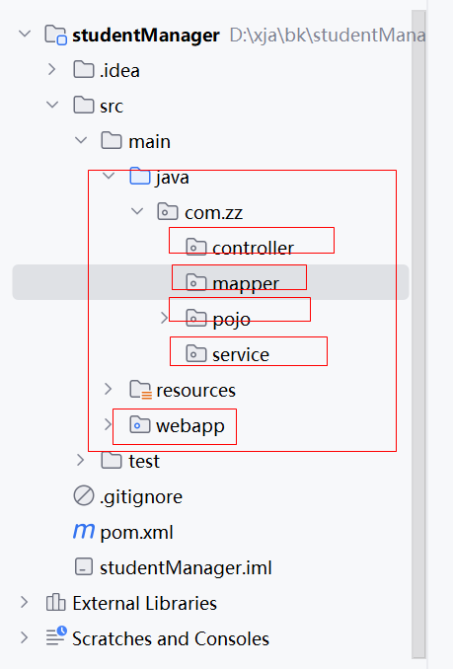

- 封装MybatisUtil工具类
- 查询所有学生的信息
  - 创建Servlet类
package com.zz.controller;
import com.zz.pojo.Student;
import com.zz.service.StudentService;
import com.zz.service.impl.StudentServiceImpl;
import javax.servlet.ServletException;
import javax.servlet.annotation.WebServlet;
import javax.servlet.http.HttpServlet;
import javax.servlet.http.HttpServletRequest;
import javax.servlet.http.HttpServletResponse;
import java.io.IOException;
import java.util.List;
/**
*功能描述：查询所有学生信息
*作者：zz
*时间：2024/7/3 15:35
*/
@WebServlet("/getStudentList")
public class GetStudentListServlet extends HttpServlet {
//创建业务层的对象
private StudentService studentService = new StudentServiceImpl();
@Override
protected void doGet(HttpServletRequest req, HttpServletResponse resp) throws ServletException, IOException {
doPost(req, resp);
}
@Override
protected void doPost(HttpServletRequest req, HttpServletResponse resp) throws ServletException, IOException {
//调用业务层查询所有学生信息的方法
List<Student> studentList = studentService.getStudentList();
System.out.println("studentList = " + studentList);
//带着数据跳转jsp页面展示数据，转发
req.setAttribute("slist",studentList);//把数据设置到Request作用域中
//跳转，使用转发
req.getRequestDispatcher("/studentList.jsp").forward(req, resp);
}
}

  - 编写StudentMapper中查询的方法
<mapper namespace="com.zz.mapper.StudentMapper">
<!--查询必须定义返回值的类型-->
<select id="getStudentList" resultType="com.zz.pojo.Student">
select * from student
</select>
</mapper>

  - 编写service业务层
@Override
public List<Student> getStudentList() {
try {
SqlSession sqlSession = MybatisUtil.getSqlSession();
StudentMapper studentMapper = sqlSession.getMapper(StudentMapper.class);
return studentMapper.getStudentList();
} catch (SQLException e) {
e.printStackTrace();
} finally {//不管try中是否有异常，finally一定会执行
MybatisUtil.closeSqlSession();//关闭SqlSession对象
}
return null;
}

- 编写studentList.jsp页面
把数据展示
使用jstl标签库展示数据-需要jsp页面中引入使用
<%@ taglib prefix="c" uri="http://java.sun.com/jsp/jstl/core"%>

<%--items:设置遍历的对象 var：设置遍历对象别名--%>
<c:forEach items="${slist}" var="stu">
<tr align="center">
<td>${stu.sid}</td>
<td>${stu.sname}</td>
<td>${stu.age}</td>
<td>${stu.phone}</td>
<td>${stu.sex}</td>
<td>${stu.gid}</td>
</tr>
</c:forEach>

任务
- 关联查询返回数据中包含班级的名称
- 实现登录功能User表
@Override
protected void doPost(HttpServletRequest req, HttpServletResponse resp) throws ServletException, IOException {
//req.getParameter()根据表单中name获取请求中参数
System.out.println("req.getParameter() = " + req.getParameter("uname"));
System.out.println("req.getParameter() = " + req.getParameter("pwd"));
}

