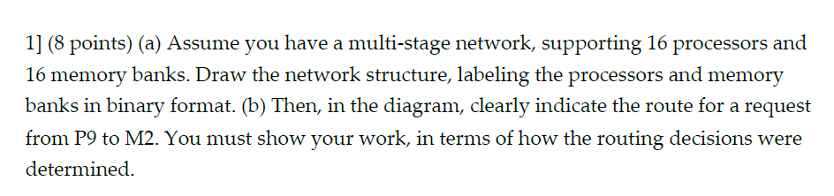

* 1. The network structure is shown below.
  2. There is Log16=4 stages

Each stage has 16/2=8 switches

P9=1001 M2=0011

Route, exam the destination binary format, which is 0011, at stage k ,check bit k of the destination. If 0, go up if 1, go down.

1. 0, go up
2. 0, go up
3. 1, go down
4. 1, go down

The routing decision is highlighted in red in the multi-stage network graph below.

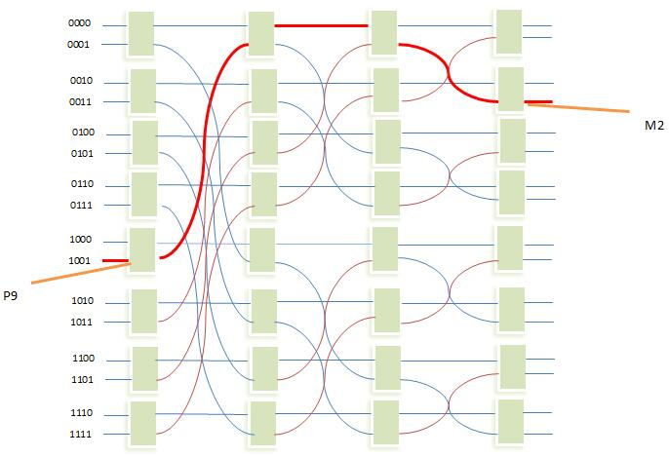

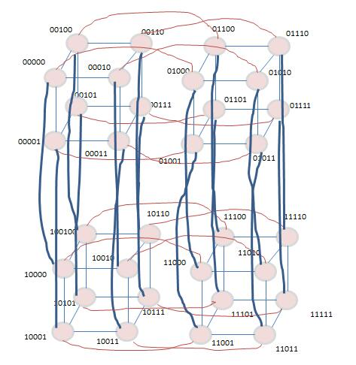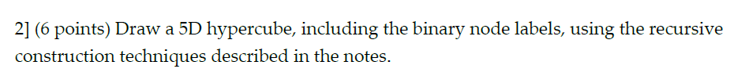the hypercube is as follows,

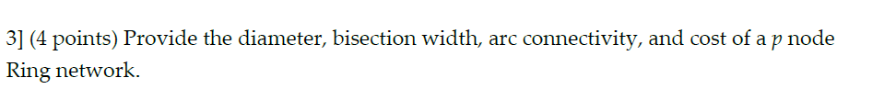Diameter: p-1

Bisection width: 2

Art connectivity: 2

Cost: p



27=128

As 2 n-1 dimension hypercubes form the n dimension hypercube by 2n-1 links, reversely,

The connectivity for an n dimension hypercube is 2n-1.

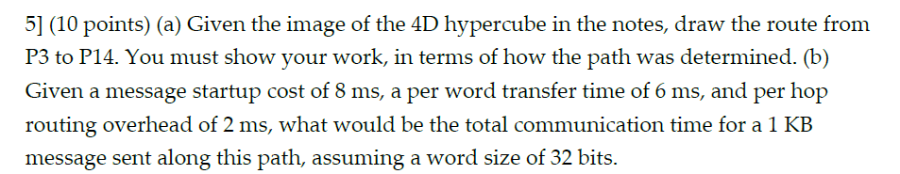

1. P3 = 0011 , P14 = 1110

0011 XOR 1110 = 1101(LS 1-bit)

We move along the x-axis towards 0010

0010 XOR 1110 = 1100 (LS 1-bit)

We move along the z-axis towards 0110

0110 XOR 1110 = 1000(ls 1-bit)

We move along the 4th-axis towards 1110, and reaches the destination P14.

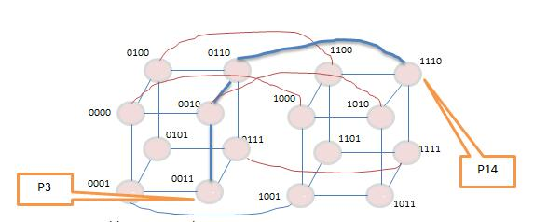

1. tcomm= ts +ltn+twm

= 8+3\*2+(1024/32)\*6 = 206 ms

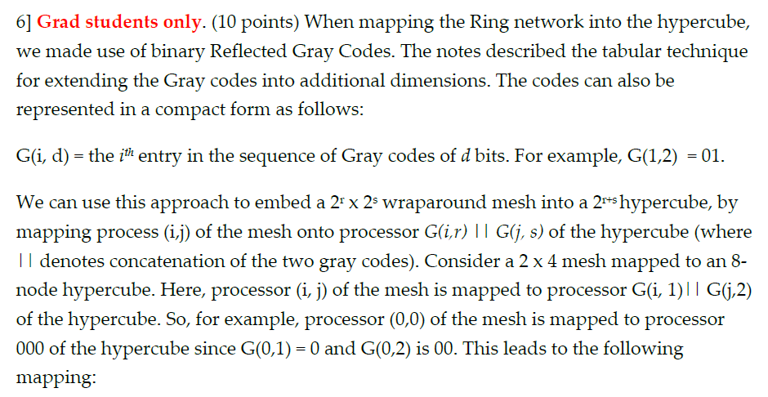

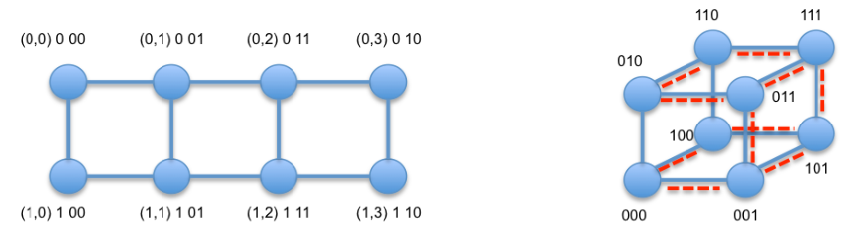

For 4\*4 mash, r=2, s=2. We will map to a 22+2 hypercube

G(0,2)||G(0,2) = 0000

(0,2)0011

(0,1)0001

(0,3)0010

(0,0)0000

(1,3)0110

(1,2)0111

(1,1)0101

(1,0)0100

(2,3)1110

(2,2)1111

(2,1)1101

(2,0)1100

(3,3)1010

(3,2)1011

(3,1)1001

(3,0)1000

G(0,2)||G(1,2)= 0001

G(0,2)||G(2,2)= 0011

G(0,2)||G(3,2)= 0010

G(1,2)||G(0,2)= 0100

G(1,2)||G(1,2)= 0101

G(1,2)||G(2,2)= 0111

G(1,2)||G(3,2)= 0110

G(2,2)||G(0,2)= 1100

G(2,2)||G(1,2)= 1101

G(2,2)||G(2,2)= 1111

G(3,2)||G(3,2)= 1110

G(3,2)||G(0,2)= 1000

G(3,2)||G(1,2)= 1001

G(3,2)||G(2,2)= 1011

G(3,2)||G(3,2)= 1010