**What included in this Matplotlib Exercise?**

This exercise contains ten questions. The solution is provided for each issue. Each question includes a specific Matplotlib topic you need to learn. When you complete each question, you get more familiar with Data data visualization using matplotlib.

**Exercise 1: Read Total profit of all months and show it using a line plot**

Total profit data provided for each month. Generated line plot must include the following properties: –

* X label name = Month Number
* Y label name = Total profit

The line plot graph should look like this.

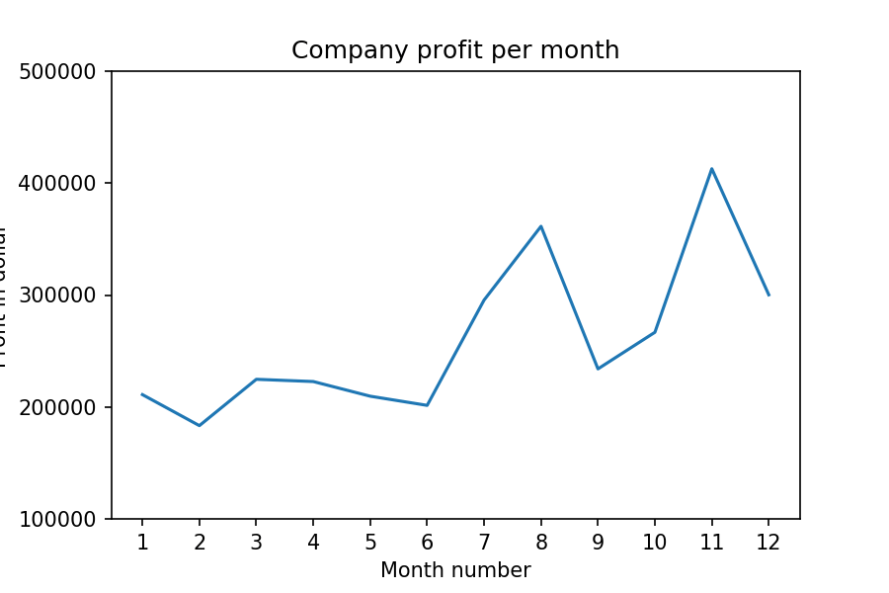

**Exercise 2: Get total profit of all months and show line plot with the following Style properties**

Generated line plot must include following Style properties: –

* Line Style dotted and Line-color should be red
* Show legend at the lower right location.
* X label name = Month Number
* Y label name = Sold units number
* Add a circle marker.
* Line marker color as read
* Line width should be 3

The line plot graph should look like this.

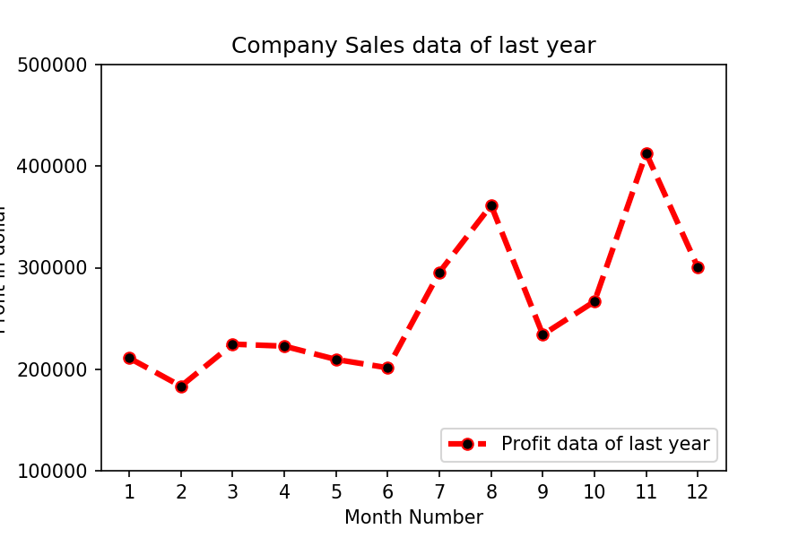

### Exercise 3: Read all product sales data and show it  using a multiline plot

Display the number of units sold per month for each product using multiline plots. (i.e., Separate Plotline for each product ).

The graph should look like this.

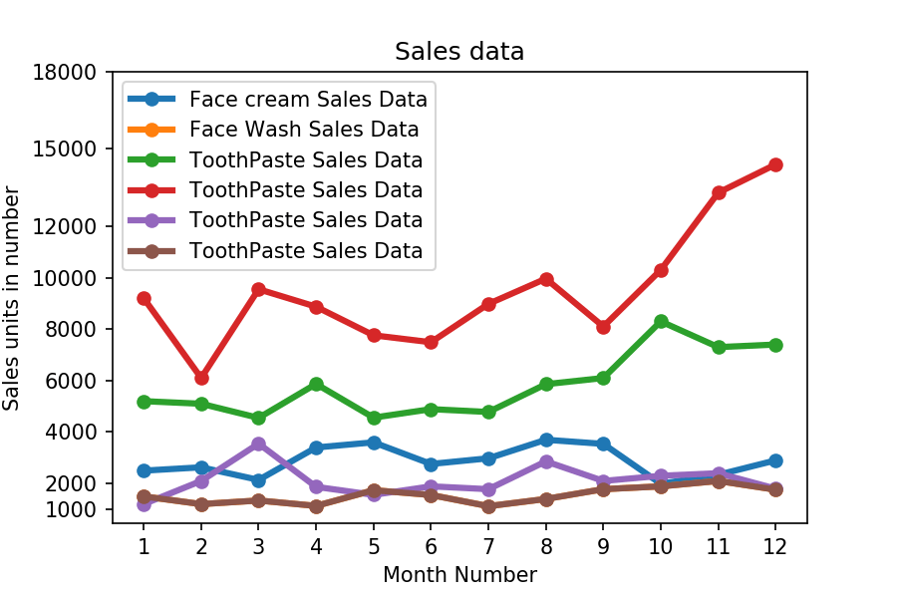

### Exercise 4: Read toothpaste sales data of each month and show it using a scatter plot

Also, add a grid in the plot. gridline style should “–“.

The scatter plot should look like this.

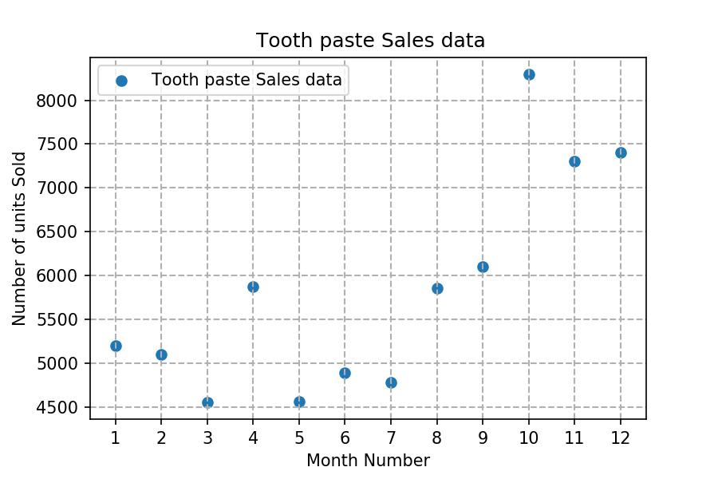

### Exercise 5: Read face cream and facewash product sales data and show it using the bar chart

The bar chart should display the number of units sold per month for each product. Add a separate bar for each product in the same chart.

The bar chart should look like this.

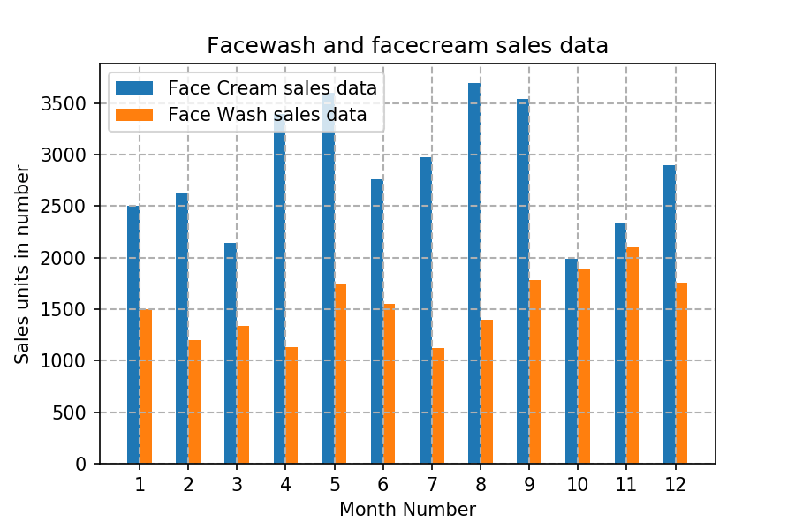

### Exercise 6: Calculate total sale data for last year for each product and show it using a Pie chart

**Note**: In Pie chart display Number of units sold per year for each product in percentage.

The Pie chart should look like this.

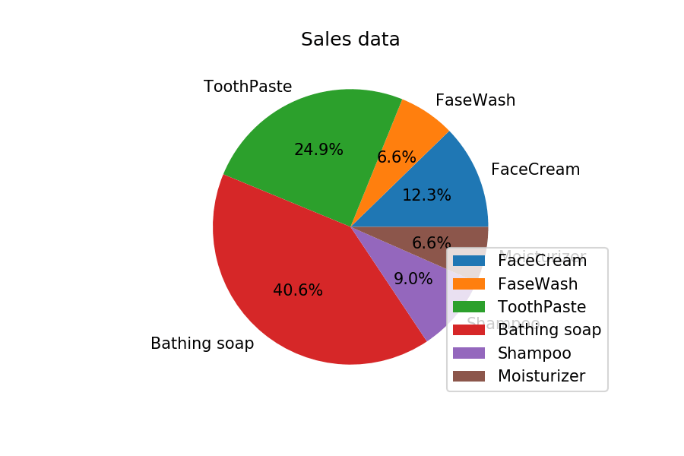

### Exercise Question 7: Read all product sales data and show it using the stack plot

The Stack plot should look like this.

