IB Mathematics

HL Internal Assessment

Exploring the Volume and Surface Area of Revolution of a Watermelon

**IB Candidate Code:** jgt145

**Date of Submission:** 2023/01/16

**Table of Contents**

| Introduction…………………………………………………………………………………  Rationale…………………………………………………………………………….  Aim………………………………………………………………………………….  Modelling…………………………………………………………………………………...  Method 1: ellipse equation………………………………………………………….  Method 2: polynomials……………………………………………………………...  Evaluating Modelling Methods……………………………………………………………..  The Volume of Revolution………………………………………………………………….  The Surface Area of Revolution…………………………………………………………….  Deriving the surface area of revolution formula……………………………………  Calculating the surface area of revolution…………………………………………..  Calculating the Amount of Servings………………………………………………………..  Conclusion…………………………………………………………………………………..  Bibliography………………………………………………………………………………... | 1  1  1  2  3  6  12  12  13  13  17  18  19  21 |
| --- | --- |

**INTRODUCTION**

**Rationale**

Over the summer I visited my home country, Pakistan. Pakistan is known to have a very hot and dry climate with temperatures reaching record-breaking heights. As a result, my cousins and I always indulged ourselves by making ice cream cakes or mustering various cool beverages to keep ourselves and our families refreshed under the summer heat. One trademark beverage of ours was called *Tarbooz ka Sharbat,* which consists of mostly watermelon mixed with Rooh Afza, cold water, lemon juice and sugar. It’s offered on the side of many streets across the country and has therefore become predominant in Pakistan’s street food culture. Along with various other drinks and food my cousins and I loved to cook up, this beverage was the go-to for when guests were arriving or when there was a heatwave. So, when the opportunity to mathematically approach an interest I had was presented through this IA, I decided to turn to my interest in culinary arts. With my recent visit to Pakistan circling my mind, my focus landed on this beverage. I decided to revisit my summer days in Pakistan by making this drink for my family and me, in Canada. Since the largest portion of this recipe is watermelons and we had only one at home, I wanted to determine how many servings of the homely recipe I can make with the fruit. Therefore, the research question for my IA is “How many servings of the recipe for Tarbooz ka Sharbat can be made with the watermelon I have at home?”

**Aim**

This IA aims to explore suitable mathematical models for the watermelon and use the model with the most accurate fit to determine the surface area and volume of revolution of the fruit, and hence the number of servings that can be made. This IA will attempt to achieve this by modelling the watermelon using two different methods; ellipse equation and polynomials. Then an evaluation of the two methods will take place to form a conclusion of the most suitable one, whose equation will be used to calculate the volume and surface area of revolution of the fruit. The total servings will then be found by using the difference between the calculated volume and surface area of revolution values. This volume is indicative of the total amount of pulp and rind present and the surface area is indicative of the amount of rind. As the surface area of revolution is not a part of the syllabus, it will be explained and derived from concepts I am familiar with.

**MODELLING**

After capturing a picture of the watermelon, shown in Figure 1, I imported it into the photoshop software, Krita, so I could remove the background and make it easier to graph the watermelon. Then, I imported the altered picture into Desmos, a graphing software, which will assist me in finding a good model for the fruit. Whilst doing so, I stumbled upon the problem of how to scale it so it best reflects the watermelon I had at home. I decided to perform a longitudinal cut on the fruit, cutting lengthwise from top to bottom via the longest axis, which will show the line of symmetry and thus the length and width of the watermelon can be accurately measured. After using a measuring tape, the length came out to be 37.2cm and the width 31.1cm. These measurements were then used to scale the watermelon picture on Desmos, as shown in Figure 2.

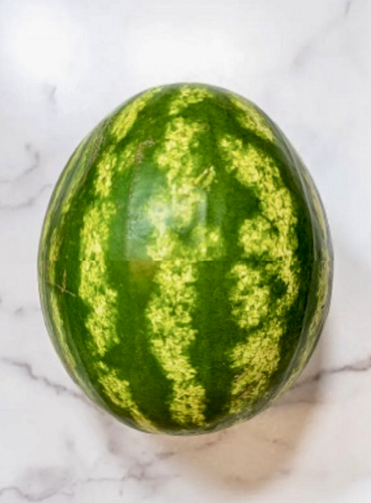

*Figure 1. A picture of the watermelon I had at home*

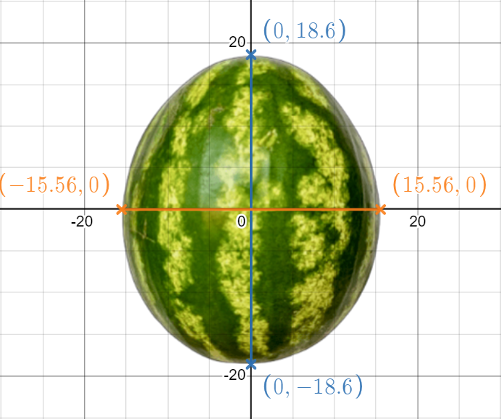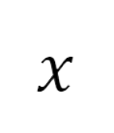

*Figure 2. Superimposing the altered image onto Desmos*

There are many limitations to how I went about this that may confound with the accuracy of the aim. For example, the longitudinal cut performed is subjective to where I believe the longest axis of the watermelon lies. Also, since watermelons are difficult to cut due to their sturdiness, there's also the possibility that the cut performed was not straight through, introducing bumps and grooves while I was measuring. There is also uncertainty associated with the measurements, as the precision of the tape was 0.1cm, there is an uncertainty of 0.05cm, which introduces the possibility of error in the number of servings that will be found. An improvement could be to use a more accurate ruler with a 0.01cm minimum division to increase accuracy. However, since a ruler like that was not available, I will round all values in my IA to 2 decimal places because of the 2 decimal uncertainty of the ruler and how the main software being used, Desmos, also rounds all values to two decimal places. A strength of using Desmos is the data points used are digitally plotted onto an overlaid image of the watermelon which reduces human error and boosts accuracy in the model.

**Method 1: The Ellipse Equation**

My initial prediction when I looked at the watermelon was that it resembled an ellipse. This is why I decided to attempt to model the watermelon using the equation of the ellipse and see how well it fits. A generic ellipse has the following equation:

(OpenStax, 2021)

where the and axes-intercepts, respectively, are represented by and . Since they are equal distances away from the origin, they are also known as the vertical and horizontal radii. The longest diameter of the ellipse is known as the major axis and is represented by twice the value with the larger magnitude. The shortest diameter of the ellipse is known as the minor axis and is thus represented by twice the value with the smaller magnitude, as shown in Figure 3.

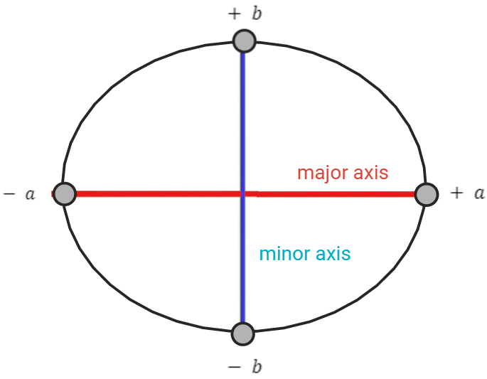

*Figure 3. Structure of an ellipse*

In order to apply the equation above to the watermelon, appropriate values for the parameters and need to be found. Since is half the length of the major axis, this will just be the coordinate at which the watermelon intercepts the -axis and since is half the distance of the minor axis, this will just be the coordinate at which the watermelon intercepts the -axis. Looking at Figure 2, it can be seen that the watermelon intercepts the -axis at and the -axis at . So therefore and . This gives the equation:

(1)

After graphing the equation on Desmos, as seen in Figure 4, I was able to see how well it encompassed the watermelon.

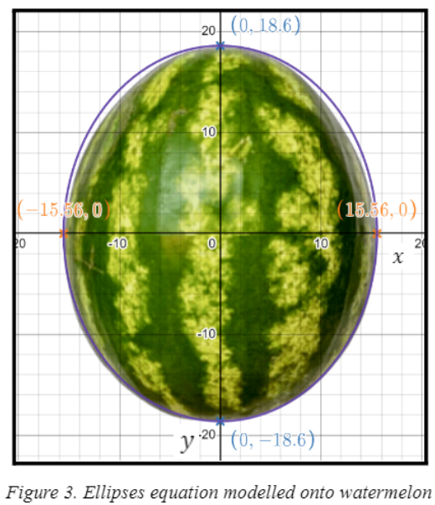

*Figure 4. Ellipses equation modelled onto the watermelon*

Surprisingly, the watermelon turned out to not be perfectly elliptical, as I had previously predicted. This called for another method of modelling to perhaps find a more accurate fit, which is why I decided to model the fruit using polynomials as well. However, it is also important to note that the equation of this ellipse generally represents the curvature of the watermelon quite well, which is a strength of this model. The equation does pass through the intercepts, as expected, and also captures the curvature of the watermelon below the -axis almost perfectly. The problem arises above the -axis as the graph stretches out wider than the shape of the fruit, which is a limitation that may affect the aim through an overestimation in the calculations. An improvement could be to experiment with different coordinates for the axis intercepts which would give different elliptical shapes and then use the most accurate one. However, the same problem would have still occurred as the ellipse would not have been perfectly aligned with the curvature of the fruit, meaning that the problem is rooted in the equation itself. Upon doing research, I discovered that the ellipse equation can be modified in several ways, for example by adding “” in the denominator to alter the symmetry of the equation. It could be a good next step to investigate which function should be built to offer the best fit, but doing so is not necessary given that the current function only barely deviates from the curvature of the watermelon.

**Method 2: Polynomials**

As the ellipse equation was imperfect, it is important to approach the topic from a different angle and attempt at finding a more accurate model of the watermelon. The watermelon in Figure 2 will be turned 90 degrees clockwise and positioned along the x-axis to aid with modelling. Now, assuming that the fruit is symmetrical about the -axis, this method entails obtaining polynomial equations that can model the upper portion of the watermelon, and then reflecting them across the -axis to obtain equations for the lower half. However, as the precision of the model of the watermelon increases, so would the complexity, or degree, of the polynomial equation needed to represent it. Initial observations indicate that a second, third, or fourth-degree polynomial is not sufficient to accurately depict the top half of the watermelon in its entirety. While higher degree polynomials such as fifth or sixth degree may be attempted, this would just be time-consuming and could also introduce human errors in the calculations. Therefore, I simply decided to use quadratic equations. One singular equation cannot represent the entirety of the top half of the fruit, so I divided the watermelon into left, middle, and right sections so that each section can be modelled using a different quadratic. Three randomly chosen data points from each of the sections were used and are in the table below to 2 decimal places.

| Point |  |  |  | Point |  |  |  | Point |  |  |
| --- | --- | --- | --- | --- | --- | --- | --- | --- | --- | --- |
| A | 3.64 | 9.74 |  | A | 18.50 | 15.56 |  | A | 31.20 | 10.56 |
| B | 6.40 | 12.30 |  | B | 24.77 | 14.20 |  | B | 36.90 | 0.40 |
| C | 0.10 | 0.30 |  | C | 10.40 | 14.20 |  | C | 34.00 | 7.30 |

*Table 1. Left section coordinates*   *Table 2. Middle section coordinates Table 3. Right section coordinates*

The general equation for a quadratic is:

There are three unknowns in this equation, , and . Using three randomly chosen data points in the left section (Table 1), the unknowns can be solved for using a system of equations:

The unknown variables can be found using mathematical matrices, which are arrangements of numbers into rows and columns. Three matrices can be arranged using the three points A (3.64, 9.74), B (6.40,12.30), and C (0.10, 0.30). In the first matrix, all the values of are added (A matrix), in the second, the coefficients a, b, and c are added (B matrix), and in the third the values of are added (C matrix). When multiplying two matrices, each element of the first row in the first matrix is multiplied by each element of the first column of the second matrix (Khan Academy, n.d.). The final column in the first matrix holds the value of 1, as is a constant and its value remains unchanged regardless of the value of . This is illustrated below:

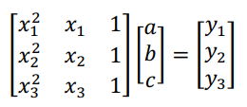

This is the same as:

Matrice B needs to be isolated as that is what is being calculated. To do this, both sides of the equation need to be multiplied by the inverse of matrix A:

Since anything multiplied by the inverse of it is just 1, we obtain:

Substituting in the values into their corresponding matrices and using the matrix option (pressing the buttons 2nd then ) on the GDC, the values for matrice B are found:

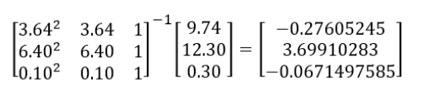

Using Desmos, I set to various decimal places and after 6 decimal places, minimal fluctuations in the function were seen. Therefore, the equation for the left section, , is:

(*6 d.p.*)

This process was then repeated to find quadratic equations for the middle section, , using the values in Table 2 and the right section, , using the values from Table 3. To six decimal places, the functions were calculated to be:

The three functions were then all graphed on Desmos, as seen below in Figure 5.

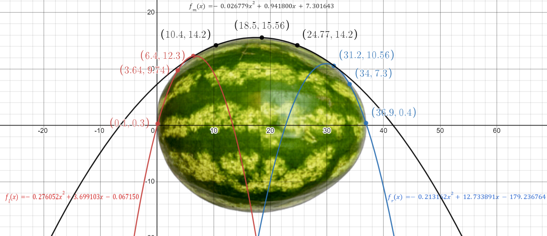

*Figure 5. Graphical representation of , and alongside the watermelon.*

The functions are reflected on the -axis and the domains restricted to get the piecewise relation:

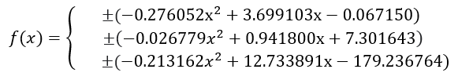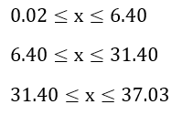

This piecewise relation was then graphed on Desmos, as seen in Figure 6.

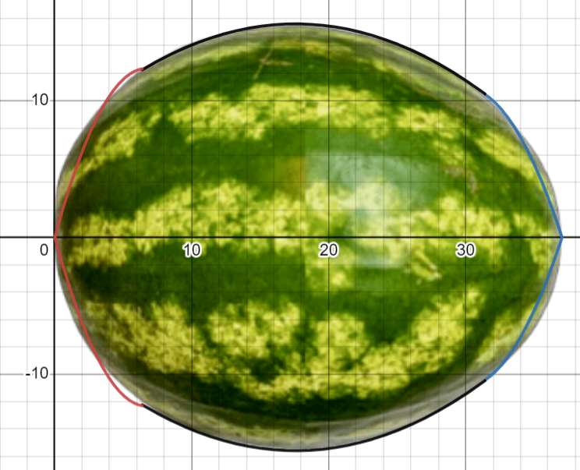

*Figure 6. Piecewise relation graphed alongside the watermelon*

It was assumed before that the watermelon was perfectly symmetrical about the -axis, however from observing Figure 6, this prediction is discovered to be untrue. Although the watermelon looked to be at first glance, fruits, in general, are usually unsymmetrical by nature and also since this watermelon is store-bought, it may have developed bumps and penetrations during the moving process, which is a limitation that may affect the accuracy of the aim. Since this is the case, in order to get more accurate results, an improvement would be to find piecewise relations for the bottom half too. However, the watermelon is only slightly unsymmetrical and doing so would be pointless and time-consuming as it would just have resulted in a slight improvement in accuracy. Furthermore, although is well fit, and extend below the outline of the fruit, which is another limitation. As an improvement, it would have been beneficial to test multiple different coordinates along the right and left sections to try and capture the curve more effectively. The transition from to seems to be uneven as well and there is a rise in that extends away from the curvature of the watermelon and forms a sort of a hump, as seen in Figure 7 labelled “Before”. If the volume of revolution was taken, there would be a sharp bump on the surface instead of a smooth curve. Therefore, to improve upon the piecewise relation and find a more accurate representation of the fruit, I have decided to find the points of intersection between the functions and . To do this, the functions are equated:

The roots are found using the GDC (PlySmlt2 app), to simplify the process and prevent the possibility of human error:

The lower value is used so the rise in , as I predict, can be removed, so . Figure 7 allows to see the comparison between the intersections between the functions and .

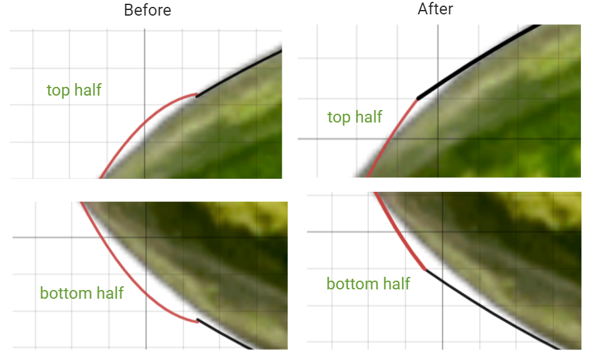

*Figure 7. Comparison between before the domain of the piecewise relation was changed versus after*

The new point of intersection is beneficial as the rise in has been almost removed, which shows my prediction was true. Therefore, the new domain of the piecewise relation is:

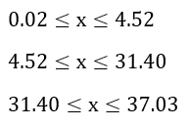

It is important to note that the intersection, although smoother which is a strength, is not fully seamless. An improvement would be to stray from polynomials and use other functions, such as sinusoidal or exponential. Therefore, a further investigation would be worth doing as a good next step, although not essential, into which function would provide the best fit for the watermelon. Additionally, employing matrices requires lengthy calculations that increase the likelihood of human error when entering values into GDC which is also a limitation. For this reason, it would have been beneficial to make code as an improvement that would automatically calculate the equation of the polynomial function.

**EVALUATING MODELLING METHODS**

The main distinction between the models is that method 1 is more generic than method 2 since, given the axes-intercepts of the watermelon, it can be simply applied to any unique watermelon bearing the same general shape. Contrarily, method 2 is more specific in that modelling a different watermelon will require the use of numerous distinct, various polynomial functions. Comparing Figures 4 and 6 shows that both the models have about the same fit to the curvature of the fruit, with Figure 4 overestimating and extending away while Figure 6 underestimates and falls below the curve. I decided that overestimating the volume and surface area, although not by much, would be the better choice in this situation as an overestimate of servings was preferred. Furthermore, I decided to use the ellipses model also due to its stronger generalizability and the fact that its graph is continuous and appears to be smoother. Consequently, equation (1), will be used in the subsequent calculations. Although the polynomial piecewise function is not being used, the process of experimenting and coming up with them improved my understanding of how polynomials work and their real-life applications. I also learned how to improve upon them by finding the points of intersection, which I did not know how to do before. Furthermore, experimenting with ellipses furthered my understanding of circles in the topic of geometry

**THE VOLUME OF REVOLUTION**

In my HL math class, I have become familiar with how to calculate , the volume of revolution of a function, or simply just , rotated about the -axis degrees between the lower and upper limits of the function, and respectively. This calculation was performed via the formula in the “Mathematics: analysis and approaches formula booklet”:

Since (1) is being reflected on the -axis, the limits would be the intercepts, which are given in Figure 4 as . Thus since is the lower limit, and since is the upper limit, . When (1) is rearranged in terms of with the subject, we get:

(2)

Substituting into the volume of revolution equation along with values of and :

Applying the rules of integration and simplifying:

**THE SURFACE AREA OF REVOLUTION**

In order to find the amount of rind present, the surface area of revolution will be calculated.

**Deriving the Formula**

A solid of revolution can be constructed by rotating a continuous function, , about the -axis on the interval . This solid of revolution can be broken down into endless amounts of frustums, which are constructed by taking a line segment with an equal width of and rotating it around the -axis. A frustum is defined as “a section of a cone bounded by two planes, where both planes are perpendicular to the height of the cone” (Project, 2019). The frustum is used because it represents the lateral surface of a three-dimensional object generated by rotating a two-dimensional shape. An infinite number of frustums is assumed in order to model the solid as accurately as possible. Figure 8 illustrates a representation of the watermelon as a solid of revolution that has been divided into 2D frustums of equal width , but it is limited to only 4 frustums.

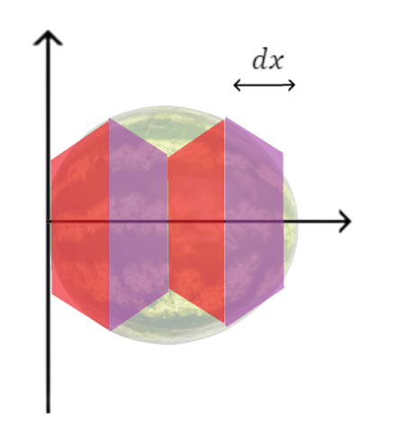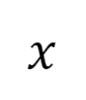

*Figure 8. 2D frustums representing the watermelon*

As can be seen in the figure above, dividing the shape into 4 frustums is not enough of an accurate representation, there are still parts of the watermelon that deviate from the curvature of the frustums. Therefore, an infinite amount of frustums is assumed to calculate surface area accurately. The formula for the surface area of a frustum is:

(3)

Where is surface area, is the slant height and is radius of the frustum with . This is because the frustum has two sides each with a different radius, as shown in Figure 9, the radius would therefore be the average of the two radii.

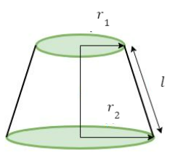

*Figure 9. A labelled diagram of a frustum (GeeksforGeeks, 2018)*

The slant height, , can be equated to the curve length of the function, . Therefore, making the substitutions into (3), we obtain:

(4)

If is continuous and the frustum is assumed to be lying on the interval , This would give the values and . Since the frustums are infinite, would, therefore, be small and and can be approximated to . Substituting these values into (4), we get:

On the interval , the definite integral of is defined as:

Since there are an infinite number of frustums, this can be approximated to:

(5)

Even if the shape of the solid is curved, there are an infinite amount of frustums so , the change in and , the change in , will be small and thus the curve length, , will just be a straight line. A right-angled triangle, in Figure 10, can be used to illustrate how and , relate to .

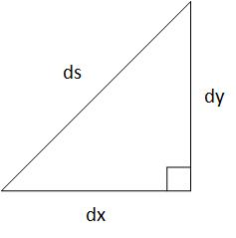

*Figure 10. Right-angled triangle relating , and*

Applying the Pythagorean Theorum:

Square rooting both sides and factoring:

Substituting into (5), on the interval the surface area of a solid of revolution is found:

In order to arrange this formula in terms of , the same derivation process is applied where instead and are the horizontal limits and the function is revolved through about the -axis instead of the -axis, which gives us:

**Calculating the Surface Area of Revolution**

Calculating the surface area of revolution is necessary in order to fulfill the aim and determine how much rind is in the watermelon. The formula for the surface area of revolution of a solid derived in the previous section will be used. Solving for the positive solutions of from (2) gives us or simply just :

(6)

We can find the derivative, , using the chain rule for the square root part of the equation:

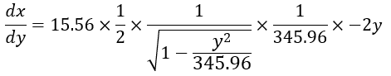

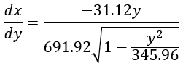 (7)

We can now use the derived formula for surface area and substitute (6) for the function and (7) for the derivative. The bounds are the same as used for the volume of revolution for the same reason:

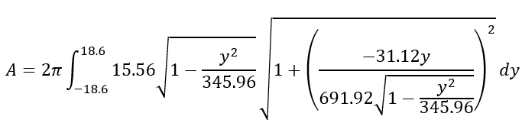

Using a GDC to find the value of the integral and prevent human error gives:

**CALCULATING THE AMOUNT OF SERVINGS**

The recipe I am following to make Tarbooz ka Sharbat is by Hebbars Kitchen (2019). It requires two cups of watermelon for three servings and I have enough of all other ingredients. There are approximately in a cup (Asknumbers, n.d.). So, two cups have the volume:

So each serving needs the volume:

It was found that the watermelon had the volume . However, this volume includes the volume of the rind too, which is not usable in the recipe. Therefore the total volume that is usable is the difference between the volume calculated and the volume of the rind present. The volume of the rind present can be calculated by taking the surface area and multiplying it by the thickness of the rind in the watermelon. When I did the longitudinal cut for the watermelon and cut it in half, I was able to measure the thickness of the rind as well, which was 2.1cm. So:

Now that we have the total amount of volume that can be used, we can calculate the amount of servings that can be made by dividing the usable volume by the volume needed for each serving:

Therefore, I have met the aim of this IA and found that 73 servings ofTarbooz ka Sharbatcan be made with the watermelon I have at home. I used two significant figures because it is not possible to make 0.72 of a serving, so I assumed whole numbers. There was also an assumption made that the thickness of the rind was 2.1cm across the entire fruit, when naturally the rind may be uneven, which is a limitation. One improvement could have been to obtain multiple values of the thickness of the rind across the fruit and find the average of the thickness to improve accuracy. It is important to note that the number of servings is an overestimate as the model used was inaccurate, as aforementioned. As a next step, the water displacement method could be used to assess the accuracy of the results by using a volume-divided bucket with the watermelon fully submerged in water. The actual volume of the watermelon would then be the volume of displaced water. Another limitation that may affect the accuracy of the results is how the decimals were not carried throughout the exploration. An improvement would have been to carry them throughout. Finally, a strength is that the thickness of the rind was measured from the actual watermelon, which increases the accuracy of the results.

**CONCLUSION**

The aim of this IA was to explore mathematical models to calculate the volume and surface area of revolution of a watermelon I had at home and hence determine the number of servings I could make of a recipe of Tarbooz ka Sharbat with it. This aim was successfully met and in the process, required me to expand my calculus expertise, from which I deduced the formula for the surface area of a solid of revolution. I also cut the watermelon and measured its dimensions to accurately model the curvature using two different approaches; ellipse equation and polynomials. After comparing and evaluating the two models, the ellipse equation was used to calculate the volume and surface area, which were and respectively. These values were then used to determine the number of servings which was calculated to be 73. This means that I can make the recipe, in fact, a total of 24 times, with the watermelon I have at home, assuming enough of all other ingredients.

Since I established a method to fairly accurately compute the surface area of solids of revolution, this can be applied to the industrial sector in many ways, such as estimating the expenses of painting decorations in bulk. Furthermore, the method of calculating the number of servings of a watermelon can be generalized to the food industry as well. Such as, when producing food on a mass scale, this method can be applied to find if the number of fruits is sufficient. Therefore, although this exploration was useful was helpful in my culinary arts endeavour, it also has global significance

Through this exploration, I have improved my math skills while also enhancing my ability to use mathematical software. Using Desmos and Krita has taught me how to appropriately model various shapes and reduce human error. Furthermore, I also learned how to use my GDC as an alternate way to solve a system of equations through matrices. This is something that I will apply while doing mathematics in the future. Also, this IA has presented an opportunity for me to enhance my critical thinking and problem-solving skills as I had gotten stuck on various occasions and had to find a way out. Additionally, my research skills have also improved as this exploration allowed me an opportunity to expand my calculus knowledge through working with concepts such as the ellipse equation and surface area of revolution that are not covered in the syllabus. Lastly, it provided an enjoyable excuse for me to turn to my interest in culinary arts once again and revisit my summer memories by making Tarbooz ka Sharbat.

**BIBLIOGRAPHY**

*8.1 the ellipse - college algebra 2E*. OpenStax. (2021, December 21). Retrieved January 9, 2023,

from

<https://openstax.org/books/college-algebra-2e/pages/8-1-the-ellipse#:~:text=Thus%2C%2>

0the%20standard%20equation%20of,further%20in%20the%20vertical%20direction.

*Cups to cubic centimeters conversion*. Asknumbers. (n.d.). Retrieved December 29, 2022,

from https://www.asknumbers.com/cup-to-cubic-centimeter.aspx

Foundation, K. (2020, August 31). *Digital painting. creative freedom.* Krita. Retrieved

January 3, 2023, from https://krita.org/en/

*Graphing calculator*. Desmos. (n.d.). Retrieved January 9, 2023, from

https://www.desmos.com/calculator

Khan Academy. (n.d.). *Intro to matrices (article) | matrices*. Khan Academy. Retrieved

January 7, 2023, from

<https://www.khanacademy.org/math/precalculus/x9e81a4f98389efdf:matrices/x9e81a4f9>

8389efdf:mat-intro/a/intro-to-matrices

Kitchen, H. (2019, May 3). *Watermelon juice recipe: Tarbooz Ka Juice: Tarbuj Ka juice*.

Hebbar's Kitchen. Retrieved January 6, 2023, from

<https://hebbarskitchen.com/watermelon-juice-recipe-tarbooz-ka-juice/>

*Program for volume and surface area of frustum of Cone*. GeeksforGeeks. (2018, April 23).

Retrieved January 9, 2023, from

https://www.geeksforgeeks.org/program-for-volume-and-surface-area-of-frustum-of-cone/