

Assignment 01: Git, Gitea, GitHub, Git LFS, and GitHub Pages

Student Name:
Wania Zainab

Submitted To:
Engr.Waqas Saleem

Registration Number:
FA24B1-SE-017

Department:
Software Engineering (A)

Course:
Cloud Computing

University:
Fatima Jinnah Women University

Date:
10th October, 2026

Task 1: Install Gitea and Push a Repository from the Ubuntu Server
Step 1.1: Install and Run Gitea on the Ubuntu Server
task1_gitea_running.png
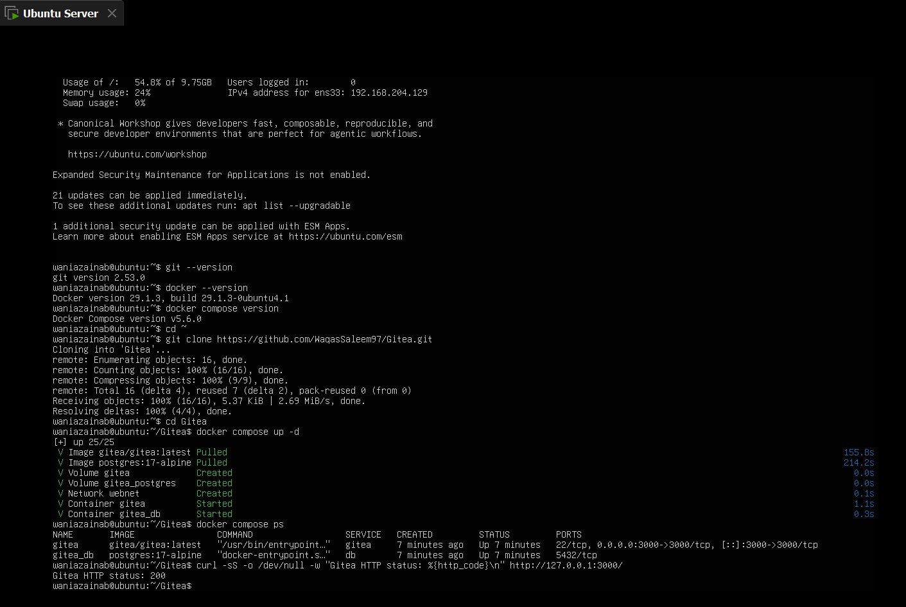
This screenshot shows the Gitea and PostgreSQL containers running on my Ubuntu server. The curl command at the end confirms that Gitea answers on port 3000.
Step 1.2: Create and Push the Initial Repository
task1_gitea_push.png
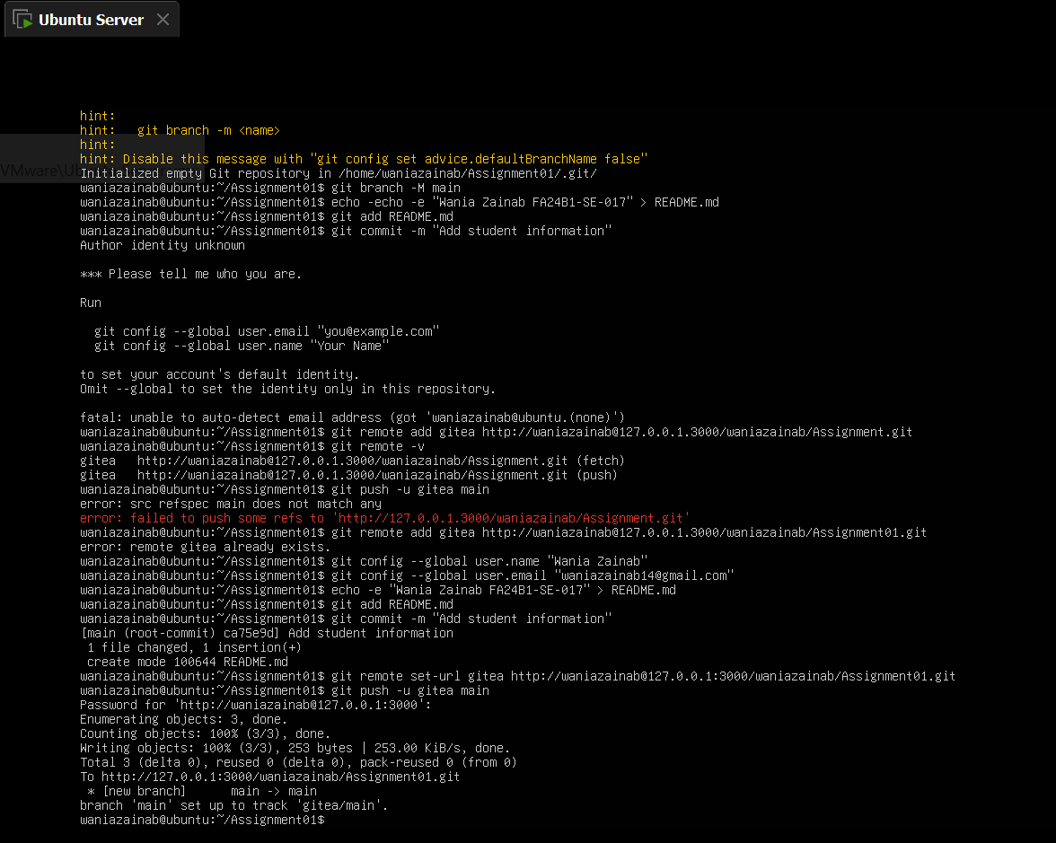
Here I push the first commit from the local Assignment01 repository to the gitea remote. The remote address has no token in it, and Git asked for the token as a password.
Step 1.3: Verify the Gitea Repository
task1_gitea_repository.png
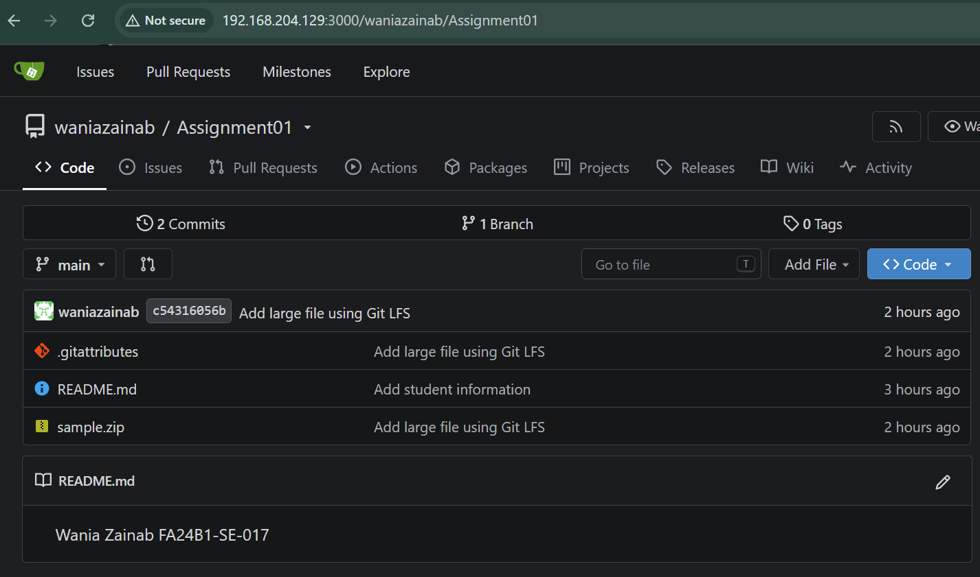
This is the public Assignment01 repository in Gitea, opened from the server address on port 3000. The owner, the repository name and the rendered README with my name and registration number are visible.

Task 2: Push the Same Repository to GitHub
Step 2.1: Create the GitHub Repository and Verify Both Remotes
task2_remotes.png
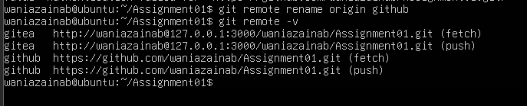
The output of git remote -v lists both the gitea and github remotes. Each one shows a fetch and a push address, and neither contains a password or token.
Step 2.2: Push to GitHub
task2_github_push.png
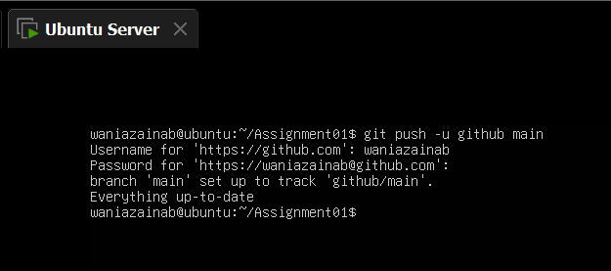
This shows git push -u github main sent to the GitHub remote. The terminal reports that main tracks github/main and that everything is up to date.
Step 2.3: Verify the GitHub Repository
task2_github_repository.png
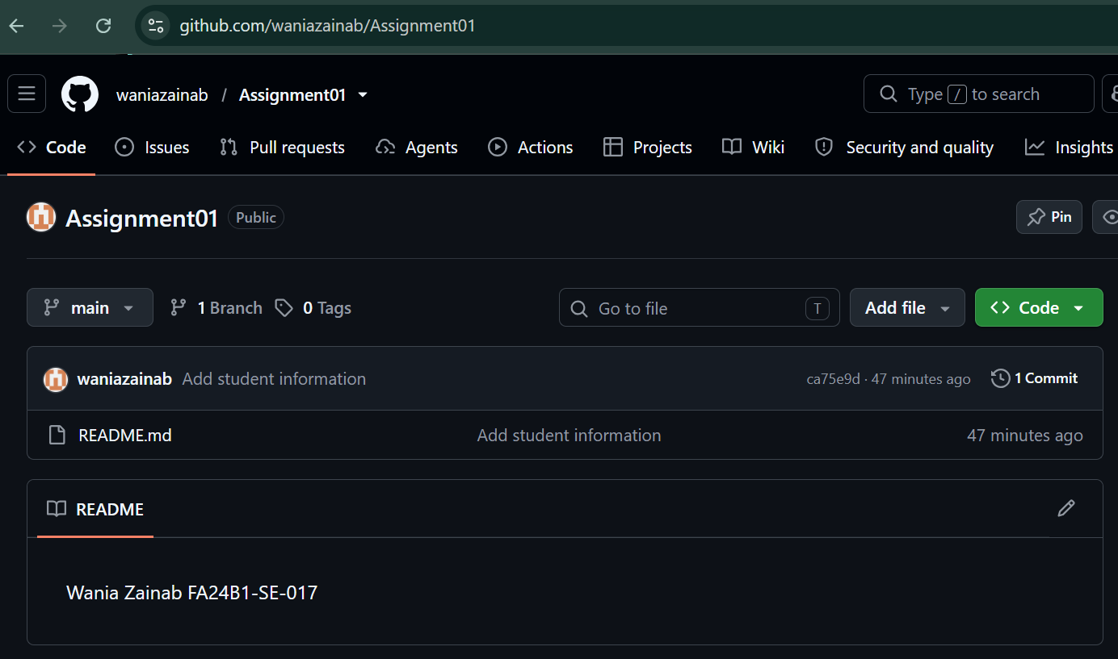
This is the public Assignment01 repository on GitHub under my account. The README shown on the page lists my full name and registration number.

Task 3: Track Three Large Files with Git LFS
Step 3.1: Configure Git LFS
task3_lfs_setup.png
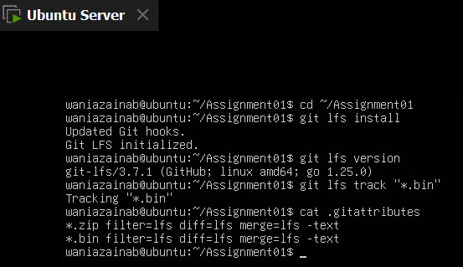
Here I run git lfs install and check the Git LFS version on the server. The command git lfs track adds the *.bin rule, which cat shows in the .gitattributes file.
Step 3.2: Create and Verify Three LFS Files
task3_lfs_files.png
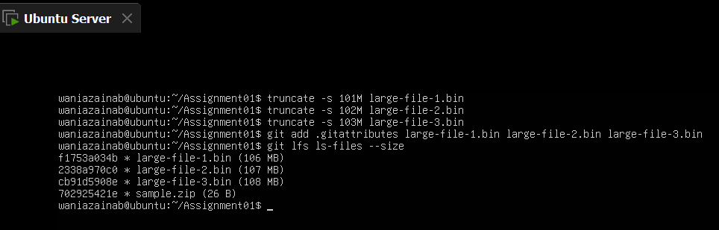
This shows three .bin files, each larger than 100 MiB, after they were staged. The command git lfs ls-files --size lists all three as Git LFS files with their sizes.
Step 3.3: Commit and Push the LFS Files
task3_lfs_push.png
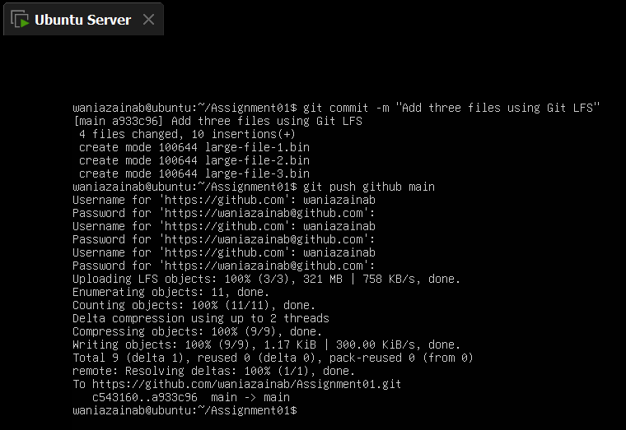
This shows the commit and the push of the three large files to the github remote. The terminal reports the LFS upload at 100% (3/3) and the push to main.

Task 4: Create a Portfolio or CV with GitHub Pages
Step 4.1: Create and Push the Portfolio Repository
task4_pages_repository.png
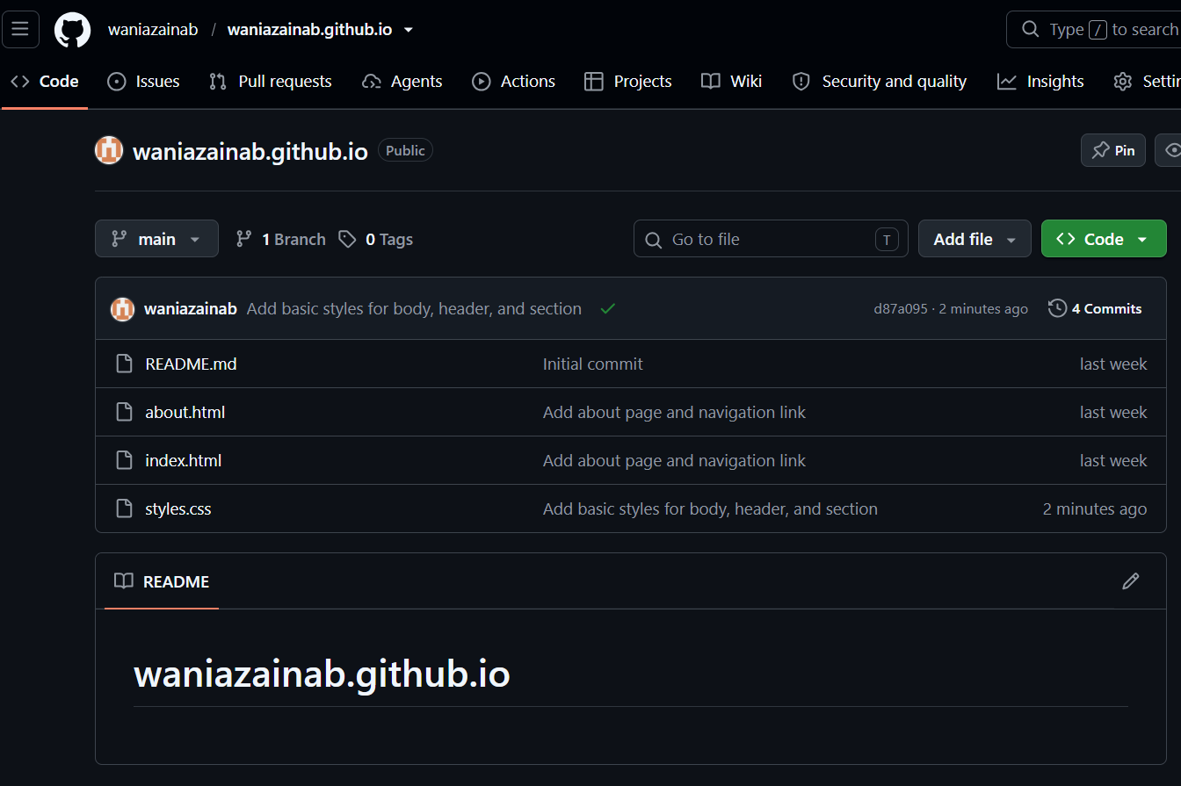
This is my username.github.io repository on GitHub. The file list shows index.html and styles.css, which hold the portfolio pages and their styling.
Step 4.2: Publish with GitHub Pages
task4_pages_deployment.png
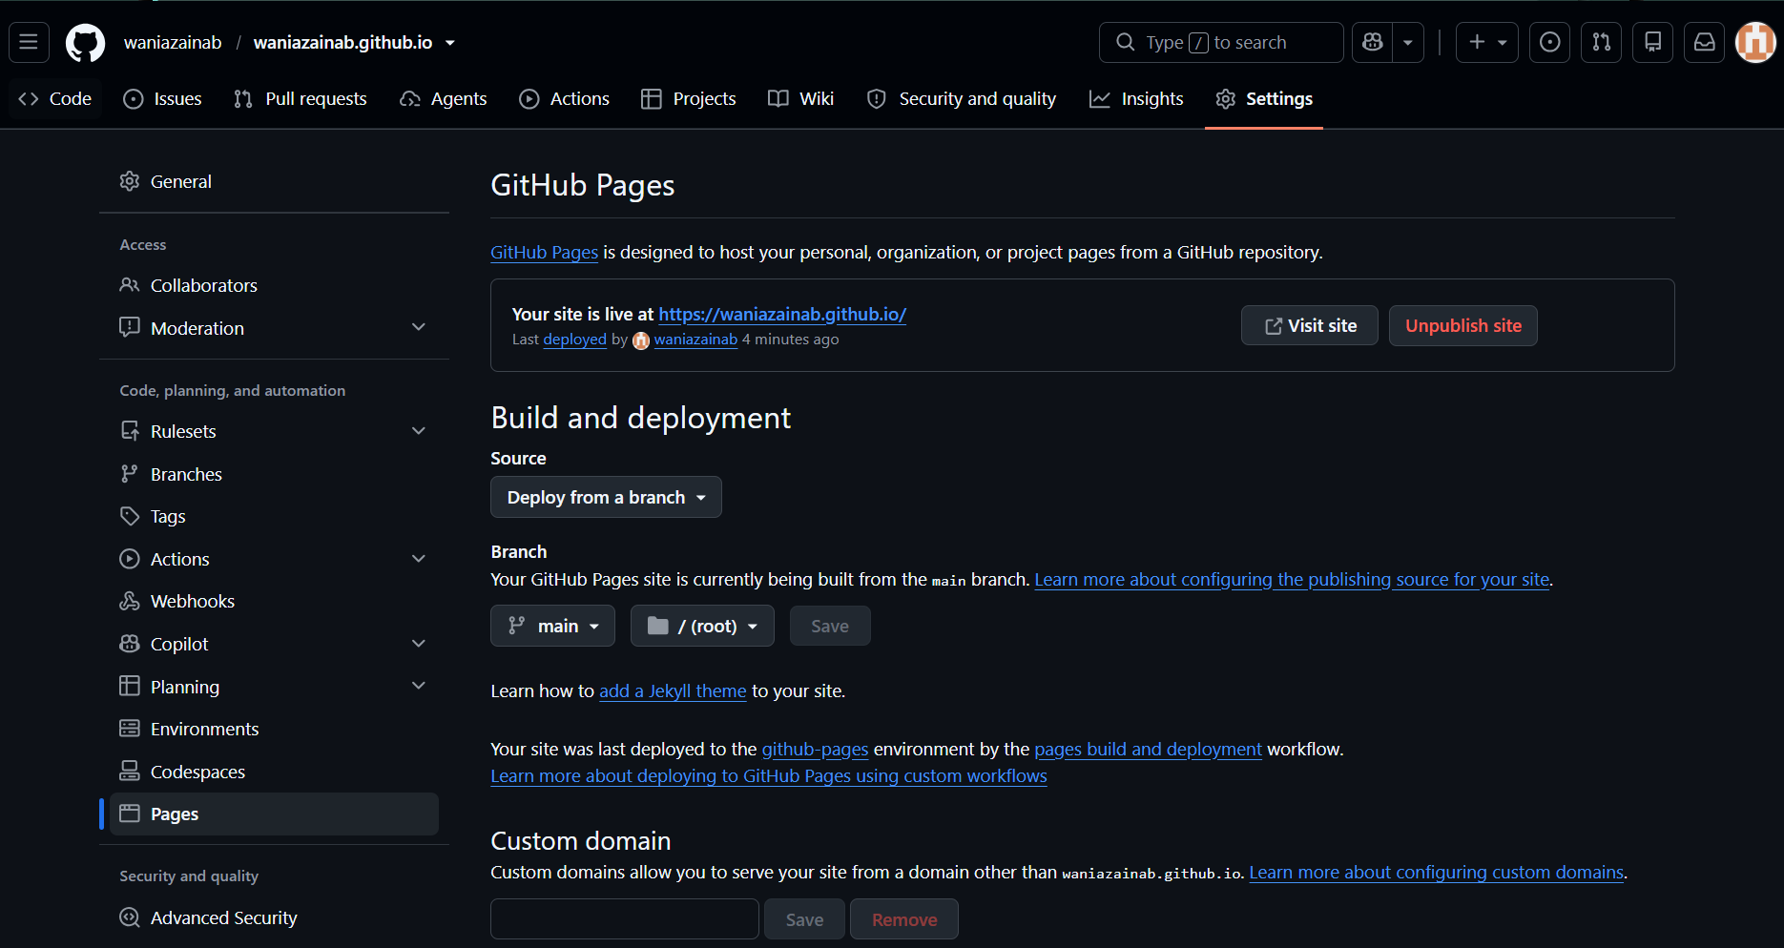
This is the Pages section in the repository settings. It shows the site being built from the main branch and the root folder, with the live github.io address.
Step 4.3: Verify the Live Portfolio
task4_portfolio_live.png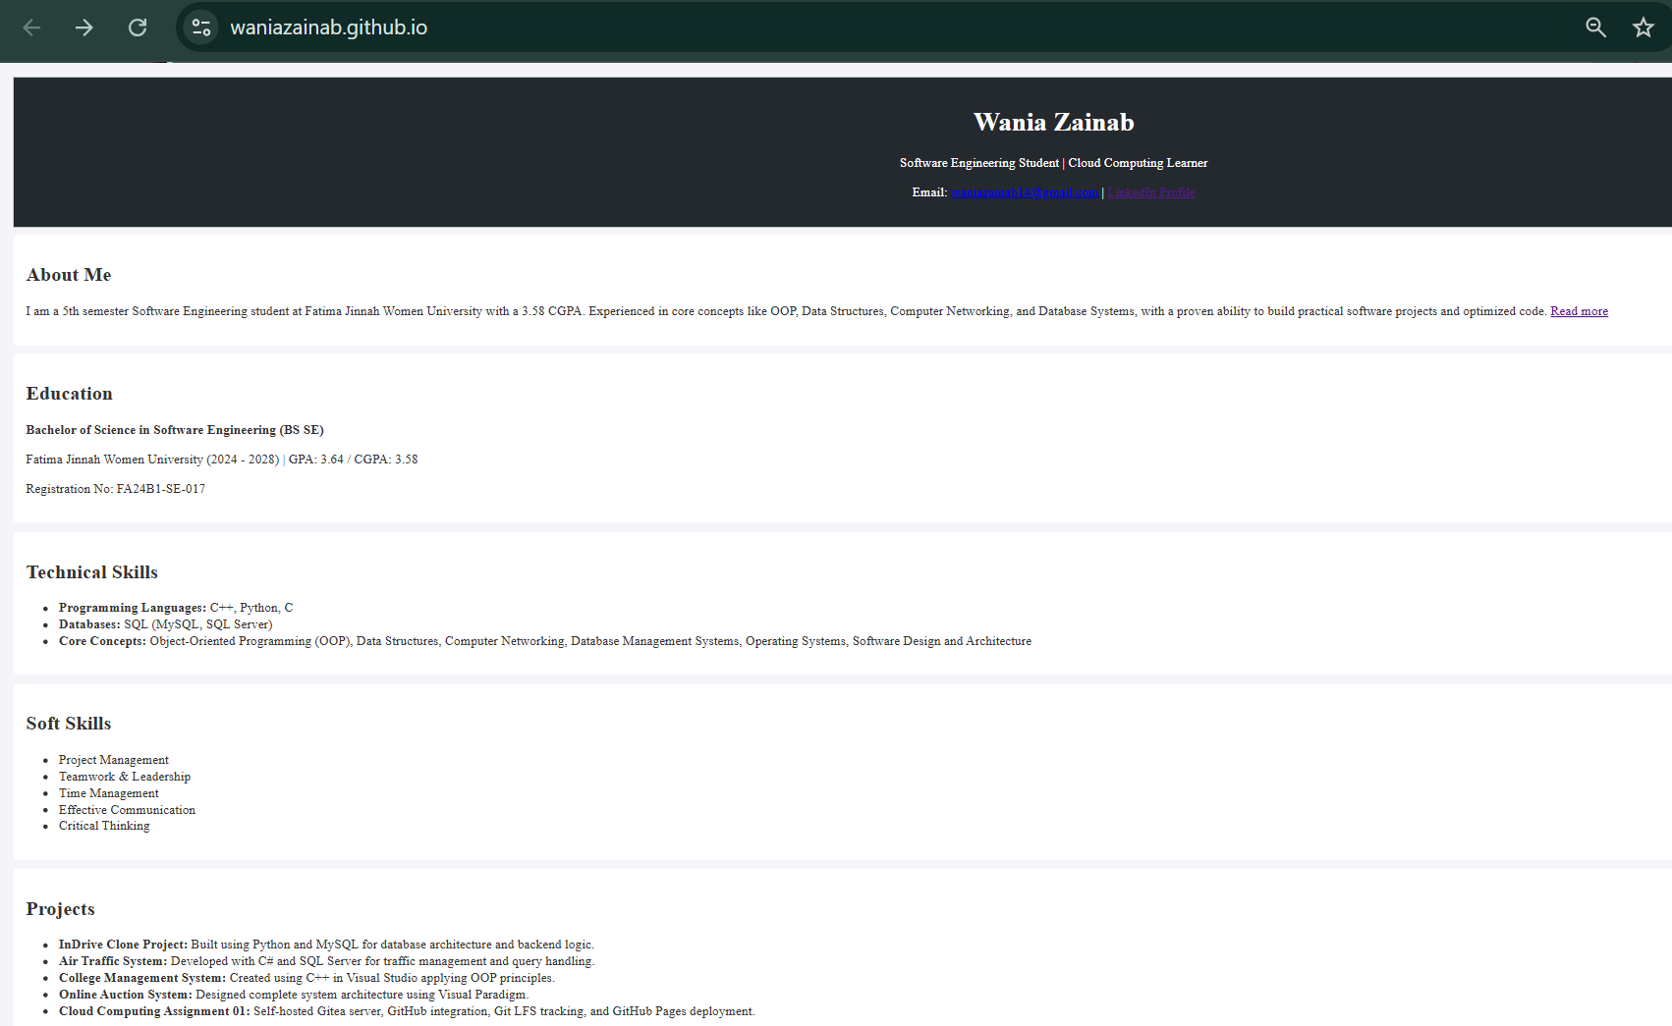
This is the published portfolio opened in the browser at the github.io address. The page shows sections such as About Me, Education, Skills and Projects.

THE END

