WANIA ZANIB
23-NTU-CS-1289
BSAI 5TH
EMBEDDED IoT SYSTEM
QUESTION NO 3
TASK A
WOKWI LINK:
https://wokwi.com/projects/445865576113924097
CODE:

//Assisgnment
//Embedded IoT System Fall-2025

//Name: wania zanib Reg#: 1289

#include <Wire.h>
#include <Adafruit_GFX.h>
#include <Adafruit_SSD1306.h>

// Pins
#define BTN_MODE 13
#define BTN_RESET 12
#define LED1 18
#define LED2 19
#define LED3 23

// OLED
Adafruit_SSD1306 display(128, 64, &Wire, -1);

// State
int mode = 0;
unsigned long lastTime = 0;
int fadeValue = 0;
int fadeStep = 5;
bool blinkOn = false;

void setup() {
pinMode(BTN_MODE, INPUT_PULLUP);
pinMode(BTN_RESET, INPUT_PULLUP);
pinMode(LED1, OUTPUT);
pinMode(LED2, OUTPUT);
pinMode(LED3, OUTPUT);

Wire.begin(21, 22);
display.begin(SSD1306_SWITCHCAPVCC, 0x3C);
display.setTextSize(2);
display.setTextColor(WHITE);

turnOffLEDs();
updateDisplay();
}

void loop() {
// Button 1: Cycle modes
if (digitalRead(BTN_MODE) == LOW) {
delay(200);
mode = (mode + 1) % 4;
fadeValue = 0;
fadeStep = 5;
turnOffLEDs();
updateDisplay();
}

// Button 2: Reset
if (digitalRead(BTN_RESET) == LOW) {
delay(200);
mode = 0;
fadeValue = 0;
fadeStep = 5;
turnOffLEDs();
updateDisplay();
}

if (mode == 0) {
// OFF
}
else if (mode == 1) {
// Alternate Blink
if (millis() - lastTime > 500) {
blinkOn = !blinkOn;
digitalWrite(LED1, blinkOn ? HIGH : LOW);
digitalWrite(LED2, blinkOn ? LOW : HIGH);
digitalWrite(LED3, blinkOn ? HIGH : LOW);
lastTime = millis();
}
}
else if (mode == 2) {
// ON
digitalWrite(LED1, HIGH);
digitalWrite(LED2, HIGH);
digitalWrite(LED3, HIGH);
}
else if (mode == 3) {
// PWM Fade
if (millis() - lastTime > 10) {
analogWrite(LED1, fadeValue);
analogWrite(LED2, fadeValue);
analogWrite(LED3, fadeValue);

fadeValue += fadeStep;
if (fadeValue <= 0 || fadeValue >= 255) {
fadeStep = -fadeStep;
fadeValue = constrain(fadeValue, 0, 255);
}
lastTime = millis();
}
}
}

void turnOffLEDs() {
digitalWrite(LED1, LOW);
digitalWrite(LED2, LOW);
digitalWrite(LED3, LOW);
}

void updateDisplay() {
display.clearDisplay();
display.setCursor(0, 10);
display.print("Mode: ");
display.println(mode);
display.setCursor(0, 35);

if (mode == 0) display.print("LEDs OFF");
else if (mode == 1) display.print("BLINK");
else if (mode == 2) display.print("LEDs ON");
else if (mode == 3) display.print("PWM FADE");

display.display();
}

PIN DIAGRAM:
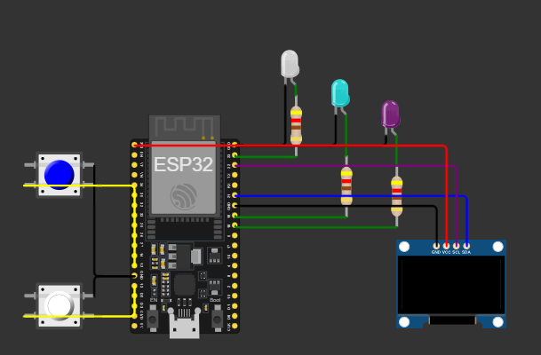
PIN MAP:
Component | ESP32 Pin | Description
Mode Button | GPIO 13 | Switches between LED modes
Reset Button | GPIO 12 | Resets back to mode 0
LED 1 | GPIO 18 | LED output
LED 2 | GPIO 19 | LED output
LED 3 | GPIO 23 | LED output
OLED SDA | GPIO 21 | I2C Data Line
OLED SCL | GPIO 22 | I2C Clock Line
OLED VCC | 3.3V | Power
OLED GND | GND | Ground

SCREENSHOT:
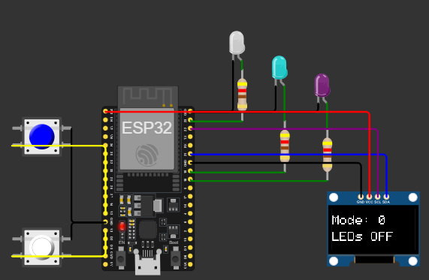
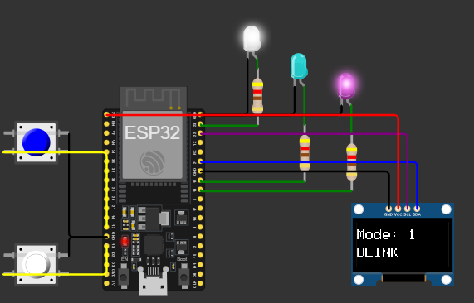
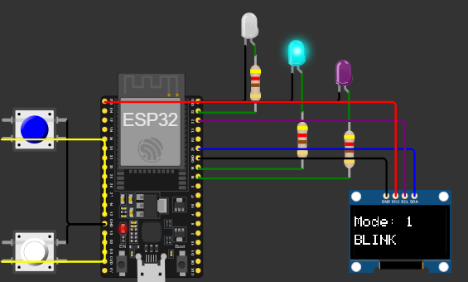
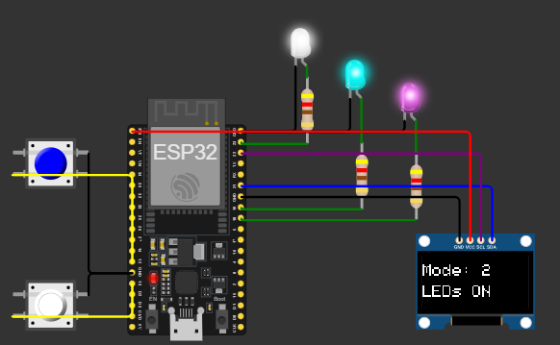
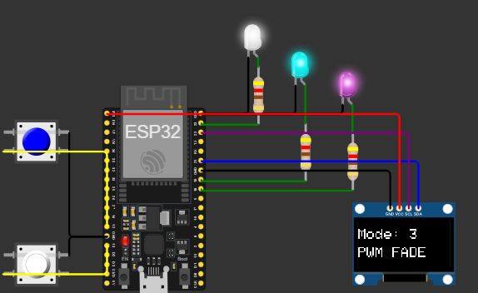
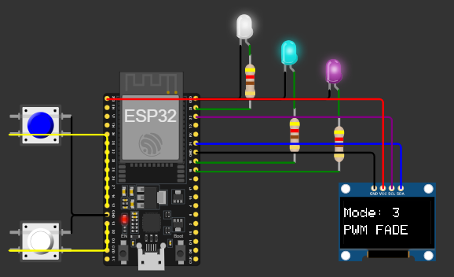

TASK B
WOKWI LINK:
https://wokwi.com/projects/445872733591798785
CODE:
//Assisgnment
//Embedded IoT System Fall-2025

//Name: wania zanib Reg#: 1289

#include <Wire.h>
#include <Adafruit_GFX.h>
#include <Adafruit_SSD1306.h>

// Pin Definitions
#define BTN 13
#define LED1 18
#define BUZZER 27

// OLED Setup
#define SCREEN_WIDTH 128
#define SCREEN_HEIGHT 64
Adafruit_SSD1306 display(SCREEN_WIDTH, SCREEN_HEIGHT, &Wire, -1);

// Variables
bool ledState = false;
bool btnPressed = false;
unsigned long pressStart = 0;
String lastEvent = "Ready";

void setup() {
// Initialize pins
pinMode(BTN, INPUT_PULLUP);
pinMode(LED1, OUTPUT);
pinMode(BUZZER, OUTPUT);

// Initialize OLED
Wire.begin(21, 22);
display.begin(SSD1306_SWITCHCAPVCC, 0x3C);
display.clearDisplay();
display.setTextSize(2);
display.setTextColor(WHITE);

updateDisplay();
}

void loop() {
bool btnState = digitalRead(BTN);

// Button pressed
if (btnState == LOW && !btnPressed) {
btnPressed = true;
pressStart = millis();
}

// Button released
if (btnState == HIGH && btnPressed) {
unsigned long pressDuration = millis() - pressStart;
btnPressed = false;

if (pressDuration > 1500) {
// Long press - play buzzer
lastEvent = "Long Press";
tone(BUZZER, 1000, 500); // 1kHz for 500ms
}
else if (pressDuration > 50) {
// Short press - toggle LED
ledState = !ledState;
digitalWrite(LED1, ledState);
lastEvent = ledState ? "LED ON" : "LED OFF";
}

updateDisplay();
}
}

void updateDisplay() {
display.clearDisplay();
display.setCursor(0, 10);
display.print("Event:");
display.setCursor(0, 35);
display.print(lastEvent);
display.display();
}
PIN DIAGRAM:
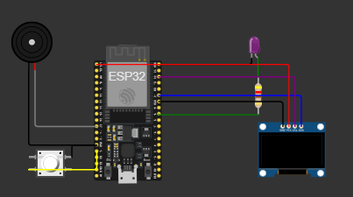

PIN MAP:
Component | ESP32 Pin | Description
Button | GPIO 13 | Input (with internal pull-up)
LED | GPIO 18 | Output LED
Buzzer | GPIO 27 | Output (plays tone on long press)
OLED SDA | GPIO 21 | I²C Data line
OLED SCL | GPIO 22 | I²C Clock line
OLED VCC | 3.3V | Power
OLED GND | GND | Ground

SCREENSHOTS:
