**Operating System Objectives and functions: -**

An OS is a program that control the execution of the application programs and acts as an interface between the computer hardware and application. The main objectives of OS are:

* + Convenience: An OS makes computer more convenient to use.
  + Efficiency: An OS makes computer used in more efficient way.
  + Ability to evolve: An OS should be constructed in such a way that it permits the effective development, testing and introduction of new system functions without interfering with service.

The OS as a User/Computer Interface: -

The hardware and software used to provide application can be viewed in layered or hierarchical fashion as shown in figure. The user of application is not generally concerned with the details of computer hardware. Thus, the end user views a computer system in the terms of application. An application can be developed by various programming language by an application programmer. The frequently used functions can be used to assist in program creation, the management of files and the control of I/O devices.

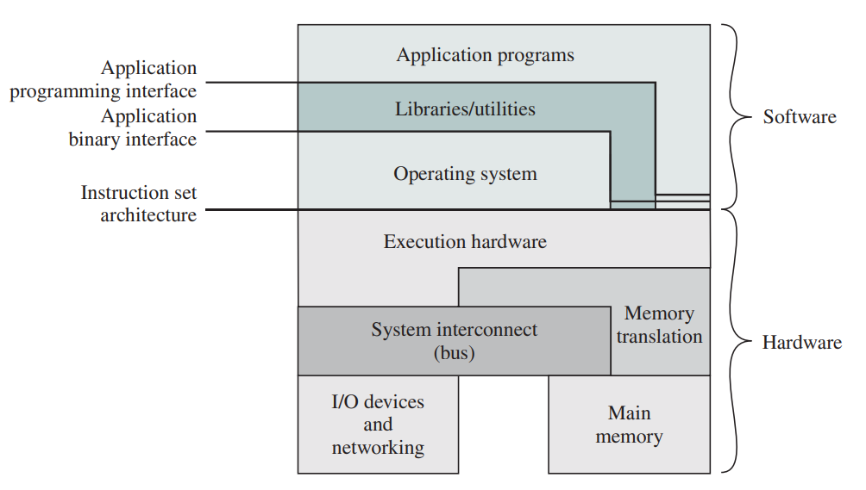

OS Provides services in following areas:

Program Development: - The OS provides various facilities and services, such as editor and debuggers, to assist the programmer in creating the programs.

Program execution: - To execute the program number of steps need to be performed. Instruction and data must be initialized and other resources must be prepared. The OS handles these scheduling duties for the user.

Access to I/O devices: - Each I/O devices required its own instruction and control signals for operation. The OS allows the programmer or user to access the I/O devices.

Controlled access to files: - The OS must be able to read, write and store files into memory. In case of multiple users, the OS should provide protection mechanisms to control access to the files.

Error detection and response: - The variety of error can occur while the computer system is running. These errors can be due to internal or external hardware. Internal error includes error related to memory and external error includes the error related to I/O devices. The OS should be able to detect and response to this error.

Instruction set architecture (ISA): -

The ISA defines the sequence of instruction that the computer can follow.

Application binary interface (ABI): -

The ABI defines the standard for binary portability across programs.

Application programming interface (API): -

An application programming interface provides a program access to the hardware resources and services available in system through the user.

The OS as Resource Manager

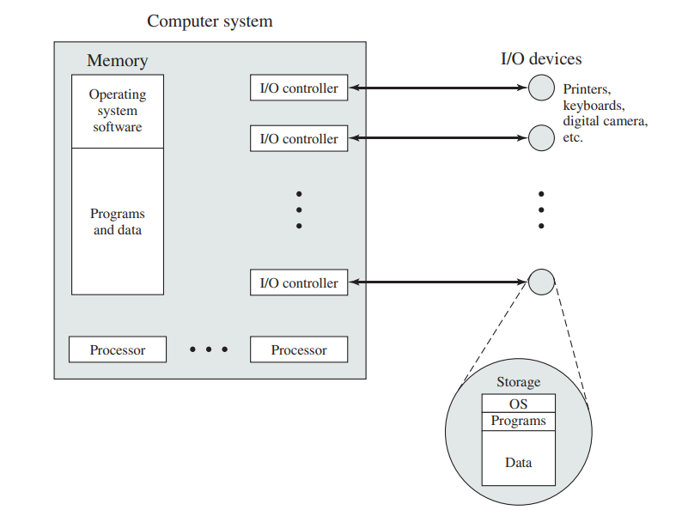

**The Evolution of OS: -**

Serial Processing: -