|  |  |  |  |  |  |  |  |  |  |  |  |  |
| --- | --- | --- | --- | --- | --- | --- | --- | --- | --- | --- | --- | --- |
| **Software Requirement Specifications**  E-COMMERCE FLOWER SHOP   |  |  | | --- | --- | | Project Code | - | | Supervisor | Miss Mahrukh Khan | | Co Supervisor | - | |  |  | | Project Team | Alishba Hassan 22k-4333  Waniya Badar 22k-4526  Nimil Zubair 22k-4617 | | Submission Date | 07-05-2025 | |

Document History

|  |  |  |  |
| --- | --- | --- | --- |
| **Version** | **Name of Person** | **Date** | **Description of change** |
| 1.0 | Waniya Badar | 05-04-2025 | SRS and SDS Created |
| 1.1 | Alishba Hassan | 12-05-2025 | Added Non-functional requirements |
| 1.2 | Nimil Zubair | 14-04-2025 | Added Use Cases |
| 1.3 | Waniya Badar | 05-04-2025 | Added Data Requirements |
| 1.4 | Alishba Hassan | 13-04-2025 | Added System architecture |
| 1.5 | Nimil Zubair | 20-04-2025 | Added functional Requirements |
| 1.6 | Alishba Hassan | 05-05-2025 | Revised Detailed Design Section |

Distribution List

|  |  |  |
| --- | --- | --- |
| **Name** | **Role** | |
| Miss Mahrukh Khan | | Supervisor |
| - | | Co- Supervisor |
|  | |  |

Document Sign-Off

|  |  |  |
| --- | --- | --- |
| Version | Sign-off Authority | Sign-off Date |
| 1.0 | Miss Mahrukh Khan | 07-05-2025 |
|  |  |  |
|  |  |  |
|  |  |  |
|  |  |  |
|  |  |  |
|  |  |  |

Table of Contents

1. Introduction .................................................................................................. 6

1.1 Purpose of Document ............................................................................. 6

1.2 Intended Audience .................................................................................. 6

1.3 Abbreviations .......................................................................................... 6

1.4 Document Convention ............................................................................ 6

2. Overall System Description ........................................................................ 7

2.1 Project Background ............................................................................... 7

2.2 Project Scope ........................................................................................ 7

2.3 Not In Scope ......................................................................................... 7

2.4 Project Objectives ................................................................................. 7

2.5 Stakeholders ......................................................................................... 7

2.6 Operating Environment ......................................................................... 8

2.7 System Constraints ............................................................................... 8

2.8 Assumptions & Dependencies .............................................................. 8

3. External Interface Requirements ............................................................... 9

3.1 Hardware Interfaces ............................................................................. 9

3.2 Software Interfaces .............................................................................. 9

3.3 Communications Interfaces .................................................................. 9

4. Functional Requirements ........................................................................... 10

4.1 Functional Hierarchies .......................................................................... 10

4.2 Use Cases ............................................................................................ 10

4.2.1 User Authentication ....................................................................... 11

4.2.2 Product Management .................................................................... 11

4.2.3 Shopping Cart Management ......................................................... 12

4.2.4 Order Management ....................................................................... 12

4.2.5 Contact Management .................................................................... 13

5. Non-functional Requirements .................................................................... 14

5.1 Performance Requirements ................................................................. 14

5.2 Safety Requirements ............................................................................ 14

5.3 Security Requirements ......................................................................... 14

5.4 User Documentation ............................................................................ 14

6. References ................................................................................................. 15

7. Appendices ................................................................................................ 16

7.1 Database Schema Diagram .................................................................. 16  
 7.2 User Interface (UI) Mockups ................................................................. 16  
 7.3 Glossary of Terms ................................................................................. 16  
 7.4 Security Policy Summary ...................................................................... 16  
 7.5 Backup & Recovery Procedures ........................................................... 17

**1. Introduction**

**1.1. Purpose of Document**

This document outlines the software requirements and specifications for the E-commerce Flower Shop system. It details the system's functionality, interfaces, and performance expectations, serving as a guide for development and verification.

**1.2. Intended Audience**

This document is intended for the following stakeholders:

* Project Team (Developers, Designers)
* Project Supervisor
* Clients/Users
* Testers

**1.3. Abbreviations**

* SRS - Software Requirements Specification
* SDS - Software Design Specification
* UI - User Interface
* DB - Database
* HTTP - Hypertext Transfer Protocol
* SQL - Structured Query Language

**1.4. Document Convention**

This document uses the following conventions:

* Font: Arial
* Font Size: 12 pt for body text, 18 pt for headings
* Headings: Numbered using the decimal system (e.g., 1., 2.1, 2.1.1)
* Requirements: Identified with unique IDs (e.g., UC-USER-001)
* Keywords: Boldface for emphasis

**2. Overall System Description**

**2.1. Project Background**

The current online shopping experience lacks a user-friendly interface and efficient order management. This project aims to develop an e-commerce system that provides a seamless and efficient platform for both customers and administrators, improving the online shopping process and streamlining administrative tasks.

**2.2. Project Scope**

The scope of this project includes the development of an e-commerce system with the following functionalities:

* User registration and authentication
* Product catalog display and management
* Shopping cart functionality
* Order processing and management
* User and administrator communication via a contact form

**2.3. Not In Scope**

The following functionalities are not within the scope of this project:

* Payment gateway integration
* Shipping and delivery tracking
* Advanced marketing tools
* Mobile application development

**2.4. Project Objectives**

The objectives of this project are to:

* Provide a user-friendly interface for browsing and purchasing products.
* Enable administrators to efficiently manage products, orders, and user inquiries.
* Develop a secure and reliable e-commerce platform.
* Improve the overall efficiency of the online shopping experience.

**2.5. Stakeholders**

The stakeholders of this system are:

* Customers: Users who browse and purchase products.
* Administrators: Personnel who manage the system's content and operations.
* Developers: The team responsible for designing and implementing the system.
* Project Supervisor: The academic supervisor overseeing the project.

**2.6. Operating Environment**

The system will operate in the following environment:

* Web Server: Apache
* Operating System: Windows
* Database: MySQL / XAMPP
* Programming Languages: PHP, HTML, CSS, JavaScript
* Browsers: Modern web browsers (Chrome, Firefox, Safari, Edge)

**2.7. System Constraints**

The system is subject to the following constraints:

* Time Constraints: The project must be completed within the given academic timeframe.
* Resource Constraints: Development resources (hardware, software) are limited.
* Technical Constraints: The system must be developed using the specified technologies (PHP, MySQL, etc.).
* Browser Compatibility: The system must be compatible with standard web browsers.
* Security Constraints: User data and transactions must be protected.

**2.8. Assumptions & Dependencies**

The following assumptions and dependencies apply to the system:

* Assumption: A stable internet connection is available for users accessing the system.
* Dependency: The system's functionality relies on the proper functioning of the web server and database server.

**3. External Interface Requirements**

**3.1. Hardware Interfaces**

The system will interact with standard hardware components:

* User Devices: Desktop computers, laptops, tablets, and smartphones with web browsers.
* Server Hardware: A web server to host the application and a database server to store data.

**3.2. Software Interfaces**

The system will interface with the following software components:

* Operating System: The server's operating system (Linux or Windows Server) to provide file system and network services.
* Database Management System: MySQL for data storage and retrieval.
* Web Server Software: Apache to process HTTP requests and serve web pages.
* Programming Language Libraries: PHP libraries for database interaction and other server-side functionalities, JavaScript libraries for client-side interactivity.
* CSS Frameworks for styling and layout.

**3.3. Communications Interfaces**

The system will use the following communication interfaces:

* HTTP Protocol: For communication between the client (user's browser) and the server.
* HTML: For structuring the web pages displayed in the browser.
* CSS: For styling the web pages.
* JavaScript: For client-side scripting and asynchronous communication
* Database Connection: MySQL connection using PHP's Mysql .

**4. Functional Requirements**

**4.1. Functional Hierarchy**

The system's functionality is organized into the following hierarchy:

1. **User Management**

* Register new user (users table)
* User login/logout
* View & update user profile

1. **Product Management**

* Add new product (products table)
* Edit product
* Delete product
* View product list
* View product details

1. **Shopping Cart Management**

* Add to cart (cart table)
* View cart
* Update cart items
* Remove item from cart
* Clear cart

1. **Wishlist Management**

* Add to wishlist (wishlist table)
* View wishlist
* Remove from wishlist

1. **Order Management**

* Place order (orders table)
* View my orders
* Cancel my order
* View all orders (admin)
* View order details (admin)
* Update order status (admin)
* Delete order (admin)

1. **Contact Management**

* Send message to admin (message table)
* View messages (admin)
* Delete message (admin)

1. **Admin Management**

* Admin login
* Manage users
* Manage products
* Manage orders
* Manage messages
  1. Use Cases
     1. User Authentication

|  |  |  |
| --- | --- | --- |
| UC-AUTH-001**: USER AUTHENTICATION** | | |
| **Use Case Id** | UC-AUTH-001 | |
| **Actors** | User | |
| **Feature** | User Management | |
| **Pre-condition** | None | |
| **Step#** | Action | Software Reaction |
| **1** | User navigates to the registration page. | display |
| **2** | User enters registration details (username, email, password). | display |
| **3** | System validates the input. | display. |
| **4** | System creates a new user account. | register |
| **5** | System logs in the user. | login |
| **Alternate Scenarios** |  | |
| - Invalid input: System displays error messages.  -Username/email already exists: System prompts user to use a different one. | | |
| **Post Conditions** |  | |
| - User is logged in or logged out.  -User account is created. | | |
| **Use Case Cross referenced** | None | |

4.2.2 Product Management

|  |  |  |
| --- | --- | --- |
| UC-PROD-001: **PRODUCT MANAGEMENT** | | |
| **Use Case Id** | UC-PROD-001 | |
| **Actors** | Administrator | |
| **Feature** | Product Management | |
| **Pre-condition** | Administrator is logged in. | |
| **Step#** | Action | Software Reaction |
| **1** | Admin navigates to Add Product page. | Display add product form. |
| **2** | Admin enters product details. | Form captures details. |
| **3** | Admin submits the form. | System validates and adds product. |
| **4** | Admin edits a product. | System updates the product. |
| **5** | Admin deletes a product. | System removes the product. |
| **Alternate Scenarios** |  | |
| - Invalid product data: System displays error messages. | | |
| - Product not found: System notifies admin. | | |
| **Post Conditions** |  | |
| **-** Product is added, updated, or deleted in the system. | | |
| **Use Case Cross referenced** | None | |

## 4.2.3 Shopping Cart Management

|  |  |  |
| --- | --- | --- |
| UC-CART-001: **SHOPPING CART MANAGEMENT** | | |
| **Use Case Id** | UC-CART-001 | |
| **Actors** | User | |
| **Feature** | Shopping Cart | |
| **Pre-condition** | User is logged in. | |
| **Step#** | Action | Software Reaction |
| **1** | User browses products. | Display product list. |
| **2** | User adds product to cart. | System updates cart. |
| **3** | User views cart. | System shows cart details. |
| **4** | User removes product from cart. | System updates cart. |
| **Alternate Scenarios** |  | |
| - Product out of stock: System notifies user. | | |
| **Post Conditions** |  | |
| - Cart reflects current selections. | | |
| **Use Case Cross referenced** | None | |

## 4.2.4 Order Management

|  |  |  |
| --- | --- | --- |
| UC-ORDER-001:**ORDER MANAGEMENT** | | |
| **Use Case Id** | UC-ORDER-001 | |
| **Actors** | User, Administrator | |
| **Feature** | Order Management | |
| **Pre-condition** | User has items in cart. | |
| **Step#** | Action | Software Reaction |
| **1** | User proceeds to checkout. | System displays order summary. |
| **2** | User confirms order. | System places the order. |
| **3** | Admin views order list. | System displays orders. |
| **4** | Admin updates order status. | System updates order status. |
| **Alternate Scenarios** |  | |
| - Payment failure: System notifies user. | | |
| **Post Conditions** |  | |
| - Order is placed and status is updated. | | |
| **Use Case Cross referenced** | None | |

## 4.2.5 Contact Management

|  |  |  |
| --- | --- | --- |
| UC-CONTACT-001:**CONTACT MANAGEMENT** | | |
| **Use Case Id** | UC-CONTACT-001 | |
| **Actors** | User, Administrator | |
| **Feature** | Contact Management | |
| **Pre-condition** | User is logged in. | |
| **Step#** | Action | Software Reaction |
| **1** | User navigates to contact page. | Display contact form. |
| **2** | User submits message. | System stores message. |
| **3** | Admin views messages. | System displays message list. |
| **Alternate Scenarios** |  | |
| - Invalid input: System displays error. | | |
| **Post Conditions** |  | |
| - Message is sent and viewed by admin. | | |
| **Use Case Cross referenced** | None | |

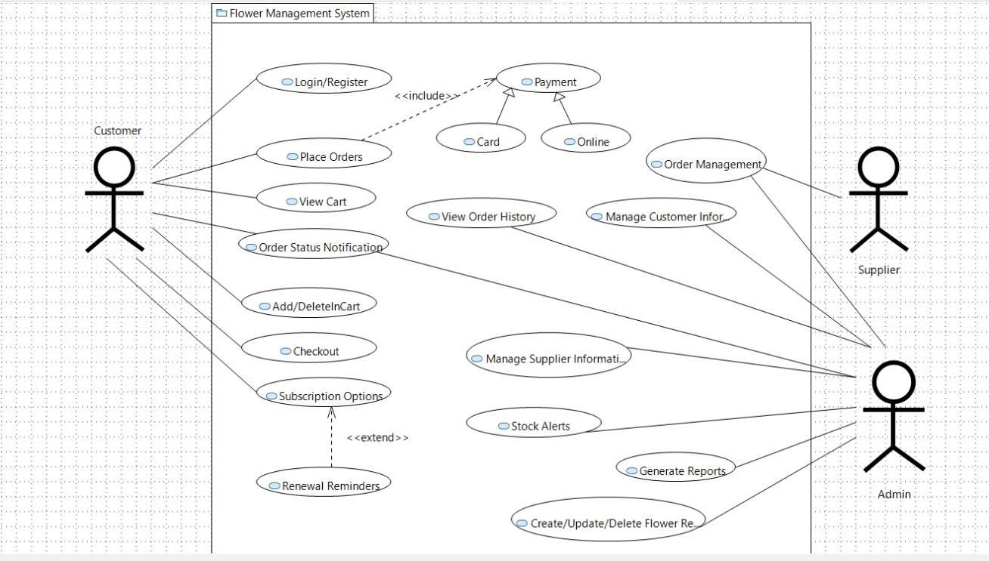

**5. Non-functional Requirements**

**5.1. Performance Requirements**

* Response Time: The system shall respond to user requests (e.g., page loads, search queries) within 2 seconds.
* Concurrency: The system shall support at least 100 concurrent users without significant performance degradation.
* Scalability: The system shall be scalable to handle increasing user load and data volume.
* Availability: The system shall be available 99% of the time.

**5.2. Safety Requirements**

* The system shall not cause any physical harm to users or damage to their devices.
* The system shall handle errors gracefully and provide informative error messages.
* Data backups shall be performed regularly to prevent data loss.

**5.3. Security Requirements**

* Authentication: User passwords shall be stored securely using hashing algorithms.
* Authorization: Access to administrator functionalities shall be restricted to authorized users.
* Data Protection: User data shall be protected from unauthorized access and modification.
* Input Validation: The system shall validate user input to prevent security vulnerabilities (e.g., SQL injection, cross-site scripting).
* Session Management: User sessions shall be managed securely to prevent session hijacking.

**5.4. User Documentation**

The following user documentation will be provided:

* User Manual: A guide for customers on how to use the system.
* Administrator Manual: A guide for administrators on how to manage the system.
* Online Help: Context-sensitive help integrated into the system's user interface.

**6. References**

* **PHP Manual**: <https://www.php.net/manual/en/>
* **MySQL Reference Manual**: <https://dev.mysql.com/doc/>
* **HTML Living Standard** (WHATWG): https://html.spec.whatwg.org/
* **CSS Specifications** (W3C): <https://www.w3.org/Style/CSS/specs.en.html>
* **JavaScript Documentation (MDN Web Docs)**: <https://developer.mozilla.org/en-US/docs/Web/JavaScript>
* **phpMyAdmin Documentation**: https://docs.phpmyadmin.net/

**7. Appendices**

**7.1. Database Schema Diagram**

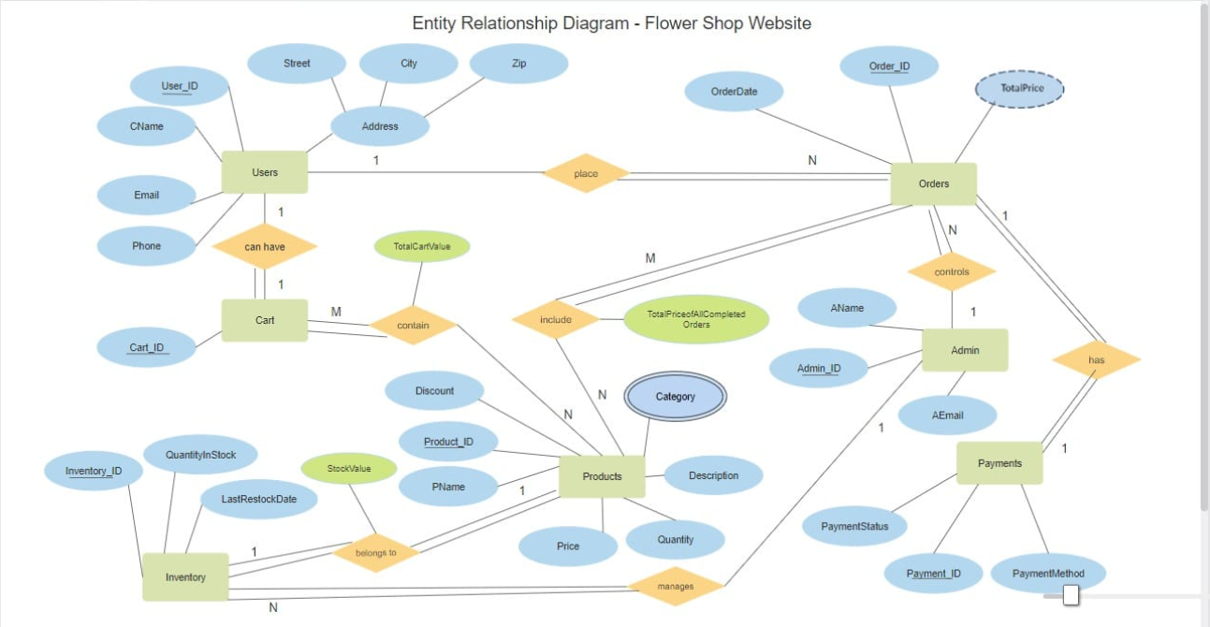

* **Users**:  
  (id, name, email, password, user_type)
* **Products**:  
  (id, name, details, price, image)
* **Orders**:  
  (id, user_id, name, number, email, method, address, total_products, total_price, placed_on, payment_status)
* **Cart**:  
  (id, user_id, pid, name, price, quantity, image)
* **Wishlist**:  
  (id, user_id, pid, name, price, image)
* **Messages**:  
  (id, user_id, name, email, number, message)

**7.2. User Interface (UI) Mockups**

Screenshots or design prototypes of the main system interfaces:

* Home Page
* Product Listing Page
* Product Details Page
* Shopping Cart Page
* Checkout Page
* User Registration/Login Page
* Admin Dashboard

**7.3. Glossary of Terms**

|  |  |
| --- | --- |
| **Term** | **Definition** |
| **E-commerce** | Buying and selling goods/services online. |
| **Shopping Cart** | A virtual cart that allows users to store items they intend to purchase. |
| **Order** | A confirmed request by a user to purchase products. |
| **Admin** | System user with privileges to manage products, orders, and user inquiries. |
| **UI** | User Interface – the space where interactions between humans and computers occur. |

**7.4. Security Policy Summary**

* Input validation is enforced on both client-side and server-side.
* Sessions are securely managed and time out after inactivity.

**7.5. Backup & Recovery Procedures**

* Logs to maintain backup