Software Design Specifications

E-COMMERCE FLOWER SHOP

Project Code | -
Supervisor | Miss Mahrukh Khan
Co Supervisor | -
Project Team | Alishba Hassan 22k-4333  Waniya Badar 22k-4526  Nimil Zubair 22k-4617
Submission Date | 07-05-2025

Document History

Version | Name of Person | Date | Description of change
1.0 | Waniya Badar | 05-04-2025 | SRS and SDS Created
1.1 | Alishba Hassan | 12-05-2025 | Added Non-functional requirements
1.2 | Nimil Zubair | 14-04-2025 | Added Use Cases
1.3 | Waniya Badar | 05-04-2025 | Added Data Requirements
1.4 | Alishba Hassan | 13-04-2025 | Added System architecture
1.5 | Nimil Zubair | 20-04-2025 | Added functional Requirements
1.6 | Alishba Hassan | 05-05-2025 | Revised Detailed Design Section

Distribution List

Name | Role
Miss Marukh Khan |  | Supervisor
- |  | Co- Supervisor

Document Sign-Off

Version | Sign-off Authority | Sign-off Date
1.0 | Miss Mahrukh Khan | 07-05-2025

Document Information

Category | Information
Customer | FAST-NU
Project | Flower Shop Website
Document | Software Design Specification
Document Version | 1.0
Status | Draft
Author(s) | Alishba Hassan, Waniya Badar, Nimil Zubair
Approver(s) | Miss Mahrukh Khan
Issue Date | 01-03-2025
Document Location | -
Distribution | -

Definition of Terms, Acronyms and Abbreviations

Term | Description
ASP | Active Server Pages
DD | Design Specification
ERD | Entity-Relationship Diagram
UI | User Interface
SRS | Software Requirements Specification
SQL | Structured Query Language
CRUD | Create, Read, Update, Delete
MVC | Model-View-Controller

Table of Contents
1. Introduction ..................................................................................... 7
1.1 Purpose of Document ............................................................... 7
1.2 Intended Audience ................................................................. 7
1.3 Document Convention ......................................................... 7
1.4 Project Overview ................................................................. 7
1.5 Scope .......................................................................... 7
2. Design Considerations ............................................................... 8
2.1 Assumptions and Dependencies ....................................... 8
2.2 Risks and Volatile Areas ................................................... 8
3. System Architecture ............................................................... 9
3.1 System Level Architecture ............................................... 9
3.2 Software Architecture .................................................... 10
4. Design Strategy .................................................................. 11
5. Detailed System Design ......................................................... 12
5.1 Database Design ............................................................. 12
5.1.1 ER Diagram ............................................................ 12
5.1.2 Data Dictionary .................................................. 12
5.1.2.1 User Table ................................................... 12
5.1.2.2 Product Table ............................................. 13
5.1.2.3 Order Table ................................................ 14
5.1.2.4 Contact Table ............................................. 14
5.1.2.5 Cart Table .................................................. 15
5.1.2.6 Wishlist Table ............................................ 16
5.2 Application Design ........................................................ 17
5.2.1 Sequence Diagram .......................................... 17
5.2.2 State Diagram .................................................. 19
6. References ....................................................................... 20
7. Appendices ...................................................................... 21
7.1 Collaboration Diagram ................................................ 21
7.2 Appendix A: Tools & Technologies ......................... 21
7.3 Appendix B: Team Members & Responsibilities ....... 21
7.4 Appendix C: Glossary of Use Cases ......................... 21

Introduction

Purpose of Document
This document provides the detailed Software Design Specification (SDS) for the Flower Shop Website. It defines the architecture, design considerations, and diagrams needed for system implementation. The document is intended for supervisors, team members, and stakeholders. The design methodology used is Object-Oriented Design (OOD).

Intended Audience
- Project Supervisors
- Project Coordinators
- Software Developers
- QA Engineers
- Other Stakeholders

Document Convention
This document uses the following conventions:
- Font: Arial
- Font Size: 12 pt for body text, 18 pt for headings
- Headings: Numbered using the decimal system (e.g., 1., 2.1, 2.1.1)
- Requirements: Identified with unique IDs (e.g., UC-USER-001)
- Keywords: Boldface for emphasis

Project Overview
The Flower Shop Website is a full-stack web application that enables users to browse, order, and manage floral products online. The system is designed using php as the backend framework with MySQL(XAMPP) as the database. It follows the MVC architecture to ensure modularity, scalability, and maintainability.

Scope
The system provides the following features:
- User registration and authentication
- Product catalog management
- Shopping cart functionality
- Order placement and management
- Contact and query handling
Out of scope : Payment gateway integration and mobile application development (for now).

Design Considerations

Assumptions and Dependencies
- Users will have internet access to use the website.
- The system depends on a stable MySQL database connection.
- Php , javascript ,css and its dependencies must be properly installed and configured.

Risks and Volatile Areas
- Technology Risks: Integration of MYSQL with php may face driver/connection issues.
- Scalability Risks: Without caching and optimization, performance could degrade with high traffic.
- Mitigation: Use modular code, ensure detailed testing, and keep room for scaling.

System Architecture

System Level Architecture
The system is divided into three main components:
- Frontend (UI): HTML/CSS/JavaScript
- Backend (Logic Layer): PHP Framework
- Database Layer: MYSQL(XAMPP)

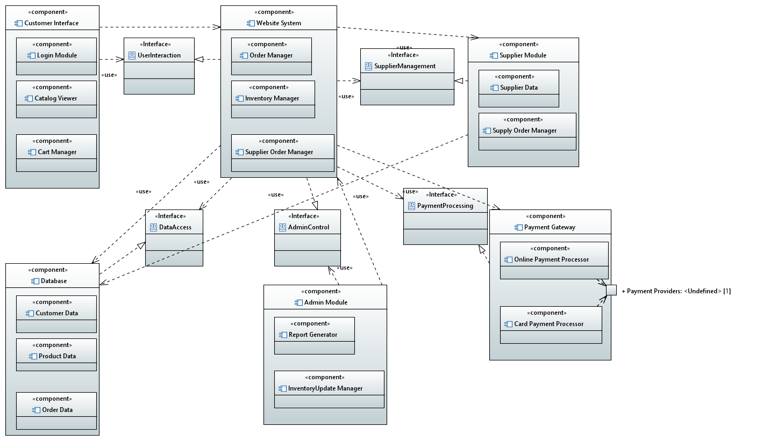

Software Architecture
We follow the 3-tier architecture:
- Presentation Layer: Interfaces with the user.
- Business Logic Layer: Processes requests.
- Data Access Layer: Manages data storage and retrieval.

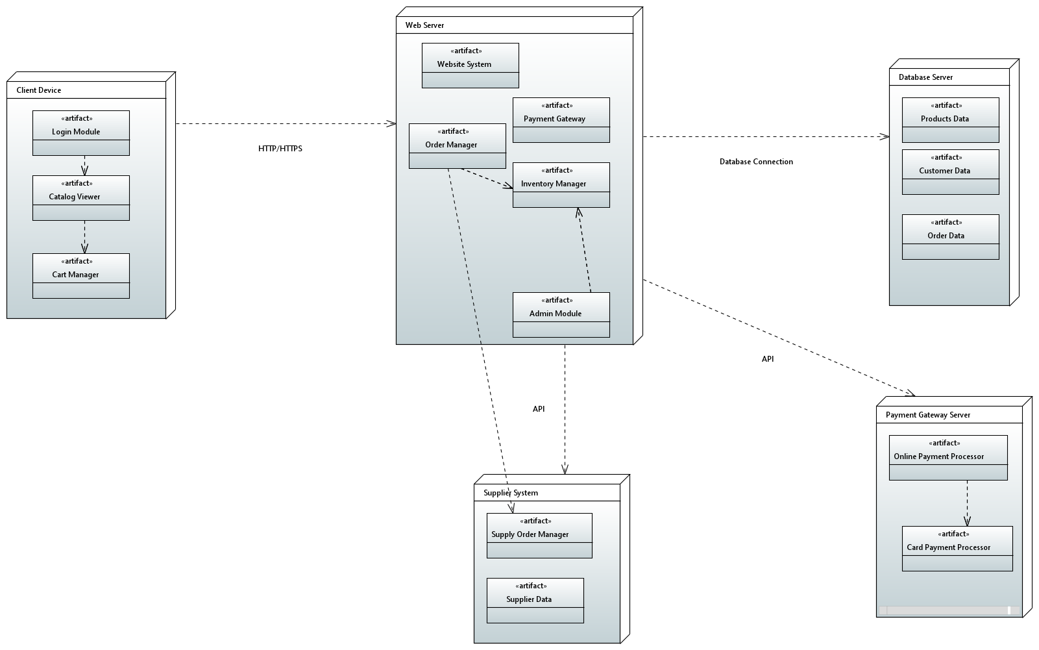

Design Strategy
- Extensibility:
- The system is built with a modular structure, allowing for easy addition of new features without disrupting the existing code. New functionalities, such as payment options or user features, can be integrated with minimal effort.
- Example: Adding a new admin module for managing user roles is simple and doesn't affect the core system.
- Reusability:
- Components such as login forms and product display modules are designed for reuse across multiple pages. This ensures consistency in functionality and design, while also reducing development time.
- Example: The same login form can be used for both registration and login processes, maintaining uniformity in the user interface.
- Data Management:
- The system utilizes MySQL for data storage, supporting CRUD operations (Create, Read, Update, Delete) through PHP. This enables seamless interaction between the backend and frontend.
- Example: When a user adds an item to their cart, the system updates the cart in the database through a CRUD operation. Orders are stored and can be easily retrieved.
- Concurrency:
- The system supports multiple users interacting simultaneously via secure sessions. Each user’s data is isolated, preventing conflicts and ensuring that actions such as adding items to a cart or placing an order are user-specific.
- Sessions are securely managed, with automatic timeouts for inactivity, ensuring security and data integrity across concurrent users.
- Example: If multiple users are browsing products at the same time, their actions (such as adding items to their cart) are tracked independently without any interference.

Detailed System Design

Database Design

ER Diagram

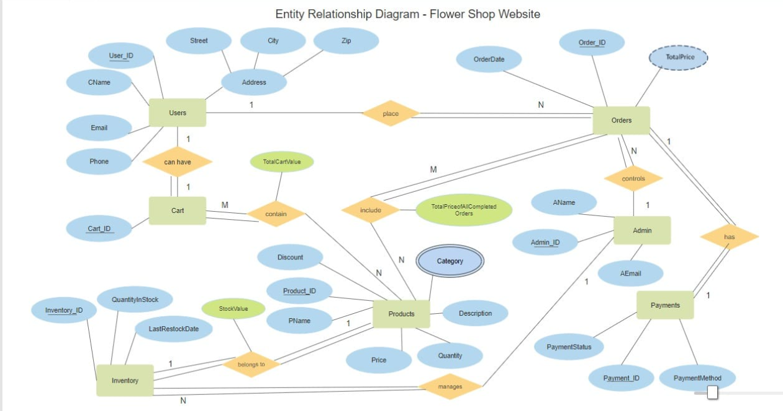

Data Dictionary

Column Name | Description | Type | Length | Nullable | Default Value | Key Type
user_id | Unique User ID | NUMBER | - | No | Auto Increment | PK
username | Username | VARCHAR2 | 50 | No | NULL
email | User Email | VARCHAR2 | 100 | No | NULL
password | User Password | VARCHAR2 | 255 | No | NULL
User_type | Type(user/admin) | VARCHAR2 | 20 | No | ‘USER’

User Table

Data 1 |  | Details
Name |  | Users
Alias |  | User Accounts, Customer Table
Where-used/how-used |  | - Input: User registration (new users)- Output: Authentication (validates users)- Store: Stores user data
Content description |  | Holds user personal data including username, email, hashed password, and role type.
Column Name | Description |  | Type | Length | Nullable | Default Value | Key Type
id | Unique User ID |  | INT | 100 | No | Auto Increment | PK
name | Username |  | VARCHAR | 100 | No | NULL
email | User Email |  | VARCHAR | 100 | No | NULL
password | User Password (Hashed) |  | VARCHAR | 100 | No | NULL
user_type | Role Type (admin/user) |  | VARCHAR | 20 | No | 'user'

Product Table

Data 1 |  | Details
Name |  | Products
Alias |  | Items, Inventory
Where-used/how-used |  | - Input: Product addition (admin panel)- Output: Product listings (shop page)- Store: Holds product details
Content description |  | Stores product information such as name, description, price, stock, category, and image URL.
Column Name | Description |  | Type | Length | Nullable | Default Value | Key Type
product_id | Unique Product ID |  | NUMBER | - | No | Auto Increment | PK
name | Product Name |  | VARCHAR2 | 100 | No | NULL
description | Product Description |  | VARCHAR2 | 500 | Yes | NULL
price | Product Price |  | NUMBER | - | No | 0.0
category | Product Category |  | VARCHAR2 | 50 | Yes | NULL
image_url | Image File Path/URL |  | VARCHAR2 | 255 | Yes | NULL

Order table

Field |  | Details
Name |  | Orders
Alias |  | Orders Table
Where-used/how-used |  | - Input: During order placement- Output: Displayed in order details- Store: Holds full order info
Content description |  | Contains high-level order information (summary, address, payment status).
Column Name | Description |  | Type | Length | Nullable | Default Value | Key Type
id | Unique Order ID |  | INT | 100 | No | Auto Increment | PK
user_id | Related User ID |  | INT | 100 | No | NULL | FK
name | Customer Name |  | VARCHAR | 100 | No | NULL
number | Customer Phone |  | VARCHAR | 12 | No | NULL
email | Customer Email |  | VARCHAR | 100 | No | NULL
method | Payment Method |  | VARCHAR | 50 | No | NULL
address | Shipping Address |  | VARCHAR | 500 | No | NULL
total_products | Product Summary |  | VARCHAR | 1000 | No | NULL
total_price | Total Price |  | INT | 100 | No | NULL
placed_on | Order Date |  | VARCHAR | 50 | No | NULL
payment_status | Payment Status |  | VARCHAR | 20 | No | 'pending'

Contact Table

Field |  | Details
Name |  | Message
Alias |  | Contact Messages
Where-used/how-used |  | - Input: User submits contact form- Output: Admin views/responds to message- Store: Saves contact inquiries
Content description |  | Holds user-submitted messages and contact details.
Column Name | Description |  | Type | Length | Nullable | Default Value | Key Type
id | Unique Contact ID |  | INT | 100 | No | Auto Increment | PK
user_id | Related User ID |  | INT | 100 | No | NULL
name | Sender's Name |  | VARCHAR | 100 | No | NULL
email | Sender's Email |  | VARCHAR | 100 | No | NULL
number | Phone Number |  | VARCHAR | 12 | No | NULL
message | Message Content |  | VARCHAR | 500 | No | NULL

Cart

Field |  | Details
Name |  | Cart
Alias |  | Shopping Cart
Where-used/how-used |  | - Input: User adds items to cart- Output: Cart preview at checkout- Store: Temporary cart data until order is placed
Content description |  | Holds items added to the cart by each user before placing an order.
Column Name | Description |  | Type | Length | Nullable | Default Value | Key Type
id | Unique Cart ID |  | INT | 100 | No | Auto Increment | PK
user_id | Related User ID |  | INT | 100 | No | NULL | FK
pid | Related Product ID |  | INT | 100 | No | NULL | FK
name | Product Name |  | VARCHAR | 100 | No | NULL
price | Product Price |  | INT | 100 | No | NULL
quantity | Quantity in Cart |  | INT | 100 | No | 1
image | Image File Path |  | VARCHAR | 100 | No | NULL

Wish list table

Field |  | Details
Name |  | Wishlist
Alias |  | Favorites
Where-used/how-used |  | - Input: User adds items to wishlist- Output: Wishlist page- Store: Temporary user favorite items
Content description |  | Holds products added to a wishlist by each user.
Column Name | Description |  | Type | Length | Nullable | Default Value | Key Type
id | Unique Wishlist ID |  | INT | 100 | No | Auto Increment | PK
user_id | Related User ID |  | INT | 100 | No | NULL | FK
pid | Related Product ID |  | INT | 100 | No | NULL | FK
name | Product Name |  | VARCHAR | 100 | No | NULL
price | Product Price |  | INT | 100 | No | NULL
image | Image File Path |  | VARCHAR | 100 | No | NULL

Application Design

Sequence Diagram
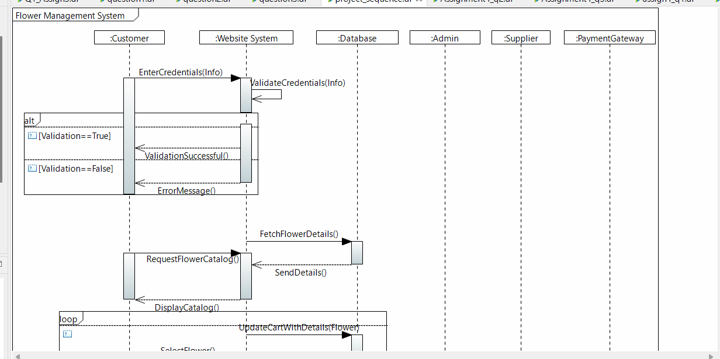
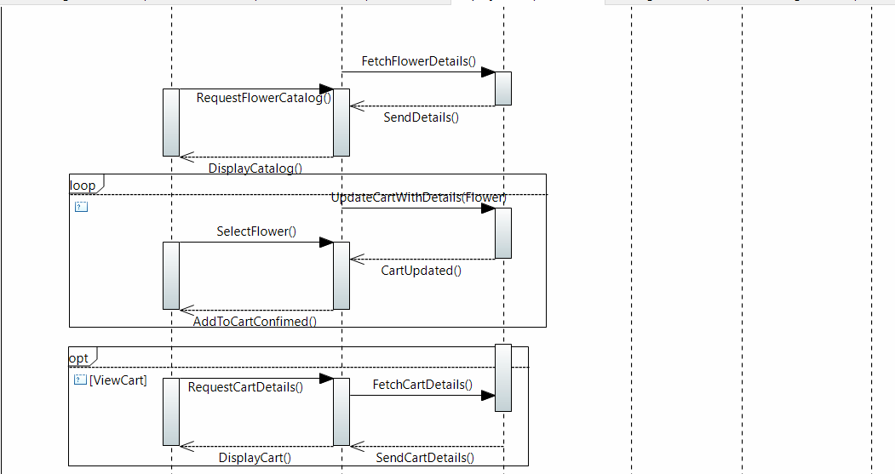
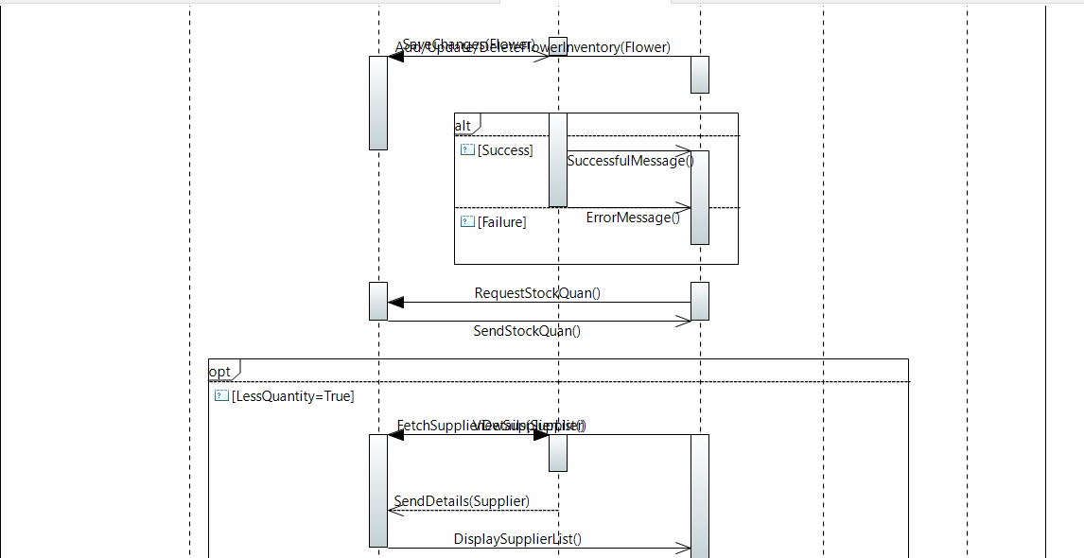
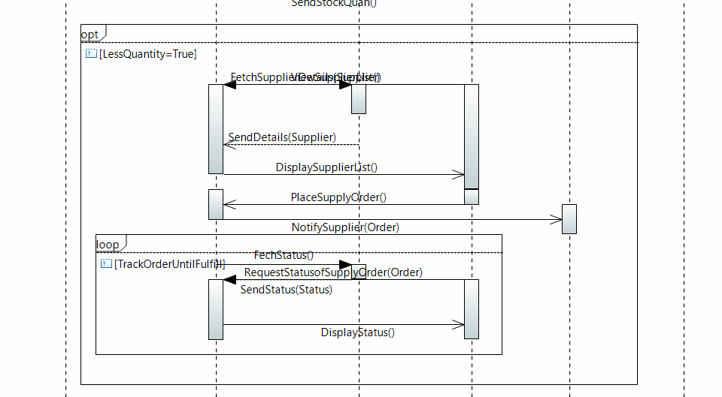

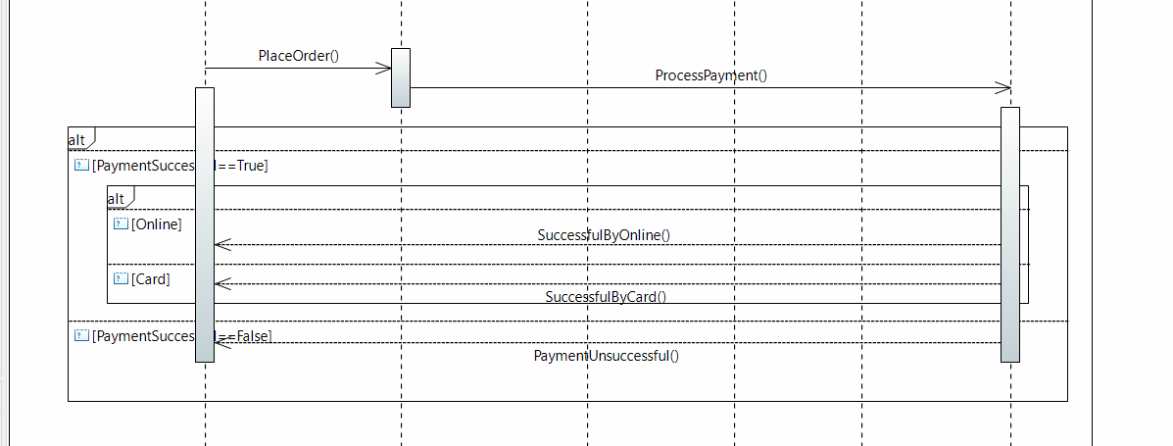
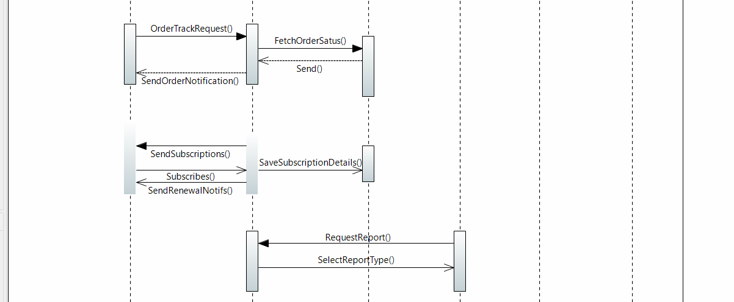

State Diagram

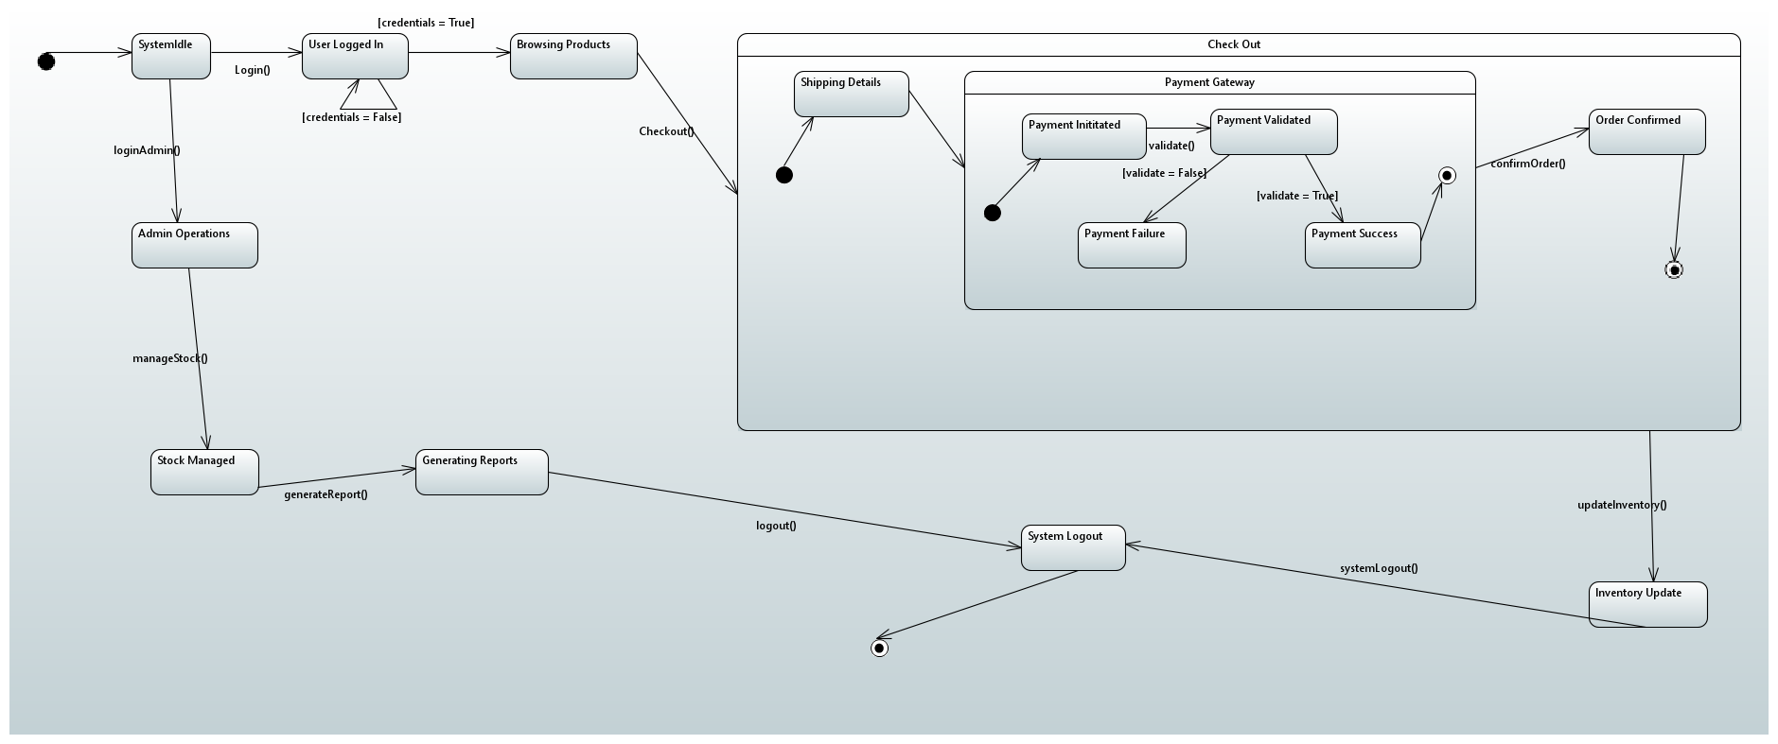

6. References
- PHP Manual: https://www.php.net/manual/en/
- MySQL Reference Manual: https://dev.mysql.com/doc/
- HTML Living Standard (WHATWG): https://html.spec.whatwg.org/
- CSS Specifications (W3C): https://www.w3.org/Style/CSS/specs.en.html
- JavaScript Documentation (MDN Web Docs): https://developer.mozilla.org/en-US/docs/Web/JavaScript
- phpMyAdmin Documentation: https://docs.phpmyadmin.net/

Appendices

Collaboration Diagram
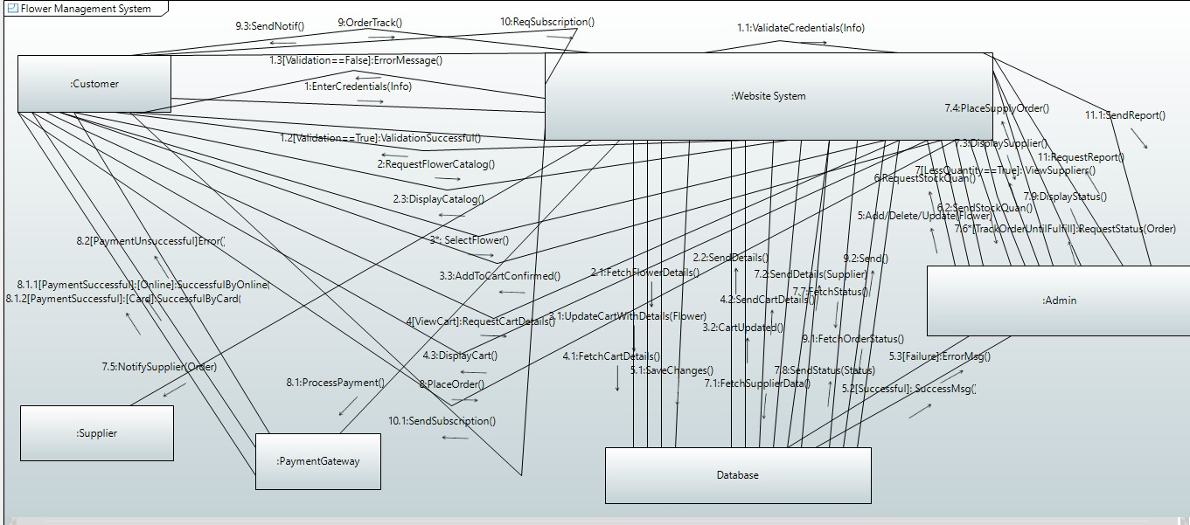

Appendix A: Tools & Technologies

Technology | Purpose
HTML/CSS | Frontend Design
JavaScript | Interactivity and Frontend Logic
PHP | Backend Development
MYSQL | Database Management
GitHub | Version Control

Appendix B: Team Members & Responsibilities

Name | Role | Responsibilities
Alishba Hassan | Team Leader | Backend Development, Deployment, Integration
Waniya Badar | Frontend Developer | UI/UX Design, Responsive Web Design
Nimil Zubair | Database Specialist | Database Design, Optimization, Data Security

Appendix C: Glossary of Use Cases

Use Case Id | Description
UC-AUTH-001 | User Authentication (Registration & Login)
UC-PROD-001 | Product Management (Add/Edit/Delete Products)
UC-CART-001 | Shopping Cart (Add/Remove/View Cart Items)
UC-ORDER-001 | Order Management (Place/View Orders)
UC-CONTACT-001 | Contact Management (Send/View Messages)

