

Object-Oriented Programming

OCT 2021

**GUI PROJECT**

**GROUP MEMBERS :**

|  |  |
| --- | --- |
| MOHAMAD AMIRUDDIN BIN ZAINAL | 2020872676 |
| SITI SYAHZANANI AFIQAH BINTI SHAIPULLIZAN | 2020456114 |
| NURUL ZAWANI BINTI ZULKEPLEE | 2020828608 |

|  |  |
| --- | --- |
| QnA | /5 |
| Ordered / Clear | /5 |
| **Total** | /10 |

**PROJECT TITLE : FRUNCHIES SHOP**

**PRESENTATION MARKS**

|  |  |
| --- | --- |
| Introduction | /5 |
| Application User Manual | /5 |
| Originality / Creativity /  Complexity | /10 |
| **Total** | /20 |

**REPORT**

1. **INTRODCTION**

NetBeans is an integrated development environment for Java. NetBeans allows applications to be developed from a set of modular software components called modules. NetBeans runs on Windows, macOS, Linux and Solaris.

We use Netbeans to create our GUI project called Frunchies Shop. In this application, the process to buy Frunchies requires different layers of important processes. We have 3 frames which is main page that show our product detail, second frame where customer can fill up their details and choose the product and our last frame, customer can choose payment method to pay their chosen product. We include requirement given in this project, JButton, JLabel, JTextField and JRadioButton. We also have an extra JComponent which is JSlider, JPopupmenu, JScrollPane and JPanel.

1. **APPLICATION USER MANUAL**
2. First, customer will see our main page. It shows our product and product details here. When customer already decide on what they want to buy, they will click ‘Order Now’ Button.

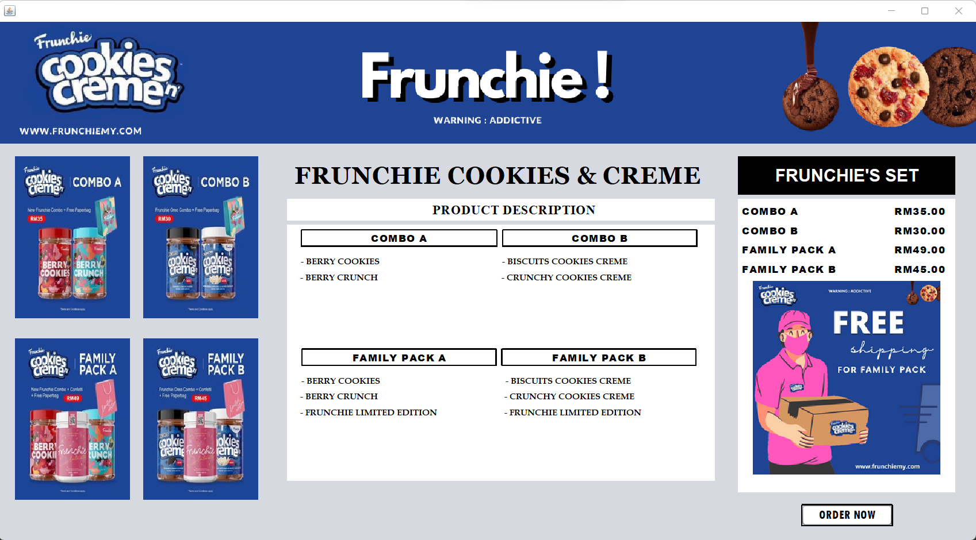

1. Then, it brings to our second frame. In this side, customer need to fill their details such as name, phone number and address.

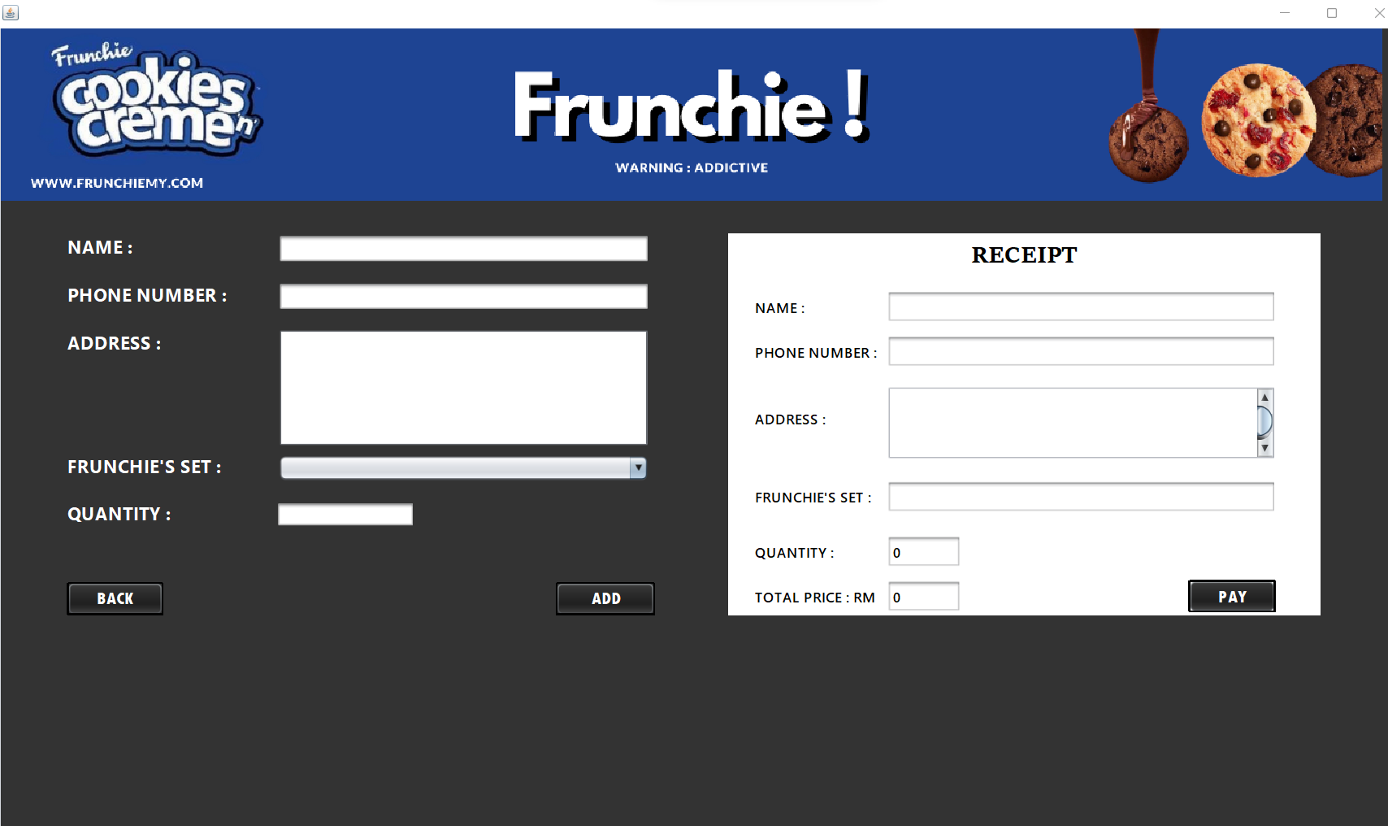

This is what will be look like when customer fill up their details.

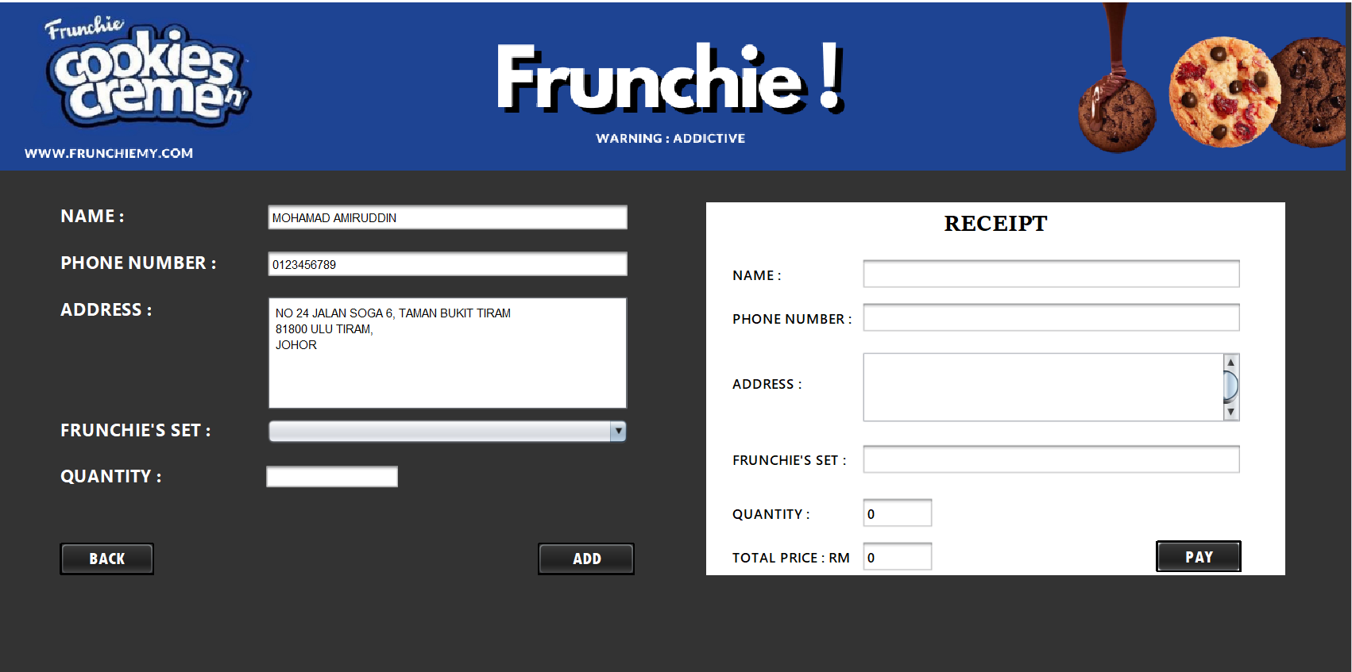

1. Next, customer need to choose Frunchie’s Set and enter the quantity needed.

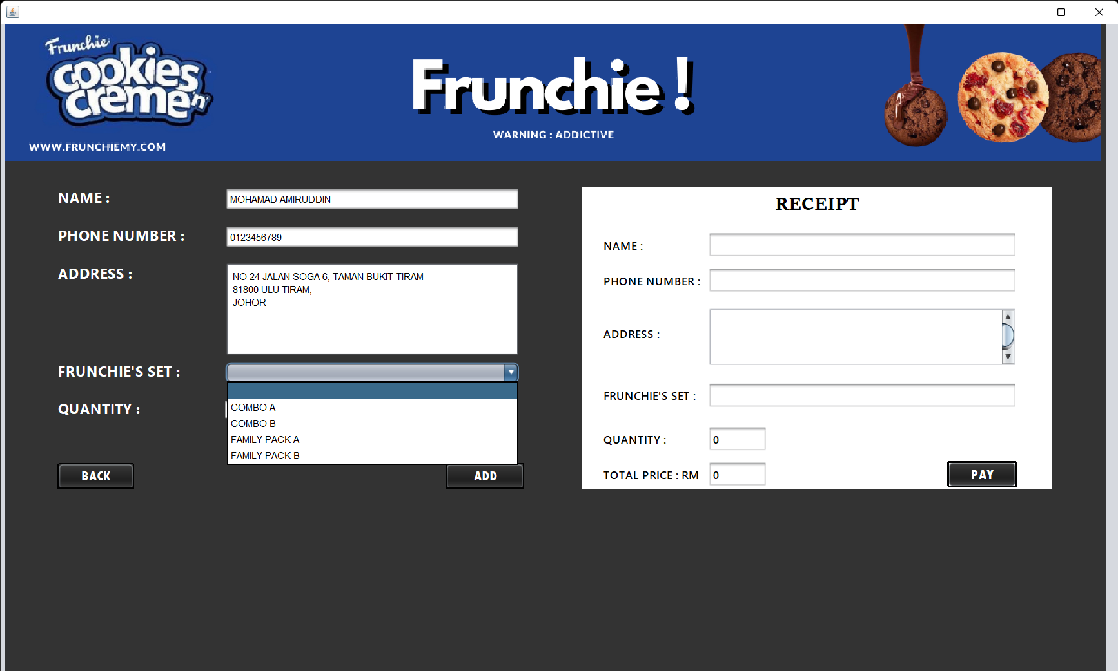

1. After customer fill in their details, customer need to click ‘Add’ Button and the details will auto-generate in the receipt form. Customer can see the total price they need to pay afterward. When customer agree, customer need to click on ‘Pay’ button.

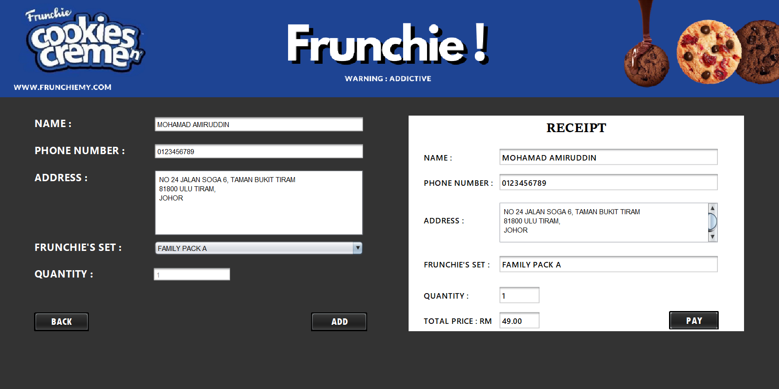

1. It will bring to our last frame which is third frame. In this frame, customer can just click on ‘Show Detail’ Button then the details they already filled in the second frame will display on the Frunchie Form.

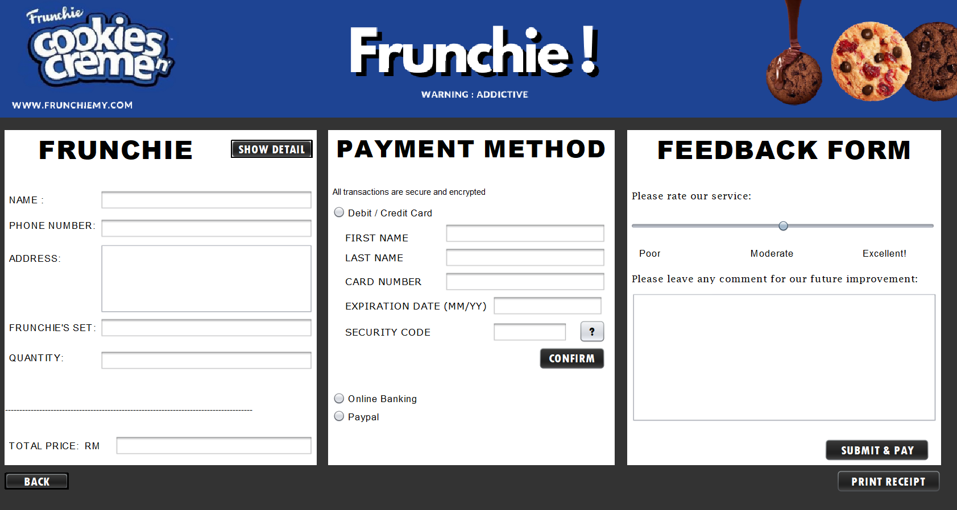

1. Again, customer need to decide on how they will pay the product in the Payment Method Form.

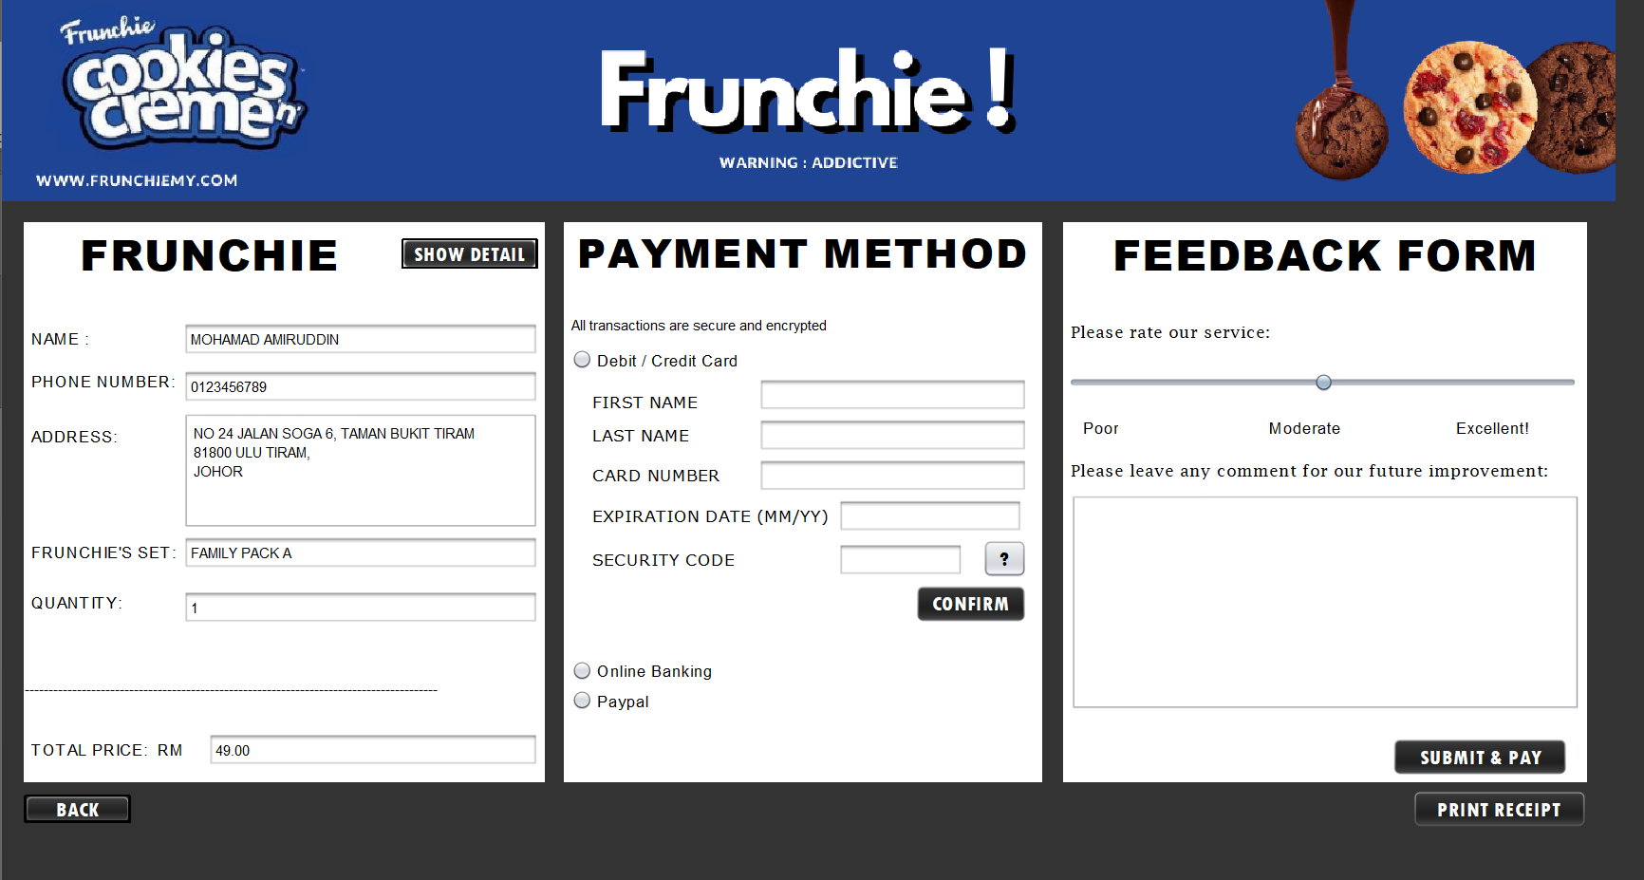

1. If customer does not know what is security code, they can click on the key button and it will give an information about security code.

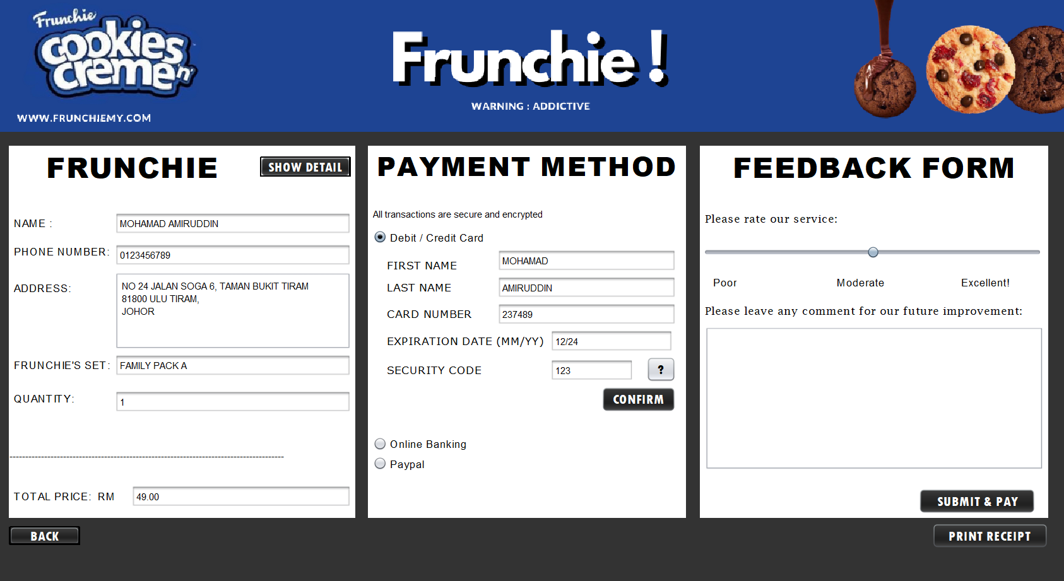

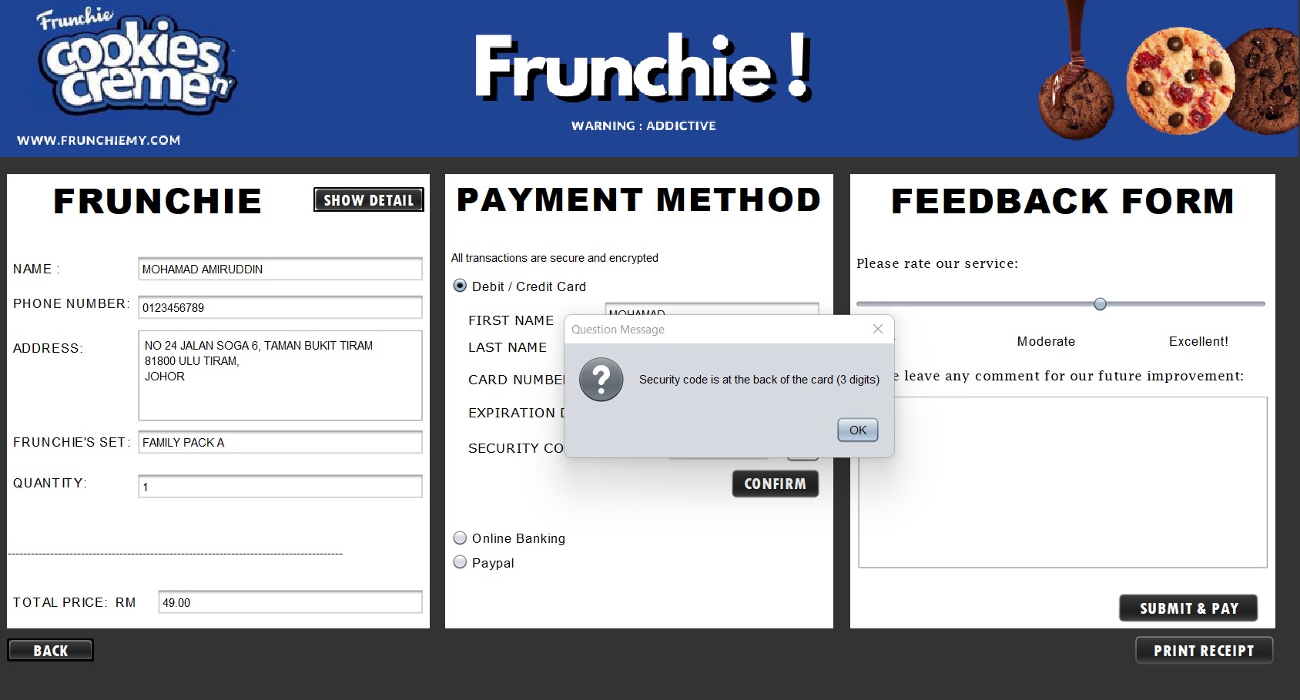

1. In feedback form, customer can slide the button to rate our service and write us a feedback for our improvement.

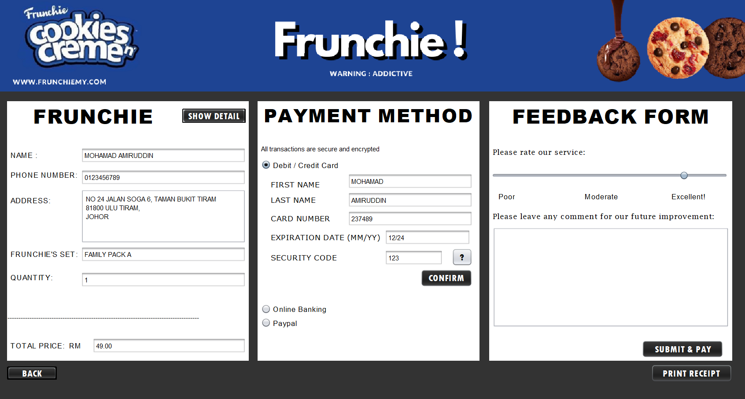

1. After done, customer can click on ‘Submit & Pay’ Button and a box will display show that the payment is successful.

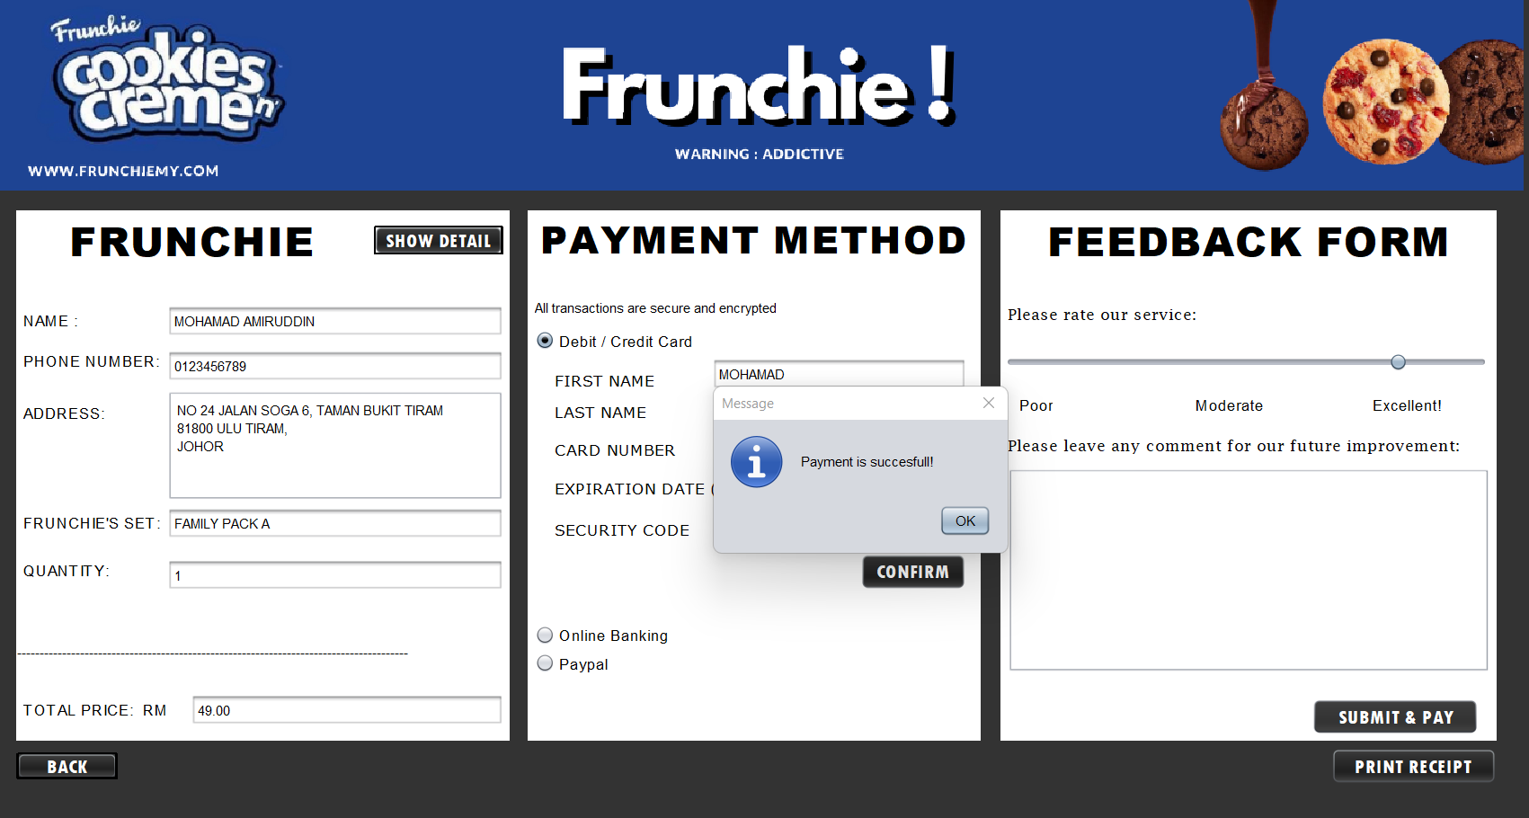

1. Lastly, customer can click on the ‘Print Receipt’ Button and a box will display show that the ticket is printing.

