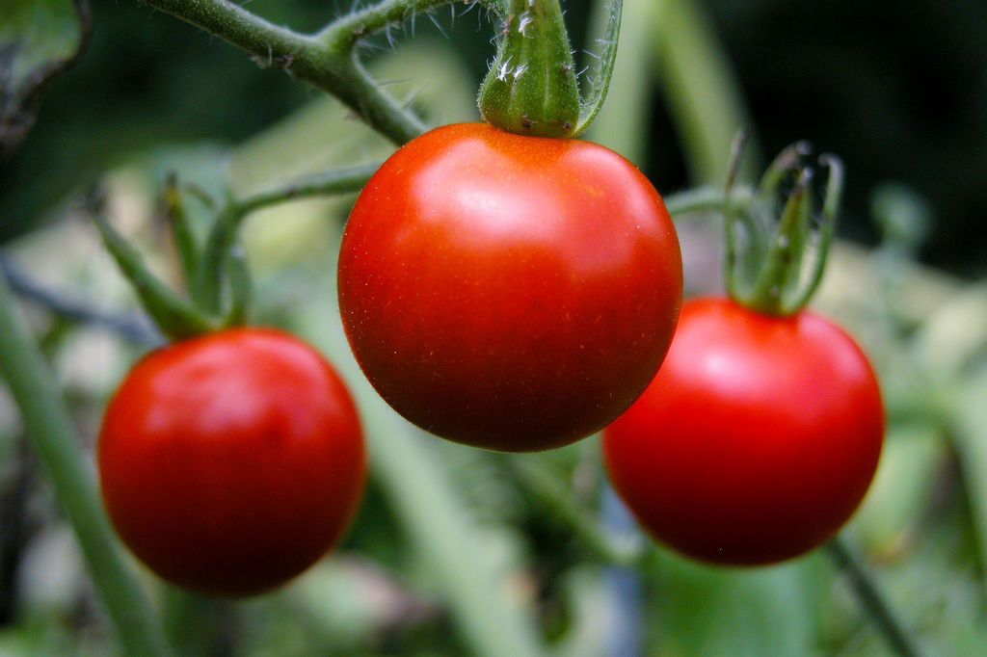

**Defining A Vegetable**

According to botanists, most of the edible parts of a plant are vegetables. Vegetables can be a root, stem, leaf, or flower. Even bulbs, like onions, and buds like brussels sprouts are vegetables.

**Defining Fruits**

A fruit, on the other hand, is always the matured ovary of a flowering plant. Fruit is formed when pollen, which carries sperm, lands on the sticky part of the flower.

The sperm travel from the pollen grain into the ovary then into the ovule where one fertilizes the egg. Once the egg is fertilized, the ovule becomes a seed, and the whole ovary becomes a fruit. This is why fruits usually contain seeds.

**An Unlikely Fruit**

Of course, when we generally think of fruit we think of sweet fruits like apples and pears that are eaten raw or baked in dessert. We don’t think of tomatoes or cucumbers as fruit, although they are fruit because they develop from the ovary of the plant.

**Scandalous!**

Back to the 1893 court case. The Supreme Court declared that tomatoes were vegetables because they are usually eaten cooked like vegetables. The decision allowed the court to uphold a tax on imported tomatoes because, at that time, vegetables were taxed but fruits were not.

### 定义蔬菜

根据植物学家的说法，植物的大部分可食用部分都是蔬菜。蔬菜可以是根，茎，叶或花。甚至像洋葱一样的灯泡和像布鲁塞尔芽菜一样的芽都是蔬菜。

### 定义水果

另一方面，水果总是开花植物的成熟卵巢。当携带精子的花粉落在花的粘性部分上时形成果实。

精子从花粉粒进入卵巢，然后进入胚珠，卵子受精。一旦卵子受精，胚珠就会变成种子，整个卵子就变成了果实。这就是水果通常含有种子的原因。

### 不太可能的水果

当然，当我们通常想到水果时，我们会想到甜的水果，如苹果和梨，可以生吃或在甜点中烘烤。我们不认为西红柿或黄瓜是水果，虽然它们是水果，因为它们是从植物的卵巢发育而来的。

### 可耻！

回到1893年的法庭案件。最高法院宣称西红柿是蔬菜，因为它们通常像蔬菜一样被煮熟。该决定允许法院对进口西红柿征税，因为当时蔬菜已经征税，但水果却没有。