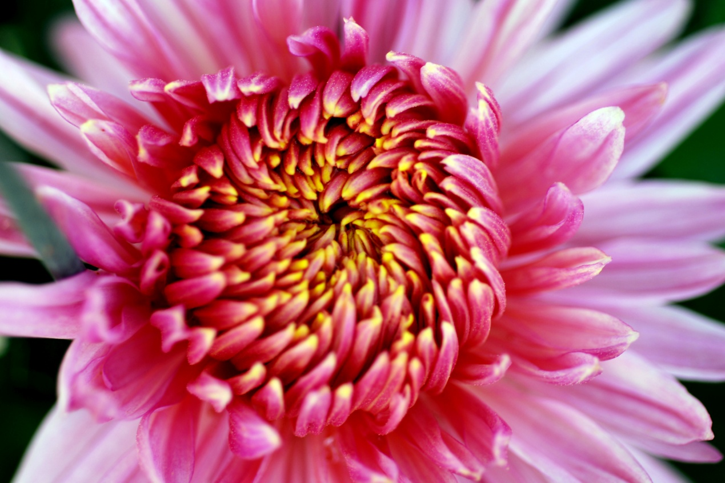

It isn’t just fruit, vegetables and nuts we humans eat—many species of flowering plant have edible and delicious flowers as well. For example, in Japan and China the chrysanthemum is eaten—they even make chrysanthemum fritters.

Flowers of the **compositae** family were once candied in England. Today we call them daisies. Jasmine is a genus of the olive family, and its petals are made into tea. Lavender is a member of the mint family, and can be found in jellies. Calendula officinalis, a.k.a. marigolds, are eaten by the Dutch in eel soup. Nasturtium is sometimes used in salads. And the French use violets in cakes, soups, and in violet vinegar.

我们人类吃的不仅仅是水果，蔬菜和坚果 - 许多种类的开花植物也有可食用和美味的花朵。例如，在日本和中国，菊花被吃掉了 - 它们甚至可以制作菊花油条。

该花**菊**家庭曾经蜜饯在英国。今天我们称他们为雏菊。茉莉花是橄榄科的一个属，它的花瓣被制成茶。薰衣草是薄荷家族的成员，可以在果冻中找到。金盏花，又名金盏花，被鳗鱼汤中的荷兰人吃掉。金莲花有时用于沙拉。法国人在蛋糕，汤和紫醋中使用紫罗兰。